
Sample Assessment Tasks
Music
ATAR Year 12
Acknowledgement of Country
Kaya. The School Curriculum and Standards Authority (the Authority) acknowledges that our offices are on Whadjuk Noongar boodjar and that we deliver our services on the country of many traditional custodians and language groups throughout Western Australia. The Authority acknowledges the traditional custodians throughout Western Australia and their continuing connection to land, waters and community. We offer our respect to Elders past and present.
Copyright
© School Curriculum and Standards Authority, 2023
This document – apart from any third-party copyright material contained in it – may be freely copied, or communicated on an intranet, for non-commercial purposes in educational institutions, provided that the School Curriculum and Standards Authority (the Authority) is acknowledged as the copyright owner, and that the Authority’s moral rights are not infringed.
Copying or communication for any other purpose can be done only within the terms of the Copyright Act 1968 or with prior written permission of the Authority. Copying or communication of any third-party copyright material can be done only within the terms of the Copyright Act 1968 or with permission of the copyright owners.
Any content in this document that has been derived from the Australian Curriculum may be used under the terms of the Creative Commons Attribution 4.0 International licence.
Disclaimer
Any resources such as texts, websites and so on that may be referred to in this document are provided as examples of resources that teachers can use to support their learning programs. Their inclusion does not imply that they are mandatory or that they are the only resources relevant to the course. Teachers must exercise their professional judgement as to the appropriateness of any they may wish to use.

Contents
Sample practical assessment tasks 1
Task 1 – Prepared repertoire 1
Marking key for Task 1 – Prepared repertoire 2
Task 1 – Composition portfolio 3
Marking key for Task 1 – Composition portfolio 4
Task 6 – Ensemble 5
Marking key for Task 6 – Ensemble 6
Task 6 – Presentation 8
Marking key for Task 6 – Presentation 10
Sample written assessment tasks 12
Task 5 – Composition 12
Marking key for Task 5 – Composition 14
Task 7 – Music literacy 16
Marking key for Task 7 – Music literacy 21
Task 8 – Music analysis 29
Marking key for Task 8 – Music analysis 38

Sample assessment tasks

Music – ATAR Year 12
Notes on the sample assessment tasks.
- These sample assessment tasks are provided to support the sample course outline, providing examples of how teachers may choose to assess the Year 12 Music ATAR course.
- Assessment tasks are numbered according to the sample assessment outline and sample course outline.
- Not all practical assessment options are exemplified in this document.
- A sample written examination is provided as a separate document on the music page of the School Curriculum and Standards Authority (the Authority) website.
- Teachers should refer to the practical examination design brief in the syllabus, as well as the Practical examinations requirements document and marking keys (all available on the Music page of the Authority website) for guidelines on the Practical examinations.

Sample practical assessment tasks

Task 1 – Prepared repertoire
Assessment type: Prepared repertoire (performance)
Select one piece that you are preparing for the Semester 1 performance examination to present to the class. Assessment is of technique, style and expression appropriate to the selected repertoire and style.
Conditions: In-class performance assessment: Semester 1, Week 7
Task weighting: 10% of the school mark for this pair of units

Prepared repertoire ( marks)
You will be scheduled a time to perform one piece during class in Week 7 that you are preparing for the Semester 1 performance examination. The rest of the class will be the audience and there may be an additional marker in the room as well as your class teacher. The performance will be video recorded as part of the marking process and stored securely by the school as part of your assessment records.
In preparing for this assessment:
- consult with your instrumental/vocal teacher and/or classroom teacher regarding repertoire selection
- use the Music Performance Resource Package as a guide to the appropriate standard
- finalise your repertoire selection well in advance of your performance assessment
- prepare to perform with accompaniment (recorded or live) as appropriate to the repertoire. Discuss this requirement with your instrumental/vocal teacher and/or classroom teacher
- consider there will be at least one opportunity for performance practice in class with feedback from your teacher and fellow students. Seek out additional performance practice opportunities
- familiarise yourself with the marking key and self-assess your performance practice using the marking key criteria
- provide a copy of the music score to your teacher on the day of the assessment
- organise necessary equipment in advance to ensure a smooth performance
- check instrument settings, tuning etc. prior to the commencement of your performance
- consider appropriate performance etiquette for a formal performance.
Audience members are expected to always act in a respectful and supportive manner.
Remember, these are formal assessments and the video recordings will be retained by the school.
Following the assessment, analyse the video of your performance with your instrumental/vocal teacher and/or classroom teacher to inform future performances.

Marking key for Task 1 – Prepared repertoire
It is recommended that teachers use the current Music ATAR course practical (performance) examination marking key, available on the Music page of the Authority website (https://senior-secondary.scsa.wa.edu.au/syllabus-and-support-materials/arts/music), to mark student performances.
Note:
- this marking key is for the Year 12 external performance examination, but may be used for Year 12 school-based assessment, with or without modification by the teacher
- the Music: Practical (performance) marking template can be used to record individual student marks and teacher comments. This document is available on the Music page of the Authority website under ‘Support materials: Practical component’
- it is commonly accepted practice to either remove the ‘balance of program’ and ‘time requirements’ criteria, or all of the ‘program requirements’ criteria for non-examination performance assessments. The Music: Practical (performance) marking template includes a version with ‘balance of program’ and ‘time requirements’ removed.

Sample practical assessment tasks

Task 1 – Composition portfolio
Assessment type: Composition portfolio
Submit one work from the composition portfolio for marking by the classroom and/or composition teacher. Assessment is of the compositional process and the application of stylistic conventions appropriate to the chosen style or genre.
Conditions: Submission date: Semester 1, Week 7
Task weighting: 10% of the school mark for this pair of units

Composition portfolio ( marks)
Submit one music work (that you are preparing for the practical examination) as both a music score (printed or handwritten) and a recording of the work (live recording or software generated). An additional marker may be utilised as well as your class teacher.
In preparing for this assessment:
- consult with your composition teacher and/or classroom teacher regarding the selection of work to submit
- finalise your work selection well in advance of the due date to allow for refinement of the work
- consider this submission may be a substantial portion of an incomplete work, including a written plan to outline the intent for the finished work
- consider there will be at least one opportunity for feedback from your class teacher prior to submission. Seek out additional feedback opportunities
- familiarise yourself with the marking key and self-assess your work using the marking key criteria
- complete a ‘composition outline’ that must be no longer than one page, may be as short as you deem adequate, and must:
  - outline the inspiration behind the composition and explain the generation and development of ideas. This must be supported by evidence within the composition. Acknowledge the influence of any specific style/genre, composition and/or composer/arranger/performer, as relevant
  - cite use of, or reference correctly, another person’s work (musical, literary or otherwise)
  - write a brief musical analysis of the piece, addressing features, such as form/structure, melody, harmonisation, instrumentation, accompaniment writing and/or stylistically appropriate orchestration/arranging techniques.

Marking key for Task 1 – Composition portfolio
It is recommended that teachers use the current Music ATAR course practical (composition portfolio) examination marking key, available on the music page of the Authority website (https://senior-secondary.scsa.wa.edu.au/syllabus-and-support-materials/arts/music), to mark student composition portfolio works.
Note:
- this marking key is for the Year 12 external composition portfolio examination, but may be used for Year 12 school-based assessment, with or without modification by the teacher
- the Music: Practical (composition) marking template can be used to record individual student marks and teacher comments. This document is available on the Music page of the Authority website under ‘Support materials: Practical component’
- it is commonly accepted practice to either remove the ‘time requirements and number of compositions’ and ‘balance of portfolio’ criteria, or all of the ‘composition portfolio requirements’ criteria for non-examination composition portfolio assessments. The Music Practical (composition) marking template includes a version with all of the ‘composition portfolio requirements’ removed.

Sample practical assessment tasks

Task 6 – Ensemble
Assessment type: Ensemble (performance)
Perform one piece (one of the designated works or a suitable piece selected in consultation with the teacher) as part of an ensemble. Students will be assessed on their individual musical performance. Students may demonstrate a significant solo or leadership role.
Conditions: In-class performance assessment: Semester 2, Week 6
Task weighting: 10% of the school mark for this pair of units

Ensemble (performance) (26 marks)
Perform one piece (one of the designated works or a suitable piece selected in consultation with the teacher) as part of an ensemble. As you will be assessed on your individual musical performance, each ensemble member should, where possible, demonstrate a significant solo or leadership role within the group. The assessment will be marked by your class teacher and there may be an additional marker/s. The performance will be video recorded as part of the marking process and stored securely by the school as part of your assessment records.
In preparing for this assessment:
- form an ensemble with at least one other person. If your class has sufficient numbers to form more than one ensemble, consider the balance of instruments/voices between ensembles, with guidance from your teacher
- select the music you will prepare for the performance. This could be one of your designated works, or a suitable piece selected in consultation with your teacher. Listen to/watch available audio and/or video recordings of your selected music, noting differences and similarities from various recordings, and consider aspects of recordings that may be incorporated into your own performance
- arrange the music to suit the size and instrumentation of your ensemble. Your teacher and/or pre-recorded tracks may be used to fill gaps within the ensemble. Try to plan at least one feature/solo/lead section for each ensemble member
- ensure that the selection of music and the arrangement allows each ensemble member to demonstrate a high level of performance skill
- rehearse your performance with your group across several sessions. You may need to practise your individual part outside of rehearsal time. Make use of feedback from group members, your teacher and students from other groups to improve your performance. This might include making modifications to your arrangement as the rehearsal process progresses
- complete a performance, either in class or as part of a suitable school event, that your teacher will video record. You will be marked on your individual musical performance according to the marking key on the next page.
Following the performance, review your work by watching the video recording and critiquing the group’s music choice, arrangement decisions and musical performance.

Marking key for Task 6 – Ensemble
Description | Marks
Rhythm
Consistently performs with excellent rhythmic and tempo control | 6
Performs with excellent rhythmic and tempo control, with only slight and infrequent errors | 5
Performs with proficient rhythmic control, maintains a suitable tempo, recovering well from minor errors/fluctuations | 4
Performs with satisfactory rhythmic control or minor fluctuations in tempo, making some errors | 3
Performs with inconsistent rhythm and fluctuations in tempo, making several errors | 2
Performs with limited rhythmic control and significant fluctuations in tempo, making considerable errors | 1
Subtotal | /6
Pitch and tone
Consistently performs with excellent note accuracy and intonation, and quality and control of tone across all registers and dynamic ranges | 6
Performs with excellent note accuracy and intonation, and quality and control of tone, with only slight and infrequent lapses | 5
Performs with proficient note accuracy and/or intonation, and quality and control of tone, recovering well from minor lapses | 4
Performs with satisfactory note accuracy and/or intonation, and quality and control of tone | 3
Performs with inconsistent note accuracy and/or intonation, and quality and control of tone | 2
Performs with limited note accuracy and/or control of intonation, and quality and control of tone | 1
Subtotal | /6
Musical interaction
Sensitively and consistently demonstrates musical interaction and balance between parts/voices, soloist/accompanist, conductor/director, and/or ensemble members | 5
Effectively demonstrates musical interaction and balance between parts/voices, soloist/accompanist, conductor/director, and/or ensemble members | 4
Competently demonstrates musical interaction and balance between parts/voices, soloist/accompanist, conductor/director, and/or ensemble members | 3
Inconsistently demonstrates musical interaction and balance between parts/voices, soloist/accompanist, conductor/director, and/or ensemble members | 2
Demonstrates mostly ineffective musical interaction and balance between parts/voices, soloist/accompanist, conductor/director, and/or ensemble members | 1
Subtotal | /5

Style and expression
Consistently and effectively applies indicated and implied expressive elements, and demonstrates exceptional interpretation of stylistic performance conventions, melody, rhythm, harmony and phrasing | 9
Effectively applies most indicated and implied expressive elements, and demonstrates excellent interpretation of stylistic performance conventions, melody, rhythm, harmony and phrasing | 7–8
Competently applies many indicated and implied expressive elements, and demonstrates appropriate interpretation of stylistic performance conventions, melody, rhythm, harmony and phrasing | 5–6
Applies some indicated and implied expressive elements, and demonstrates inconsistent and sometimes ineffective interpretation of stylistic performance conventions, melody, rhythm, harmony and phrasing | 3–4
Applies a limited number of indicated or implied expressive elements, and demonstrates mostly ineffective interpretation of stylistic performance conventions, melody, rhythm, harmony and phrasing | 1–2
Subtotal | /9
Total | /26

Sample practical assessment tasks

Task 6 – Presentation
Assessment type: Presentation (composition portfolio)
An in-class presentation of a work/s, complete or in development, from the composition portfolio. Discuss aspects of the work, such as inspiration/purpose, application of the elements of music, creative process, form/structure, instrumentation/orchestration. The work/s should be played (live or as a recording) and the score/s viewed as part of the presentation.
Conditions: In-class presentation: Semester 2, Week 6
Task weighting: 10% of the school mark for this pair of units

Presentation (composition portfolio) (32 marks)
You will present one or more works, complete or in development, from your composition portfolio to the class. Discuss aspects of the work/s such as inspiration/purpose, application of the elements of music, creative process, form/structure, instrumentation/orchestration. The work/s should be played (live or as a recording) and the score/s viewed as part of the presentation. The presentation will be video recorded as part of the marking process and stored securely by the school as part of your assessment records.
In preparing for this assessment:
- consult with your composition teacher and/or classroom teacher regarding the selection of work to be presented
- finalise your selection of work well in advance of the presentation date to allow for adequate preparation time
- consider the format of your presentation (e.g. live speech with slides, prerecorded video)
- analyse your work, creating a dot point script for your presentation. Include the following aspects of your work:
  - inspiration/purpose
  - application of the elements of music
  - creative process
  - form/structure
  - instrumentation/orchestration
- include excerpts from a music score/s (displayed on screen or hard copy) as part of the presentation
- consider there will be at least one opportunity to discuss your presentation with your teacher/s for feedback. Seek out additional feedback opportunities
- familiarise yourself with the marking key and self-assess your presentation using the marking key criteria

- organise necessary equipment in advance to ensure a smooth presentation
- check sound levels, display settings, room set up etc. prior to the commencement of your presentation.
Following the assessment, discuss written feedback with your composition teacher and/or classroom teacher to inform potential changes to your work/s.

Marking key for Task 6 – Presentation
Description | Marks
Application of music elements (rhythm, pitch, form)
Demonstrates excellent skill in the selection and manipulation of music elements and their relationship within the works | 8
Demonstrates proficient skill in the selection and manipulation of music elements and their relationship within the works | 6–7
Demonstrates satisfactory skill in the selection and manipulation of music elements and their relationship within the works | 4–5
Demonstrates inconsistency in the selection and manipulation of music elements and inconsistently applies these within the works | 2–3
Demonstrates limited skill in the selection and manipulation of music elements and ineffectively applies these within the works | 1
Subtotal | /8
Creative process
Demonstrates excellent creativity and development when establishing and sustaining musical material/ideas, including excellent skill in the selection and manipulation of compositional devices | 8
Demonstrates proficient creativity and development when establishing and sustaining musical material/ideas, including proficient skill in the selection and manipulation of compositional devices | 6–7
Demonstrates satisfactory creativity and development when establishing and sustaining musical material/ideas, including satisfactory skill in the selection and manipulation of compositional devices | 4–5
Demonstrates inconsistent evidence of creativity and development of musical material/ideas, including inconsistent skill in the selection and manipulation of compositional devices | 2–3
Demonstrates limited evidence of creativity and development of musical material/ideas, including limited skill in the selection and manipulation of compositional devices | 1
Subtotal | /8

Description | Marks
Stylistic application
Demonstrates excellent application of a range of stylistic conventions to create a highly effective representation of a style or genre | 5
Demonstrates proficient application of a range of stylistic conventions to create a contextually appropriate representation of a style or genre | 4
Demonstrates satisfactory application of a range of stylistic conventions, most of which are contextually appropriate to the chosen style or genre | 3
Demonstrates inconsistent application of stylistic conventions, most of which are contextually appropriate to the chosen style or genre | 2
Demonstrates limited application of stylistic conventions, some of which are contextually appropriate to the chosen style or genre | 1
Subtotal | /5
Orchestration (timbre and texture)
Demonstrates proficient application of timbre, texture, producing a well-balanced sound | 3
Demonstrates satisfactory application of timbre, texture, producing a mostly well-balanced sound | 2
Demonstrates inconsistent application of timbre, texture, producing a sometimes unbalanced sound | 1
Subtotal | /3
Score presentation
Demonstrates proficient application of relevant scoring and notation conventions, performance directions, terminology and techniques for the chosen style | 3
Demonstrates satisfactory application of relevant scoring and notation conventions, performance directions, terminology and techniques for the chosen style | 2
Demonstrates inconsistent application of relevant scoring and notation conventions, performance directions, terminology and techniques for the chosen style | 1
Subtotal | /3
Presentation content
Demonstrates excellent skill in the analysis of the work and presentation | 5
Demonstrates proficient skill in the analysis of the work and presentation | 4
Demonstrates satisfactory skill in the analysis of the work and presentation | 3
Demonstrates inconsistent skill in the analysis of the work and presentation | 2
Demonstrates limited skill in the analysis of the work and presentation | 1
Subtotal | /5
Total | /32

Sample written assessment tasks

Task 5 – Composition
Assessment type: Composition (written)
Submit two complete, original works:
- with a total duration of at least two minutes each
- with at least one work composed for a minimum of four instruments/parts/voices
- that have been developed and refined over time.
A selection of draft materials, recordings and other evidence of the creative and refinement processes are submitted, along with a short purpose statement and musical analysis. A score must be submitted and contain the necessary detail to prepare a performance.
Conditions: Assessment task issued to students: Semester 1, Week 8
Submission due date: Semester 2, Week 3. See below for detailed submission instructions.
Time for task: some class time is allocated to developing and refining works. Students may need to dedicate some time outside of class to this task. As there are approximately 10 weeks between the issue and submission of the task, students could spend approximately five weeks on each of the two music works.
Task weighting: 10% of the school mark for this pair of units

Composition (written) (27 marks)
Compose a set of two works that are related either by music style and/or instrumentation, or purpose (e.g. two parts of an imagined film score, two movements from a larger work). You might consider the integration of one of the unit themes for this course (identities or innovations). Each work must be at least two minutes long, with at least one work composed for a minimum of four instruments/parts/voices.
Planning
In planning for your composition work:
- determine how your two works will be related
- choose a music style that each work will reflect. Depending on the purpose of the works, multiple styles may be appropriate
- consider the formal structure for each work. This may be chosen before composition begins, or evolve and change during the process
- present these ideas to your teacher for feedback before beginning the next phase.

Composing
In composing each of the two works:
- experiment with melodic fragments and harmonic progressions, recording these in notation or audio form. Consider how the purpose of the work might guide musical choices like tonality, tempo, expressive devices or the balance of long and short notes in melodic ideas
- choose ideas from the experimental phase with which to build the work. Construct sections of the work and join them together according to the formal structure. As the work evolves, decisions made earlier can be modified or changed
- explore various accompaniment patterns and combinations of instruments to expand chord symbols or simple harmonic accompaniment into a more complex accompaniment in the arrangement
- select and manipulate relevant musical elements and compositional devices in the arrangement, such as texture, timbre, ostinato/riff
- ensure each instrumental part demonstrates the relevant performance techniques specific to the instrument, e.g. bowing notations, guitar techniques
- review the planning phase to determine if the developing work fits the established parameters and that key relationships between the two works are maintained
- play and/or listen to the work often during composition, making adjustments to the melody and accompaniment
- save drafts of the work often to show the development of the work as required in the final submission.
In finalising each of the two works:
- present the work to your teacher for feedback
- consider presenting the work to others for feedback, e.g. fellow students, a parent or a musician you know
- play and/or listen to the work with a critical ear
- consider all the feedback sources available and decide on any adjustments to the work based on this feedback
- check that the music score is presented in a way that is clear for a marker or performer to interpret, contains adequate performance directions, a title for the work, and your name.
Final submission
In the final submission of the two works, include:
- a short statement specifying how your two works are related, the purpose/intent of the compositions, the chosen music style/s and a brief musical analysis of the work according to the elements of music, including choices of instrumentation
- the music score for both works in a format negotiated with the teacher (handwritten, printed, or digital). Audio/video recordings may be submitted if available, but are only used by markers to assist in interpreting the score
- a selection of draft materials, recordings and other evidence of the creative and refinement processes. This will vary but, as a guide, provide at least three separate pieces of evidence that show the works in different stages of development.

Marking key for Task 5 – Composition
Teachers may choose to mark each of the two student works individually and then decide on a final mark or mark the two works as a single task.
Description | Marks
Application of music elements (rhythm, pitch, form)
Demonstrates excellent skill in the selection and manipulation of music elements and their relationship within the works | 8
Demonstrates proficient skill in the selection and manipulation of music elements and their relationship within the works | 6–7
Demonstrates satisfactory skill in the selection and manipulation of music elements and their relationship within the works | 4–5
Demonstrates inconsistency in the selection and manipulation of music elements and inconsistently applies these within the works | 2–3
Demonstrates limited skill in the selection and manipulation of music elements and ineffectively applies these within the works | 1
Subtotal | /8
Creative process
Demonstrates excellent creativity and development when establishing and sustaining musical material/ideas, including excellent skill in the selection and manipulation of compositional devices | 8
Demonstrates proficient creativity and development when establishing and sustaining musical material/ideas, including proficient skill in the selection and manipulation of compositional devices | 6–7
Demonstrates satisfactory creativity and development when establishing and sustaining musical material/ideas, including satisfactory skill in the selection and manipulation of compositional devices | 4–5
Demonstrates inconsistent evidence of creativity and development of musical material/ideas, including inconsistent skill in the selection and manipulation of compositional devices | 2–3
Demonstrates limited evidence of creativity and development of musical material/ideas, including limited skill in the selection and manipulation of compositional devices | 1
Subtotal | /8

Description | Marks
Orchestration and score presentation (timbre, texture, expressive devices)
Demonstrates excellent application of timbre, texture and expressive devices, producing a score with relevant scoring and notation conventions | 4
Demonstrates proficient application of timbre, texture and expressive devices, producing a score with most relevant scoring and notation conventions | 3
Demonstrates satisfactory application of timbre, texture and expressive devices, producing a score with some relevant scoring and notation conventions | 2
Demonstrates inconsistent application of timbre, texture and expressive devices, producing a score with some relevant scoring and notation conventions | 1
Subtotal | /4
Stylistic conventions and task brief application
Demonstrates excellent use of stylistic conventions and application of the task brief, meeting the stated purpose of the works, and specifications such as form, instrumentation etc. | 4
Demonstrates proficient use of stylistic conventions and application of the task brief, meeting the stated purpose of the works, and specifications such as form, instrumentation etc. | 3
Demonstrates satisfactory use of stylistic conventions and application of the task brief, meeting the stated purpose of the works, and specifications such as form, instrumentation etc. | 2
Demonstrates inconsistent application of stylistic conventions and, meeting the stated purpose of the works, and specifications such as form, instrumentation etc. | 1
Subtotal | /4
Evidence of development and refinement process (draft materials, evidence of feedback)
Provides clear and detailed evidence of a methodical process/journey of development and refinement of compositions | 3
Provides evidence of a process/journey of development and refinement of compositions | 2
Provides some evidence of development and/or refinement processes | 1
Subtotal | /3
Total | /27

Sample written assessment tasks

Task 7 – Music literacy
Assessment type: Music literacy (written)
The assessment consists of questions requiring recognition, identification, analysis and notation, covering music literacy content from Unit 3 and Unit 4. Assessed content includes:
- scales
- intervals
- chords
- harmonic progressions
- modulations
- transpositions
- rhythmic and melodic dictations
- aural/visual score analysis.
Conditions: Formal in-class assessment: Semester 2, Week 8
Time for task: 50 minutes
Task weighting: 5% of the school mark for this pair of units

Music literacy (written) (63 marks)
Question 1: Scales (9 marks)
- Name the prevailing scale/mode heard in each of the audio tracks below. Choose from the following list: major pentatonic, minor pentatonic, major, natural minor, harmonic minor, melodic minor, chromatic, blues, dorian, mixolydian. (4 marks)
  - track 1: _________________________________________
  - track 2: _________________________________________
  - track 3: _________________________________________
  - track 4: _________________________________________

- Name the scale/mode (including scale type and tonic/home note) which most closely aligns to the melody below. (1 mark)
Scale/mode:
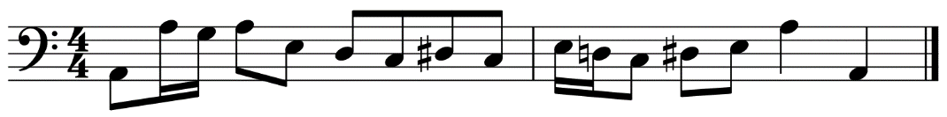
- Write the following: (4 marks)
  - D mixolydian mode
  - The melodic minor scale with the given key signature
Question 2: Chords (6 marks)
- Name the chord type heard in each of the audio tracks below. Choose from the following chord types: major, minor, augmented, diminished, dominant 7th. (3 marks)
  - track 5: ________________________________________
  - track 6: ________________________________________
  - track 7: ________________________________________
- Write the following chords as specified below: (3 marks)
E dominant 7th
E flat minor 9th
G augmented
Question 3: Rhythmic dictation and harmonic progression (18 marks)
Listen to track 8 and examine the score below.
- Complete the following eight-bar dictation by providing bar lines, rhythm and ties as required to the given pitches. The correct rhythm for the first note of each phrase is provided. Alter noteheads as required to reflect the rhythm played. (12 marks)
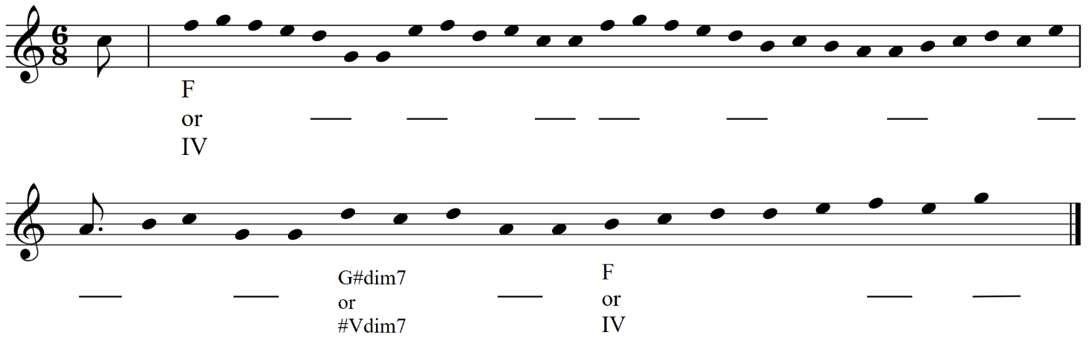
- Insert the missing chords on the lines below the stave. (6 marks)

Question 4: Melodic dictation, intervals, and transposition (20 marks)
Listen to track 9 and examine the score below.
- Name the intervals (by quality and number) as marked in the first two bars. (4 marks)

  - ___________________________________
- Complete the melody by writing the notation (including rhythm and pitch) on the score below.
(12 marks)
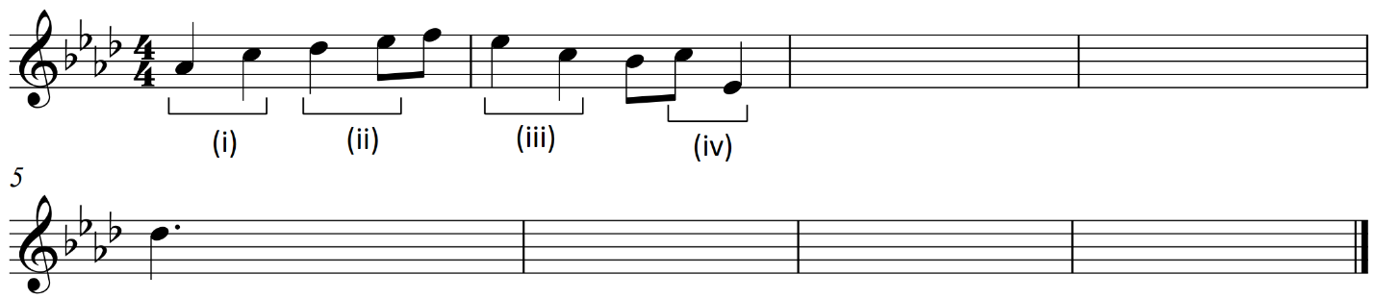
- Transpose the first two bars for a Horn in F, so that it would sound an octave lower than written above. (4 marks)
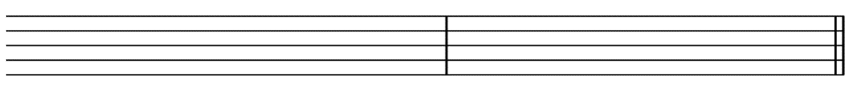

Question 5: Aural analysis (10 marks)
- Listen to track 10. Name the compositional device evident throughout, and the instrument family that enters most prominently part way through the excerpt (0:26). (2 marks)
Compositional device:
Instrument family:
- Listen to track 11. Name the instruments heard in the excerpt and the texture that best fits the excerpt. (3 marks)
Instruments:
Texture:
- Listen to track 12. Name the metre of this excerpt and the instrument that first enters at 1:10 (after the lyrics ‘… suggests maybe not so much anymore.’) (2 marks)
Metre:
Instrument:
- Listen to track 13. Name the tonality at the start and end of the excerpt, and the instrument that plays the featured solo. (3 marks)
Tonality at start:
Tonality at end:
Instrument:

Marking key for Task 7 – Music literacy
Question 1: Scales (9 marks)
- Name the prevailing scale/mode heard in each of the audio tracks below. Choose from the following list: major pentatonic, minor pentatonic, major, natural minor, harmonic minor, melodic minor, chromatic, blues, dorian, mixolydian. (4 marks)
Description | Marks
One mark per correct answer | 1–4
Total | /4
- Name the scale/mode (including scale type and tonic/home note) which most closely aligns to the melody below. (1 mark)
Description | Marks
A blues scale (accept blues scale on A, or similar) | 1
Total | /1
- Write the following: (4 marks)
  - D mixolydian mode
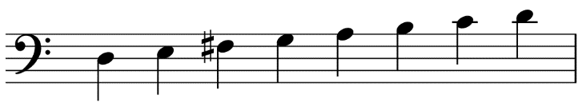
  - The melodic minor scale with the given key signature
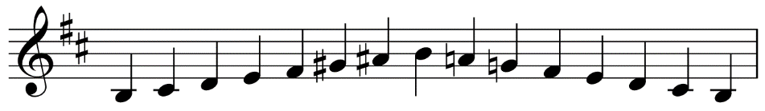
Description | Marks
Two marks for each correct scale  One mark for a scale containing one error  Accept any variation of the correct pitches (ascending/descending, any octave, any note value etc.) | 1–4
Total | /4

Question 2: Chords (6 marks)
- Name the chord type heard in each of the audio tracks below. Choose from the following chord types: major, minor, augmented, diminished, dominant 7th. (3 marks)
Description | Marks
One mark for each correct response | 1–3
Total | /3
- Write the following chords as specified below: (3 marks)
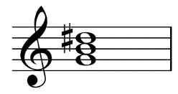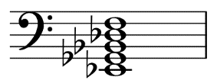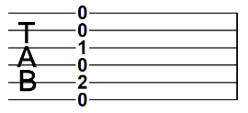
E dominant 7th
E flat minor 9th
G augmented
Description | Marks
One mark for each correct response (accept correct variations) | 1–3
Total | /3

Question 3: Rhythmic dictation and harmonic progression (18 marks)
- Complete the following eight-bar dictation by providing bar lines, rhythm and ties as required to the given pitches. The correct rhythm for the first note of each phrase is provided. Alter noteheads as required to reflect the rhythm played. (12 marks)
Description | Marks
Rhythm (there are 44 note values, not including the final note)
44 note values correct | 8
38–43 note values correct | 7
32–37 note values correct | 6
26–31 note values correct | 5
20–25 note values correct | 4
14–19 note values correct | 3
8–13 note values correct | 2
1–7 note values correct | 1
Subtotal | /8
Final note
Final note is notated as a dotted crotchet tied to a crotchet | 1
Subtotal | /1
Bar lines
All bar lines correct | 2
One error in bar lines | 1
Subtotal | /2
Rhythmic grouping
All rhythmic grouping correct for compound time | 1
Subtotal | /1
Total | /12

See next page for answer score.
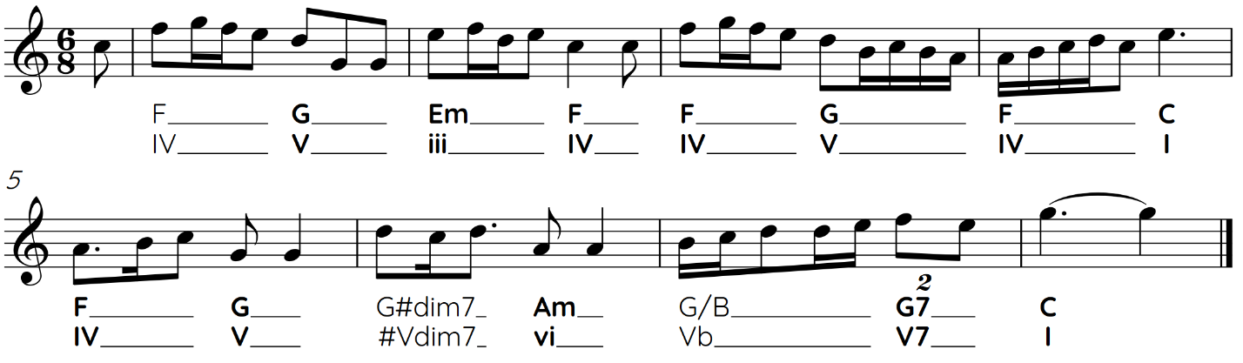
- Insert the missing chords on the lines below the stave (6 marks)
Description | Marks
Chords
12 chords correct | 6
10–11 chords correct | 5
8–9 chords correct | 4
6–7 chords correct | 3
4–5 chords correct | 2
1–3 chords correct | 1
Total | 6
Question 4: Melodic dictation, intervals, and transposition (20 marks)
- Name the intervals (by quality and number) as marked in the first two bars. (4 marks)
Description | Marks
Intervals
One mark per correct interval (no half marks)
- major 3rd | 1
- major 2nd | 1
- minor 3rd | 1
- major 6th | 1
Total | 4
- Complete the melody by writing the notation (including rhythm and pitch) on the score below.
(12 marks)
Description | Marks
Pitch
24 pitches correct | 9
22–23 pitches correct | 8
20–21 pitches correct | 7
17–19 pitches correct | 6
14–16 pitches correct | 5
11–13 pitches correct | 4
8–10 pitches correct | 3
5–7 pitches correct | 2
1–4 pitches correct | 1
Subtotal | 9
Rhythm
All rhythm correct | 3
1–2 rhythm errors | 2
3–4 rhythm errors | 1
Subtotal | 3
Total | 12

See next page for answer score.
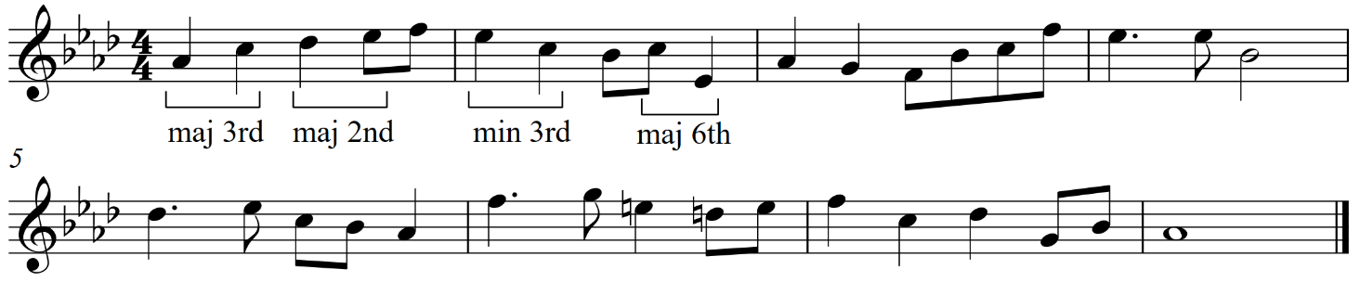
- Transpose the first two bars for a Horn in F, so that it would sound an octave lower than written above. (4 marks)
Description | Marks
Pitches
All pitches correct (including at the correct octave) | 2
1–2 pitch errors; or all pitches correct, but written in an incorrect octave | 1
Subtotal | 2
Key signature
Provides the correct key signature | 1
Subtotal | 1
Clef and time signature
Provides the correct clef and time signature | 1
Subtotal | 1
Total | 4

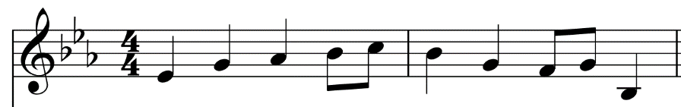
Question 5: Aural analysis (10 marks)
- Listen to track 10. Name the compositional device evident throughout, and the instrument family that enters most prominently part way through the excerpt (0:26). (2 marks)
Description | Marks
Excerpt: Ruins – Toby Fox, 0:00–0:46
https://open.spotify.com/track/1vuSdk2EGjh3eXCXBbT9Qf?si=1d5e110d2a8e46f2
Compositional device: ostinato (accept riff) | 1
Instrument family: synthesisers | 1
Total | 2
- Listen to track 11. Name the instruments heard in the excerpt and the texture that best fits the excerpt. (3 marks)
Description | Marks
Excerpt: Soneto De La Noche – Morten Lauridsen, 0:00–0:58
https://open.spotify.com/track/1LCCsTqF1CXrj69eyiS9Mg?si=eacdf291f2a04587
Instruments: soprano, alto, tenor, bass (voices)  2 marks if all four voice types are listed  1 mark if three of the voice types are listed, or for ‘male and female voices’ | 1–2
Texture: homophonic | 1
Total | 3
- Listen to track 12. Name the metre of this excerpt and the instrument that first enters at 1:10 (after the lyrics ‘… suggests maybe not so much anymore.’) (2 marks)
Description | Marks
Excerpt: Kristine From The 7th Grade – Ben Folds, 0:33–1:36
https://open.spotify.com/track/6oFY67imnu9QaR1bcnlFOc?si=53c59c12b5024b82
Metre: six-eight or compound duple (accept twelve-eight or compound quadruple) | 1
Instrument: cello | 1
Total | 2

- Listen to track 13. Name the tonality at the start and end of the excerpt, and the instrument that plays the featured solo. (3 marks)
Description | Marks
Excerpt: Seven Nation Army – Jack White, performed by Haley Reinhart, and Scott Bradlee’s Postmodern Jukebox, 1:40–2:40 https://open.spotify.com/track/2Lv9mFjcIFPn8zyWF89EAe?si=4ebcf9d84748470f
Tonality at start: minor | 1
Tonality at end: minor (a key change has occurred, but is still minor) | 1
Instrument: trombone (with mute) | 1
Total | 3

Sample written assessment tasks

Task 8 – Music analysis
Assessment type: Music analysis (written)
The assessment consists of visual and aural analysis of an unseen work/s and designated works from Unit 3 and Unit 4. Assessed content includes:
- identifying links to unit themes
- stylistic conventions
- contextual features
- use of music elements
- instrumentation and orchestration.
Conditions: Formal in-class assessment: Semester 2, Week 10
Time for task: 50 minutes
Task weighting: 5% of the school mark for this pair of units
__________________________________________________________________________________
Music analysis (67 marks)
Question 1: Unseen analysis (15 marks)
Treaty – Yothu Yindi
Score: https://www.musicnotes.com/sheetmusic/mtd.asp?ppn=MN0121210
Audio: https://open.spotify.com/track/6S8AoLX1vjvScELjPMrrJ3?si=927e52406366493d (excerpt only from 0:00–2:30)
__________________________________________________________________________________
In this question, the word Balanda describes music of Western/European influence.
- List the seven instruments heard in this work. (2 marks)

- This work features elements of Balanda and First Nations music styles. Complete the table below, explaining how each musical style is featured according to the listed music characteristics. (6 marks)
Characteristic | Balanda music | First Nations music
Instrumentation
Rhythm
Vocal timbre
- Explain how the Balanda text used in this work, and the designated work by Baker Boy, convey the identity of First Nations Australians. Provide a quote from the text of each work to support your answer. (4 marks)

- Compare and contrast the use of harmony in both Treaty and Marryuna, making three distinct points. Use Roman numerals when discussing the harmonic function of each work. (3 marks)

Question 2: Unseen analysis (15 marks)
History has a Heartbeat – Joseph Tawadros with William Barton
Audio: https://open.spotify.com/track/174nOIUA7kFVIqIfpvqvv7?si=2b46af639bc24d61
No score available; not required for this question.
- Name and define the time signature of this piece. (2 marks)

- State the scale/mode type on which the opening melody is based. (1 mark)

- Name and describe the instrumental technique performed by the stringed instrument producing the high pitches in the opening bars. (2 marks)

- This is an Australian work released in 2022. Discuss how this work is a representation of identity in modern-day Australia, with reference to an element of music. (2 marks)

- Using music language, describe how the didgeridoo player varies their performance during this work. (2 marks)

- Discuss one musical characteristic that is innovative about this work, and one musical characteristic that is traditional. (2 marks)

- Complete the following table describing two similarities and two differences between this work and your designated work Tha Thin Tha, stating which element of music each similarity/difference relates to. (4 marks)
Element of music | Description of similarity/difference
Similarity 1 element:
Similarity 2 element:
Difference 1 element:
Difference 2 element:
Question 3: Identities (14 marks)
Examine the score for Gaelic Symphony, first movement by Amy Beach.
- State the form of this work. (1 mark)

- Name one composer who was a significant influence on the Gaelic Symphony and explain the nature of this influence. (2 marks)
Composer:
Nature of influence:

- (i) Name the original song by Beach that provides the basis for the first two themes of the designated work. (1 mark)

(ii) Name the scale on which the flute part is based between bars 7–12. (1 mark)

(iii) Describe the imagery suggested by the flute part above. (1 mark)

- Referring to the use of the main motifs or themes, explain why Beach’s work is considered to be romantic. (1 mark)

- Name the instrument family that features the motif at bar 17 and the new section that begins at this point. (2 marks)
Instrument family:
New section:
- Explain the historical significance of this piece and explain why Beach’s success can be considered remarkable. (2 marks)

- State how the given elements of music are used to express identity in the designated works.
(3 marks)
Designated work and element of music | How the given element of music is used to express identity
Gaelic Symphony
melody (pitch)
Young, Gifted and Black
tonality (pitch)
Marryuna
instrumentation (timbre)

Question 4: Innovations (23 marks)
Examine the score for Tha Thin Tha (excerpt only: pages 1–2)
- Observe the first page of the score. Give a bar and beat numbers that show a clear example of syncopation. (1 mark)

- Examine the accents in bars 1–2. Write the rhythm implied by these accents on the stave below (1 mark)

- Describe the term ‘konnakol’ and how it is evident in this designated work. (2 marks)

- Examine the chord progression of this work.
- Explain what is meant by the chord symbol A/G. (1 mark)

- List the notes found in the chord F+. (1 mark)

- Circle two terms below that best describe the bassline in this work. (2 marks)
chromatic syncopation polymetric canonic
diatonic ostinato inversion retrograde
minor call and response 3 over 4 fugal
- Discuss the rhythmic interplay between the drums and voice during the trading section. (2 marks)

- During the performance of this work, the singer uses hand gestures that relate to the performance. Give the term used to describe these gestures and explain their purpose. (2 marks)

- The guitar solo is marked by the chord symbol A7#11. Circle the scale/mode below that would best fit this chord. (1 mark)
Lydian dominant (1, 2, 3, #4, 5, 6, b7, 1)
Altered scale (1, b2, b3, 3, #4, #5, b7, 1)
Locrian #2 (1, 2, b3, 4 ,b5, b6, b7, 1)
Diminished scale (1, 2, b3, 4, #4, #5, 6, 7, 1)

The following questions relate to the designated works Bohemian Rhapsody and A Short Ride in a Fast Machine.
- Discuss how both of these works are innovative in their use of form. Make specific, musical references to both works to support your response. (6 marks)

- Explain how these two designated works contrast in their use of texture. Make specific, musical references to both works to support your response. (4 marks)

Marking key for Task 8 – Music analysis
Question 1: Unseen analysis (15 marks)
Treaty – Yothu Yindi
- List the seven instruments heard in this work. (2 marks)
Description | Marks
Lists at least six of the listed instruments: drums, bass guitar, electric guitar, keyboard, bongo/conga drum, voices, clapping sticks | 2
Lists four or five of the above instruments | 1
Total | /2
- This work features elements of Balanda and First Nations music styles. Complete the table below, explaining how each musical style is featured according to the listed music characteristics. (6 marks)
Description | Marks
Balanda instrumentation: rock instrumentation (guitar, bass guitar and drums) | 1
Balanda rhythm: simplistic rhythm | 1
Balanda vocal timbre: almost spoken, clearly articulated as it is a narrative | 1
First Nations instrumentation: clapsticks and didgeridoo | 1
First Nations rhythm: more complex rhythmic patterns | 1
First Nations vocal timbre: drone like – mirrors the timbre of the didgeridoo which features with it | 1
Total | /6
- Explain how the Balanda text used in this work, and the designated work by Baker Boy, convey the identity of First Nations Australians. Provide a quote from the text of each work to support your answer. (4 marks)
Description | Marks
One mark for each example of how text is used in each work and one mark for each relevant quote. Examples provided, accept other relevant responses:  Treaty  - connection to country (e.g. ‘words are cheap, much cheaper than our priceless land’)  - colonisation and land rights (e.g. ‘the planting of the Union Jack never changed our law at all’)  Marryuna  - growing up in urban cites in comparison to on Country (e.g. ‘city lights, the sound, too much for my mind’)  - speaking proudly of Aboriginal heritage (e.g. ‘I’m a proud black Yolngu boy’) | 1–4
Total | /4

- Compare and contrast the use of harmony in both Treaty and Marryuna, making three distinct points. Use Roman numerals when discussing the harmonic function of each work. (3 marks)
Description | Marks
One mark per point, accept other relevant answers:  - both pieces are set in minor keys beginning on chord I  - Treaty only features chords I and VI, making the harmonic variety limited  - Marryuna also begins on I, and features mainly IV and V chords | 1–3
Total | /3
Question 2: Unseen score analysis (15 marks)
- Name and define the time signature of this piece. (2 marks)
Description | Marks
Name: 4/4 or common time | 1
Definition: four crotchet/quarter note beats in each bar | 1
Total | /2
- State the scale/mode type on which the opening melody is based. (1 mark)
Description | Marks
Major scale/ionian mode | 1
Total | /1
- Name and describe the instrumental technique performed by the stringed instrument producing the high pitches in the opening bars. (2 marks)
Description | Marks
Name: harmonics | 1
Description: lightly touching the string with the finger, without the string making contact with the fingerboard/fretboard, producing a higher pitch (overtone) | 1
Total | /2
- This is an Australian work released in 2022. Discuss how this work is a representation of identity in modern-day Australia, with reference to an element of music. (2 marks)
Description | Marks
Links an aspect of Australian identity with a relevant element of music, e.g. combination of rock instruments and Aboriginal instruments reflects Australia as a multicultural society | 2
Mentions how the works represent Australian identity without a link to elements of music | 1
Total | /2

- Using music language, describe how the didgeridoo player varies their performance during this work. (2 marks)
Description | Marks
Any two of:  - altering the timbre  - varying rhythmic passages  - slow vibrato  Accept other relevant answers | 1–2
Total | /2
- Discuss one musical characteristic that is innovative about this work, and one musical characteristic that is traditional. (2 marks)
Description | Marks
Any one innovative characteristic:  - unusual orchestration  - use of non-western harmony; diatonic over pedal  - recording techniques  Accept other relevant answers | 1
Any one traditional characteristic:  - use of First Nations instrument  - use of First Nations rhythms  - didgeridoo performed with many traditional techniques  Accept other relevant answers | 1
Total | /2
- Complete the following table describing two similarities and two differences between this work and your designated work Tha Thin Tha, stating which element of music each similarity/difference relates to. (4 marks)
Description | Marks
One mark for each similarity and difference (must correctly reference an element of music).  Similarities  - unusual rhythms (rhythm)  - world instruments (timbre)  - major tonality (pitch)  - homophonic (texture)  - time signature (rhythm)  Differences  - different instrumentation (timbre)  - variations in form (form)  - Tha Thin Tha varies more in dynamics (expressive elements)  - Tha Thin Tha has a moving chord progression (pitch)  Accept other relevant answers | 1–4
Total | /4

Question 3: Identities (14 marks)
Examine the score for Gaelic Symphony, first movement by Amy Beach.
- State the form of this work. (1 mark)
Description | Marks
Sonata form | 1
Total | /1
- Name one composer who was a significant influence on the Gaelic Symphony and explain the nature of this influence. (2 marks)
Description | Marks
Composer: Dvorak  Note: could also accept Brahms and Wagner for their influence of harmony | 1
Nature of influence: focused on nationalistic music which Beach used for inspiration to draw on influences from her own heritage | 1
Total | /2
- (i) Name the original song by Beach that provides the basis for the first two themes of the designated work. (1 mark)
Description | Marks
Dark is the Night | 1
Total | /1
(ii) Name the scale on which the flute part is based between bars 7–12. (1 mark)
Description | Marks
Chromatic | 1
Total | /1
(iii) Describe the imagery suggested by the flute part above. (1 mark)
Description | Marks
The ocean and swirling waves | 1
Total | /1

- Referring to the use of the main motifs or themes, explain why Beach’s work is considered to be romantic. (1 mark)
Description | Marks
Motifs/themes are allocated to the string and woodwind families as opposed to just strings  Use of chromaticism  Accept other relevant answers | 1
Total | /1
- Name the instrument family that features the motif at bar 17 and the new section that begins at this point (2 marks)
Description | Marks
Instrument family: brass | 1
New section: exposition | 1
Total | /2
- Explain the historical significance of this piece and explain why Beach’s success can be considered remarkable. (2 marks)
Description | Marks
Any two of the following:  - first symphony by an American woman to be published and performed by a major symphony orchestra  - Beach had no formal training in composition or orchestration and was self-taught as women at the time were generally denied higher education opportunities  - Beach achieved international success in a male-dominated profession | 1–2
Total | /2
- State how the given elements of music are used to express identity in the designated works.
(3 marks)
Description | Marks
Gaelic Symphony – melody (pitch): use of motifs written by Beach inspired by Irish tunes and motifs referencing Irish dances | 1
Young, Gifted and Black – tonality (pitch): in a major key to convey hope for and pride in young black people | 1
Marryuna – instrumentation (timbre): instruments and language of First Nations Australians, including didgeridoo | 1
Total | /3

Question 4: Innovations (23 marks)
Examine the score for Tha Thin Tha (excerpt only: pages 1–2)
- Observe the first page of the score. Give a bar and beat numbers that show a clear example of syncopation. (1 mark)
Description | Marks
Bar 5 beats 2–3, or bar 10 beats 1–2  Accept other relevant answers | 1
Total | /1
- Examine the accents in bars 1–2. Write the rhythm implied by these accents on the stave below.
(1 mark)
Description | Marks
Accept any correctly grouped permutation of this rhythm | 1
Total | /1
- Describe the term ‘konnakol’ and how it is evident in this designated work. (2 marks)
Description | Marks
Konnakol is South Indian vocal percussion combining intricate rhythms with syllabic language | 1
This piece is entirely based around the concept of konnakol | 1
Total | /2
- Examine the chord progression of this work.
(i) Explain what is meant by the chord symbol A/G. (1 mark)
Description | Marks
The harmonic instrument should play an A major triad while the bass instrument plays a G bass note | 1
Total | /1
(ii) List the notes found in the chord F+. (1 mark)
Description | Marks
F, A, C# | 1
Total | /1

- Circle two terms below that best describe the bassline in this work. (2 marks)
Description | Marks
Accept any two of the following:  - syncopation  - polymetric  - ostinato  - 3 over 4 | 1–2
Total | /2
- Discuss the rhythmic interplay between the drums and voice during the trading section. (2 marks)
Description | Marks
The drums and voice trade solo ideas | 1
The length of the trades alternate in length from three minims to four minims | 1
Total | /2
- During the performance of this work, the singer uses hand gestures that relate to the performance. Give the term used to describe these gestures and explain their purpose. (2 marks)
Description | Marks
Term: tala | 1
Definition: provide an individual gesture for each beat of an eight-beat count. These gestures help the performer to keep their place during the performance of intricate rhythms | 1
Total | /2
- The guitar solo is marked by the chord symbol A7#11. Circle the scale/mode below that would best fit this chord. (1 mark)
Description | Marks
Lydian dominant (1, 2, 3, #4, 5, 6, b7, 1) | 1
Total | /1

The following questions relate to the designated works Bohemian Rhapsody and A Short Ride in a Fast Machine.
- Discuss how both of these works are innovative in their use of form. Make specific, musical references to both works to support your response. (6 marks)
Description | Marks
Discusses accurately and in specific detail how both works are innovative in their use of form, including relevant musical references in the response | 6
Discusses accurately and in some detail how both works are innovative in their use of form, including relevant musical references in the response | 4–5
Provides general comment on how both works are innovative in their use of form, including some musical references in the response | 3
Makes superficial comment on how both works (or general comment on only one work) are innovative in their use of form, including some musical references in the response, with some inaccuracy evident | 2
Makes superficial comment on how the works are innovative in their use of form and/or mostly inaccurate comments | 1
Total | /6
- Explain how these two designated works contrast in their use of texture. Make specific, musical references to both works to support your response. (4 marks)
Description | Marks
Explains the contrasting use of texture in the two works, with relevant musical references to both works in the response | 4
Explains the use of texture in the two works with relevant musical references, without highlighting the contrast, or explains the contrasting application with only somewhat relevant musical references in the response | 3
Makes general comment on the use of texture in one or both works, including some musical references in the response, with some inaccuracy evident | 2
Makes superficial comment on the use of texture in the two works and/or makes mostly inaccurate comments | 1
Total | /4

