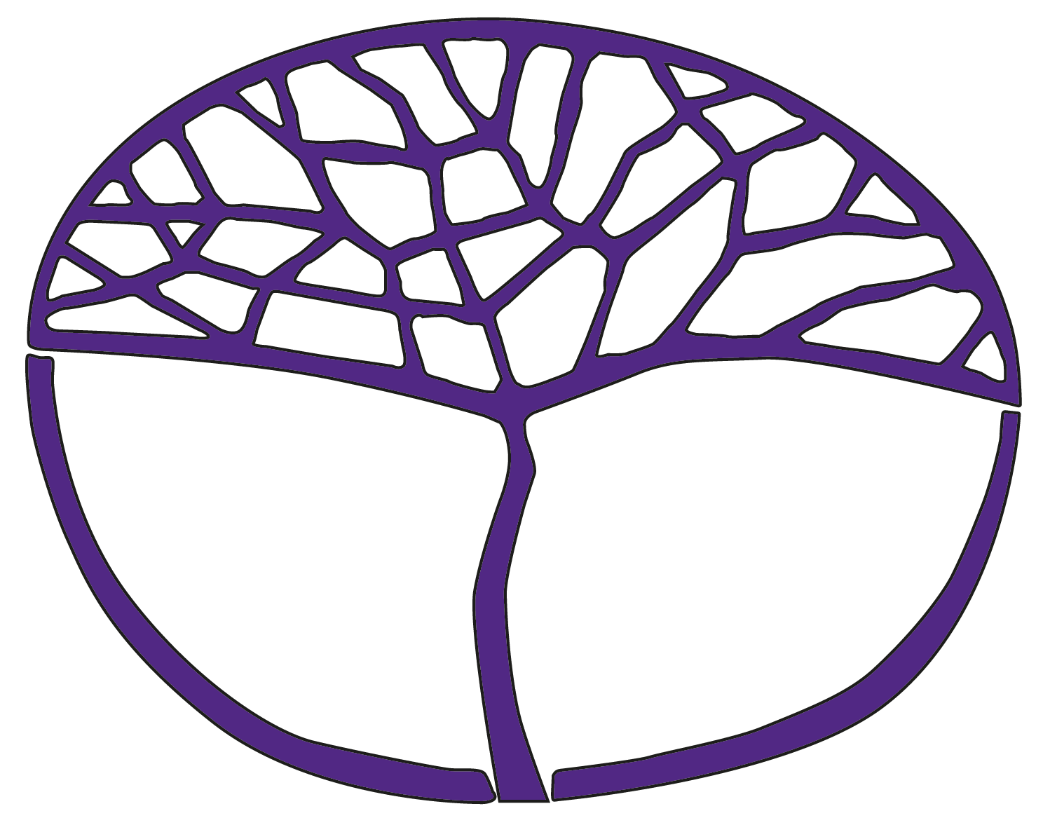Sample Course Outline

Aboriginal and Intercultural Studies

ATAR Year 11 for 2024

**Acknowledgement of Country**

Kaya. The School Curriculum and Standards Authority (the Authority) acknowledges that our offices are on Whadjuk Noongar boodjar and that we deliver our services on the country of many traditional custodians and language groups throughout Western Australia. The Authority acknowledges the traditional custodians throughout Western Australia and their continuing connection to land, waters and community. We offer our respect to Elders past and present.

**Copyright**

© School Curriculum and Standards Authority, 2023

This document – apart from any third-party copyright material contained in it – may be freely copied, or communicated on an intranet, for non-commercial purposes in educational institutions, provided that the School Curriculum and Standards Authority (the Authority) is acknowledged as the copyright owner, and that the Authority’s moral rights are not infringed.

Copying or communication for any other purpose can be done only within the terms of the *Copyright Act 1968* or with prior written permission of the Authority. Copying or communication of any third-party copyright material can be done only within the terms of the *Copyright Act 1968* or with permission of the copyright owners.

Any content in this document that has been derived from the Australian Curriculum may be used under the terms of the [Creative Commons Attribution 4.0 International licence](https://creativecommons.org/licenses/by/4.0/).

**Disclaimer**

Any resources such as texts, websites and so on that may be referred to in this document are provided as examples of resources that teachers can use to support their learning programs. Their inclusion does not imply that they are mandatory or that they are the only resources relevant to the course. Teachers must exercise their professional judgement as to the appropriateness of any they may wish to use.

Sample course outline

Aboriginal and Intercultural Studies – ATAR Year 11 for 2024

Intercultural Skills

All the skills must be taught during the units. Relevant skills should be emphasised for each depth study.

**Research**

* construct a set of focus questions to investigate a specific topic/issue (who, what, when, where, how, why)
* plan an inquiry with clearly defined aims, using appropriate methodologies
* collect, record and organise information and/or data from relevant culturally responsive resources

**Analysis and use of sources**

* identify the origin, purpose and context of primary sources and/or secondary sources
* evaluate the usefulness of different sources
* recognise different perspectives presented in a variety of different primary and/or secondary sources
* identify and use evidence from different sources to support a point of view

**Evaluating and communicating**

* draw conclusions and develop explanations using evidence taking into account different perspectives
* communicating findings using formats appropriate to purpose, including written, oral or multimodal presentations
* use respectful and inclusive language and terminology
* identify and practise ethical scholarship when conducting research, including
* respecting variation between cultural groups of processes and protocols for collecting, acknowledging and communicating information
* adopting protocols and conventions to communicate in culturally appropriate ways
* applying appropriate referencing techniques accurately and consistently

**Reflection**

* acknowledge differences in personal perspectives, interpretations and world views when developing a response
* reflect on own learning to review original understandings

Semester 1 – Unit 1

| **Week** | **Key teaching points** |
| --- | --- |
| 1–3 | **First Nations Peoples’ perspectives** Cultural perspectives  * concept of culture and cultural perspectives * features of **two** First Nations Peoples of the world (one from each hemisphere), including   + identity   + location   + language   + demographics   + worldview   **Place and belonging**   * Australian First Nations Peoples’ cultural and spiritual connection to Country, including   + maintenance of cultural identity   + cultural knowledge   + family   + kinship roles and obligations   + connection with ancestors   **Intercultural Skills**   * Analysis and use of sources * Evaluating and communicating * Reflection   **Task 1: Response** |
| 4–7 | **Sustainable societies** Australian First Nations Peoples’ contributions to Australian society  * Australian First Nations Peoples’ technological innovations, including agriculture, aquaculture, astronomy and science * contribution of Australian First Nations Peoples to Australian economic development, including   + Aboriginal owned businesses   + Aboriginal Community Controlled Organisations   **Intercultural Skills**   * Research * Analysis and use of sources * Evaluating and communicating * Reflection   **Task 2: Inquiry** |
| 8–9 | Empowering people  * the *Aboriginal Empowerment Strategy – Western Australia 2021–2029*, including why the strategy was needed, the purpose, goals and principles * **two** Australian First Nations Peoples governance in caring for Country, e.g. South West Native Title Settlement, the Ngaanyatjarra Lands and Rangers, Kimberley Land Council |
| 10–12 | Relationships with the environment over time  * Australian First Nations Peoples caring for Country practices, including three of the following   + use and management of waterways   + fire management   + native animal endangerment and extinctions   + control of introduced and feral species, i.e. animals/plants   + regeneration of mine sites * Australian First Nations Peoples’ care and protection over time of **one** significant site, e.g. the Burrup Peninsula, Wadjamup, Paruku Indigenous Protected Area   **Intercultural Skills**   * Analysis and use of sources * Evaluating and communicating * Reflection   **Task 3: Response** |
| 13–14 | **First Nations Peoples’ perspectives** Diversity and change  * response of Australian First Nations Peoples over time to   + climate change   + changing land use   + new technologies * changing responses to engaging with and using First Nations Peoples’ care of Country practices and cultural knowledge |
| 15 | **Task 4: Examination** |

Semester 2 – Unit 2

| **Week** | **Key teaching points** |
| --- | --- |
| 1–3 | **First Nations Peoples’ perspectives** Cultural perspectives  * concept of empowerment, self-determination and resiliency * the experiences and impacts of colonisation on two Australian First Nations Peoples located in different parts of Australia, e.g. Western Australia and Tasmania |
| 4–7 | Place and belonging  * the ways First Nations Peoples maintain their connection to Country over time as evidenced by native title findings and significant sites * **one** example of a fight to maintain, regain and sustain the ownership and access to land and water by Australian First Nations Peoples, e.g. the South West Native Title Settlement  Relationships with the environment over time  * for **one** Australian First Nations Peoples and **one** international First Nations Peoples the environmental and cultural issues concerning the use and management of natural resources on their Country   **Intercultural Skills**   * Analysis and use of sources * Evaluating and communicating * Reflection   **Task 5: Response** |
| 8–11 | Diversity and change  * the contribution of cultural expressions to the empowerment and resiliency of First Nations Peoples’ cultures and identities both in Australia and internationally, e.g. visual arts, music, theatre, dance, literature * select **two** government policies, actions and/or laws and explain their impact on Australian First Nations Peoples, such as   + the *Aborigines Act 1905* (WA)   + *Aborigines Protection Amending Act 1915* (NSW) – Stolen Children   + *Native Administration Act 1936* (amendment to the *Aborigines Act 1905*)   + the Commonwealth right to vote 1962   + Referendum 1967   + *Aboriginal Land Rights (Northern Territory) Act 1976* and the symbolic Hand back ceremony 1975   + Prime Minister Keating’s Redfern Park Speech 1992   + *Native Title Act 1993*   + *Native Title Amendment Act 1997*   + *Bringing Them Home report* 1997 – Stolen Generations   + *Northern Territory National Emergency Response Act 2007* (the Intervention)   + the Apology 2008 * select **one** significant example of Australian First Nations Peoples’ civil activism, and examine the catalyst to the action, the key individuals and/or groups involved, and the outcomes of the action, such as   + the Pilbara Strike 1946   + the Coolbaroo League 1947   + the Noonkanbah dispute 1979–80  Empowering people  * the flow on effects of the Uluru Statement from the Heart   **Intercultural Skills**   * Research * Analysis and use of sources * Evaluating and communicating * Reflection   **Task 6: Inquiry** |
| 12–14 | **Sustainable societies** Australian First Nations Peoples’ contributions to Australian society  * the contribution of Australian First Nations Peoples’ cultural expressions to the cultural, political and social growth of Australian society, e.g. visual arts, music, dance, literature, and events-based projects, referendum, reconciliation * the contribution of the growth of Australian First Nations Peoples’ tourism industry to the Australian economy   **Intercultural Skills**   * Analysis and use of sources * Evaluating and communicating * Reflection   **Task 7: Response** |
| 15 | **Task 8: Examination** |