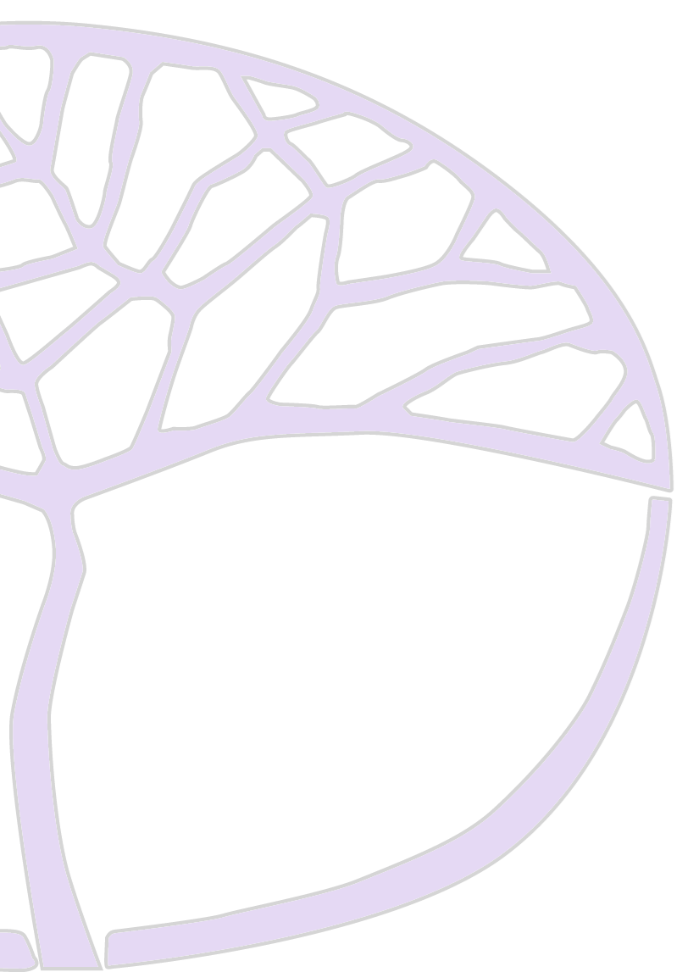

SAMPLE ASSESSMENT OUTLINE
COMPUTER SCIENCE ATAR YEAR 11

Acknowledgement of Country
Kaya. The School Curriculum and Standards Authority (the Authority) acknowledges that our offices are on Whadjuk Noongar boodjar and that we deliver our services on the country of many traditional custodians and language groups throughout Western Australia. The Authority acknowledges the traditional custodians throughout Western Australia and their continuing connection to land, waters and community. We offer our respect to Elders past and present.

IMPORTANT INFORMATION
Copyright
© School Curriculum and Standards Authority, 2023
This document – apart from any third party copyright material contained in it – may be freely copied, or communicated on an intranet, for non-commercial purposes in educational institutions, provided that the School Curriculum and Standards Authority is acknowledged as the copyright owner, and that the Authority’s moral rights are not infringed.
Copying or communication for any other purpose can be done only within the terms of the Copyright Act 1968 or with prior written permission of the School Curriculum and Standards Authority. Copying or communication of any third party copyright material can be done only within the terms of the Copyright Act 1968 or with permission of the copyright owners.
Any content in this document that has been derived from the Australian Curriculum may be used under the terms of the Creative Commons Attribution 4.0 International licence.

Disclaimer
Any resources such as texts, websites and so on that may be referred to in this document are provided as examples of resources that teachers can use to support their learning programs. Their inclusion does not imply that they are mandatory or that they are the only resources relevant to the course.

2022/34238

1

Sample assessment outline Computer Science – ATAR Year 11 Unit 1 and Unit 2

Assessment type (from syllabus) | Assessment type weighting (from syllabus) | Assessment task weighting | When/start and submission date | Assessment task
Project | 40% | 20% | Semester 1  Weeks 5–12 | Task 1: Using the framework for development, design and create an interactive puzzle, card or board game in Python using a variety of control structures, data types and one-dimensional arrays.
 |  | 20% | Semester 2  Week 10–12 | Task 6: Investigate, design, create and manipulate a relational database with a minimum of three tables (RDBMS) for a community organisation or based on a local innovation. The design should include a data dictionary, entity relationship (ER) diagrams and normalisation. Include a variety for SQL queries for data output.
Theory test | 20% | 10% | Semester 1  Week 14 | Task 3: A series of short answer and extended questions based upon Network Communications and programming content that includes the creation of network diagram using CISCO diagrammatic conventions.
 |  | 10% | Semester 2  Week 4 | Task 5: A series of short answer and extended questions based upon Cyber Security concepts including the use of common ciphers.
Practical test | 10% | 5% | Semester 1  Week 10 | Task 2: A practical test that includes error detection, debugging code and testing of a predetermined programming prototype. Use appropriate test data, type and range checking to gather solutions
 |  | 5% | Semester 2  Week 14 | Task 7: A practical test that requires the manipulation of an existing RDBMS through SQL queries including SELECT, INSERT, DELETE, UPDATE and aggregate functions.
Examination | 30% | 10% | Semester 1  Week 16 | Task 4: Semester 1 examination – 2.5 hours using a modified examination design brief from the ATAR Year 12 syllabus. Section One: 15 questions (40%); Section Two: four questions (60%).
 |  | 20% | Semester 2  Week 16 | Task 8: Semester 2 examination – 3 hours using the examination design brief from the ATAR Year 12 syllabus.  Section One: 20–30 questions (40%); Section Two: four to six questions (60%).
Total | 100% | 100%

Sample assessment outline | Computer Science | ATAR Year 11

