Design ATAR course practical (portfolio) examination 2025
References/acknowledgements
WA student number:
Instructions to candidate
As a candidate of this examination, you must acknowledge sources of information (references, appropriations, attributions) used in your practical portfolio submitted for assessment.
References and acknowledgments must include:
- the name of the CAD software packages, graphics editing software and/or generative artificial intelligence (AI) tools used throughout the practical (portfolio) examination submission
- all sources (i.e. another person’s ideas, works or images) used in the investigation and development of design concepts. All images obtained from the internet or created with the assistance of AI must be disclosed and the URL cited as shown in the example below.
Examples of completed tables
Software program used | Design use of software
Adobe Photoshop | Photo editing and manipulation
Adobe InDesign | Design proposal layout
Fusion 360 | 3D model construction and rendering
Procreate | Digital illustrations
Generative artificial intelligence (AI) tools used | Design use of AI
ChatGPT | Summary of text and graph creation
VIZCOM | Idea visualisations and iterations (as specified below)

Thumbnail of image | Page of portfolio | Current authentic and specific URL
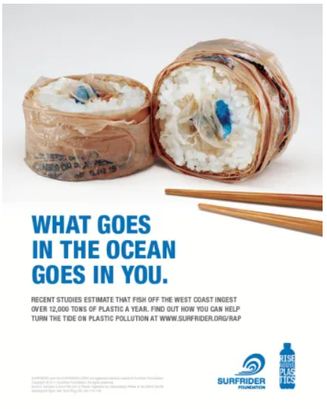 | 5 | https://tbarneyblog.wordpress.com/2017/10/12/what-goes-in-the-ocean-goes-in-you-a-visual-analysis/
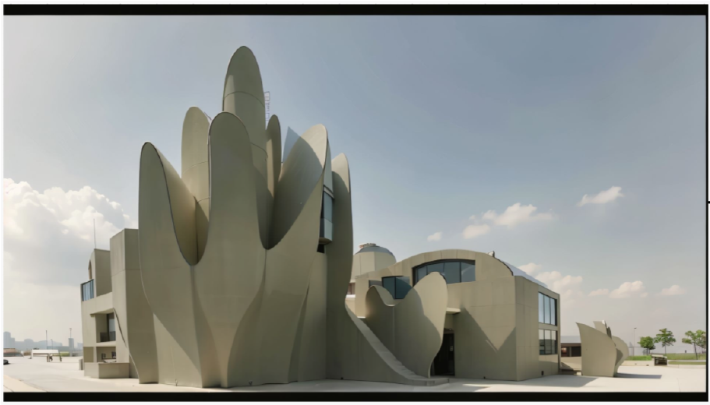 | 15 | https://app.vizcom.ai/
 | 16 | https://chatgpt.com/

Tables for candidate to complete
Software program used | Design use of software
Generative artificial intelligence (AI) tools used | Design use of AI

Thumbnail of image | Page of portfolio | Current authentic and specific URL
As a candidate of this examination, I acknowledge that all other work not listed above is my own.

