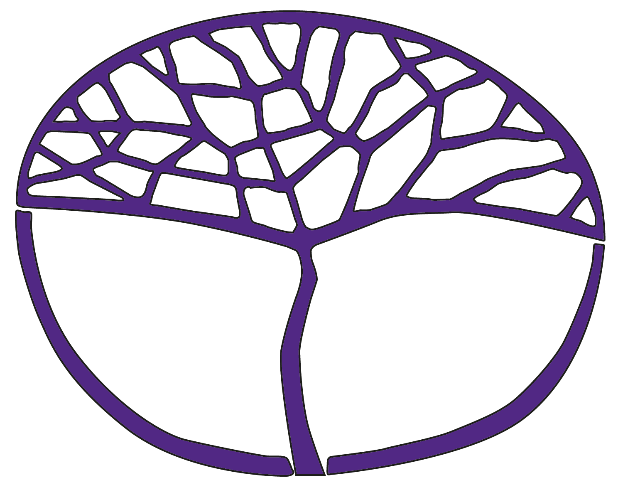Sample Assessment Outline

Human Biology

General Year 12

**Acknowledgement of Country**

Kaya. The School Curriculum and Standards Authority (the Authority) acknowledges that our offices are on Whadjuk Noongar boodjar and that we deliver our services on the country of many traditional custodians and language groups throughout Western Australia. The Authority acknowledges the traditional custodians throughout Western Australia and their continuing connection to land, waters and community. We offer our respect to Elders past and present.

**Copyright**

© School Curriculum and Standards Authority, 2020

This document – apart from any third-party copyright material contained in it – may be freely copied, or communicated on an intranet, for non-commercial purposes in educational institutions, provided that the School Curriculum and Standards Authority (the Authority) is acknowledged as the copyright owner, and that the Authority’s moral rights are not infringed.

Copying or communication for any other purpose can be done only within the terms of the *Copyright Act 1968* or with prior written permission of the Authority. Copying or communication of any third-party copyright material can be done only within the terms of the *Copyright Act 1968* or with permission of the copyright owners.

Any content in this document that has been derived from the Australian Curriculum may be used under the terms of the [Creative Commons Attribution 4.0 International licence](http://creativecommons.org/licenses/by/4.0/).

**Disclaimer**

Any resources such as texts, websites and so on that may be referred to in this document are provided as examples of resources that teachers can use to support their learning programs. Their inclusion does not imply that they are mandatory or that they are the only resources relevant to the course. Teachers must exercise their professional judgement as to the appropriateness of any they may wish to use.

Sample assessment outline

Human Biology – General Year 12

Unit 3 and Unit 4

|  |  |  |  |  |
| --- | --- | --- | --- | --- |
| Assessment type  (from syllabus) | Assessment type weighting  (from syllabus) | Assessment task weighting | When/due date/start and submission date | Assessment task |
| **Investigation** | 25% | 25% | Semester 2 Weeks 2–6 | **Assessment task 5 – Kitchen hygiene**  Students work individually or in groups to plan and conduct the investigation and summarise their findings in a live or virtual poster presentation. Each student will prepare a written report to communicate their findings.  Planning, working safety and group contributions will be monitored via student logbooks, responses to reflection questions, peer and self-assessments and teacher observations.  Time: 15 hours |
| **Project** | 30% | 15% | Semester 1 Weeks 13–15 | **Assessment task 3 – Human fertility**  Students will work individually to analyse and synthesise information from at least two different sources to illustrate an issue by explaining the relevant scientific concepts and describing the impact and/or influence on society.  Students will use their research to produce an infographic.  Time: 8 hours |
| 15% | Semester 2 Weeks 11–12 | **Assessment task 7 – Control of infectious diseases**  Students will work individually to analyse and synthesise information from at least two different sources to illustrate a claim by explaining the relevant scientific concepts and describing the impact on society.  Students will use their research to produce a persuasive newspaper or blog article.  Time: 8 hours |
| **Practical assessment** | 10% | 5% | Semester 1  Week 3 | **Assessment task 1 – DNA extraction**  Students will work individually to demonstrate their ability to manipulate apparatus and take accurate readings to safely collect meaningful data.  Time: 50 minutes |
| 5% | Semester 2  Week 14 | **Assessment task 8 – Infectious diseases**  Students will work individually to demonstrate their ability to manipulate apparatus and to safely collect meaningful data.  Time: 20 minutes |
| **Supervised written assessment** | 20% | 10% | Semester 1  Week 8 | **Assessment task 2 – Cell reproduction, reproductive systems and pregnancy**  Students will work individually to answer short and extended answer questions on the identified syllabus content.  Time: 50 minutes |
| 10% | Semester 2  Week 8 | **Assessment task 6 – Immune system**  Students will work individually to answer short and extended answer questions on the identified syllabus content.  Time: 50 minutes |
| **Externally set task** | 15% | 15% | Semester 1  Week 15 | **Assessment task 4 – Externally set task**  A written task developed by the School Curriculum and Standards Authority.  Students will work individually to answer short and extended answer questions on the Scientific Method and Scientific Literacy content, with Unit 3 Science Understanding content providing the context for questions.  Time: 50 minutes |
| **Total** | **100%** | **100%** |  | |