**Sample Assessment Tasks**

Biology

ATAR Year 11

**Copyright**

© School Curriculum and Standards Authority, 2014

This document – apart from any third party copyright material contained in it – may be freely copied, or communicated on an intranet, for non-commercial purposes in educational institutions, provided that the School Curriculum and Standards Authority is acknowledged as the copyright owner, and that the Authority’s moral rights are not infringed.

Copying or communication for any other purpose can be done only within the terms of the *Copyright Act 1968* or with prior written permission of the School Curriculum and Standards Authority. Copying or communication of any third party copyright material can be done only within the terms of the *Copyright Act 1968* or with permission of the copyright owners.

Any content in this document that has been derived from the Australian Curriculum may be used under the terms of the [Creative Commons Attribution-NonCommercial 3.0 Australia licence](http://creativecommons.org/licenses/by-nc/3.0/au/)

**Disclaimer**

Any resources such as texts, websites and so on that may be referred to in this document are provided as examples of resources that teachers can use to support their learning programs. Their inclusion does not imply that they are mandatory or that they are the only resources relevant to the course.

Sample assessment task

Biology – ATAR Year 11

Task 1 – Unit 1

**Assessment type:** Science inquiry: Investigation

**Conditions**

Period allowed for completion of the task: 3–10 weeks

* 1 week to research and plan investigation
* 1–8 weeks to collect data using biological field techniques
* 1 week to collate data, analyse results and write a scientific report in class under invigilated conditions

**Task weighting**

15% of the school mark for this pair of units

____________________________________________________________________________________________________

**The effect of fire on the forest ecosystem**  **(50 marks)**

Periodic burning and wildfires alter the population dynamics in a forest ecosystem. Investigate an area of forest that has been burnt in the last five years and compare it with an area that has been undisturbed by fire for over twenty years.

Present your findings in a scientific report to inform fire management regimes in the forest.

1. **Plan the investigation**

* Research the history of the local area to determine fires that have occurred in the area
* Make a preliminary visit to the sites
* Research the sampling methods that can be used
* Discuss other types of evidence that need to be collected
* Prepare tables to record observations and the results of tests carried out

1. **Conduct the investigation**

* Overview of each site being investigated
* Use sampling methods to show differences in the composition of plants and animals between the sites. You will need to use quadrats, transects and at least one other field sampling method.
* The study site/s may be revisited over a period of time

1. **Process, evaluate and communicate findings**

* Collate results from all class groups (raw data from each group will be provided to teacher who will distribute to you)
* Represent data using the most suitable format
* Analyse results identifying trends and quality of data
* Discuss the effect of fire on the ecosystem
* Prepare a scientific report of your findings. Include relevant information from your background notes in the introduction.

**Resources**

Department of Environment and Conservation: [www.dec.wa.gov.au](http://www.dec.wa.gov.au)

Marking key for sample assessment task 1 — Unit 1

|  |  |
| --- | --- |
| **Description** | **Marks** |
| **Introduction** | **/6** |
| Selects appropriate information from research notes and succinctly writes an introduction to the investigation including:   * local history of controlled burns and wildfires * clearly drawn maps of each of the study sites * the sampling methods to be used e.g. quadrats, transects, capture-recapture, pit trapping, radiotracking * other data that needs to be collected e.g. physical features of the area | 1–4 |
| * aim/purpose clearly identified | 2 |
| * attempts to identify an aim/purpose | 1 |
| **Materials and method** | **/4** |
| * clearly lists materials with sizes and quantities | 2 |
| * briefly lists materials | 1 |
| * explains the method in detail, including how the sampling will be determined | 2 |
| * briefly describes the method | 1 |
| **Results** | **/12** |
| * describes overall visual observations of each study site, including diagrams, maps or other visual representation | 2 |
| * briefly comments on each study site | 1 |
| * presents quadrat data for each site in appropriate tables, including raw and collated data | 3–4 |
| * constructs incomplete tables for quadrat data | 1–2 |
| * presents transect data for each site in appropriate tables, including raw and collated data | 3–4 |
| * constructs incomplete tables for transect data | 1–2 |
| * includes data presented in appropriate tables for other population study e.g. capture recapture, pit traps | 1–2 |
| **Discussion of results** | **/20** |
| * compares data between the two study sites * overall observations * types of plant species present * number/density of plant species present * numbers/types of animals | 1–2  1–2  1–2  1–2 |
| * explains data using relevant science concepts * describes adaptations of Australian plants for surviving fires and relates these adaptations to types of plants present * differentiates between plants in each site and their survival for the type of fire or the time since the fire * explains the distribution of plants at each site * explains why different animals may be present at each site related to fire | 1–2  1–2  1–2  1–2 |
| * accounts for factors other than fire that may have impacted on the study sites  e.g. differences in topography, soil types, human influence | 1–2 |
| * describes any difficulties encountered and suggests improvements in experimental design or method of data collection for accuracy | 1–2 |
| **Conclusion** | **/8** |
| * concisely summarises the results of the investigation | 2 |
| * briefly describes the results of the investigation, omitting some key points | 1 |
| * explains the consequences of both controlled burns and wildfires on the population dynamics of a forest ecosystem | 5–6 |
| * identifies the effects of both controlled burns and wildfires on the population dynamics of a forest ecosystem | 3–4 |
| * list the effects of either a controlled burn or a wildfire on the population dynamics of a forest ecosystem | 1–2 |
| **Total marks** | **/50** |

Sample assessment task

Biology – ATAR Year 11

## Task 3 – Unit 1

**Assessment type:** Extended response

**Conditions**

Period allowed for completion of the task:

* 1 week research and discussion in class
* 50 minutes to respond to questions in class under invigilated conditions

**Task weighting**

5% of the school mark for this pair of units

____________________________________________________________________________________________________

**Population dynamics**  **(20 marks)**

Read the Landscope article 'Down but not out: solving the mystery of the woylie population crash' written by Samille Mitchell and Adrian Wayne. [Landscope 23 (4) 2008]

Use the following questions to focus your reading:

1. What is a woylie?

2. Where does it live?

3. Briefly describe all of the relationships the woylie has with other organisms.

4. What factors (abiotic and biotic) might threaten the survival of the woylie?

5. Describe two of the conservation measures taken that helped to increase the woylie population from the 1970s to 1996.

6. Describe three measures that have been taken to understand the decline of the woylie population since 1996.

7. Name two possible causes for the decline of the woylie since 1996.

8. Why should we try to save the woylie?

Discuss these questions with other members of your group. You may wish to do further research on woylies. Enter ‘Landscope woylie' into a search engine to access other information.

You will be asked to answer extended answer questions as an in-class assessment. These questions will allow you to show your understanding of population dynamics in woylie populations, but will not be exactly the same questions that you have prepared.

**In-class questions for Task 3: Extended response**

Use your knowledge of population dynamics and your research into woylie population changes to answer the following questions.

1. Describe **four (4)** factors that could affect the population size and distribution of woylies. (4 marks)

2. Explain how **two (2)** activities carried out by woylies help to keep the woodlands healthy and productive. (4 marks)

3. The following graph shows the number of woylies captured at eight different sites in the southwest of WA.



[Graph from: Wayne, A et al. (2008). *Woylie trap success rates in Perup*. Retrieved 2008 from Science division. Department of Conservation and Environment [www.dec.wa.gov.au/component/docman/doc_download/3358/1](http://www.dec.wa.gov.au/component/docman/doc_download/3358/1).]

(a) Describe the trend in capture rates of woylies between 1974 and 1996. Use data to support your answer. (2 marks)

(b) Suggest **two (2)** reasons for this trend. (2 marks)

(c) Numerous hypotheses have been suggested by scientists to account for the decline in capture rates since 2001–2003. Some of these hypotheses have been discounted by evidence collected by the scientists.

(i) Explain how **two (2)** hypotheses have been discounted based on the evidence provided. (2 marks)

(ii) Explain **two (2)** hypotheses that are still being considered by scientists. (2 marks)

(iii) Which hypothesis is considered the most likely cause for the decline in the population of woylies? Explain why. (2 marks)

(d) Suggest **two (2)** reasons for the variation between the sites when the populations began to decline. (2 marks)

# Marking key for sample assessment task 3 — Unit 1

|  |  |
| --- | --- |
| **Description** | **Marks** |
| **1. Describe four (4)** **factors that could affect the population size and distribution of woylies.** | **/4** |
| * predators may limit or reduce woylie numbers | 1 |
| * resources such as plant material for cover and nesting, food sources | 1 |
| * disease such as parasites that can weaken individuals | 1 |
| * climate, extreme weather events (drought, flood, fire) | 1 |
| **2. Explain how two (2)** **activities carried out by woylies help to keep the woodlands healthy and productive.** | **/4** |
| * by feeding on plants and fungi, it helps disperse these throughout the ecosystem * trees and plants rely on some types of fungi to help them to gain nutrients | 1–2 |
| * digging for food * buries leaf litter reducing fire risk and helping in nutrient recycling for plants to grow | 1–2 |
| **3(a) Describe the trend in capture rates of woylies between 1974 and 1996.** Use data to support your answer. | **/2** |
| * capture rates have increased * from 10% or less to a range of between 40–60% | 1–2 |
| **3(b) Suggest two (2)** **reasons for this trend.** | **/2** |
| Any two of the following:   * resources e.g. food availability increased * fox baiting programs have reduced the number of predators * translocations of woylies – reintroductions and establishment of new populations | 1–2 |
| **3(c)(i) Explain how two (2)** **hypotheses have been discounted based on the evidence provided.** | **/2** |
| * no significant loss/change of habitat (nor food resources) | 1 |
| * fire history is not related to the declines (nor human interference) | 1 |
| **3(c)(ii) Explain two (2)** **hypotheses that are still being considered by scientists.** | **/2** |
| * disease: parasites have been shown to cause population decline in other species | 1 |
| * predators: either made more vulnerable by other factors (e.g. disease) or increased numbers of predators | 1 |
| **3(c)(iii) Which hypothesis is considered the most likely cause for the decline in the population of woylies? Explain why.** | **/2** |
| * disease | 1 |
| * two parasites have been linked to woylie deaths | 1 |
| **3(d) Suggest two (2)** **reasons for the variation between the sites when the populations began to decline.** | **/2** |
| Any two of the following:   * disease may spread in one population before it reaches another * there may be different numbers of predators in these populations * different habitat quality (i.e. carrying capacity) e.g. differences in available food and shelter | 1–2 |
| **Total marks** | **/20** |

Sample assessment task

Biology – ATAR Year 11

## Task 11 – Unit 2

**Assessment type:** Test

**Conditions**

Time for the task: 50 minutes in class under invigilated conditions

**Task weighting**

5% of the school mark for this pair of units

_________________________________________________________________________________________

**Multicellular organisms**

## Section One: Multiple-choice (15 marks)

Answer all questions on the separate multiple-choice answer sheet provided. For each question shade the box to indicate your answer.

1. Which of the following is a logical hierarchy of organisation?

(a) tissues, cells, systems, organs

(b) tissues, organs, systems, cells

(c) cells, tissues, organs, systems

(d) cells, tissues, systems, organs

2. The type of gas exchange system used by an organism is dependent on

(a) the size of the organism only.

(b) the size of the organism and the environmental medium.

(c) the shape of the organism only.

(d) the shape of the organism and the environmental medium.

3. Gas exchange in insects occurs through the

(a) spiracles.

(b) lungs.

(c) skin.

(d) gills.

4. Which of the following characteristics would an efficient respiratory organ have?

I. large surface area to volume ratio

II. impermeable to oxygen

III. a high flow of blood to and from it

IV. impermeable to carbon dioxide

(a) I only

(b) III only

(c) I and III

(d) II, III and IV

5. In mammals, most enzymes cease to function when they pass from one part of the alimentary tract to another. Which one of the following is the most likely explanation of this generalisation?

(a) The different substrates require a variety of enzymes.

(b) Some enzymes will only operate in a relatively narrow pH range.

(c) The enzymes are affected by temperature changes.

(d) Absorption of products of digestion has occurred.

6. The term digestion refers to

(a) burning food for energy.

(b) building up proteins from amino acids.

(c) changing organic molecules.

(d) breaking large molecules into smaller ones.

7. Nectar feeders such as the honey possum differ from herbivores in the structure of the teeth, tongue, stomach and intestines. A honey possum would have

(a) small teeth, a smooth tongue and a long caecum.

(b) small teeth, a tongue with small projections and no caecum.

(c) large teeth, a tongue with small projections and no caecum.

(d) large teeth, a smooth tongue and a long caecum.

8. The main difference in the circulatory systems of vertebrates is in the structure of the heart. Fish have a

(a) two chambered heart which means that oxygen-rich blood mixes with oxygen-poor blood.

(b) two chambered heart which means that oxygen-rich blood is separated from oxygen-poor blood.

(c) three chambered heart which means that oxygen-rich blood mixes with oxygen-poor blood.

(d) three chambered heart which means that oxygen-rich blood is separated from oxygen-poor blood.

9. Mammals are said to have a 'double circulatory system'. This means that

(a) the blood vessels are paired e.g. an artery to each leg.

(b) there are two types of blood vessel attached to every organ e.g. an artery and a vein.

(c) the blood circulates twice as quickly.

(d) there is one system from the heart to the lungs and back and another system to and from the rest of the body.

10. The circulatory system in invertebrates is an

(a) open system in which the blood is pumped at low pressure into the main body cavity where it slowly flows about the cells.

(b) open system in which the blood remains within tubes and materials diffuse in and out of the blood through the walls of the tubes.

(c) closed system in which the blood is pumped at low pressure into the main body cavity where it slowly flows about the cells.

(d) closed system in which the blood remains within tubes and materials diffuse in and out of the blood through the walls of the tubes.

11. Which one of the following best describes the function of the root hairs? They

(a) add to the length of the root by repeated cell division.

(b) provide anchorage for the root.

(c) protect the delicate surface cells of the elongating root.

(d) provide a large surface area for absorption.

12. A cross section of a leaf from a terrestrial plant reveals many large spaces between the cells in the mesophyll. The most important effect of these spaces is to

(a) ensure that the leaf is turgid at all times.

(b) provide an outlet for the excess water from the plant.

(c) allow for transport of food substances to other parts of the plant.

(d) allow for rapid diffusion of gases between the leaf and the outside air.

13. The following table shows the volume of oxygen evolved from a given leaf area by two plant species, which were placed in sunlight and artificial light at different temperatures and for different lengths of time.

|  |  |  |  |  |
| --- | --- | --- | --- | --- |
| **Plant** | **Type of light** | **Total volume of oxygen evolved (ml)** | **Temperature (°C)** | **Time (days)** |
| barley | sunlight | 500 | 20 | 5 |
| barley | artificial light | 1000 | 22 | 10 |
| geranium | sunlight | 500 | 22 | 5 |
| geranium | artificial light | 300 | 22 | 5 |

To interpret these results, it would be valid for a scientist to compare the volume of oxygen evolved by

(a) barley leaves at 20 °C and 22 °C.

(b) geranium leaves in artificial light and sunlight.

(c) barley leaves in artificial light and sunlight.

(d) geranium and barley leaves at 22 °C.

14. Transpiration in a well-watered potted plant would be expected to be the highest when environmental conditions included

(a) still air and shade.

(b) moving air and shade.

(c) still air and bright sunlight.

(d) moving air and bright sunlight.

15. The amount of water lost per unit area from the leaf surface of two different plants was measured. Both plants were grown in the same conditions. The results are shown in the graph.

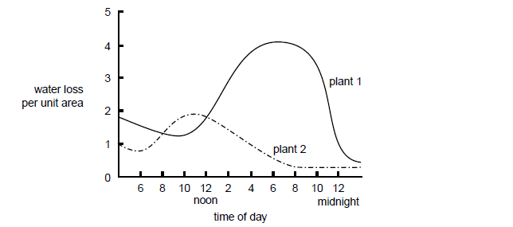

From the information given you can conclude that

(a) plant 2 will be more likely to survive in a dry environment than plant 1.

(b) at 12.00 noon, plant 1 has a greater water loss per unit area than plant 2.

(c) at 10.00 am, the average stomatal aperture will be greater in plant 1 than in plant 2.

(d) at 5.00 pm, the rate of photosynthesis will be greater in plant 2 than in plant 1.

## Section Two: Short answer (24 marks)

**Question 16 (16 marks)**

The diagram below shows an apparatus designed to demonstrate how water moves in a plant. It can be built in different sizes and the largest working models are up to 1.7 metres high.

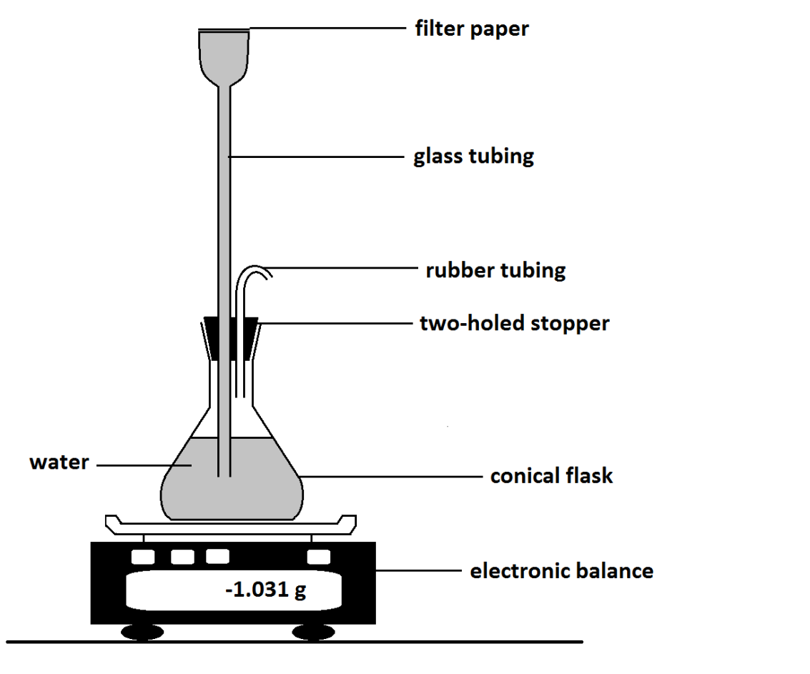

(a) (i) What part of the plant is represented by: (2 marks)

The glass tubing

The filter paper

(ii) What is the purpose of the balance? (1 mark)

(iii) Name an important part of the plant involved in water transport that is not represented by any part of the apparatus. (1 mark)

(b) A biologist decided to test the effects of environmental conditions on the rate of water movement through the apparatus.

(i) Explain what is likely to happen if the biologist positions a fan to blow air gently across the filter paper. (2 marks)

(ii) Explain what is likely to happen if the biologist places the apparatus in a chamber with high humidity. (2 marks)

(c) The apparatus simulates only water movement in plants, not the movement of sugars. (4 marks)

(i) Name the tissue responsible for the movement of sugars in plants.

(ii) Name the part of the plant responsible for producing sugars in plants.

(iii) Name the energy source for the movement of

water in plants.

sugars in plants.

(d) (i) Name the process that moves substances through the xylem. (1 mark)

(ii) Describe three factors that drive this movement. (3 marks)

**Question 17 (8 marks)**

Many Australian plants are xerophytes with adaptations to survive in hot, dry conditions.

(a) Plants that live in hot, dry conditions have adaptations that reduce water loss from their leaves.

Name **two (2)** possible adaptations of plants living in hot and dry conditions and explain how they help to reduce water loss. (4 marks)

(b) Vascular plants contain structures on the epidermal surface of its leaves as shown in the diagram below. These structures are related to water loss.



Epidermal cell

B

A

(i) Name the parts of the diagram labelled as A and B. (2 marks)

A

B

(ii) During the daytime, the size of A increases. Explain briefly how changes in B

cause this. (2 marks)

**Section Three: Extended response (15 marks)**

Mammals vary widely in food requirements, feeding behaviours and digestive systems. Explain the differences in teeth structure and features of the alimentary canal between a named carnivore, herbivore and omnivore.

# Marking key for sample assessment task 11 — Unit 2

**Section One: Multiple-choice (15 marks)**

|  |  |
| --- | --- |
| **Question** | **Answer** |
| 1 | c |
| 2 | b |
| 3 | a |
| 4 | c |
| 5 | b |
| 6 | d |
| 7 | b |
| 8 | a |
| 9 | d |
| 10 | a |
| 11 | d |
| 12 | d |
| 13 | b |
| 14 | d |
| 15 | a |

**Section Two: Short answer**

**Question 16 (16 marks)**

|  |  |
| --- | --- |
| **Description** | **Marks** |
| **(a) (i) What part of the plant is represented by:** | **/2** |
| * the glass tubing – stem of the plant/trunk/xylem * the filter paper – stomata | 1  1 |
| **(a) (ii) What is the purpose of the balance?** | **/1** |
| * provide an accurate measurement of water loss by transpiration | 1 |
| **(a) (iii) Name an important part of the plant involved in water transport that is not represented by any part of the apparatus.** | **/1** |
| * roots | 1 |
| **(b) (i) Explain what is likely to happen if the biologist positions a fan to blow air gently across the filter paper.** | **/2** |
| * increased transpiration/water loss * level of water in beaker will fall/decrease in mass of apparatus | 1–2 |
| **(b) (ii) Explain what is likely to happen if the biologist places the apparatus in a chamber with high humidity.** | **/2** |
| * decreased transpiration/water loss * level of water in beaker may fall slightlyl/slight decrease in mass of apparatus | 1–2 |
| **(c) (i) Name the tissue responsible for the movement of sugars in plants.** | **/1** |
| * phloem | 1 |
| **(c) (ii) Name the part of the plant responsible for producing sugars in plants.** | **/1** |
| * chloroplasts | 1 |
| **(c) (iii) Name the energy source for the movement of**   * **water in plants.** * **sugars in plants.** | **/2** |
| * sun * ATP/cellular respiration | 1–2 |
| **(d) (i) Name the process that moves substances through the xylem.** | **/1** |
| * transpiration stream | 1 |
| **(d) (ii) Describe three factors that drive this movement.** | **/3** |
| * radiant energy from the sun heats water molecules so that water evaporates | 1 |
| * cohesion between water molecules draws water from the xylem vessels to replace the water molecules that are lost | 1 |
| * root pressure due to an osmotic gradient formed by the active transport if ions into the vascular tissue in the root | 1 |
| **Total marks** | **/16** |

**Question 17 (8 marks)**

(a) Plants that live in hot, dry conditions have adaptations that reduce water loss from their leaves.(4 marks)

|  |  |
| --- | --- |
| **Criteria** | **Marks** |
| **(a) Name two (2) possible adaptations of plants living in hot and dry conditions and explain how they help to reduce water loss.** | **/4** |
| Any **two** of the following (1 mark for the feature and 1 mark for the explanation): |  |
| * waxy/thick cuticle on surface of leaf * waterproof/reflects heat so less evaporation | 1–2 |
| * leaf shape is narrow/cylindrical/spines * reduces the surface area for water loss | 1–2 |
| * hairs on leaves/tomentum * absorb less/reflect more heat than smooth leaves/decrease rate of evaporation | 1–2 |
| * stems flatten and become leaf like (cladodes/phyllodes) * cladodes lose less water than similar sized leaves | 1–2 |
| * succulent leaves * for storing water | 1–2 |
| * stomata only on the lower epidermis * less exposed to direct heat radiation | 1–2 |
| * depressed/sunken stomata * water vapour trapped | 1–2 |
| * stomata open at night * carbon dioxide stored overnight | 1–2 |
| * closing of stomata in the middle of the day/open for only short periods during drought * open when sunlight but lower temperatures. | 1–2 |
| * deciduous in the dry season * no leaves to lose water from | 1–2 |
| * rolling of leaves in dry conditions * reduced number of stomata exposed to the dry conditions/inner surface stomata not exposed | 1–2 |
| * leaves hang vertically * less surface area exposed to radiant heat | 1–2 |
| **(b) (i) Name the parts of the diagram labelled as A and B.** | **/2** |
| * A – stomatal pore/stomata/stoma/stomata * B – guard cell | 1–2 |
| **(b) (ii) During the daytime, the size of A increases. Explain briefly how changes in B cause this.** | **/2** |
| 1 each (maximum 2)  During the daytime:   * chloroplasts in B photosynthesise * glucose levels rise in B/guard cells * increase in osmotic pressure in B/guard cells. * potassium ions are pumped into B/guard cells * water enters structure B/guard cells/B/guard cells becomes turgid * A/stomata opens due to uneven thickness of walls of B/guard cells/thickened inner walls of B/guard cells causes A/stomata to open | 1–2 |
| **Total marks** | **/8** |

**SectionThree: Extended answer (15 marks)**

Mammals vary widely in food requirements, feeding behaviours and digestive systems. Explain the differences in teeth structure and features of the alimentary canal between a named carnivore, herbivore and omnivore.

|  |  |
| --- | --- |
| **Description** | **Marks** |
| **Examples (1 example for each dietary pattern)** | **/3** |
| Herbivore e.g. cows, horses, koalas, possums, kangaroo, rabbit, sheep  Carnivore e.g. dogs, cats, foxes  Omnivore e.g. humans | 1–3 |
| **Teeth** | **/6** |
| **Herbivore** (any two of the following):   * flat incisors to cut through grass * upper incisors may be replaced by a thick pad and the lower incisors bite against this pad (in some herbivores) * premolars and molars are the predominant teeth * large flat premolars/molars used for grinding vegetable matter * canines absent or very small * diastema/gap allows grass to be pushed between the upper and lower jaw through the gap to be stored in the cheek. | 1–2 |
| **Carnivore** (any two of the following):   * sharp incisors bite and hold prey * long, thin canines are used to tear prey * strong and pointed molars to chew through bone and break down meat. | 1–2 |
| **Omnivore**(any two of the following):   * more like carnivores than herbivores * flat, sharp incisors for cutting * pointed canines for ripping and tearing food (smaller than carnivores) * premolars and molars for grinding and crushing food. | 1–2 |
| **Alimentary canal** | **/6** |
| **Herbivore** (any two of the following):   * grasses are made up of cellulose. Only microorganisms contain enzyme cellulose which breaks down cellulose. Herbivores have a symbiotic relationship with bacteria (fungi or protozoans) * long caecum provides a large surface area for the action of bacterial enzymes to digest cellulose * complex stomachs/additional stomachs for the action of bacterial/protozoan enzymes to digest cellulose e.g. ruminants * long alimentary canal provides a greater surface area for absorption * nutrients are less concentrated in vegetation than meat/ less energy per gram. | 1–2 |
| **Carnivore** (any two of the following)   * meat has more energy per gram than vegetable matter * enzymes produced by carnivores digest meat completely * alimentary canal is comparatively short * caecum is short and has no function. | 1–2 |
| **Omnivore**(any two of the following)   * alimentary canal shorter than herbivores but longer than carnivores * long small intestine to complete the digestion of food and absorption of nutrients * one stomach for digestion of proteins * caecum reduced to an appendix. | 1–2 |
| **Total marks** | **/15** |

# **ACKNOWLEDGEMENTS**

**Question 3** Graph from: Wayne, A et al. (2008). Woylie trap success rates in Perup. Retrieved 2008 from Science division. Department of Conservation and Environment www.dec.wa.gov.au/component/docman/doc_download/3358/1

**Question 15** Victorian Curriculum and Assessment Authority. (2002). *VCE Biology: Written examination 1* (p. 3, q. 4.). Retrieved May 9, 2014, from www.vcaa.vic.edu.au/Documents/exams/biology/biology12002.pdf