Sample Assessment Tasks

Mathematics Essential

General Year 11

Copyright
© School Curriculum and Standards Authority, 2014
This document – apart from any third party copyright material contained in it – may be freely copied, or communicated on an intranet, for non-commercial purposes in educational institutions, provided that the School Curriculum and Standards Authority is acknowledged as the copyright owner, and that the Authority’s moral rights are not infringed.
Copying or communication for any other purpose can be done only within the terms of the Copyright Act 1968 or with prior written permission of the School Curriculum and Standards Authority. Copying or communication of any third party copyright material can be done only within the terms of the Copyright Act 1968 or with permission of the copyright owners.
Any content in this document that has been derived from the Australian Curriculum may be used under the terms of the Creative Commons Attribution-NonCommercial 3.0 Australia licence
Disclaimer
Any resources such as texts, websites and so on that may be referred to in this document are provided as examples of resources that teachers can use to support their learning programs. Their inclusion does not imply that they are mandatory or that they are the only resources relevant to the course.

Sample assessment task

Mathematics Essential– General Year 11

Task 1 – Unit 1
Assessment type: Practical Application
Conditions
Time allowed for completion of the task: 1 week
Authentication interview to be conducted between teacher and student, mid task and at task completion
Calculators permitted
Task weighting
10% of the school mark for this pair of units

Situation
Designing a Staff Roster for a Small Business
Jane is the new owner of a small sushi bar café and take away restaurant. She has employed the following people to work in the business which is open from 9 am to 5 pm, 7 days a week. Jane has asked you to prepare a weekly staffing roster that incorporates all of the following conditions:
SALARY/WAGES
Kevin: The Manager; $52 500 pa plus 10% superannuation for a 40-hour week
Cassie: The Assistant Manager; $46 850 pa plus 10% superannuation for a 40-hour week
Daniel: An 18-year-old casual employee on $17.60 p/h
Kelsey: A 16-year-old casual employee on $14.25 p/h
Will: A 15-year-old casual employee on $13.65p/h
WORKING CONDITIONS
- One manager must be working on each of the weekend days and have one weekend day off
- Managers must have consecutive days off (e.g. Sunday and Monday)
- Casuals are paid time and a half for Saturdays and double time for Sundays
- Each casual must receive at least one shift per week
- Kelsey cannot work on Saturdays and Daniel and Will can only work weekends
- Two of the five employees are needed each weekday to prepare sushi and serve in the busy lunch period (i.e. from 9 am – 2.30 pm) and three employees are needed to do this on the weekends. At least one employee is required to work from 2.30 pm – 5 pm each day cleaning
- Both managers work until 5 pm on each of their work days cleaning and completing other tasks.
Practical Application Task (36 marks)
Prepare a report which presents a weekly roster and an explanation of how the roster meets all of the conditions and is the most cost effective.
In your report, indicate how much money Jane should budget for weekly wages and discuss situations that could affect her predicted budget. Show, using appropriate calculations, how one of these situations could affect Jane’s budgeting.
Your report on developing the roster should:
- Include an introduction in which you interpret and describe the task in your own words, including all key information. (4 marks)
- Identify the mathematics you will have to use to complete the task. (4 marks)
- Analyse the information and construct a possible roster that incorporates all of the working conditions of the employees. (8 marks)
- Apply your mathematical knowledge and strategies to obtain the total wages for the roster.
(6 marks)
- Verify and justify the design of your roster. How much Jane should budget for weekly wages? Discuss. (6 marks)
- Communicate your task findings. What situations could affect the costing for wages that you have predicted? Show calculations/spreadsheets to support your thinking. Describe how Jane’s budget will be affected by a given situation. (8 marks)

Marking key for sample assessment task 1 – Unit 1
- Include an introduction in which you interpret and describe the task in your own words, including all key information.
Description | Marks
Clearly restates the problem in own words | 1
Identifies at least two key pieces of information that influence the task | 2
Outlines plan of report | 1
Total | /4
Sample answer
In this Practical Application we need to design a staffing roster for a small business owner. The business has 2 full-time staff members and 3 casual staff. The full time staff are on a salary and the casual staff are on a wage that attracts penalty rates for weekend work.
Many factors need to be considered when designing a work roster. These factors include giving full-time staff consecutive days off, placing workers with the cheapest wage where the penalty rates are highest and balancing experienced staff members with inexperienced staff during peak times. Budgeting for staff wages is an important part of business success.
This report will involve determining weekly wages for all staff, which involves the calculation of overtime and then finding a total for the week’s wages. It will state the amount that Jane needs to budget for wages each week. It will also look at factors that impact the budget including sick leave or holiday leave and provide budgeting and record keeping suggestions for Jane should these conditions occur.
- Identify the mathematics you will have to use to complete the task.
Description | Marks
Describes in detail the mathematics needed to solve the problem | 4
Describes most of the mathematics needed to solve the problem | 3
Describes some of the mathematics needed to solve the problem | 2
Describes a single part of the mathematics needed to solve the problem | 1
Total | /4
Sample answer
10% of the Manager and Assistant Manager’s salaries to be calculated in order to find the amount of superannuation Jane would need to contribute for these employees. This would then need to be added to their yearly salary and converted to a weekly amount.
A rate of 1.5 and 2 times the hourly wage of the casual workers who have weekend shifts to be applied.
Reasoning and problem solving to be utilised in order to prepare a weekly roster that satisfies all the working conditions of the employees.
Multiplication and addition required to calculate a predicted weekly amount of wages that Jane would need to budget for.

- Analyse the information and construct a possible roster that incorporates all of the working conditions of the employees.
Description | Marks
Demonstrates that managers have two consecutive days off | 1
Demonstrates that managers have one weekend day off | 1
Demonstrates that all casuals get at least one shift | 1
Demonstrates that Kelsey cannot work on Saturdays and Daniel and Will work only on weekends | 1
Demonstrates that two employees work on every weekday | 1
Demonstrates that three employees work on weekends | 1
Demonstrates that the managers work until 5 pm on their work days | 1
The roster is drawn up in an easy to read manner | 1
Total | /8
Sample answer
TIME | MON | TUES | WED | THURS | FRI | SAT | SUN
9 am – 2.30 pm | Cassie  Kelsey | Kevin  Cassie | Kevin  Cassie | Kevin  Cassie | Kevin  Kelsey | Kevin  Daniel  Will | Cassie  Kelsey  Will
2.30 pm – 5 pm | Cassie | Kevin  Cassie | Kevin  Cassie | Kevin  Cassie | Kevin | Kevin | Cassie

- Apply your mathematical knowledge and strategies to obtain the total wages for the roster.
Description | Marks
Correctly finds 10% of each manager’s wages | 1
Correctly increases the managers’ salaries by 10% | 1
Correctly converts both managers’ salaries to a weekly amount | 1
Correctly calculates penalty rates using time and a half for casual workers | 1
Correctly calculates penalty times using double time for casual workers | 1
Determines the total wages required for a week’s roster | 1
Total | /6
Sample answer
Kevin: 10% of $52 500 = $5250
Total salary package is $52 500 + $5250 = $57 750
Budget for Kevin $57 750 ÷ 52 = $1110.58 per week
Cassie: 10% of $46 850 = $46 850
Total salary package is $46 850 + $4685 = $51 535
Budget for Cassie $51 535 ÷ 52 = $991.06 per week
Daniel: Weekdays $17.60 p/h
Saturdays $17.60 × 1.5 = $26.40
Sundays $17.60 × 2 = $35.20
Kelsey: Weekdays $14.25 p/h
Saturdays $14.25 × 1.5 = $21.38
Sundays $14.25 × 2 = $28.50
Will: Weekdays $13.65p/h
Saturdays $13.65 × 1.5 = $20.48
Sundays $13.65 × 2 = $27.30
Total wages for the week:
Kevin: $1110.58
Cassie: $991.06
Daniel: 5.5 × $26.40 = $145.20
Kelsey: 11 × $14.25 + 5.5 × $28.50 = $313.50
Will: 5.5 × $20.48 + 5.5 × $27.30 = $262.79
TOTAL: $2823.13
Jane must have $2823.13 per week for wages

- Verify and justify the design of your roster. How much Jane should budget for weekly wages? Discuss.
Description | Marks
Provides 4 or more valid justifications for the roster design | 4
Provides 3 valid justifications for the roster design | 3
Provides 2 valid justifications for the roster design | 2
Provides 1 valid justifications for the roster design | 1
Subtotal | /4
Clearly states the total wages and suggests that a reasonable amount of extra money be budgeted for to allow for contingencies | 2
Subtotal | /2
Total | /6
Sample answer
Kevin and Cassie have to have consecutive days off (Kevin – Sunday, Monday; Cassie – Friday, Saturday) and work only one weekend day. Therefore, the managers cover all shifts on Tuesday, Wednesday and Thursday.
Will is the cheapest employee and, therefore, works both weekend days.
Daniel can only work weekends and, therefore, must have a Saturday shift as otherwise his wage is very expensive on Sunday.
Kelsey is the casual with the most flexibility. She works Monday, Friday and Sunday.
Even though Jane needs a total of $2823.13 per week for wages, she should budget about $500 per week more in order to be able to cover changes in the roster. I suggest that Jane should budget $3300 per week.

- Communicate your task findings. What situations could affect the costing for wages that you have predicted? Show calculations/spreadsheets to support your thinking. Describe how Jane’s budget will be affected by a given situation.
Description | Marks
Clearly states at least one factor that influenced the design of the roster. | 1
States the weekly wages | 1
States the amount the owner should budget for wages | 1
Correctly lists at least two situations that could affect Jane’s budget | 2
Shows detailed calculations as to how and by how much the budget could be affected should a situation arise with staff | 2
Compares the changed budget to the original budget | 1
Total | /8
Sample answer
There are many factors to consider when designing a cost efficient budget, including where to place the cheapest staff or the most experienced staff on the roster. With the designed roster, Jane must budget $2823.13 per week for wages. This budget could be affected by a staff member being ill, taking holidays, resigning suddenly or by sudden increases or decreases in trade.
For example, if Cassie was ill for the week, her wages would still need to be paid but Jane would also have to pay for a casual to fill Cassie’s shifts. Jane would be best to budget $3300 per week to cover all contingencies.
A new possible roster for this scenario (with Kevin not working any of the weekend days, i.e. altered work condition) could be:
TIME | MON | TUES | WED | THURS | FRI | SAT | SUN
9 – 2.30 pm | Kelsey  Kevin | Kevin  Kelsey | Kevin  Kelsey | Kevin  Kelsey | Kevin  Kelsey | Kelsey  Daniel  Will | Daniel  Kelsey  Will
2.30 pm– 5 pm | Kevin | Kevin | Kevin | Kevin | Kevin | Will | Will
Note: this roster involves Kevin working on his own until the end of each day for his weekday shifts. Kelsey works the weekday shifts as she is the only employee with any flexibility. Will works all day on Saturday and Sunday as he is the cheapest worker. This necessitates Daniel picking up an extra shift.
This wages for this roster would be:
Kevin: $1110.58
Cassie: $991.06 (she still gets paid even though she is ill)
Daniel: Saturdays 5.5 × $26.40 = $145.20
Sundays 5.5 × $35.20= $193.60
Will: Saturdays 8 × $20.48= $163.84
Sundays 8 × $27.30= $218.40
Kelsey: Weekdays 27.5 × $14.25 = $391.88
Saturdays 5.5 × $21.38= $117.59
Sundays 5.5 × $28.50= $156.75
TOTAL WAGES FOR REVISED ROSTER $3488.90
This is a difference of $665.77. It would be best for Jane to budget approx. $500 per week above the required amount in order to account for circumstances such as illness, holidays or staff resignation. An amount of $500 would allow a stockpile of money to account for any changes. The use of spreadsheets would reduce the workload when designing or changing new rosters.

Mathematics Essential– General Year 11

Task 5 – Unit 2
Assessment type: Statistical investigation process
Conditions:
Period allowed for completion of the task: 1 week
Conditions: In class, technology and/or calculator permitted
Maximum number of marks: 24 marks
Task weighting:
18% of the school mark for this pair of units

Are males better drivers? (24 marks)
A student in class has suggested that males are better drivers than females. He went on to say that to be a good driver you need fast reflexes. This promoted some discussion with other students in the class saying the ability to concentrate was also very important.
Investigate the statements made above and produce a report that justifies your answer to the question ‘Are males better drivers?’
A completed statistical investigation should include:
- an introduction that outlines the question to be answered and any further questions that could be explored
- selection and application of suitable mathematical and graphical techniques you have studied to analyse the provided data
- interpretation of your results relating your answer to the original problem
- communication of your results and conclusions in a concise systematic manner.
Your investigation report should include the following:
- Introduction – two or three sentences providing an overview of your investigation. (3 marks)
- Numerical and graphical analysis
- choose various statistical measures you have studied to analyse the data (5 marks)
- consider the most appropriate graphs which represent the data provided. (5 marks)
- Interpretation of the results of this analysis in relation to the original question (7 marks)
- describe any trend and pattern in your data (two to three sentences)
- state how your data relates to the original problem (two to three sentences)
- use your knowledge and understanding gained in this unit to explain your results in one paragraph.
- Conclusion (4 marks)
- Summarise your findings and conclusions in one paragraph.
DATA
A sample of data from the 2013 Census At School survey is provided below. The data was generated from a random sample of 60 Year 11 and 12 students who provided information on their reaction time using their dominant hand and their concentration activity.
Female |  |  |  | Male
 | Reaction Time (sec)  (dominant hand) | Concentration  Activity (secs) |  |  | Reaction Time (sec)  (dominant hand) | Concentration  Activity (secs)
1 | 0.03 | 52 |  | 1 | 0.35 | 35
2 | 0.38 | 61 |  | 2 | 0.51 | 61
3 | 0.39 | 34 |  | 3 | 0.35 | 38
4 | 0.39 | 22 |  | 4 | 0.32 | 43
5 | 0.44 | 38 |  | 5 | 0.37 | 43
6 | 0.31 | 24 |  | 6 | 0.38 | 47
7 | 0.43 | 41 |  | 7 | 0.37 | 48
8 | 0.34 | 19 |  | 8 | 0.31 | 64
9 | 0.56 | 59 |  | 9 | 0.37 | 38
10 | 0.34 | 44 |  | 10 | 0.31 | 43
11 | 0.38 | 40 |  | 11 | 0.45 | 33
12 | 0.56 | 41 |  | 12 | 0.37 | 38
13 | 0.37 | 56 |  | 13 | 0.31 | 31
14 | 0.44 | 33 |  | 14 | 0.34 | 52
15 | 0.32 | 50 |  | 15 | 2.61 | 58
16 | 0.31 | 41 |  | 16 | 0.35 | 34
17 | 0.35 | 40 |  | 17 | 0.4 | 49
18 | 18.62 | 60 |  | 18 | 0.31 | 35
19 | 0.35 | 47 |  | 19 | 0.32 | 47
20 | 0.34 | 47 |  | 20 | 0.42 | 37
21 | 0.94 | 50 |  | 21 | 0.35 | 36
22 | 0.32 | 28 |  | 22 | 0.32 | 38
23 | 0.35 | 38 |  | 23 | 0.41 | 43
24 | 0.37 | 40 |  | 24 | 0.31 | 60
25 | 0.4 | 58 |  | 25 | 0.32 | 36
26 | 0.45 | 43 |  | 26 | 0.35 | 47
27 | 0.34 | 34 |  | 27 | 0.3 | 30
28 | 0.32 | 27 |  | 28 | 0.14 | 35
29 | 0.3 | 39 |  | 29 | 0.36 | 41
30 | 0.67 | 77 |  | 30 | 0.27 | No Data

Data from: Australian Bureau of Statistics. (2013). [Driver reaction time and concentration activity data]. Retrieved May, 2014, from www.abs.gov.au/websitedbs/CaSHome.nsf/Home/CaSMa06+ARE+MALES+BETTER+DRIVERS#hello
Used under Creative Commons Attribution 2.5 Australia licence.

Marking key for sample assessment task 9 – Unit 2
Introduction
After being posed the question are male drivers better than female drivers, I have been asked to investigate this statement. Whilst other factors may affect someone’s ability to drive I will use the data provided of reflex and concentration times to try to explore this statement.
Description | Marks
Provides a simple introduction of the question | 1
Restates question in their own words | 1
Mentions reflexes and concentration as two measures of driving ability | 1
Total | /3

Numerical analysis
 |  | Dominant  Hand | Concentration Activity
Females
(f) | Mean | 0.38 | 42.77
 | Median | 0.36 | 41.00
 | Standard Deviation | 0.07 | 12.94
Males | Mean | 0.35 | 43.33
(m) | Median | 0.35 | 42.00
 | Standard Deviation | 0.06 | 9.61

 | Female dominant | Male dominant | Female  concentration | Male  concentration
Minimum | 0.3 | 0.14 | 19 | 30
Q1 | 0.34 | 0.31 | 34 | 36
Median | 0.37 | 0.35 | 40.5 | 42
Q3 | 0.43 | 0.37 | 47.75 | 47.75
Maximum | 0.56 | 0.51 | 61 | 64

Description | Marks
Calculates measures of central tendency including mean, median & mode | 1
Calculates mean, median with outliers removed | 1
Calculates range | 1
Calculates standard deviation or inter-quartile range (IQR) | 1
Calculates standard deviation and IQR | 1
Total | /5

Graphical analysis
Box and Whisker plots
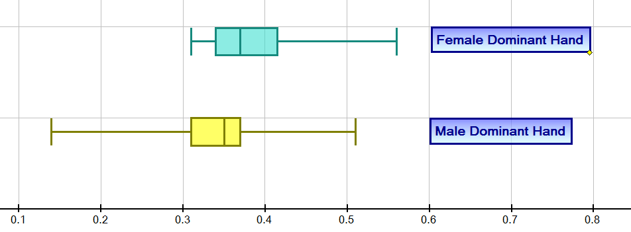

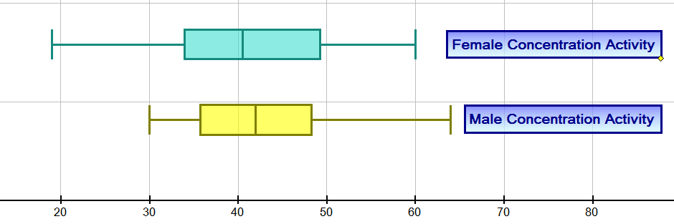

Back to back stem and leaf plots
Female Dominant Hand | Seconds | Male Dominant Hand
 | 0.0
 | 0.1 | 4
 | 0.2 | 7
9 9 8 8 7 7 5 5 5 4 4 4 4 2 2 2 1 1 0 | 0.3 | 0 1 1 1 1 1 2 2 2 2 4 5 5 5 5 5 6 7 7 7 7 8
5 4 4 3 0 | 0.4 | 0 1 2 5
6 6 | 0.5 | 1
7 | 0.6
 | 0.8

Female Concentration Activity | Seconds | Male Concentration Activity
 | 0
9 | 10
8 7 4 2 | 20
9 8 8 4 4 3 | 30 | 0 1 3 4 5 5 5 6 6 7 8 8 8 8
7 7 4 3 1 1 1 0 0 0 | 40 | 1 3 3 3 3 7 7 7 8 9
9 8 6 2 0 0 | 50 | 2 8
1 0 | 60 | 4
7 | 70
 | 80

Distributions: Dominant hand
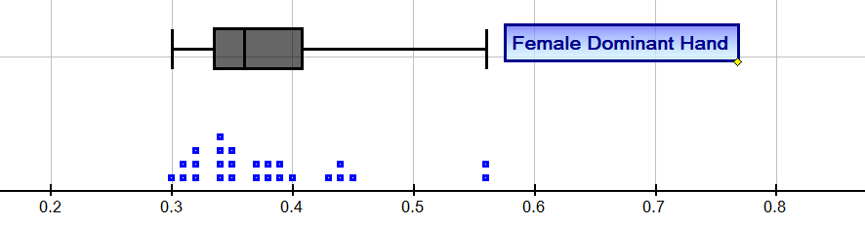
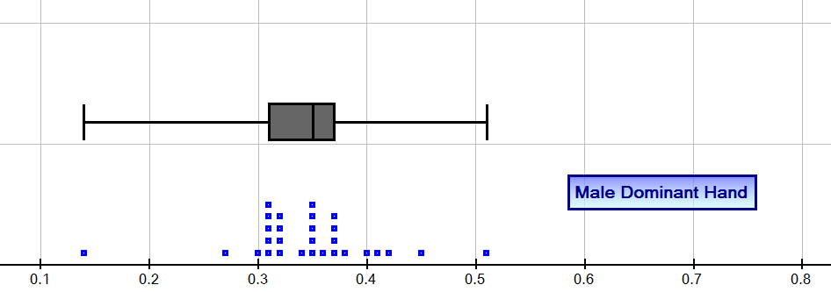
Distribution: Concentration activities
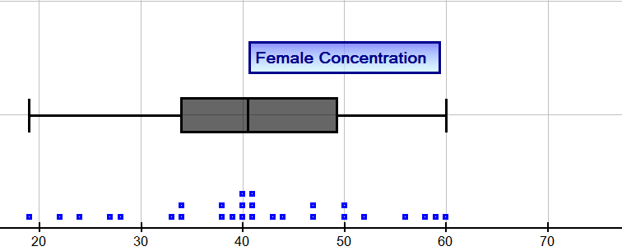

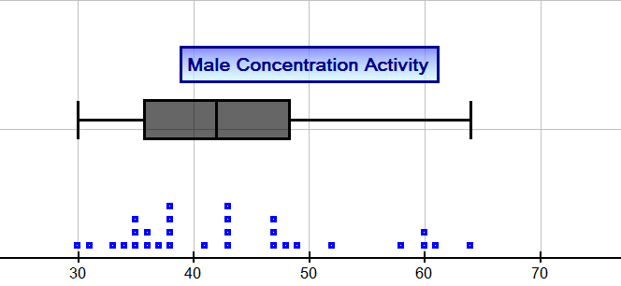

Description | Marks
Constructs simple single graphs | 1
Shows comparative graphs: stem and leaf, histograms or dot frequency | 1
Uses box and whisker plots to compare male and female attributes | 1
Presents correct graphs, including labelling | 2
Total | /5

Interpretation
Discussion of frequency/proportion, measures of central tendency, removal of outliers and measures of spread
Sample interpretation:
It is clear from looking at measures of central tendency, such as mean and median, that males performed faster on the reflex activity.
Outliers have been removed from six data points as these would have increased the mean and median for female reflexes.
Females produced better results on the concentration activity with the mean and median indicating females were faster.
The range of scores for males was higher for the reflex activity and higher for females on the concentration activity.
The inter-quartile ranges (IQR) are higher for females in both reaction times and also the concentration activity.
On the concentration task there was a greater range for the female results which are confirmed by the larger standard deviation compared with the males. The distribution for females is symmetrical but the male distribution indicates a tail of students with larger times indicating a positive skew in the results.
Description | Marks
Discusses frequency | 1
Discusses proportion, e.g. median | 1
Discusses removal of outliers and effects on mean, median | 1
Makes comparisons using measures of spread, e.g. range, IQR | 1
Makes comparisons using central tendency measures: mean and median | 1
Discusses clusters of results in the data | 1
Interpretation linked to numerical and graphical data | 1
Total | /7

Conclusion
Short statement outlining summary of findings
Sample conclusion:
To summarise, while the mean and median scores were better for males than those for females for the reflex activity, female concentration times were better than males with a cluster of males with slower concentration results and a significant number of females with very good concentration results (with the median being lower than the mean).
Reaction times and concentration are important skills for driving but we would need to make a study of other skills or data to answer the question posed. Other skills are important such as general knowledge and adherence to road rules, risk taking behaviour etc. Road accident statistics could also help to answer the question ‘Are males better drivers?’
Description | Marks
Makes a valid statement about the results | 1
Relates conclusion back to the original question | 1
Proposes that other data should be collected to help answer question | 1
Provides a concise and coherent summary of the analysis | 1
Total | /4

Sample assessment task

Mathematics Essential– General Year 11

Task 6 – Unit 2
Assessment type: Response
Conditions:
Time for the task: 50 minutes
In class, calculator permitted
Marks: 61 marks
Task weighting:
12% of the school mark for this pair of units

Question 1 (3 marks)
The WA Learner's Theory Test is a 32 question multiple-choice test. Katie answered 21 of these questions correctly.
- What was Katie’s percentage score to the nearest percent? (2 marks)
- If the pass mark was 75%, what score will Katie need to achieve next time she sits the test in order to pass? (1 marks)
Question 2 (4 marks)
Morrison’s Art Supplies advertises a two week sale on watercolour paint kits.
A painting kit with the original price of $79.99 is reduced by 15%.
At the end of two weeks, the painting kit still has not sold and it is decided to further discount it by 30% off the reduced price. What is the new selling price of the painting kit?

Question 3 (6 marks)
A group of 4 friends invested the same amount of money over different time periods and different interest rates of simple interest. Who earned the most in interest and how much more was this than the person who earned the least?
Name | Amount | Percentage | Time of investment
Caroline | $500 | 4.25% | 2 years, 6 months
Nick | $500 | 5% | 2 years
Mandy | $500 | 3.65% | 33 months
Adriana | $500 | 4.70% | 2¼ years

Question 4 (4 marks)
Tom and Lil were discussing a $2500 painting that was estimated to appreciate in value by 7% pa. Tom calculated the value of the painting after 2 years by finding 114% of the original value. Lil calculated the value of the painting at the end of each year for each of the 2 years to find the final value. Who calculated the correct value and what is it? Use calculations to explain and justify the differences between the thinking of the two friends.

Question 5 (17 marks)
For most domestic concreting jobs a concrete mix ratio of 1.5 parts cement, 2 parts sand and 4 parts course aggregate is used.
- What is the ratio of course aggregate to sand in its simplest form? (2 marks)
- Express the components of concrete mix as a simplified ratio (2 marks)
- What fraction of the sand is the cement? (2 marks)
- What percentage of the total mix is cement? (2 marks)
- Cement Pro mixed up 1.4 tonne of concrete. How many kilograms of course aggregate did Cement Pro use in the mixture? Round to the most appropriate unit. (4 marks)
- An urgent concreting job requires 100 kilograms of concrete. Cement Pro only have 21.3 kg of cement in their warehouse. Could they complete the job? Justify your answer. (5 marks)

Question 6 (3 marks)
The plans of Ruby’s house show a room to be 3.8 m by 4.2 m. On the plan the dimensions of the room measure 19 mm by 21 mm. What is the scale on Ruby’s plan?
Question 7 (3 marks)
Draw a line to connect the situation with the correct rate:
Situation | Rate
- 5 m of material cost $24 | - 10 L/min
- Liquid pours out at 600 mL per 5 minutes | - $4/m
- The tap drips 12 mL per hour | - $4.50/m
- $1.80 for 45 cm of lace | - 1 mL/5mins
- 5 litres of petrol flows out in 30 seconds | - $4.80/m
- 0.5 m of wood for $2.25 | - 7.2 L/hour
Question 8 (5 marks)
Lemonade was mixed in two glasses.
The first glass had 150 mL of lemon juice and 250 mL of water.
The second glass had 200 mL of lemon juice and 300 mL of water.
Which mixture has the stronger tasting lemonade? Use diagrams and calculations to justify your answer.

Question 9 (8 marks)
Use the graph and the following statements to assist Farmer Joe in hiring a shearer.
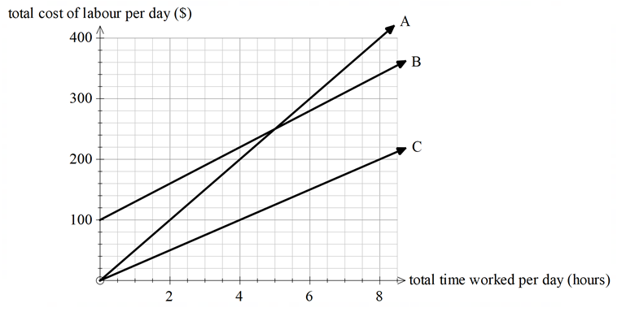
Statements:
- Shorn Sheep charges a callout fee
- Ed Shearin charges $200 per day (8-hour day)
- Baa-bara Sheepscaping charges $50/hour
- Match the shearer to the graph (2 marks)
Graph | Shearer
A
B
C
- Baa-Bara Sheepscaping does not have a very good reputation, so Farmer Joe needs to decide between Shorn Sheep or Ed Shearin for one day’s work. How would you advise him? (2 marks)
- Baa-Bara Sheepscaping received its bad reputation by overcharging. She charged a farmer $950 to shear 525 sheep. If the owner, Barbara, takes 5 minutes to shear a sheep, how much did she overcharge the farmer? (4 marks)

Question 10 (8 marks)
Michael lives in Perth and his cousin Angelo lives 1530 km away in Karratha. Michael decides to drive to Karratha and Angelo decides to drive to Perth. They leave at the same time and travel the same route but in opposite directions.
Michael drives at an average speed of 80 km/h and Angelo drives at an average speed of 100 km/h.
- Will the cousins meet closer to Perth or closer to Karratha? Explain your thinking. (2 marks)
- How long will it take Michael to drive from Perth to Karratha? (2 marks)
- How far from each town will the two cousins meet? (4 marks)

Marking key for sample assessment task 6 – Unit 2
Question 1
The WA Learner's Theory Test is a 32 question multiple-choice test. Katie answered 21 of these questions correctly.
- What was Katie’s percentage score to the nearest percent?
Solution
Percentage scored = $\frac{21}{32}$ $×100$ $=65.625\%$
Rounded score = 66%
Specific behaviours | Marks
Determines the percentage scored | 1
Rounds the percentage | 1
Total | /2
- If the pass mark was 75%, what score will Katie need to achieve next time she sits the test in order to pass?
Solution
Percentage required to pass is $75\% of 32$ $=$ 24
Score will be at least 24
Specific behaviours | Marks
Determines the required score | 1
Total | /1
Question 2
Morrison’s Art Supplies advertises a two week sale on watercolour paint kits.
A painting kit with the original price of $79.99 is reduced by 15%.
At the end of two weeks, the painting kit still has not sold and it is decided to further discount it by 30% off the reduced price. What is the new selling price of the painting kit?
Solution
Discount is $\frac{15}{100}$ $×\$79.99$ $=11.9985$
Rounded discount = $12
New selling price is $79.99 - $12 = $67.99
Discount is $\frac{30}{100}$ $×\$67.99$ $=\$20.40$
Final selling price is $67.99 - $20.40 = $47.59
Specific behaviours | Marks
Determines the first rounded discount | 1
Determines the new selling price | 1
Determines the second discount on the reduced price | 1
Determines the final selling price | 1
Total | /4

Question 3
A group of 4 friends invested the same amount of money over different time periods and different interest rates of simple interest. Who earned the most in interest and how much more was this than the person who earned the least?
Solution
Caroline: $500×4.25\% ×2.5$ $=\$53.12$(highest interest earned)
Nick:$500×5\% ×2$ $=\$50$ (lowest interest earned)
Mandy: $500×3.65\% ×$ $\frac{33}{12} =\$50.19$
Adriana:$500×4.70\% ×2.25$ $=\$52.88$
Difference between highest and lowest interest earned is $53.12 - $50 = $3.12
Specific behaviours | Marks
Shows interest earned for all friends | 4
Determines highest interest | 1
Determines difference between highest and lowest interest | 1
Total | /6
Question 4
Tom and Lil were discussing a $2500 painting that was estimated to appreciate in value by 7% pa. Tom calculated the value of the painting after 2 years by finding 114% of the original value. Lil calculated the value of the painting at the end of each year for each of the 2 years to find the final value. Who calculated the correct value and what is it? Use calculations to explain and justify the differences between the thinking of the two friends.
Solution
Tom: Increased the value of the painting by 14% (double 7%) overall
Value of painting after 2 years is 114% $×\$2500$ $=\$2850$
Lil: Increased the value by 7% each year
Value of the painting after 1 year = 1.07 $×$ 2500 = $2675
Value of the painting after 2 years = 1.07 $×$ 2675 = $2862.25
Lil calculated the correct value of $2862.25 as the increase in value was 7% pa (per year). The value at the end of the first year became the new value for the increase in the second year.
Specific behaviours | Marks
Shows Tom’s thinking with calculations | 1
Shows Lil’s thinking with calculations | 1
States the correct value of the painting after 2 years | 1
Justifies the reason for the value | 1
Total | /4

Question 5
For most domestic concreting jobs a concrete mix ratio of 1.5 parts cement, 2 parts sand and 4 parts course aggregate is used.
- What is the ratio of course aggregate to sand in its simplest form?
Solution
Ratio is 4 : 2 = 2 : 1
Specific behaviours | Marks
Determines the ratio | 1
Simplifies the ratio | 1
Total | /2
- Express the components of concrete mix as a simplified ratio (2 marks)
Solution
Ratio is 1.5 : 2 : 4 = 3 : 4 : 8
Specific behaviours | Marks
Determines the ratio of the components | 1
Simplifies the ratio | 1
Total | /2
- What fraction of the sand is the cement?
Solution
$\frac{1.5}{2}$ = $\frac{3}{4}$
Specific behaviours | Marks
Determines the fraction | 1
Simplifies the fraction | 1
Total | /2
- What percentage of the total mix is cement?
Solution
$\frac{1.5}{7.5}$ $×100$ = 33.33%
Specific behaviours | Marks
Determines the total parts of the mix | 1
Determines the percentage that is cement | 1
Total | /2

- Cement Pro mixed up 1.4 tonne of concrete. How many kilograms of course aggregate did Cement Pro use in the mixture? Round to the most appropriate unit.
Solution
Ratio of 1.5 :2 : 4 has 7.5 parts
One part is $\frac{1.4}{7.5}$ = 0.187 tonne
Course aggregate is therefore 4 $×0.187$ = 0.747 tonne
Rounded to the most appropriate unit is 747 kg
Specific behaviours | Marks
Determines number of tonnes or kilograms in one part of concrete | 1
Determines number of kilograms for course aggregate | 1
Converts tonnes to kilograms | 1
Rounds appropriately throughout problem | 1
Total | /4
- An urgent concreting job requires 100 kilograms of concrete. Cement Pro only have 21.3 kg of cement in their warehouse. Could they complete the job? Justify your answer.
Solution
Ratio in concrete is 1.5 : 2 : 4
21.3 kg of cement means each part is 14.2 times the corresponding part ($\frac{21.3}{1.5}$)
1.5 : 2 : 4 = 21.3 : 28.4 : 56.8
This is 21.3 + 28.4 + 56.8 = 106.5 kg
Cement Pro will have enough to complete the job. They will have 6.5 kg of concrete left over.
Specific behaviours | Marks
Determines scale of ratio | 1
Determines number of kilograms of each component | 1
Determines total number of kilograms of concrete that can be made | 1
States whether they will have enough concrete for the job | 1
Justifies the answer appropriately | 1
Total | /5
Question 6
The plans of Ruby’s house show a room to be 3.8 m by 4.2 m. On the plan the dimensions of the room measure 19 mm by 21 mm. What is the scale on Ruby’s plan?
Solution
19 mm : 21 mm = 3.8 m : 4.2 m
1.9 cm : 2.1 cm = 380 cm : 420 cm
The scale on Ruby’s plan is 1 : 200
Specific behaviours | Marks
Determines dimensions on plan and in real life in common units (e.g. cm) | 1
Determines real life is 200 times bigger | 1
Writes correct scale | 1
Total | /3

Question 7
Draw a line to connect the situation with the correct rate:
Solution
5 m of material cost $24 = $4.80/m
Liquid pours out at 600 mL per 5 minutes = 7.2 L/hour
The tap drips 12 mL per hour = 1 mL/5mins
$1.80 for 45 cm of lace = $4/m
5 litres of petrol flows out in 30 seconds = 10 L/min
0.5 m of wood for $2.25 = $4.50/m
Specific behaviours | Marks
Connects 5 pairs of matching rates | 3
Connects 3 pairs of matching rates | 2
Connects 1 or 2 pairs of matching rates | 1
Total | /3
Question 8
Lemonade was mixed in two glasses.
The first glass had 150 mL of lemon juice and 250 mL of water.
The second glass had 200 mL of lemon juice and 300 mL of water.
Which mixture has the stronger tasting lemonade? Use diagrams and calculations to justify your answer.
Solution
Glass 1 is 150 mL : 250 mL = 3 : 5 ($\frac{5}{3}$ is 1.67 times more water than lemon juice)
Glass 2 is 200 mL : 300 mL = 2 : 3 ($\frac{3}{2}$ is 1.5 times more water than lemon juice)
The calculations and diagrams show that Glass 2 has the stronger tasting lemonade
Specific behaviours | Marks
Calculates scale of lemon to water for both glasses | 2
Calculates scale of lemon to water for one glass | 1
Subtotal | /2
Draws correct diagram for both glasses | 2
Draws correct diagram for one glass | 1
States which glass has the strongest tasting lemonade | 1
Subtotal | /3
Total | /5

Question 9
Use the graph and the following statements to assist Farmer Joe in hiring a shearer.
Statements:
- Shorn Sheep charges a callout fee
- Ed Shearin charges $200 per day (8-hour day)
- Baa-bara Sheepscaping charges $50/hour
- Match the shearer to the graph
Solution
Graph A is Baa-bara Sheepscaping
Graph B is Shorn Sheep
Graph C is Ed Shearin
Specific behaviours | Marks
Matches all 3 graphs correctly | 2
Matches 1 graph correctly | 1
Total | /2
- Baa-Bara Sheepscaping does not have a very good reputation, so Farmer Joe needs to decide between Shorn Sheep or Ed Shearin for one day’s work. How would you advise him?
Solution
Farmer Joe should choose Ed Shearin because for one day’s work it would cost him $200, whereas for Shorn Sheep it would cost $340
Specific behaviours | Marks
Chooses Ed Shearin | 1
Explains reason for choice | 1
Total | /2
- Baa-Bara Sheepscaping received its bad reputation by overcharging. She charged a farmer $950 to shear 525 sheep. If the owner, Barbara, takes 5 minutes to shear a sheep, how much did she overcharge the farmer?
Solution
525 sheep costs $950; therefore, 1 sheep costs $1.81 to shear.
If it takes 5 minutes to shear one sheep, Barbara would shear 12 sheep per hour
This amounts to 1.81 $×12$ = $21.72/h.
If Barbara charges $50/h then she is overcharging by $28.28 ($50 - $21.72)
Specific behaviours | Marks
Calculates the price for shearing one sheep | 1
Calculates how many sheep she shears in one hour | 1
Calculates real cost per hour | 1
Calculates overcharge | 1
Total | /4

Question 10
Michael lives in Perth and his cousin Angelo lives 1530 km away in Karratha. Michael decides to drive to Karratha and Angelo decides to drive to Perth. They leave at the same time and travel the same route but in opposite directions.
Michael drives at an average speed of 80 km/h and Angelo drives at an average speed of 100 km/h.
- Will the cousins meet closer to Perth or closer to Karratha? Explain your thinking.
Solution
Closer to Perth as Michael will travel less distance because he is driving slower.
Specific behaviours | Marks
Chooses Perth | 1
Explains reason for choice | 1
Total | /2
- How long will it take Michael to drive from Perth to Karratha?
Solution
Average Speed = $\frac{Distance}{Time}$
80 km/h= $\frac{1530}{Time}$
Time taken is 1530 ÷ 80 = 19.125 hours
Specific behaviours | Marks
Chooses division as the correct operation | 1
Calculates the time taken for the trip | 1
Total | /2
- How far from each town will the two cousins meet?
Possible Solution
80 × time = 1530 – (100 × time)
Trial and error:
Try time = 8 hours
Then 80 × 8 ≠ 1530 – (100 × 8)
Try 8.5 hours
Then 80 × 8.5 = 1530 – (100 × 8.5)
Therefore after 8.5 hours, the cousins will meet and they will be 680 km from Perth and 850 km from Karratha
Specific behaviours | Marks
Chooses appropriate method | 1
Calculates at what time after leaving the two cousins will meet | 1
Calculates the distance from Perth the cousins will be when they meet | 1
Calculates the distance from Karratha the cousins will be when they meet | 1
Total | /4

