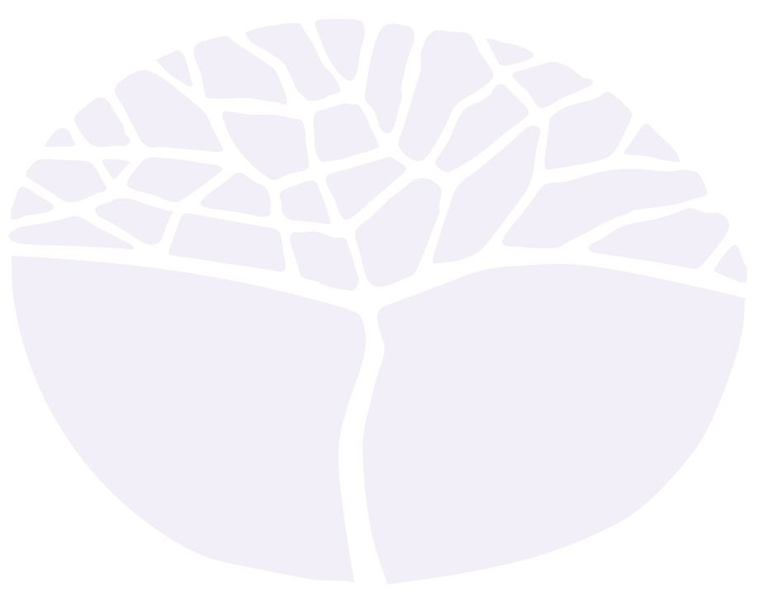
Materials Design and Technology

General course
Marking key for the Externally set task
Sample 2016

Copyright
© School Curriculum and Standards Authority, 2014
This document – apart from any third party copyright material contained in it – may be freely copied, or communicated on an intranet, for
non-commercial purposes in educational institutions, provided that the School Curriculum and Standards Authority is acknowledged as the copyright owner, and that the Authority’s moral rights are not infringed.
Copying or communication for any other purpose can be done only within the terms of the Copyright Act 1968 or with prior written permission of the School Curriculum and Standards Authority. Copying or communication of any third party copyright material can be done only within the terms of the Copyright Act 1968 or with permission of the copyright owners.
Any content in this document that has been derived from the Australian Curriculum may be used under the terms of the Creative Commons Attribution-NonCommercial 3.0 Australia licence
Disclaimer
Any resources such as texts, websites and so on that may be referred to in this document are provided as examples of resources that teachers can use to support their learning programs. Their inclusion does not imply that they are mandatory or that they are the only resources relevant to the course.

Materials Design and Technology

Externally set task – marking key
- Think of a project you have designed and produced. Outline your design problem or situation by writing a statement of intent identifying the design considerations and requirements. (4 marks)
Description | Marks
Clearly identifies the design problem or situation to be solved and provides a detailed list of client requirements and limitations.  - clear sentences that explain the need or problem (why) for a client or end user (who), and describe a likely use or function (what)  - statements that may outline the environment or location (where), with a description of the event and frequency (when)  - separate statements explaining client requirements and limitations  i.e. constraints of cost, time, size, appearance and function | 3–4
Describes the design problem or situation and lists any needs, uses or limitations on the proposed solution. | 1–2
Total | 4

- Produce a series of annotated concept sketches, graphical displays, or drawn diagrams to demonstrate the development of design ideas and concepts around design fundamentals. Devise and propose an appropriate solution to your design problem or situation. (10 marks)
Description | Marks
Demonstrates clearly annotated development of design ideas and concepts around design fundamentals, with clear explanation of design choices that reflect back to the statement of intent, showing a clear design process to a solution.  - clear connection and flow between each image or sketch, with each concept relating back to the design intent or client need, and flow to the final proposal  - illustrations show decisions made about parts or specific sections of the design, including details about shape, dimensions, materials, colours and function  - annotations, using appropriate design terminology, explain adaptations of earlier concepts, and variations at each development stage, i.e. the elements and principles of design | 9–10
Presents annotated development of design ideas and concepts relating to some design fundamentals to propose a solution to the design problem or situation. | 7–8
Provides a progressive development of design ideas and concept sketches with limited annotations. | 5–6
Provides a collection of some annotated design ideas and concept sketches. | 3–4
Shows a collection of isolated design ideas and concept sketches. | 1–2
Total | 10

- Using standard drawing conventions, prepare sketched presentation drawing/s of the proposed design solution. (6 marks)
Description | Marks
Accurate context-appropriate drawings, with relevant information to represent the design features of the final product.  - presentation drawing/s accurate, and clearly indicates correct proportional sizes for all parts of the product  - each drawing is clearly titled, and where necessary individual parts named and dimensioned  - drawings show additional annotation to highlight surface finish – texture or colour, or special process for production | 5–6
Provides context-appropriate drawings with information to represent the final product. | 3–4
Provides poorly detailed and/or proportioned drawings with limited information about the final product. | 1–2
Total | 6

- Present a list of materials you would use in the production of the product. (4 marks)
Description | Marks
Provides a comprehensive list of all parts, components and/or embellishments, with each part correctly itemised and named, with a clear indication of type of material.  List provides correct calculated sizes and the required total lengths or number. | 3–4
Provides a list of the major materials required for manufacture of the item. | 1–2
Total | 4

- Outline a production plan, estimating the time required to complete the production. (6 marks)
Description | Marks
Provides a sequential, brief, yet explicit, explanation of processes within a realistically timed (approximate hours) schedule for production. | 5–6
Provides a logically set out plan which indicates some time estimates for the stages. | 3–4
Provides a list of the steps for the production of the product. | 1–2
Total | 6

