Sample Assessment Tasks

Indonesian: Second Language

ATAR Year 12

Copyright
© School Curriculum and Standards Authority, 2018
This document – apart from any third party copyright material contained in it – may be freely copied, or communicated on an intranet, for non-commercial purposes in educational institutions, provided that the School Curriculum and Standards Authority is acknowledged as the copyright owner, and that the Authority’s moral rights are not infringed.
Copying or communication for any other purpose can be done only within the terms of the Copyright Act 1968 or with prior written permission of the School Curriculum and Standards Authority. Copying or communication of any third party copyright material can be done only within the terms of the Copyright Act 1968 or with permission of the copyright owners.
Any content in this document that has been derived from the Australian Curriculum may be used under the terms of the Creative Commons Attribution 4.0 International licence.
Disclaimer
Any resources such as texts, websites and so on that may be referred to in this document are provided as examples of resources that teachers can use to support their learning programs. Their inclusion does not imply that they are mandatory or that they are the only resources relevant to the course.

Sample assessment task

Indonesian: Second Language – ATAR Year 12

Task 1 – Unit 3
Assessment type: Oral communication

Conditions
Time for the task: 10 minutes preparation time
8–10 minutes conversation
Other items: Indonesian/English and English/Indonesian dictionary during preparation time
Planning sheet

Task weighting: 5% of the school mark for this pair of units

Texts and genres (25 marks)
Participate in a conversation with your teacher about print and online texts and genres. You will be asked to provide information and/or your opinion on the following:
- your favourite texts and genres
- who has influenced your reading/viewing choices
- do you share your reading/viewing choices with family or friends
- have your tastes in print or online texts changed
- the types of characters with whom you identify
- how your reading/viewing choices have influenced your perspective.
Planning sheet
Use the planning sheet below in preparation for the conversation.
Your favourite texts and genres.
Who has influenced your reading/viewing choices?
Do you share your reading/viewing choices with family or friends?
Have your tastes in print or online texts changed?
The types of characters with whom you identify.
How your reading/viewing choices have influenced your perspective.

Notes for teachers
Students will participate in a conversation with a speaker of Indonesian, who may be the classroom teacher, another teacher of Indonesian or an Indonesian aide.
Students may use the planning sheet to assist them in preparing for the conversation.
Teachers may adapt the questions on the planning sheet to suit.
Students can take the planning sheet into the interview and may refer to it during the conversation; however, they should ensure that they do not read from the notes.
Below are some questions teachers may find helpful.
- Apa genre favorit kamu?
- Apa text favorit kamu?
- Jelaskan mengapa text ini menjadi favorit kamu?
- Nilai-nilai atau pendapat apa yang digambarkan dalam text ini?
- Siapa penulis favorit kamu?
- Apa atau siapa yang mempengaruhi pilihan bacaan atau tontonan kamu?
- Jenis text apa yang disukai dibaca atau dilihat oleh para remaja?
- Apakah kamu berbagi atau bicara dengan teman kamu tentang genre atau text favorit kamu?
- Apakah selera anda mengenai text print atau online mengalami perubahan?
- Bagaimana penulis dapat membuat kamu tertarik tentang apa yang mereka tulis?
- Apakah kamu mempertanyakan nilai-nilai atau argumentasi penulis ketika kamu membaca tulisan mereka?
- Karakter seperti apa yang dapat kamu kenali? Mengapa?
- Ketika kamu membaca sebuah text apakah kamu mengaitkannya dengan pengalaman kamu sendiri?
- Bagaimana bacaan atau tontonan pilihan kamu telah mempengaruhi pandangan atau pengertian kamu?
- Apakah kamu mempertanyakan apa yang kamu baca?
Marking key for sample assessment task 1 – Unit 3
Criteria | Marks
Comprehension | /4
Comprehends all questions by the marker, and responds with little or no hesitation. May pause to process complex questions and marker’s comments. Needs no support from the marker. | 4
Occasionally hesitates, but comprehends most questions from the marker. May have difficulty when processing complex questions or marker’s comments, even after repeating and/or rewording. Requires some support from the marker. | 3
Comprehends only lower-order questions and lack of comprehension of higher order questions frequently results in inappropriate answers. May have difficulty comprehending repeated or reworded questions. Requires considerable support from the marker. | 2
Shows little evidence of comprehension, resulting in partial answers and numerous silences. Leaves many questions unanswered, even after frequent repeating and rewording by the marker. Demonstrates lack of support strategies to aid comprehension. | 1
Response (relevance and depth of information) | /6
Responds, informs and engages with breadth and depth providing original opinions, ideas and a wide range of information related to questions and comments made by the marker. | 6
Responds and informs with opinions, ideas and a good range of information related to questions and comments made by the marker. | 5
Responds with relevant ideas and a range of information related to questions and comments made by the marker. | 4
Responds with adequate information related to questions and comments made by the marker. | 3
Responds with a limited range of information related to questions and comments made by the marker. | 2
Responds with very limited, or frequently irrelevant, information to questions and comments made by the marker. | 1
Linguistic resources – Accuracy | /6
Applies rules of grammar and syntax with a very high level of accuracy and consistency. | 6
Applies rules of grammar and syntax with a high level of accuracy and consistency. | 5
Applies rules of grammar and syntax with a good level of accuracy and consistency. | 4
Applies rules of grammar and syntax with a satisfactory level of accuracy and reasonable consistency. | 3
Applies rules of grammar and syntax with inaccuracies. | 2
Shows inconsistent application of rules of grammar and syntax. | 1
Linguistic resources – Vocabulary and grammar | /5
Uses a breadth and sophistication of vocabulary, and includes complex grammatical structures and sentence structures. | 5
Uses a good range of vocabulary, grammar and sentence structures. | 4
Uses a satisfactory range of vocabulary and grammar, relying predominantly on simple sentence structures. | 3
Uses a limited range of set structures and basic vocabulary evidenced by repetition and use of non-Indonesian sentence structure and/or vocabulary. | 2
Uses single words and phrases. | 1
Speech (flow, pronunciation and intonation) | /4
Uses consistently clear and comprehensible pronunciation with excellent intonation. Speaks confidently and, where ‘think time’ is required, uses appropriate fillers. | 4
Uses highly comprehensible pronunciation with correct intonation. Speaks with some confidence, but ‘think time’ may be required. | 3
Uses acceptable pronunciation and intonation with some evidence of hesitation and/or repetition. | 2
Uses unclear and inaccurate pronunciation with frequent hesitation and pauses. | 1
Total | /25
Sample assessment task

Indonesian: Second Language – ATAR Year 12

Task 2 – Unit 3
Assessment type: Response: Listening

Conditions
Preparation time: 15 minutes
Time for the task: Approximately six minutes
Other items: Recording of spoken texts
Indonesian/English and English/Indonesian dictionary during preparation time
Notes sheet

Task weighting: 5% of the school mark for this pair of units

Media and entertainment (25 marks)
Listen to three conversations and take notes on the notes sheet provided.
Following this, you will participate in a conversation in Indonesian with your teacher about the spoken texts.
Notes sheet
Use the notes sheet below to take notes in preparation for the conversation.
Text 1
Text 2
Text 3

Teacher support notes
The student has 15 minutes to listen to the audio texts and can take notes. The student can refer to notes during conversation.
Transcripts
Text 1
Yanti: Ibu, boleh saya minta uang, saya mau beli majalah Kawanku edisi terbaru.
Ibu: Dulu waktu Ibu seumur kamu, ibu juga suka membaca majalah itu.
Yanti: Benar Bu, sudah sedemikian tuanya kah majalah itu?
Ibu: Majalah itu pertama kali diterbitkan sekitar tahun 70-an, diperuntukan bagi para remaja. Pada waktu itu artikel-artikelnya membahas tentang mode, selebritis dan gosip. Termasuk di dalamnya juga ada cerita-cerita pendek dan kompetisi-kompetisi.
Yanti: Kayanya sampai sekarang belum berubah.
Ibu: Kenapa kamu tertarik pada majalah tersebut?
Yanti: Saya dengar bahwa di dalam edisi terbaru Kawanku ada artikel tentang film Sokola Rimba. Topik diskusi kelas kami besok adalah mengenai film ini yang kami tonton minggu lalu.
Text 2
Guru: Hari ini kita akan mendiskusikan film Sokola Rimba. Menurut pendapat kalian mengapa film ini begitu populer di Indonesia.
Rano: Menurut pendapat saya, film ini begitu populer karena berdasarkan kisah nyata.
Guru: Apakah ada alasan lain?
Ketut: Saya suka film ini karena ia menggambarkan bahwa masih ada suku bangsa di Indonesia yang hidup secara tradisional, berdasarkan nilai-nilai dan kepercayaan yang dianut oleh para leluhur mereka.
Sissy: Saya terkesan bahwa Butet mampu untuk mendidik orang-orang ini dan membantu mereka untuk menghadapi para penebang liar yang telah menghancurkan hutan tempat mereka hidup.
Marty: Saya setuju dengan Sissy dan dengan membantu mereka, Butet belajar bahasa dan cara hidup mereka.
Guru: Apakah ada yang sudah membaca artikel tentang Butet dan Sokola Rimba di majalah Kawanku?
Yanti: Saya sudah membacanya dan artikel itu sangat menarik. Ia menyatakan bahwa Butet Manurung, seorang antropolog, menulis buku Sokola Rimba berdasarkan pengalamannya bekerja di Sumatera. Dia menerima penghargaan Ramon Magsaysay pada tahun 2014 untuk semangatnya melindungi dan mengembangkan kehidupan masyarakat rimba di Indonesia.
Guru: Yanti karena kamu sudah membaca artikel tentang Butet Manurung, bisa tolong jelaskan kepada teman-teman kamu di kelas ini tentang Penghargaan Ramon Magsaysay?
Yanti: Penghargaan ini diberikan kepada individu dari Asia yang berprestasi dalam bidangnya masing-masing, semacam penghargaan Nobel, kecuali bahwa penghargaan Nobel bisa diberikan kepada siapa saja.
Text 3
Ibu: Bagaimana sekolah kamu hari ini?
Yanti: Menarik, hari ini kami mendiskusikan film Sokola Rimba.
Ibu: Tahun lalu Ibu dan Bapak kamu menonton film tersebut. Kami berdua suka sekali ceritanya dan sinematografinya bagus sekali. Semua orang yang bicara dengan Ibu setelah penayangan film tersebut merasa bangga terhadap film itu. Sangat penting artinya bagi bangsa kita jika cerita-cerita seperti ini diangkat ke layar perak.
Yanti: Iya Ibu saya setuju. Teman-teman saya juga mempunyai perasaan yang sama. Jauh lebih baik daripada film-film horor yang sering diputar di bioskop-bioskop.
Questions
Below are questions for the three listening texts. Teachers may wish to change and/or include additional questions. Answers are provided in the marking key.
Text 1
- Apa yang Yanti minta dari Ibunya dan mengapa?
- Apa yang dikatakan oleh Ibunya Yanti tentang majalah tersebut?
- Kapan majalah Kawanku pertama kali diterbitkan?
- Siapa sasaran pembaca majalah Kawanku?
- Apakah majalah tersebut berubah sejak tahun 1970-an? Jelaskan.
- Kenapa Yanti ingin membeli majalah tersebut?
Text 2
- Hal apa saja yang dianggap sebagai penyebab populernya Sokola Rimba, yang dikatakan oleh murid-murid di kelas Yanti?
- Bagaimana Butet membawa perubahan bagi kehidupan masyarakat rimba?
- Apa yang Butet dapatkan dari pengalamannya ini?
- Siapakah Butet Manurung?
- Penghargaan apa yang diterima oleh Butet Manurung dan pada tahun berapa?
- Mengapa dia menerima penghargaan Ramon Magsaysay?
- Apakah kesamaan dari kedua penghargaan tersebut?
- Apa yang membedakan penghargaan Ramon Magsaysay dengan penghargaan Nobel?
Text 3
- Apa yang dikatakan oleh Ibunya Yanti tentang Sokola Rimba?
- Apa yang disetujui oleh Yanti dan Ibunya?
Marking key for sample assessment task 2 – Unit 3
Text 1
Description
Question 1
uang
untuk membeli majalah Kawanku yang terbaru
Question 2
Ibu Yanti suka membaca majalah tersebut waktu seumur Yanti
Question 3
pada tahun 1970-an
Question 4
remaja
Question 5
tidak
majalah tersebut masih tetap mempunyai artikel tentang mode
selebritis dan gosip
cerita-cerita pendek
kompetisi-kompetisi
Question 6
didalamnya ada artikel tentang Sokola Rimba
kelasnya akan mendiskusikan film ini
Text 2
Description
Question 7
ceritanya berdasarkan pada kisah nyata
ceritanya menggambarkan adanya suku bangsa Indonesia yang masih hidup secara tradisional
berdasarkan nilai-nilai dan kepercayaan yang dianut oleh leluhur mereka
Question 8
Butet berhasil mendidik masyarakat rimba
dan menolong mereka menghadapi para penebang liar
yang menghancurkan hutan tempat mereka hidup
Question 9
dia belajar bahasa masyarakat rimba
dia belajar cara hidup masyarakat rimba
Question 10
dia adalah seorang antropolog
pendidik
penulis buku Sokola Rimba
Question 11
Penghargaan Ramon Magsaysay pada tahun 2014
Question 12
oleh karena semangatnya untuk melindungi dan
mengembangkan kehidupan Masyarakat Rimba di Indonesia
Question 13
kedua penghargaan tersebut menghargai prestasi individu di bidangnya masing-masing
Question 14
penghargaan Ramon Magsaysay hanya diberikan kepada perorangan yang berasal dari Asia

Text 3
Description
Question 15
dia suka sekali film tersebut
sinematografinya bagus sekali
semua orang yang bicara dengannya setelah penayangan film tersebut merasa bangga terhadap film itu
Question 16
sangat penting artinya bagi bangsa Indonesia, cerita-cerita seperti ini diangkat ke layar perak

Criteria | Marks
Comprehension | /4
Comprehends all questions and comments (simple and complex) with no, or minimal, need for clarification. | 4
Comprehends all or most questions and responds with little or no hesitation. Sometimes pauses to process complex questions. Expresses the need for clarification or repetition when required. Needs little or no support from the marker. | 3
Occasionally hesitates, but comprehends most stimulus and/or simple and well-practised questions. Has some difficulty when processing complex questions, even after repeating or rewording by the marker. Relies on support strategies and uses these appropriately and effectively. | 2
Shows little evidence of comprehension of the audio stimulus and/or questions, resulting in partial answers and numerous silences. Leaves many questions unanswered, even after frequent repeating and rewording by the marker. Demonstrates lack of support strategies to aid comprehension. | 1
Response (relevance and depth of information) | /8
Responds, analyses and engages with breadth and depth of detailed information associated with the stimulus, consistently providing own opinions, ideas and appropriate justification of opinions after questioning and comments made by the marker. | 8
Responds, analyses and engages with breadth and depth of detailed information associated with the stimulus, sometimes providing own opinions, ideas and justification after questioning and comments made by the marker. | 7
Responds by expressing and justifying relevant opinions. Ideas contain a good range of information associated with the stimulus, questions and comments made by the marker. | 6
Responds with relevant ideas and can sometimes justify opinions. Ideas may contain a range of information associated with the stimulus, questions and comments made by the marker. | 5
Responds by expressing some relevant opinions and basic information, but may lack justification in relation to the stimulus, questions and comments made by the marker. | 4
Responds with adequate information associated with the stimulus, questions and comments made by the marker. Does not justify opinions and may make some comments that do not relate directly to the stimulus. | 3
Responds with a limited range of information associated with the stimulus, questions and comments made by the marker. May make a significant number of comments that do not relate to the stimulus. | 2
Responds with minimal or frequently irrelevant information associated with the stimulus, questions and comments made by the marker. | 1
Linguistic resources – Accuracy | /5
Applies rules of grammar and syntax with a very high level of accuracy and consistency. | 5
Applies rules of grammar and syntax with a good level of accuracy and consistency. | 4
Applies the rules of grammar and syntax with a satisfactory level of accuracy and reasonable consistency | 3
Applies the rules of grammar and syntax with inaccuracies. | 2
Shows inconsistent application of rules of grammar and syntax. | 1

Linguistic resources – Vocabulary and grammar | /4
Uses a breadth and sophistication of vocabulary, and includes complex grammatical structures and sentence structures. | 4
Uses a satisfactory range of vocabulary and grammar, relying predominantly on simple sentence structures. | 3
Uses a limited range of set structures and basic vocabulary evidenced by repetition and use of non-Indonesian sentence structures and/or vocabulary. | 2
Uses single words and phrases. | 1
Speech (flow, pronunciation and intonation) | /4
Uses consistently clear, fluent and comprehensible pronunciation with excellent intonation. Speaks confidently and, where ‘think time’ is required, uses appropriate fillers. | 4
Uses highly comprehensible pronunciation with correct intonation. Speaks with some confidence, but ‘think time’ may be required. | 3
Uses acceptable pronunciation and intonation with evidence of some hesitation and/or repetition. | 2
Uses unclear and inaccurate pronunciation with frequent hesitation and pauses. | 1
Total | /25

Sample assessment task

Indonesian: Second Language – ATAR Year 12

Task 9 – Unit 4
Assessment type: Response: Viewing and reading

Conditions

Time for the task: 50 minutes
Other items: Indonesian/English and English/Indonesian dictionary

Task weighting: 6% of the school mark for this pair of units

Social issues (40 marks)
You will read five texts in Indonesian and answer questions in English. Following this, you will write a blog post response of approximately 100 words in Indonesian.
Text 1 (1 mark)
- What is this image about? (1 mark)

Text 2 (7 marks)
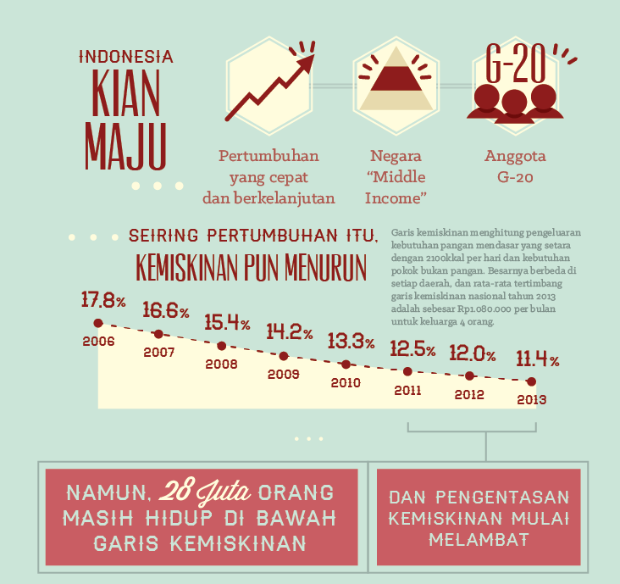
- What factor has led to a reduction in poverty in Indonesia? (1 mark)

- List two things that indicate Indonesia’s status as a nation. (2 marks)

- How is poverty measured in Indonesia? (2 marks)

- Based on the national average in 2013, when is a family of four considered to be living below the poverty line? (1 mark)

- Looking at the graph, compare the years 2006 to 2008 with 2011 to 2013. What can you say about the decline in poverty in Indonesia? (1 mark)

Text 3 (3 marks)
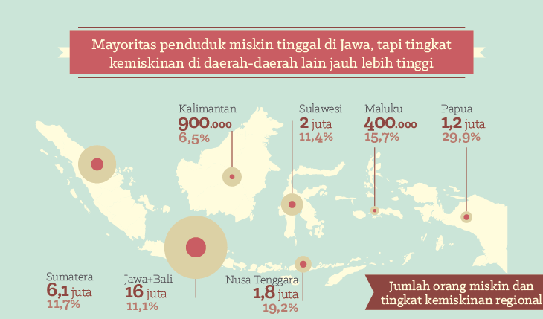
- What information is provided in this map? (3 marks)

Text 4 (18 marks)
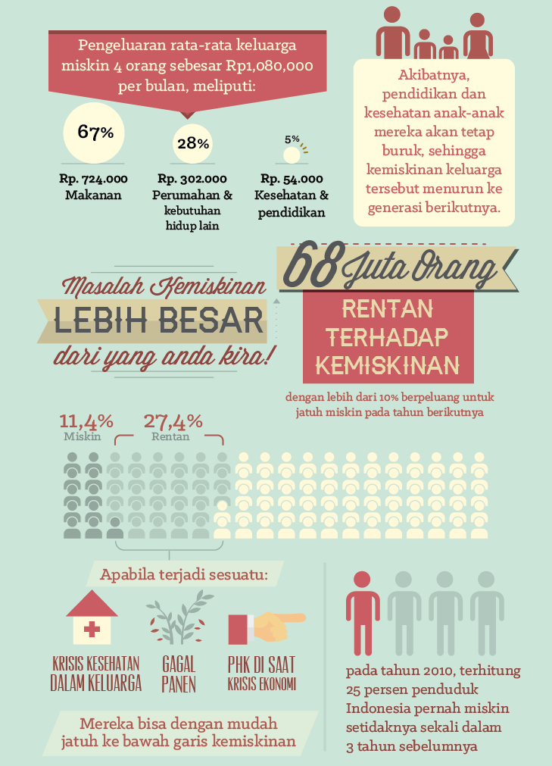
PHK = pemutusan hubungan kerja
- Complete the table below. (6 marks)
Item | Percentage of monthly income | Amount per month
Food | (1 mark) | (1 mark)
(1 mark) | 28% | (1 mark)
(1 mark) | (1 mark) | Rp. 54.000
- What is the biggest expenditure for a family living below the poverty line? (1 mark)

- Describe how the income of the average poor family of four is spent. (3 marks)

- What is the major impact of poverty on children, and what will this mean for future generations of these children? (2 marks)

- Give three reasons why the problem of poverty is considered to be greater than we think?
(3 marks)

13. What three factors could cause 27.4% of the population to fall below the poverty line?
(3 marks)

Text 5 (11 marks)
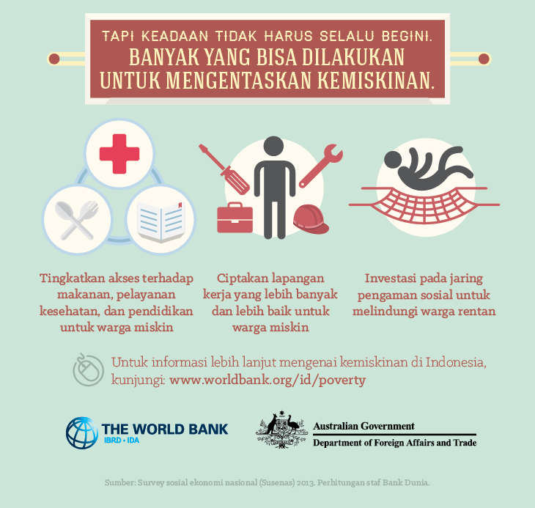
- List three ways to overcome poverty. (3 marks)

The text used for this assessment task (is one text which has been cut into five texts) has been sourced from:
http://www.worldbank.org/content/dam/Worldbank/Feature%20Story/EAP/Indonesia/Infografis%20World%20Bank%204.0%20Indonesian_01%20Poverty.png

- Choose one of the three ways to overcome poverty listed above and write a blog post describing how the way you have chosen can help to improve the lives of poor people in Indonesia. Write approximately 100 words in Indonesian. (8 marks)

Marking key for sample assessment task 9 – Unit 4
Text 1
Description | Marks
Question 1 | /1
the importance of overcoming poverty in Indonesia | 1
Subtotal | /1
Text 2
Description | Marks
Question 2 | /1
continuous/ongoing and fast economic growth | 1
Question 3 | /2
Indonesia is a middle-income nation | 1
Indonesia is a member of the G20 (group of nations) | 1
Question 4 | /2
poverty is measured based on a calorie intake of 2100 kilojoules per day | 1
necessities other than food | 1
Question 5 | /1
when a family of four has an income of Rp 1080.00 per month or less | 1
Question 6 | /1
between 2006 and 2008 the decline in the poverty rate was more than double or greater than the decline in the poverty rate between 2011 and 2013 | 1
Subtotal | /7
Text 3
Description | Marks
Question 7 | /3
the number of people | 1
the percentage of poor people | 1
in seven regions in Indonesia | 1
Subtotal | /3

Text 4
Description |  | Marks
Question 8 |  | /6
Item | Housing and other necessities | 1
 | Health and Education | 1
Percentage of monthly income | 67% | 1
 | 5% | 1
Amount per month | Rp. 724.000 | 1
 | Rp. 302.000 | 1
Question 9 |  | /1
food |  | 1
Question 10 |  | /3
67% is spent on food |  | 1
28% is spent on housing |  | 1
5% is spent on health and education |  | 1
Question 11 |  | /2
the health and education (of children living below the poverty line) is poor |  | 1
their children will also be poor (resulting in intergenerational poverty) |  | 1
Question 12 |  | /3
68 million people are susceptible to falling below the poverty line |  | 1
and have a 10% chance of falling below the poverty line |  | 1
in the coming year |  | 1
Question 13 |  | /3
a family health crisis |  | 1
a failed harvest |  | 1
becoming unemployed |  | 1
Subtotal |  | /18
Text 5
Description | Marks
Question 14 | /3
increase access to food, health and education for poor families | 1
create more job opportunities which are suitable for poor people | 1
invest in a social safety net to protect individuals who are at risk of/susceptible to becoming poor | 1
Subtotal | /3

Question 15
Criteria | Marks
Topic – Content | /3
Blog post response is well-structured, choosing one of the three ways to overcome poverty presented in the text, and describes how to improve the lives of poor people in Indonesia, through a sophisticated and coherent argument. | 3
Blog post response is clear, choosing one of the three ways to overcome poverty presented in the text, and describes how to improve the lives of poor people in Indonesia. | 2
Blog post response lacks elaboration, choosing one of the three ways to overcome poverty presented in the text, and does not describe how to improve the lives of poor people in Indonesia. | 1
Language use | /3
Uses a wide range of language (expression, syntax and grammar) and appropriate language to make the blog post flow. Maintains a high degree of accuracy. | 3
Uses a range of language (expression, syntax and grammar) appropriately and with good control, but lack of flow due to occasional word choice/grammatical error. | 2
Uses basic but comprehensible and coherent language, with some inappropriate language. | 1
Textual conventions | /2
Includes the features of a blog post by providing a response that is descriptive and persuasive, writing from a personal perspective and sustaining an argument. | 2
Includes some features of a blog post. | 1
Subtotal | /8
Total | /40

Sample assessment task

Indonesian: Second Language – ATAR Year 12

Task 10 – Unit 4
Assessment type: Written communication

Conditions

Time for the task: 50 minutes

Other items: Indonesian/English and English/Indonesian dictionary

Task weighting: 9% of the school mark for this pair of units

Australia/Indonesia relations (20 marks)
Write an article about how an economic, political or current issue/event has influenced the Australia/Indonesia relationship. Include facts, opinions and personal opinion on the issue/event. Write approximately 200 words in Indonesian.

Marking key for sample assessment task 10 – Unit 4
Criteria | Marks
Topic – Content and relevance of response | /6
Writes an engaging article and provides detailed information. Effectively supports information with well-developed examples by:  - stating how an economic, political or current issue/event has influenced the Australia/Indonesia relationship  - including facts, opinions and personal opinion on the issue/event. | 6
Includes most of the information required. Provides some facts and opinions but may be superficial with treatment of some information. | 5
Includes generally relevant content and covers a range of aspects with some elaboration. | 4
Uses familiar content which is generally relevant and attempts to clarify information. | 3
Includes some information that is irrelevant to the question and highly repetitive. | 2
Gives an unclear response and provides content with little relevance to the question. | 1
Grammar | /3
Effectively uses a range of grammar and complex sentence structures. | 3
Uses a range of grammar and sentence structures with occasional influence of the syntax of another language. | 2
Relies predominantly on a limited repertoire of sentence structures with the clear influence of the syntax of another language. | 1
Linguistic resources – Accuracy (grammar, syntax and spelling) | /3
Uses language accurately and consistently. Occasionally omits words or makes minor errors. Inaccuracies do not affect meaning or flow. | 3
Applies the rules of grammar (including items which are contemporary and colloquial) and syntax. Uses language mostly accurately; however, errors interfere with the flow of a phrase or sentence. | 2
Chooses inaccurate and incorrect language which impedes meaning and flow. Inconsistent application of rules of grammar makes some parts of writing awkward. | 1
Linguistic resources – Vocabulary | /3
Uses contextually relevant vocabulary and a range of expressions. Includes contemporary, colloquial and specialised vocabulary when required. | 3
Uses an adequate command of vocabulary and word choice appropriate to question. | 2
Relies on repetitive use of basic vocabulary. | 1
Text types – Conventions | /2
Uses all the key conventions of an article, including appropriate register, to address the purpose of writing and the audience. Writes:  - title/headings  - introductory paragraph that summarises the article  - sequences and links ideas  - appropriate ending or conclusion  Sequences information cohesively and coherently. | 2
Uses some of the conventions of an article. Generally uses register appropriate to the purpose of writing and the audience. | 1
Organisation | /3
Sequences information and ideas coherently and cohesively. | 3
Shows evidence of some sequencing with simple and straightforward connections. | 2
Uses some limited organisation which impedes the flow and understanding. The connection between the ideas is sometimes unclear. | 1
Total | /20

