Sample Assessment Tasks

Geography

ATAR Year 11

Acknowledgement of Country
Kaya. The School Curriculum and Standards Authority (the Authority) acknowledges that our offices are on Whadjuk Noongar boodjar and that we deliver our services on the country of many traditional custodians and language groups throughout Western Australia. The Authority acknowledges the traditional custodians throughout Western Australia and their continuing connection to land, waters and community. We offer our respect to Elders past and present.
Copyright
© School Curriculum and Standards Authority, 2021
This document – apart from any third party copyright material contained in it – may be freely copied, or communicated on an intranet, for non-commercial purposes in educational institutions, provided that the School Curriculum and Standards Authority is acknowledged as the copyright owner, and that the Authority’s moral rights are not infringed.
Copying or communication for any other purpose can be done only within the terms of the Copyright Act 1968 or with prior written permission of the School Curriculum and Standards Authority. Copying or communication of any third party copyright material can be done only within the terms of the Copyright Act 1968 or with permission of the copyright owners.
Any content in this document that has been derived from the Australian Curriculum may be used under the terms of the Creative Commons Attribution 4.0 International (CC BY) licence.
Disclaimer
Any resources such as texts, websites and so on that may be referred to in this document are provided as examples of resources that teachers can use to support their learning programs. Their inclusion does not imply that they are mandatory or that they are the only resources relevant to the course.

Sample assessment task

Geography – ATAR Year 11

Task 1 – Unit 1
Assessment type: Response/Practical skills
Conditions
This task is to be completed in class under standard test conditions.
Time for the task: 50 minutes
Task weighting
10% of the school mark for this pair of units

Section One: Multiple-choice 10 marks
Refer to ATAR course examination, 2017 Geography Broadsheet
Study Source 1 on the Broadsheet then answer Questions 1–8.
- Which of the following statements best describes the scale of the Quinns Rocks topographic map?
- One centimetre equals 2.5 kilometres.
- One centimetre equals 25 kilometres.
- One centimetre represents 250 metres.
- One centimetre represents 2500 metres.
- The intersection of Quinns Road and Tapping Way is nearest to grid reference
- 774949.
- 778950.
- 947727.
- 949774.
- In which of the following Area References (AR) is most of Nowergup Lake located?
- AR 7999
- AR 8099
- AR 7998
- AR 8098
- Which of the following latitude and longitude coordinates is closest to the location of One Tree Hill (GR 799972)?
- 31°39’S 115° 44’W
- 31°42’S 115° 47’W
- 31°39’S 115° 44’E
- 31°42’S 115° 47’E

- Which of the following best represents the average gradient from the spot height at Eglinton Hill (northing 98) to the coast at GR 750975?
(a) 1:114
(b) 1:57
(c) 1:35
(d) 1:17
- A person walking along Ocean Drive from GR 757959 to GR 762943 at an average speed of 4 km/hr would complete this journey in approximately
(a) 10½ minutes.
(b) 26 minutes.
(c) 52 minutes.
(d) 88 minutes.

- Which of the following terms best describes the nature of the slope along the fence line from the eastern side of Nowergup Lake (GR 799993) to the dam (GR 808994)?
  - uniform
  - undulating
  - convex
  - concave

- What land use dominates the area to the east of Gibbs Road (from GR 793000 to GR 805964)?
(a) agriculture
(b) light industry
(c) national park
(d) mining
Refer to Source 1: Quinns Rocks topographic map 1986 and Source 2: Quinns Rocks aerial photo 2016 to answer Question 9.
- Which of the following best describes the former land use of the area designated ‘A’ on
Source 2?
(a) vegetation scattered
(b) fauna sanctuary
(c) national park
(d) quarry

Refer to Source 3: Intersection of Gibbs and Wesco Roads 2016 to answer Question 10.
- Source 3 on the Broadsheet is an example of
- a vertical aerial photograph.
- a ground photograph.
- a satellite photograph.
- an oblique aerial photograph.
Section Two: Short response 28 marks
Answer all questions by writing your response in the spaces provided.
Refer to Source 1: Quinns Rocks topographic map 1986 to answer Questions 11 and 12.
Question 11
- Draw and annotate the following features on the sketch map below: (4 marks)
- Built-up area of Quinns Rocks
- Tapping Way
- Caravan Park
- Post Office.
- In the space provided, write the scale of the sketch map expressed as a ratio. (1 mark)
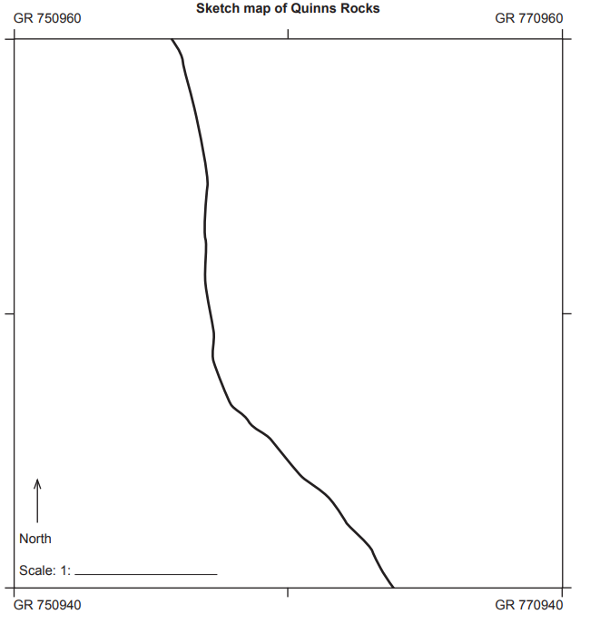

Question 12
- Describe one site feature of the settlement at Quinns Rocks. (1 mark)

- State one situation feature of the settlement at Quinns Rocks. (1 mark)

Question 13
Define the concept of hazard geography. (2 marks)

Question 14
Define the following types of natural hazards and provide one example of each. (6 marks)
Atmospheric

Example:

Hydrological

Example:

Geomorphic

Example:

Question 15
Source 4: Types of ecological hazards

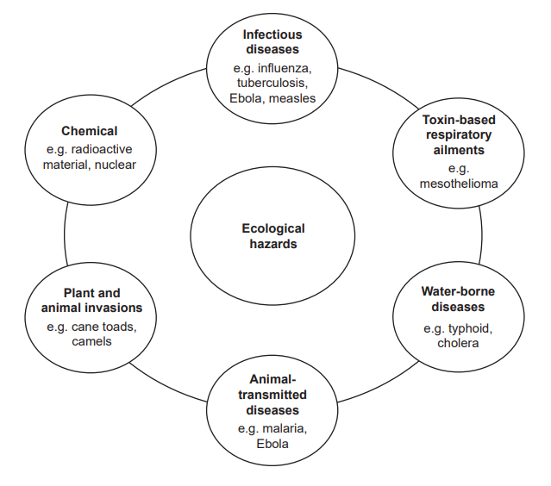
With reference to Source 4, define the term ‘ecological hazard’. (2 marks)

Question 16
Study Source 5 then answer Question 16.
Source 5: Tectonic activity and volcanism over the last one million years
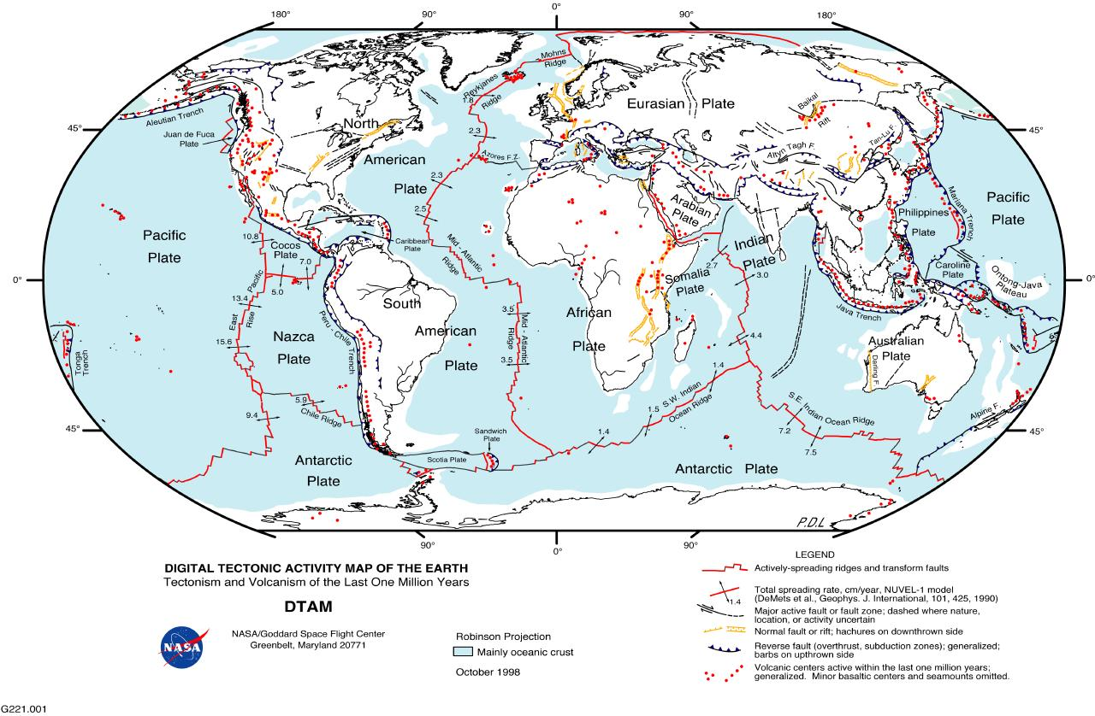
With reference to Source 5, outline the global spatial distribution of volcanic centres active within the last one million years. (2 marks)

Question 17
Define the following: (3 marks)
Frequency:

Scale of spatial impact:

Magnitude:

Question 18
Explain the concepts of preparedness and mitigation in relation to hazard risk management.
(6 marks)

Marking key for sample assessment task 1 – Unit 1
Section One: Multiple-choice
Question | Answer
1 | C
2 | A
3 | A
4 | C
5 | C
6 | B
7 | D
8 | A
9 | C
10 | B
Description | Mark
1 mark each | 0–10
Total | 10

Section Two: Short response
Refer to Source 1: Quinns Rocks topographic map 1986 to answer Questions 11 and 12.
Question 11
- Draw and annotate the following features on the sketch map below: (4 marks)
- Built-up area of Quinns Rocks
- Tapping Way
- Caravan Park
- Post Office.
Description | Marks
Correctly draws in and annotates the location of all 4 features on the  sketch map i.e. Built-up area of Quinns Rocks, Tapping Way, Caravan  Park, Post Office (within the accepted parameters). | 4
Correctly draws in and annotates the location of any 3 of the following on  the sketch map i.e. Built-up area of Quinns Rocks, Tapping Way,  Caravan Park, Post Office (within the accepted parameters). | 3
Correctly draws in and annotates the location of any 2 of the following on  the sketch map i.e. Built-up area of Quinns Rocks, Tapping Way,  Caravan Park, Post Office (within the accepted parameters). | 2
Correctly draws in and annotates the location of any 1 feature on the  sketch map i.e. Built-up area of Quinns Rocks, Tapping Way, Caravan  Park, Post Office (within the accepted parameters). | 1
Total | 4
See sample sketch map provided on the next page.

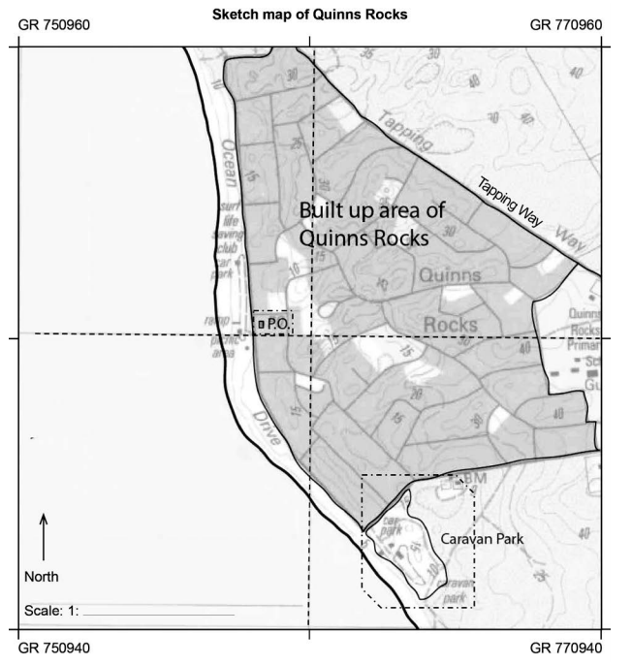

- In the space provided, write the scale of the sketch map expressed as a ratio. (1 mark)
Description | Marks
Identifies the correct scale | 1
Total | 1
Answer 1 : 12 500

Question 12
- Describe one site feature of the settlement at Quinns Rocks. (1 mark)
Description | Marks
Describes correctly one site feature. | 1
Total | 1
Answers could include:
- located on a coastal plain
- located within an undulating landscape among a number of sand dunes
- located approx. 0–50 m above sea level
- located on the coast.
- State one situation feature of the settlement at Quinns Rocks. (1 mark)
Description | Marks
States correctly one situation feature | 1
Total | 1
If absolute location stated – the correct coordinate must be provided, e.g. latitude longitude coordinate.
If relative location stated – both correct distance and direction must be stated.
Answers could include:
- situated 31°41’ 30’’S 116°41’30’’E
- situated approximately 5km south-west from Nowergup Lake.

Question 13
Define the concept of hazard geography. (2 marks)
Description | Marks
Defines the concept of hazard geography using geographical terminology.  The definition will include reference to the study of both natural and cultural hazards and one of the following:  - it involves examining the processes (natural and human causes) that produce these hazards and the different types of natural and cultural hazards that are created from these processes  - it examines a hazard’s distribution around earth  - it investigates the impact that a hazard has on natural and cultural environments  - it examines the ways that humans respond to these events and how they take action to minimise the impact or risk of the hazards in the future. | 2
States a fact about hazard geography using general terminology. The fact makes reference to either the study of natural or cultural hazards or one of the following:  - it involves examining the processes (natural and human causes) that produce these hazards and the different types of natural and cultural hazards that are created from these processes  - it examines a hazard’s distribution around earth  - it investigates the impact that a hazard has on natural and cultural environments  - it examines the ways that humans respond to these events and how they take action to minimise the impact or risk of the hazards in the future. | 1
Total | 2
Answer could include, but is not limited to:
Hazard geography is the study of both natural and cultural (human) hazards, such as earthquakes, storms, diseases or oil spills, examining where they occur, why or how they occur or are created, the impacts they have on natural and cultural environments and how humans can minimise the impacts and risks of future hazard events.
Question 14
Define the following types of natural hazards and provide one example of each. (6 marks)
Description | Marks
Three natural hazard classifications x 2 marks each
Defines correctly the natural hazard. | 1
Provides one correct example of the natural hazard classification. | 1
Subtotal | 2
Total | 6
Answer could include, but is not limited to:
Atmospheric hazards are hazards that are created from atmospheric and/or weather processes.
Examples of atmospheric hazards can include storms, heatwaves, cold waves, cyclones, droughts, hurricanes, tornadoes, wildfires.
Hydrological hazards are those that involve the movement and distribution of water. Examples of hydrological hazards include flooding, water-induced landslides, king tides, coastal erosion.
Geomorphic hazards are hazards that are created by the movement of the earth’s surface or crust, i.e. plate tectonic movements.
Examples include earthquakes, volcanic eruptions and movement- induced landslides.
Question 15
With reference to Source 4, define the term ‘ecological hazard’. (2 marks)
Description | Marks
Defines correctly the term ecological hazard using accurate geographical terminology. The definition will include reference to biological and chemical hazards and their potential impact on people (cultural environments) and natural environments.  Makes accurate reference to Source 4. | 2
Defines briefly the term ecological hazard using general terminology or accurate reference to the Source 4 only. | 1
Total | 2
Answer could include, but is not limited to:
An ecological hazard is any natural or human-made biological (e.g. virus, disease) or chemical that has the potential to impact natural or cultural environments. As can be seen in Source 4, types of ecological hazard include cholera, Ebola and chemical hazards or nuclear hazards.
Question 16
With reference to Source 5, outline the global spatial distribution of volcanic centres active within the last one million years. (2 marks)
Description | Marks
Outlines the global spatial distribution of volcanic centres active within the last one million years.  Uses relevant geographical descriptive words, (e.g. continents, hemispheres, country names, oceans, plate boundaries/faults, trenches). | 2
Makes generalised statements about the global spatial distribution of volcanic centres active within the last one million years.  Uses limited geographical terminology. | 1
Total | 2
Answer could include, but is not limited to:
Volcanic centres active within the last one million years are found along the boundaries of reverse faults, such as along the up thrown side of the Java Trench and the Mariana Trench. They are also found along normal faults, such as along the Baikal Fault in Europe and the Great Rift Valley in Africa.

Question 17
Define the following terms: (3 marks)
Description | Marks
Three definitions x 1 marks each
Defines correctly the term. | 1
Subtotal | 1
Total | 3
Answer could include, but is not limited to:
Frequency:
Frequency refers to how often a hazard event occurs in a particular area/country.
Scale of spatial impact:
Scale of spatial impact refers to the extent/size of the area and/or number of places or countries impacted by the hazard.
Magnitude:
Magnitude refers to the intensity or strength of a hazard which is measured on different scales for different hazards.
Question 18
Explain the concepts of preparedness and mitigation in relation to hazard risk management. Provide an example for each concept. (6 marks)
Description | Marks
Two concepts x 3 marks each
Explains the concept in relation to hazard risk management.  Provides a relevant example for the concept, using relevant geographical terminology. | 3
Describes the concept in relation to hazard risk management.  Provides a relevant example for the concept, using some relevant geographical terminology. | 2
Makes a generalised statement about the concept. | 1
Subtotal | 3
Total | 6
Answer could include, but is not limited to:
Preparedness:
Preparedness refers to planning and strategies put in place in order to make sure a community is aware of how to respond during a hazard event so that the effects of a hazard are minimised. For example, with a bushfire this could include education and empowerment strategies such as being aware of evacuation plans.
Mitigation:
Mitigation refers to the all the strategies implemented in order to eliminate or reduce the effects or risk from a hazard. For example, the environmental modification strategy of prescribed burning to minimise the risk of bushfires.

Geography – ATAR Year 11

Task 6 – Unit 2
Assessment type: Geographical inquiry/Fieldwork
Conditions
Period allowed for completion of Part A of the task: 3 x 50 minutes of supervised class time before the fieldtrip and 1 x 50 minutes of class time immediately following the fieldtrip, to complete the Fieldwork booklet.
Period allowed for completion of Part B of the task: 50 minutes in class.
Task weighting
15% of the school mark for this pair of units

Depth Study One: Commodity, good or service (tourism) Swan Valley tourism inquiry and fieldwork
You will be assessed on the inquiry, the fieldwork booklet and an in-class validation test, which will contain a combination of short and extended response questions. The questions could be any of the syllabus points below.
When writing your answers in the validation part of this task, you must include specific evidence from your inquiry and the fieldwork completed in the Swan Valley.
- Describe the commodity, good or service.
- Describe the process of diffusion of the commodity, good or service and its spatial distribution.
- Describe the changes occurring in the spatial distribution of the production and consumption of the commodity, good or service.
- Explain how technological advances in transport and/or telecommunications have facilitated changes in the spatial distribution of the commodity, good or service.
- Explain the role played by governments and/or enterprises in the distribution of the production and consumption of the commodity, good or service.
- Discuss the ways people and places embrace, adapt to, and/or resist the diffusion of the commodity, good or service.
- Evaluate the social, economic and environmental implications of the changes in the production and distribution of the commodity, good or service.
 | Total marks available | Your mark
Part A: Inquiry booklet | 10
Part B: Fieldwork booklet | 8
Part C: In-class validation | 26

Part A: Inquiry booklet
To be completed prior to the field trip (10 marks)
- Take notes on Tourism in the Swan Valley, making sure to include specific data. Create a table to organise your notes.
Useful resources:
- Visit the City of Swan: Swan Valley website at https://www.swan.wa.gov.au/Your-Business/Invest-in-Swan/Were-open-for-investment and download the two PDF documents located at the bottom of the webpage titled:
- Swan Investments Information Tourism PDF
- Swan Investment Information – Swan Valley PDF
- Using the notes in your table write a brief overview of tourism in the Swan Valley.

- Research and explain specific examples of the role played by governments (federal, state and/or local) in the distribution of the production and consumption of the tourist industry in the Swan Valley.

- Research, locate and evaluate two online sources of information about tourism in the Swan Valley, (e.g. website, Facebook). In your answer consider the role of telecommunications in assisting producers and consumers (owners/providers of tourist site/activity and tourist/visitors).
This question requires an evaluation. A good answer will therefore include both the positive and negative aspects of the role of telecommunications and draw a conclusion.
Name of website one:
Evaluation:

Name of website two:
Evaluation:

- Research and take notes on the impact of COVID-19 on the Swan Valley tourism industry.

Using an online map (e.g. Google maps)
- Describe the situation of each location.
The Orchard | Caversham Wildlife Park
- Describe two site factors of The Orchard and two site factors of Caversham Wildlife Park.
The Orchard | Caversham Wildlife Park
1. | 1.
2. | 2.

Research online The Orchard (Golden Grove Cafe) and Caversham Wildlife Park.
- Summarise the reviews made by local, national and global visitors. Can you identify any common trends or patterns in the feedback about each location? (List where you got the reviews from.)
The Orchard

Caversham Wildlife Park

- Outline three ways information is being diffused about each place.
The Orchard | Caversham Wildlife Park

- Explain the importance of the diffusion of information to both places.

Visit the Orchard website https://theorchardperth.com.au/ and the Caversham Wildlife Park website https://www.cavershamwildlife.com.au/.
- Summarise into a table the activities/partnerships/events that are being offered at both places.
Attach your completed table after this page.

- Formulate three questions for a questionnaire to use while on the fieldtrip. You will be required to survey at least five visitors to the Orchard and five visitors to the Wildlife Park about some of the following: how they found out about the places; what they liked; would they come again; and/or their motivation for visiting the places. (Refer to the syllabus dot points for ideas about the questions you could ask.)
Examples of question types can be found at: https://www.surveymonkey.com/mp/survey-question-types/.
Question 1:

Question 2:

Question 3:

Before going on the fieldtrip prepare how you will collect, record and collate the answers to your questionnaire.
Part B: Fieldwork booklet
All parts of this Fieldwork booklet must be completed. (8 marks)
Part 1: The Orchard
Tally visitors you see at The Orchard throughout the day (excluding our class).
Child | Adult
How would you expect this to be different on weekends at different times of year?

Describe the fruit processing process (including the use of machinery).

Take notes from the talks presented (impact of COVID-19 on tourism, normal target market, number of visitors, busiest seasons and how have they adjusted post-COVID-19, e.g. targeting more locals).

What evidence if any did you see that some people might resist the spread of tourism in the Swan Valley (e.g. noise, smells, traffic, parking)?

Questionnaire results:

Construct a sketch map of The Orchard on the following page.
Include the following features:
buildings, orchards, water supply, natural vegetation, landscape, title, orientation, legend, scale.

Part 2: To be completed during the visit to Caversham Wildlife park
Tally visitors you see at the Wildlife park throughout the day (excluding our class).
Child | Adult
How would you expect this to be different on weekends/different times of year?

Describe the activities and features of the Wildlife Park which would strongly appeal to overseas visitors.

Take notes from talks presented (impact of COVID-19 on tourism, normal target market, number of visitors; busiest seasons and how they have adjusted post-COVID-19, e.g. targeting more locals).

What evidence if any did you see that some people might resist the spread of tourism in the Swan Valley (e.g. noise, smells, traffic, parking)?

Complete the following table based on what you see at the Wildlife Park about the social, economic and environmental implications of the park.
 | Plus | Minus
Social
Economic
Environmental
Attach questionnaire results here.

Part C: In-class validation (26 marks)
Time allocation: 5 minutes reading and 45 minutes writing
In your answers to all of the questions you must include evidence from your inquiry and/or fieldwork on tourism in the Swan Valley.
- Outline tourism in the Swan Valley. (2 marks)

- Describe two ways people and places embrace and/or resist the diffusion of tourism in the Swan Valley. (6 marks)
1.

2.

- Explain the role played by governments in the distribution of the production and consumption of tourism in the Swan Valley. (4 marks)

- Explain the role played by enterprises (tourist providers) in the distribution of the production and consumption for tourism in the Swan Valley. (4 marks)

- Evaluate the social, economic and environmental implications of the changes in the production and distribution of tourism in the Swan Valley. (10 marks)

Marking key for sample assessment task 6 – Unit 2
Part A – Geographical inquiry booklet
Description | Marks
Collects accurate and detailed geographical information from a wide range of sources.  Records detailed and relevant information in a range of appropriate graphic representations.  Selects and correctly applies a wide range of accurate supporting evidence (including quotations, sources, statistics, data, maps, sketches and/or diagrams) to develop responses.  Selects and accurately applies relevant geographical terminology and concepts to develop cohesive and accurate responses.  Develops and refines relevant and appropriate questions. | 7–8
Collects accurate geographical information from a range of sources.  Records relevant information in a range of graphic representations.  Selects and applies a range of appropriate supporting evidence to develop responses.  Uses relevant geographical terminology and concepts to develop responses.  Develops relevant and mostly appropriate questions. | 5–6
Collects some relevant geographical information from sources provided.  Records generalised brief information in a limited range of graphic representations.  Uses limited supporting evidence to develop responses.  Uses some relevant geographical terminology and/or concepts to develop responses.  Develops some relevant and mostly appropriate questions. | 3–4
Collects information from a limited range of sources and may lack geographical context, and be largely plagiarised.  Includes limited and/or irrelevant supporting evidence.  Rarely or inaccurately uses geographical terminology and concepts.  Develops limited or no relevant questions. | 1–2
Total | 8
Bibliography | Marks
Provides a bibliography that includes a comprehensive list of secondary sources, which correctly follow the referencing style approved by the school. | 2
Provides a bibliography that includes a smaller range of sources which mostly follow the referencing style approved by the school. | 1
Total | 2

Part B: Fieldwork booklet
Description | Marks
Fieldwork booklet
Includes detailed relevant geographical information and/or data for all parts of the Fieldwork booklet.  Selects and accurately uses relevant geographical terminology and concepts to record concise notes.  Sketch map is accurate, relevant and includes all required features. Includes all conventions of mapping: orientation, legend (appropriate use of symbols/labels to identify features), title and scale.  Questionnaire responses recorded and collated in an effective organised way. | 7–8
Includes relevant geographical information and/or data for all parts of the Fieldwork booklet.  Uses relevant geographical terminology and concepts to develop responses.  Sketch map is accurate and includes most of the required features. Includes all conventions of mapping: orientation, legend (appropriate use of symbols/labels to identify features), title and scale.  Questionnaire responses recorded and collated in an organised way. | 5–6
Includes relevant geographical information and/or data to some of the Fieldwork booklet.  Uses some relevant geographical terminology and concepts to develop responses.  Sketch map is mostly accurate and includes most of the required features. Includes some of the conventions of mapping: orientation, legend, title and scale.  Some of the questionnaire responses recorded and/or collated in an organised way. | 3–4
Includes limited geographical information and/or data in the Fieldwork booklet.  Uses limited or inaccurate geographical terminology and concepts to develop responses.  Sketch map is mostly inaccurate and includes few of the required features. Includes some of the conventions of mapping: orientation, legend, title and scale.  Limited questionnaire responses recorded and/or not collated in an organised way. | 1–2
Total | 8

Part C Validation task – Marking key
- Outline tourism in the Swan Valley. (2 marks)
Description | Marks
Factor 1
Outlines tourism in the Swan Valley.  Correctly applies appropriate supporting evidence from the inquiry and/or fieldwork (including quotations, sources, statistics, data, maps, diagrams and/or sketches). | 2
Makes generalised statements about tourism in the Swan Valley.  Uses limited supporting evidence. | 1
Total | 2
- Describe two ways people and places embrace and/or resist the diffusion of tourism in the Swan Valley. (6 marks)
Description (2 x 3 marks) | Marks
Describes a way people and places have embraced and/or resisted tourism in the Swan Valley.  Correctly applies a wide range of appropriate supporting evidence from the fieldwork (including quotations, sources, statistics, data, maps, diagrams and/or sketches) and accurately uses relevant geographical terminology and applies concepts to enhance discussion. | 3
Outlines a way people and places have embraced and/or resisted tourism in the Swan Valley.  Makes reference to some supporting evidence from the fieldwork and uses some geographical terminology and concepts. | 2
Makes generalised statements about a way people and places have embraced and/or resisted tourism in the Swan Valley.  Uses limited supporting evidence and reference to geographical terminology and concepts. | 1
Total | 6
- Explain the role played by governments in the distribution of the production and consumption of tourism in the Swan Valley. (4 marks)
Description | Marks
Explain the role played by governments in the distribution of the production and consumption of tourism in the Swan Valley.  Correctly applies a wide range of appropriate supporting evidence from the inquiry and the fieldwork (including quotations, sources, statistics, data, maps, diagrams and/or sketches).  Applies relevant geographical terminology to enhance response. | 4
Describes the role played by governments in the distribution of the production and consumption of tourism in the Swan Valley.  Correctly applies some appropriate supporting evidence from the inquiry and the fieldwork (including quotations, sources, statistics, data, maps, diagrams and/or sketches).  Uses relevant geographical terminology to enhance response. | 3
Outlines the role played by governments in the distribution of the production and consumption of tourism in the Swan Valley.  Makes reference to some supporting evidence from the inquiry and/or fieldwork Uses some geographical terminology. | 2
Makes generalised statements about the role played by governments in the distribution of the production and consumption of tourism in the Swan Valley. | 1
Total | 4
- Explain the role played by enterprises (tourist providers) in the distribution of the production and consumption of tourism in the Swan Valley. (4 marks)
Description | Marks
Explains the role played by enterprises (tourist providers) in the distribution of the production and consumption of tourism in the Swan Valley.  Correctly applies a wide range of appropriate supporting evidence from the inquiry and the fieldwork (including quotations, sources, statistics, data, maps, diagrams and/or sketches).  Applies relevant geographical terminology to enhance response. | 4
Describes the role played by enterprises (tourist providers) in the distribution of the production and consumption of tourism in the Swan Valley.  Correctly applies some appropriate supporting evidence from the inquiry and the fieldwork (including quotations, sources, statistics, data, maps, diagrams and/or sketches).  Uses relevant geographical terminology to enhance response. | 3
Outlines the role played by enterprises (tourist providers) in the distribution of the production and consumption of tourism in the Swan Valley.  Makes reference to some supporting evidence from the inquiry and/or fieldwork. Uses some geographical terminology. | 2
Makes generalised statements about the role played by enterprises (tourist providers) in the distribution of the production and consumption of tourism in the Swan Valley. | 1
Total | 4
- Evaluate the social, economic and environmental implications of the changes in the production and distribution for tourism in the Swan Valley. (10 marks)
Description | Marks
Evaluates in detail the social, economic and environmental implications of the changes in the production and distribution for tourism in the Swan Valley.  Correctly selects and applies a wide range of appropriate supporting evidence from the inquiry and the fieldwork (including quotations, sources, statistics, data, maps, diagrams and/or sketches) to strengthen the evaluation.  Selects and accurately applies relevant geographical terminology and concepts to develop cohesive and relevant responses. | 9–10
Evaluates the social, economic and environmental implications of the changes in the production and distribution for tourism in the Swan Valley.  Correctly selects and applies a range of appropriate supporting evidence from the inquiry and the fieldwork (including quotations, sources, statistics, data, maps, diagrams and/or sketches) to strengthen the evaluation.  Applies relevant geographical terminology and concepts to strengthen the evaluation. | 7–8
Explains the social, economic and environmental implications of the changes in the production and distribution for tourism in the Swan Valley.  Selects and applies some appropriate supporting evidence from the inquiry and/or the fieldwork to develop responses.  Uses some accurate geographical terminology and concepts to develop the explanation. | 5–6
Provides a brief description of the social, economic and/or environmental implications of the changes in the production and distribution for tourism in the Swan Valley.  Uses limited supporting evidence from the inquiry or the fieldwork to support the description. | 3–4
Makes generalised statements about the social, economic and/or environmental implications of the changes in the production and distribution for tourism in the Swan Valley.  Uses limited supporting evidence and reference to geographical terminology and concepts. | 1–2
 | 10
Marker information
This question requires an evaluation. A good answer (i.e. one receiving high marks) will therefore include both the positive and negative implications of the changes and draw a conclusion.
Total | 26

Acknowledgements
Sample Assessment Task
Question 17 NASA. (1998). Digital tectonic activity map of the earth: Tectonism and volcanism of the last one million years. Retrieved September, 2021, from https://globalchange.
umich.edu/globalchange1/current/lectures/evolving_earth/tectonic_map.jpg
Marking Key
Question 11 Sketch map adapted from: Landgate. (1986). Topographic map Yanchep (2034 IV SE). Midland: Western Australia Land Information Authority.
Reproduced with permission of the Western Australian Land Information Authority, Landgate (2017).

