Sample Assessment Tasks

Geography

General Year 11

Copyright
© School Curriculum and Standards Authority, 2014
This document – apart from any third party copyright material contained in it – may be freely copied, or communicated on an intranet, for non-commercial purposes in educational institutions, provided that the School Curriculum and Standards Authority is acknowledged as the copyright owner, and that the Authority’s moral rights are not infringed.
Copying or communication for any other purpose can be done only within the terms of the Copyright Act 1968 or with prior written permission of the School Curriculum and Standards Authority. Copying or communication of any third party copyright material can be done only within the terms of the Copyright Act 1968 or with permission of the copyright owners.
Any content in this document that has been derived from the Australian Curriculum may be used under the terms of the Creative Commons Attribution 4.0 International licence.
Disclaimer
Any resources such as texts, websites and so on that may be referred to in this document are provided as examples of resources that teachers can use to support their learning programs. Their inclusion does not imply that they are mandatory or that they are the only resources relevant to the course.

Sample assessment task
Geography – General Year 11
Task 2 – Unit 1
Assessment type: Test
Conditions
In class under test conditions
Time for the task: 60 minutes
Task weighting
5% of the school mark for this pair of units

Section One – Multiple-choice (11 marks)

The non-living portion of any given biome may also be called

inorganic or biotic.

organic or abiotic.

biotic.

abiotic.

An ecosystem is different to a biome because it is

larger.

smaller.

not influenced by climate.

not part of the biosphere.

Which of the following terms is a set of interrelated food chains?

ecological pyramid

biomass

food web

habitat

The sphere where all living things exist is best described as the

atmosphere.

biosphere.

hydrosphere.

lithosphere.

The term ecosystems refers to

a community of organisms.

the study of relationships between the living and non-living things.

the biotic diversity that each plant and animal displays.

organisms interacting with each other and with the environment in which they live.

The above diagram is an example of a
Birds of prey
Small bush birds
Spiders and predaceous insects
Plant eating insects

food web.

ecological pyramid.

ecological balance.

energy flow.
Questions 7, 8 and 9 refer to the following sequence.
grass grasshopper lizard hawk

This sequence represents a

biosphere.

food web.

carbon cycle.

food chain.

Which organism is located at the third trophic level?

hawk

lizard

grasshopper

grass

Name the secondary consumer in the sequence above.

grass

grasshopper

lizard

hawk

In general, as you move up the food chain

the number of animals usually increases.

the number of animals usually decreases.

the size of the animals usually stays the same.

the size of the animal usually decreases.

Which of the following is not an example of the abiotic component of an ecosystem?

rocks

soil

atmosphere

plants and animals

Section Two – Short answer (19 marks)

Identify if each of the following features is a natural or cultural feature. Tick the correct option. (4 marks)
Feature | Natural | Cultural
beach
tropical rainforest
fruit orchard
pine tree plantation
buildings
coral reefs
roads
whales

Define the concept of Biodiversity. (2 marks)

<map of world biomes to be included by teacher in this space>

From the map of World Biome, choose one (1) biome and describe the location and distribution of the biome. (4 marks)
Biome: ______________________________

For the biome you chose in question 14 describe two (2) of the following elements.

climate

soils and landforms

flora and fauna (4 marks)
Element 1: ______________________________

Element 2: ______________________________

Discuss the concept of sustainability and how it is being applied in the image below. (5 marks)
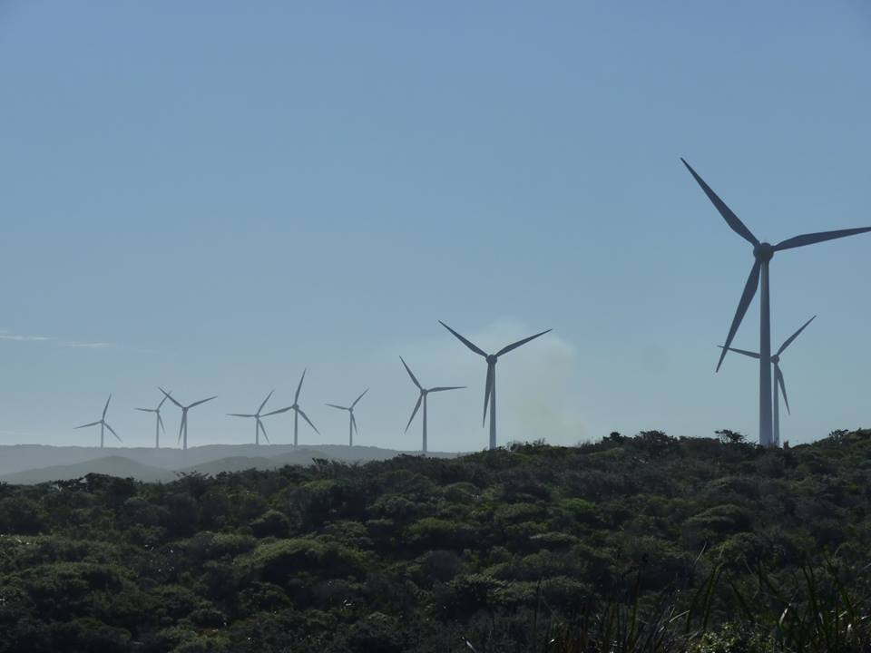

Total = 30 marks

Marking key for sample assessment task 2 – Unit 1
Section One – Multiple-choice
Question | Answer |  | Question | Answer
1 | D |  | 7 | D
2 | B |  | 8 | B
3 | C |  | 9 | C
4 | B |  | 10 | B
5 | D |  | 11 | D
6 | B

Section Two – Short answer

Identify if each of the following features is a natural or cultural feature. Tick the correct option.
Description | Marks
Correctly identifies the features | 1–4  (½ mark for each correct feature)
Answer:
Feature Natural Cultural
beach
tropical rainforest
fruit orchard
pine tree plantation
buildings
coral reefs
roads
whales

Define the concept of Biodiversity.
Description | Marks
Defines accurately the concept of biodiversity using relevant geographical terminology | 2
Makes a general statement about biodiversity | 1
Total | 2
Answer could include, but is not limited to:
Biodiversity is defined as the type, number and variety of plant and animal species within a given environment.

From the map of World Biome, choose one (1) biome and describe the location and distribution of the biome.
Description | Marks
Describes in detail the major location and distribution of their chosen biome  Refers to specific countries and gives a range of latitudes to enhance their answer using accurate and relevant geographical terminology | 4
Describes the major location and distribution of their chosen biome  Refers to some examples of specific countries and latitudes using some relevant geographical terminology | 3
Describes briefly the major location and some of the distribution of their chosen biome  Refers to one example of a specific country and either doesn’t give latitude or provides incorrect latitude | 2
States a location of a biome in a specific country or continent | 1
Total | 4
Answer could include, but is not limited to:
The location and distribution of the biome
Tropical forests are distributed in areas of the world near the equator and between the Tropic of Capricorn and the Tropic of Cancer, normally between latitude 20 degrees north and south.
Fifty seven percent of all tropical rainforests are found in Latin America. One third of the world's tropical rainforests are in Brazil. Other tropical rainforests are located in Southeast Asia and the Pacific Islands (25% of the world's tropical rainforests) and West Africa (18%).

For the biome you chose in question 14 describe two (2) the following elements.

climate

soils and landforms

flora and fauna
Description | Marks
Element 2x2
Describes in detail one element of the biome using accurate and relevant geographical terminology | 2
Describes briefly one element of the biome using relevant geographical terminology | 1
Subtotal | 2
Total | 4
Answer could include, but is not limited to:
Desert Biome
Climate: The desert climate is a climate in which there is an excess of evaporation over precipitation. The typically bald, rocky, or sandy surfaces in desert climates hold little moisture and evaporate the little rainfall they receive. Most desert climates receive between 25 and 200 mm (1 and 8 in) of rainfall annually. At the time of high sun (summer), scorching, desiccating heat prevails. Hot-month average temperatures are normally between 29 and 35 °C (84 and 95 °F), and midday readings of
43–46 °C (109–115 °F) are common.
Flora and Fauna: Plants and animals living in the desert need special adaptations to survive in the harsh environment. Plants tend to be tough and wiry with small or no leaves, water-resistant cuticles and often spines to deter herbivory. Animals need to keep cool and find enough food and water to survive. Many are nocturnal and stay in the shade or underground during the heat of the day. They tend to be efficient at conserving water, extracting most of their needs from their food and concentrating their urine.

Discuss the concept of sustainability and how it is being applied in the image below.
Description | Marks
Discusses in detail the concept of sustainability and how sustainability is being applied in the image using accurate and relevant geographical terminology. Refers to the environmental, social and economic benefit of wind power. Uses a wide range of appropriate supporting examples | 5
Discusses the concept of sustainability and how sustainability is being applied in the image using relevant geographical terminology. Refers to the environmental, social and economic benefit of wind power. Uses a range of appropriate supporting examples | 4
Explains briefly the concept of sustainability and how sustainability is being applied in the image using some relevant geographical terminology. Refers to the environmental, social and/or economic benefit of wind power. Uses some appropriate supporting examples | 3
Describes briefly the concept of sustainability and/or how sustainability is being applied in the image using limited geographical terminology. May refer to the environmental, social and/or economic benefit of wind power. Limited use of appropriate examples | 2
States a fact about sustainability or about the benefit of wind power | 1
Total | 5
Answer could include, but is not limited to:
Sustainability involves meeting the needs of current and future generations through simultaneous environmental, social and economic adaptation and improvement.
Wind power benefits the environment as it is a clean, pollution free energy source that can be relied on for the long-term future. Because wind is a source of energy which is non-polluting and renewable, wind turbines create power without using fossil fuels, without producing greenhouse gases or radioactive or toxic waste. Wind power reduces global warming. Economically wind turbines create reliable, affordable and a cost-effective, source of energy. One wind turbine can be sufficient to generate energy for a household. Socially the construction of wind farms is helping to revitalize rural communities by creating jobs in the local area, such as, assembly workers, surveyors, engineers and technicians. Wind power provides electricity to households and communities. This can enable lighting and productive activities in the evening, as well as improving quality of life.

Sample assessment task
Geography – General Year 11
Task 4: Part B – Unit 1
Assessment type: Fieldwork/Practical skills
Conditions
Time for the task: 50 minutes
All questions are based on fieldwork undertaken at South Trigg to North Beach
Notes can be referred to, but no talking or communicating with other students is permitted
Task weighting
5% of the school mark for this pair of units

Fieldwork/Practical skills test (45 Marks)

Draw and label a sketch of Trigg Beach showing the following features.
Trigg Island  wave-cut platform  stacks  berm  foredune | swale  primary dune  vehicle access ramp  public toilets and bins  dune vegetation
(10 marks)
Title: _______________________________________________

Identify the type of coastal landform of which Trigg Island is an example. (1 mark)

Wave-cut platforms are produced by wave erosion. With the aid of an annotated sketch, describe the processes responsible for its formation. (4 marks)

An understanding of longshore drift would be considered vital to councils wanting to arrest the erosion of precious sand from a popular tourist beach.

Explain the process of longshore drift and how it can be used to save a beach. Include a fully labelled sketch diagram and make specific reference to the fieldwork in your answer. (5 marks)

Explain two (2) reasons why vegetation is important to the stability of the dune system.
(6 marks)
Reason 1:

Reason 2:

Identify two (2) ways that dune vegetation is being threatened and/or destroyed. (2 marks)

________________________________________________

________________________________________________

Identify and label five (5) biotic or abiotic elements in the photograph below. (5 marks)
<coastal photograph to be included by the teacher in this space>

Describe two (2) ways humans are caring for the coastal environment from South Trigg through to North Beach. Refer to specific examples seen on the fieldtrip. (4 marks)
One:

Two:

Discuss the extent to which the two (2) ways humans are caring for the coastal environment are sustainable. Refer to specific examples seen on the fieldtrip. (8 marks)

Marking key for sample assessment task 4 – Unit 1

Draw and label a sketch of Trigg Beach.
Description | Marks
Locates and labels correctly all 10 features on the sketch | 1–10  (1 mark each)
Total | 10

Identify the type of coastal landform of which Trigg Island is an example.
Description | Marks
Identifies correctly that Trigg Island is a tombolo | 1
Total | 1

Wave-cut platforms are produced by wave erosion. With the aid of an annotated sketch, describe the processes responsible for its formation.
Description | Marks
Describes in detail how wave erosion produces wave-cut platforms using accurate and relevant geographical terminology | 2
Describes briefly how wave-cut platforms are produced by wave erosion using relevant geographical terminology | 1
Subtotal | 2
Accurately annotated sketch map | 2
Partially accurate annotated sketch map | 1
Subtotal | 2
Total | 4
Answer could include, but is not limited to:
Wave-cut platforms are formed when waves attack the base of a cliff forming a wave-cut notch (an indent in the base of the cliff) as you can see in the sketch. This undercutting is the result of erosion by waves, e.g. abrasion (where rocks are hurled against the cliffs by waves) and wave pounding (the sheer force of water hitting against the cliff face). As the cliff is undercut, the rock above collapses and so the cliff gradually retreats. A sloping, rocky platform known as a wave-cut platform is left behind where the cliff used to be. This is covered at high tide.
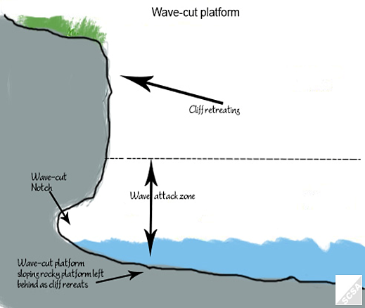

An understanding of longshore drift would be considered vital to councils wanting to arrest the erosion of precious sand from a popular tourist beach.

Explain the process of longshore drift and how it can be used to save a beach. Include a fully labelled sketch diagram and make specific reference to fieldwork in your answer.
Description | Marks
Explains in detail the process of longshore drift and how it can be used to save a beach, using accurate and relevant geographical terminology  Uses a range of appropriate supporting examples from the fieldwork | 3
Explains briefly the process of longshore drift and how it can be used to save a beach, using relevant geographical terminology  Uses some supporting evidence from the fieldwork | 2
States a fact about the process of longshore drift or how it can be used to save a beach or gives an example from the fieldwork, with limited use of geographical terminology | 1
Subtotal | 3
Provides a fully labelled accurate sketch diagram | 2
Provides a partially labelled mostly accurate sketch diagram | 1
Subtotal | 2
Total | 5
Answer could include, but is not limited to:
Longshore drift is the movement of sand along the coastline. This movement of sand is influenced by the surf zone currents created by waves and the predominant wave direction.
Under these conditions, waves break at an angle to the shoreline (forming oblique waves) and the sand is moved along the beach in the surf zone. The direction the sand moves in depends on the dominant wave direction. The construction of groynes and seawalls at Sorrento and Hillary’s boat harbour are used to prevent sand from being removed from a particular part of the coastline.

Explain two (2) reasons why vegetation is important to the stability of the dune system.
Description | Marks
For each of the reasons (2x3)
Explains in detail why vegetation is important to the stability of the dune system using accurate geographical terminology | 3
Explains briefly why vegetation is important to the stability of the dune system using some correct terminology | 2
States a fact about why vegetation is important to the stability of the dune system, with minimal or inaccurate use of geographical terminology | 1
Subtotal | 3
Total | 6
Answer could include, but is not limited to:
- The roots of dune vegetation hold sand grains in place and prevent the grains from blowing away.
- Dune vegetation traps sand grains during wind and human endeavours across dunes.

Identify two (2) ways that dune vegetation is being threatened and/or destroyed.
Description | Marks
Identifies correctly two ways dune vegetation is being threatened and/or destroyed | 1–2  (1 mark each)
Total | 2
Answer could include, but is not limited to:
• fauna (wild and domestic)
• human activity (foraging, trekking, camping etc.)
• pollution (litter)

Identify and label five (5) biotic or abiotic elements in the photograph below.
Description | Marks
Labels correctly five biotic or abiotic elements in the photograph. | 1–5  (1 mark each)
Total | 5
Answer could include, but is not limited to:
Will depend on the photograph included by the teacher

Describe two (2) ways humans are caring for the coastal environment from South Trigg through to North Beach. Refer to specific examples seen on the fieldtrip.
Description | Marks
For each way (2x2)
Describes a way humans are caring for the coastal environment from South Trigg through to North Beach, using accurate geographical terminology  Uses appropriate supporting examples from the fieldwork | 2
States a measure by which humans are caring for the coastal environment from South Trigg through to North Beach  Limited reference to relevant evidence from fieldwork to support the answer | 1
Subtotal | 2
Total | 4
Answer could include, but is not limited to:
Stabilisation and rehabilitation
• Revegetation
• Coastal management planning
• Weeds and weed management
• Walk trail, road or car park design
• Signage plans
• Recreation management plan
• Stirling Natural Environment Coastcare is a group of volunteers working to rehabilitate the coastline of Hamersley Beach, North Beach, Trigg and Watermans in the Perth metropolitan area. The group has been proactive in conducting site surveys, weed mapping, rubbish collection, planting of native species, erosion control, developing management plans and educating the community.

Discuss the extent to which the two (2) ways humans are caring for the coastal environment are sustainable. Refer to specific examples seen on the fieldtrip.
Description | Marks
For each way (2x4)
Discusses in detail the extent to which humans are caring for the coastal environment is sustainable, using accurate and relevant geographical terminology  Uses relevant and accurate evidence from the fieldwork | 4
Discusses briefly the extent to which humans are caring for the coastal environment is sustainable, using relevant geographical terminology  Uses relevant evidence from fieldwork | 3
Outlines briefly how humans are caring for the coastal environment is sustainable, using some relevant geographical terminology  Uses some evidence from fieldwork | 2
States a generalisation about how humans are caring for the coastal environment is sustainable, with minimal or inaccurate use of geographical terminology  Uses limited evidence from fieldwork | 1
Subtotal | 4
Total | 8
Answer could include, but is not limited to:
Answer should include reference to the extent to which the ways humans are caring for the coastal environment is environmentally, economically and socially sustainable.

Sample assessment task
Geography – General Year 11
Task 8 – Unit 2
Assessment type: Geographical inquiry
Conditions
Period allowed for completion of the task: 4 weeks
Task weighting
15% of the school mark for this pair of units

Investigate one (1) of the following resources in the context of the Collie region:
- soil
- water
- air
- minerals
- heritage areas/sacred sites.
The emphasis is on the sustainable use/development of the resource. Include the following aspects when investigating the resource:

stakeholders who would be potentially affected by the issue and their views and attitudes towards the issue

how the various responses to the issue are likely to lead to sustainable management practices

the impact that changing flows of people (such as tourists, employees, retirees etc.) may have on sustainable management practices.
Part A: Geographical inquiry process (12 marks = 10%)
During the investigation, use your Geographical inquiry skills to:
- devise and present a plan for the inquiry which includes aims, inquiry questions, and methodology (3 marks)
- create/collect/devise primary sources (e.g. interviews, questionnaires, student’s own experiences, field observations including photos or video on a smart phone, sources created using spatial technologies such as GIS, GPS, and Google maps) and locate secondary sources
(e.g. online maps, links to websites, text from online or print sources, satellite images) (4 marks)
- select relevant evidence from your sources and record this in an organised manner (3 marks)
- follow the school’s protocol to create a bibliography. (2 marks)

Part B: In-class presentation (25 marks = 5%)
Prepare a five minute oral or multimedia presentation which:
- addresses the three required aspects (15 marks)
- uses evidence from the collected information, data and maps to support your findings/conclusion (3 marks)
- refers to relevant geographical information (including examples, quotes from sources, sketches and/or diagrams), data (tables, graphs) and maps (4 marks)
- uses geographical terminology and concepts. (3 marks)

Marking key for sample assessment task 8 – Unit 2
Part A: Geographical inquiry process (10%)
Description | Marks
Planning
Presents a clear plan which includes clearly defined aims and appropriate methodology  Formulates relevant geographical inquiry questions | 3
Presents a generalised plan which includes some aims and indication of methodology  Formulates some relevant geographical inquiry questions | 2
Presents a limited plan which may include an aim or indication of methodology  Formulates limited relevant geographical inquiry questions | 1
Subtotal | 3
Collection of sources/notes
Collects a wide range of reliable and valid primary and secondary sources which are relevant and useful to the inquiry topic | 4
Collects a range of reliable primary and secondary sources which are relevant and useful to the inquiry topic | 3
Collects a limited range of primary and/or secondary sources which are relevant and useful to the inquiry topic | 2
Collects a limited range of primary and/or secondary sources which may not be relevant or useful to the inquiry topic | 1
Subtotal | 4
Recording of evidence
Select relevant information, data and maps, which is recorded in a well organised manner using a range of formats | 3
Selects mostly relevant information, data and maps, which is recorded in an organised manner using a simple format | 2
Selects limited relevant information, data and maps, which is recorded, but with little organisation and no use of any formats | 1
Subtotal | 3
Bibliography
Follows correct format according to school protocols | 2
Lists sources used | 1
Subtotal | 2
Total Part A | 12

Part B: In-class presentation (5%)
Description | Marks
Aspect 1 – Stakeholders and their views and attitudes
Identifies multiple relevant stakeholders and explains clearly their views and attitudes towards the development and sustainability of the selected resource | 5
Identifies multiple relevant stakeholders and describes their views and attitudes towards the development and sustainability of the selected resource | 4
Identifies some relevant stakeholders and outlines their views and attitudes towards the development and sustainability of the selected resource | 3
Identifies a few relevant stakeholders and outlines briefly their views and attitudes towards the development and sustainability of the selected resource | 2
Makes a generalised statement about the stakeholders without providing any information on their views or attitudes towards the development and sustainability of the selected resource | 1
Subtotal | 5
Aspect 2 – Responses to the issue
Detailed discussion about a range of responses to the issue and how they are likely to lead to sustainable management practices | 5
Generalised discussion about some of the responses to the issue and how they are likely to lead to sustainable management practices | 4
Brief explanation about some of the responses to the issue and how they are likely to lead to sustainable management practices | 3
Identifies one or two responses to the issue without clearly describing how they are likely to lead to sustainable management practices | 2
Makes a generalised statement about responses to the issue without making any link to sustainable management practices | 1
Subtotal | 5
Aspect 3 – Impact of a changing flow of people
Detailed discussion about the impact that the changing flow of people may have on sustainable management practices in the region | 5
Generalised discussion about the impact that the changing flow of people may have on sustainable management practices in the region | 4
Brief explanation about some of the impact that the changing flow of people may have on sustainable management practices in the region | 3
Briefly outlines one or two of the impacts that the changing flow of people may have on the sustainable management practices in the region | 2
Makes a generalised statement about the impact the changing flow of people may have on the sustainable management practices in the region | 1
Subtotal | 5
Findings/conclusion
Supported by reference to a range of relevant evidence and examples | 3
Supported by some reference to evidence and examples | 2
Generalised conclusion with no supporting evidence  OR  Evidence provided does not support the findings/conclusion | 1
Subtotal | 3
Reference to geographical information, data and maps
Refers to relevant geographical information (including examples, quotes from sources, sketches, diagrams), data (tables, graphs) and maps in a meaningful way to develop and enhance explanations | 3–4
Makes limited reference to relevant geographical information, data and maps not always linked to explanations | 1–2
Subtotal | 4
Findings/conclusion
Supported by reference to a range of relevant evidence and examples | 3
Supported by some reference to evidence and examples | 2
Generalised conclusion with no supporting evidence  OR  Evidence provided does not support the findings/conclusion | 1
Subtotal | 3
Use of geographical terminology and concepts
Correctly uses relevant geographical terminology and concepts not always in the appropriate context | 3
Limited use of geographical terminology and concepts | 2
Rarely and/or inaccurately uses geographical terminology and/or concepts | 1
Subtotal | 3
Total Part B | 25

