Modern History
General course

Externally set task Source Booklet
The Industrial Revolution in Great Britain 1750–1890s
Sample 2016

Copyright
© School Curriculum and Standards Authority, 2014
This document – apart from any third party copyright material contained in it – may be freely copied, or communicated on an intranet, for non-commercial purposes in educational institutions, provided that the School Curriculum and Standards Authority is acknowledged as the copyright owner, and that the Authority’s moral rights are not infringed.
Copying or communication for any other purpose can be done only within the terms of the Copyright Act 1968 or with prior written permission of the School Curriculum and Standards Authority. Copying or communication of any third party copyright material can be done only within the terms of the Copyright Act 1968 or with permission of the copyright owners.
Any content in this document that has been derived from the Australian Curriculum may be used under the terms of the Creative Commons Attribution-NonCommercial 3.0 Australia licence
Disclaimer
Any resources such as texts, websites and so on that may be referred to in this document are provided as examples of resources that teachers can use to support their learning programs. Their inclusion does not imply that they are mandatory or that they are the only resources relevant to the course.

Modern History

Externally set task Source Booklet

The Industrial Revolution in Great Britain 1750–1890s

Source 1

(Extract from an article on changes in infrastructure and architecture during the Industrial Revolution; from the British Museum.)
During this period of intense industrialization the landscape of the countryside was transformed. New towns were established and industrial centres became even bigger, crowded with more factories and warehouses. At the same time, the increases in production made necessary the creation of a
well-organized system of transport. With the adoption of the steam engine in locomotives, transportation of goods became quicker, easier, cheaper and more reliable. Railways expanded significantly and the new railway connections boosted coastal towns as well as previously remote and isolated provincial towns. Improved roads were built and new iron bridges were erected in areas where previously communication had been difficult. At the same time, navigation through rivers and canals expanded the distribution network of raw materials, livestock and consumer goods, and the major industries consequently benefited greatly from the new advances in communications. The first canals were dug in Lancashire and others soon followed, connecting industrial centres with ports, coalfields and trading centres. Liverpool, for example, was connected by canals to Manchester and its thriving textile industry.

Source 2

(A cartoon published during the early years of the building of the railways in Britain. The signal sign says ‘Dangerous’ and the smoke says ‘DIVIDEND’, a payment from profits. The bottom of the cartoon shows people mixed in with bags with £10,000 signs on them.)

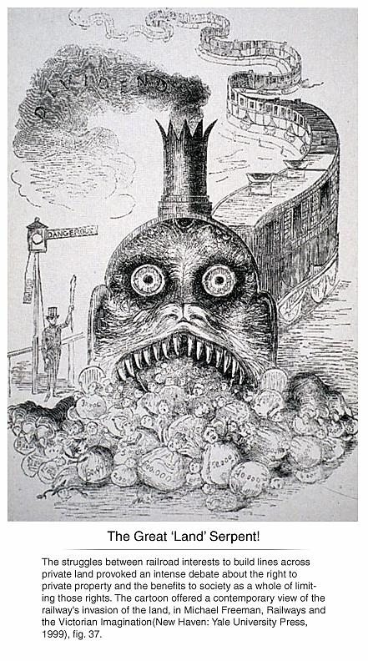

Source 3
(The Victorian era became notorious for employing young children in factories and mines and as chimney sweeps. This image is from the autobiography of James Dunn, published in 1905, who worked in a coalmine in 1843 at the age of eight.)

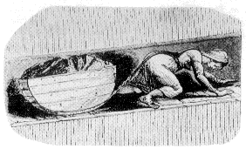

Source 4
(Extract from a newspaper article published in Britain in 1824.)
“Such Slavery, Such Cruelty”
Some of the lords of the loom [employers] hire thousands of miserable creatures. In the cotton-spinning trade, these creatures fourteen work hours in each day. They are kept locked up, summer and winter, in a heat of from 80 to 84 degrees.
The poor creatures are doomed to work day after day for 313 days in the year. They slave fourteen hours each day in an average heat of 82 degrees. Can any man with a heart in his body keep from cursing a system that produces such slavery and such cruelty?
These poor creatures have no cool room to retreat to. They do not have a moment to wipe off the sweat, nor a breath of air. The door of the place where they work is locked, except half an hour at teatime. The workers are not allowed to send for water to drink. Even the rainwater is locked up by the master's order. Otherwise, they would be happy to drink even that. If any spinner is found with his window open, he is to pay a fine of a shilling!
There is also the awful stink of gas, which adds to the murderous effects of the heat. In addition to the gas mixed with steam, there are the dust and the cotton-flying, or fuzz. The unfortunate creatures have to inhale these. Men become old and are unable work at forty years of age. Children become sickly and deformed. Thousands of them are killed by disease before they reach the age of sixteen.

ACKNOWLEDGEMENTS

Source 1 Manolopoulou, A. (n.d.). The Industrial Revolution and the changing face of Britain (p. 2; Changes in infrastructure and architecture). Retrieved December, 2013, from www.britishmuseum.org/research/publications/online_research_catalogues/paper_money/paper_money_of_england_wales/the_industrial_revolution/the_industrial_revolution_2.aspx

Source 2 The great land serpent [Image]. (1849). Puppet-Show, 2, p. 87. Retrieved December, 2013, from http://books.google.com.au/books?id=8lYAAAAAYAAJ&printsec=frontcover&source=gbs_ge_summary_r&cad=0#v=onepage&q&f=false

Source 3 Commissioners for Inquiring into the Employment and Condition of Children in Mines and Manufactories. (1842). Children’s Employment Commission: First report of the commissioners: Mines. London: Author.

Source 4 Cobbett, W. (1966). Such slavery, such cruelty. In E. Royston Pike, Human documents of the Industrial Revolution in Britain. London: Routledge. (Original work published 1824)

