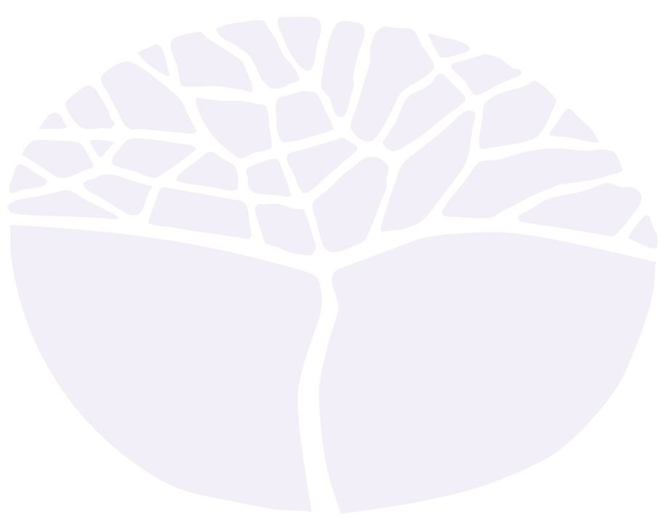
Mathematics Essential
General course

Externally set task
Sample 2016

Note: This Externally set task sample is based on the following content from Unit 3 of the General Year 12 syllabus.
Topic 3.1: Measurement
- Linear measure
- Area measure
- Volume and capacity
Topic 3.2: Scales plan and models
- Geometry
- Interpret scale drawings
- Three-dimensional objects
- Right-angled triangles (no bearings)
Topic 3.4: Data collection
- Surveys
- Simple survey procedure
- Sources of bias
In future years, this information will be provided late in Term 3 of the year prior to the conduct of the Externally set task. This will enable teachers to tailor their teaching and learning program to ensure that the content is delivered prior to the students undertaking the task in Term 2 of Year 12.

Copyright
© School Curriculum and Standards Authority, 2014
This document – apart from any third party copyright material contained in it – may be freely copied, or communicated on an intranet, for non-commercial purposes in educational institutions, provided that the School Curriculum and Standards Authority is acknowledged as the copyright owner, and that the Authority’s moral rights are not infringed.
Copying or communication for any other purpose can be done only within the terms of the Copyright Act 1968 or with prior written permission of the School Curriculum and Standards Authority. Copying or communication of any third party copyright material can be done only within the terms of the Copyright Act 1968 or with permission of the copyright owners.
Any content in this document that has been derived from the Australian Curriculum may be used under the terms of the Creative Commons Attribution-NonCommercial 3.0 Australia licence
Disclaimer
Any resources such as texts, websites and so on that may be referred to in this document are provided as examples of resources that teachers can use to support their learning programs. Their inclusion does not imply that they are mandatory or that they are the only resources relevant to the course.

Mathematics Essential

Externally set task
Working time for the task: 60 minutes
Total marks: 30 marks
Weighting: 15% of the school mark
Materials required for this task:
Drawing instruments, templates, notes on one unfolded sheet of A4 paper, a calculator

________________________________________________________________________________
________________________________________________________________________________
________________________________________________________________________________
________________________________________________________________________________
________________________________________________________________________________
________________________________________________________________________________
________________________________________________________________________________

When developing a new product for the retail market, a number of decisions need to be made.
These include how a product is packaged, how the product is stacked for cost effective transportation, the placement of the product on the shelf, and whether the product is priced competitively.
The Delice Chocolate Company has developed a new range of chocolate and is investigating two possible designs for the packaging.
Shape A | Shape B
- For the cylindrical shape package, determine: (5 marks)

- the area of the circular base

(b) the volume of the Shape B

(c) the amount of chocolate to the nearest millilitre (mL) that would be required to fill the shape

- The following diagram shows the dimensions of the carton used for display of the product
Shape B.
Determine the maximum number of product Shape B that could fit in this carton.
Clearly show your workings to justify your answer. (5 marks)

- Place correct dimensions (mm) of the radius, length of rectangle, and the width of rectangle for the net of the cylinder. (4 marks)

- The following is the net of the triangular prism, Shape A (see page 1). (6 marks)

(a) Verify that the width of the shaded rectangle is 43mm as shown. (2 marks)

(b) Determine the surface area of Shape A. (4 marks)

- Large sheets of card are used to cut templates of Shape A for packaging. The dimensions of the card are 680 mm x 170 mm. (5 marks)

(a) Use a labelled sketch to show that five templates for Shape A can fit on one sheet of card. Justify your sketch with appropriate calculations. (4 marks)

(b) Graphic designers have reported that a maximum of four templates only can be cut from each sheet of card. How best could the designers explain the reduced number? (1 mark)

- The next stage in product development is to determine whether potential customers would prefer Shape A or Shape B for the new product. Market research can be carried out using a number of different methods, however the company needs to ensure that any data collected is representative of the ‘population’. (5 marks)

(a) Describe the ‘population’ referred to in this situation. (1 mark)

(b) State a possible advantage and disadvantage in using each of the following methods of survey to carry out the market research. (4 marks)
(i) Customers in a local supermarket were approached to complete a questionnaire about the product.

(ii) A sample of each shape was delivered to a number of residences in the local area and they were asked to phone their responses to the company, given the sample size is large enough; for example, greater than 30.

(iii) An email survey of randomly chosen students from the local secondary school was conducted.

