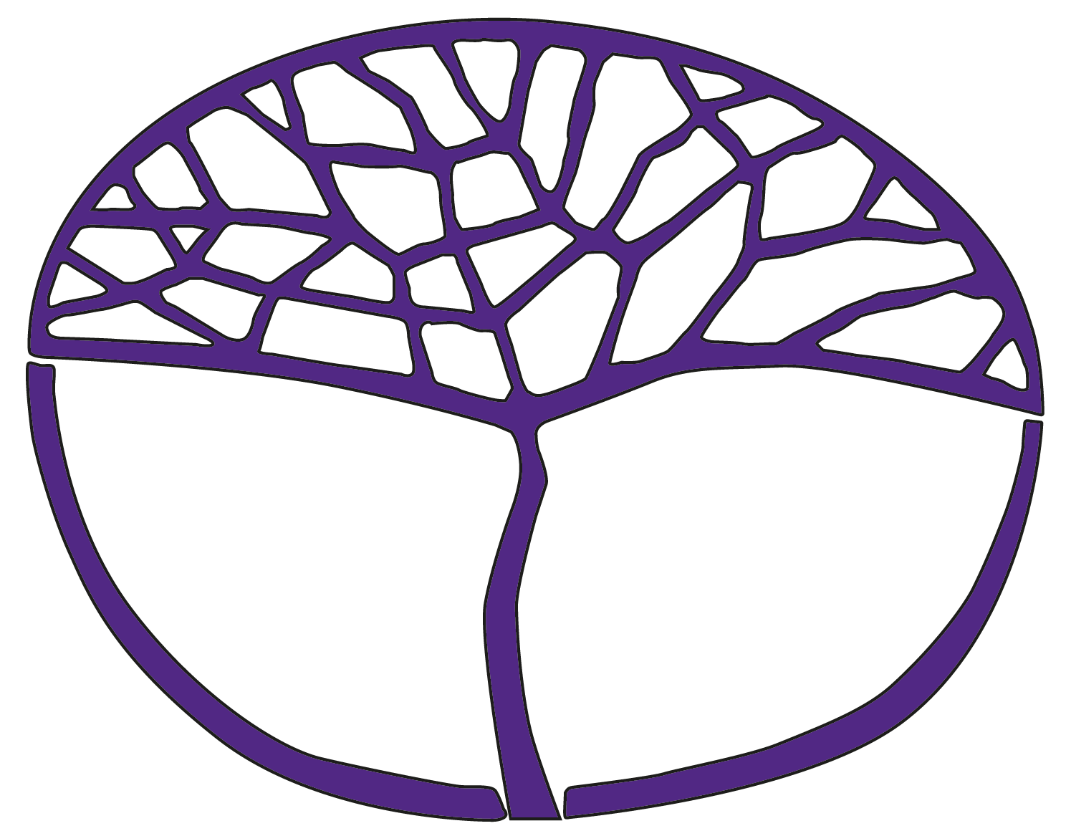Sample Assessment Outline

Human Biology

ATAR Year 11

**Acknowledgement of Country**

Kaya. The School Curriculum and Standards Authority (the Authority) acknowledges that our offices are on Whadjuk Noongar boodjar and that we deliver our services on the country of many traditional custodians and language groups throughout Western Australia. The Authority acknowledges the traditional custodians throughout Western Australia and their continuing connection to land, waters and community. We offer our respect to Elders past and present.

**Copyright**

© School Curriculum and Standards Authority, 2023

This document – apart from any third-party copyright material contained in it – may be freely copied, or communicated on an intranet, for non-commercial purposes in educational institutions, provided that the School Curriculum and Standards Authority (the Authority) is acknowledged as the copyright owner, and that the Authority’s moral rights are not infringed.

Copying or communication for any other purpose can be done only within the terms of the *Copyright Act 1968* or with prior written permission of the Authority. Copying or communication of any third-party copyright material can be done only within the terms of the *Copyright Act 1968* or with permission of the copyright owners.

Any content in this document that has been derived from the Australian Curriculum may be used under the terms of the [Creative Commons Attribution 4.0 International licence](https://creativecommons.org/licenses/by/4.0/).

**Disclaimer**

Any resources such as texts, websites and so on that may be referred to in this document are provided as examples of resources that teachers can use to support their learning programs. Their inclusion does not imply that they are mandatory or that they are the only resources relevant to the course. Teachers must exercise their professional judgement as to the appropriateness of any they may wish to use.

Sample assessment outline

Human Biology – ATAR Year 11

Unit 1 and Unit 2

| **Assessment type**  **(from syllabus)** | **Assessment type weighting**  **(from syllabus)** | Assessment task weighting | **When** | **Assessment task** |
| --- | --- | --- | --- | --- |
| Science inquiry | 20% | 12% | Semester 1 Weeks 8–11 | **Task 2:** Investigation – Cardiovascular health in teenagers  Students will investigate factors that affect teenage cardiovascular health. The planning and conducting component of the task will be completed in groups. The analysis of data and follow-up questions will be completed individually in class. |
| 8% | Semester 2 Weeks 9–15 | Task 5: Practical – Observing mitosis  Students work individually to prepare a slide of a growing onion root tip to examine cells undergoing mitosis. Students will analyse their data and combined group data to answer questions. |
| Extended response | 15% | 5% | Semester 1  Weeks 13–15 | Task 3: Extended response – Osteoporosis and osteoarthritis  A research task on the degenerative bone diseases, osteoporosis and osteoarthritis. Students will use their research to respond to questions in class under invigilated conditions. |
| 10% | Semester 2 Weeks 6–9 | Task 6: Extended response – Genetic screening  A research task resulting in the production of a persuasive essay supported by references from at least two different sources, including tables of data, diagrams and/or flowcharts. A student research journal will be monitored regularly and submitted with the essay. |
| Test | 25% | 10% | Semester 1 Week 6 | Task 1: Test – Cells, tissues and metabolism  A test consisting of 10 multiple-choice questions, three to four short answer questions and one extended answer question |
| 15% | Semester 2 Week 14 | **Task 7:** Test – Human reproduction and types of inheritance  A test consisting of 10 multiple-choice questions, three short answer questions and one extended answer question |
| Examination | 40% | 15% | Examination week | Task 4: Semester 1 examination  2.5 hours using a modified examination design brief from the ATAR Year 12 syllabus  Section One: 30 multiple-choice questions (30%)  Section Two: four to six short answer questions (50%)  Section Three:one question from a choice of two (20%) |
| 25% | Examination week | Task 8: Semester 2 examination  3 hours using the examination design brief from the ATAR Year 12 syllabus  Section One: 30 multiple-choice questions (30%)  Section Two: six to eight short answer questions (50%)  Section Three: two questions from a choice of four (20%)  (Content weighting: Unit 1 – 50% and Unit 2 – 50%) |
| Total | 100% | 100% |  |  |