Sample Assessment Tasks

Psychology

General Year 11

Copyright
© School Curriculum and Standards Authority, 2014
This document – apart from any third party copyright material contained in it – may be freely copied, or communicated on an intranet, for non-commercial purposes in educational institutions, provided that the School Curriculum and Standards Authority is acknowledged as the copyright owner, and that the Authority’s moral rights are not infringed.
Copying or communication for any other purpose can be done only within the terms of the Copyright Act 1968 or with prior written permission of the School Curriculum and Standards Authority. Copying or communication of any third party copyright material can be done only within the terms of the Copyright Act 1968 or with permission of the copyright owners.
Any content in this document that has been derived from the Australian Curriculum may be used under the terms of the Creative Commons Attribution-NonCommercial 4.0 Australia licence
Disclaimer
Any resources such as texts, websites and so on that may be referred to in this document are provided as examples of resources that teachers can use to support their learning programs. Their inclusion does not imply that they are mandatory or that they are the only resources relevant to the course.

Sample assessment task

Psychology – General Year 11

Task 2 — Unit 1
Assessment type: Investigation

Conditions

Time for the task: 50 minutes

In-class

Scientific calculator allowed

Task weighting

5% of the school mark for this pair of units
__________________________________________________________________________________

Data Interpretation (24 marks)
- Describe two (2) differences between psychologists and psychiatrists. (2 marks)

Difference one:

______________________________________________________________________________

______________________________________________________________________________

Difference two:

______________________________________________________________________________

______________________________________________________________________________
- Data is collected from Mia and Zara about their thoughts on exercise. Mia completes a survey in the form of a self-rating scale while Zara is interviewed by the researcher. Identify the type of data collected from Mia. Explain your response. (2 marks)

______________________________________________________________________________

______________________________________________________________________________

- A psychologist, specialising in adolescent behaviour, wants to investigate whether teens are more likely to be ‘early birds’ or ‘night owls’. She advertises the study in the local paper, asking for volunteers between the ages of 15 to 17.
- Identify three (3) ethical considerations relevant to this study. For each consideration, identify how the researchers should deal with it. (6 marks)

One:

__________________________________________________________________________

__________________________________________________________________________

__________________________________________________________________________

Two:

__________________________________________________________________________

__________________________________________________________________________

__________________________________________________________________________

Three:

__________________________________________________________________________

__________________________________________________________________________

__________________________________________________________________________
- The researcher also collected data from people in their 30s, 50s and 70s to compare the result to the data gathered from adolescents. Is this an example of a longitudinal design or a cross-sectional design? (1 mark)
__________________________________________________________________________
- The participants completed a Morningness-Eveningness questionnaire which asked participants to respond to a series of questions related to sleep-wake routines and the times of day they prefer to complete certain activities. Scores ranged from 16–81, with scores below 41 indicating that the participants are ‘evening types’ (or night owls) and scores above 59 indicating that participants are ‘morning types’ (or early birds).
The following table shows the individual results collected from the 25 adolescents.
Participants | Questionnaire score
1 | 16
2 | 33
3 | 41
4 | 60
5 | 75
6 | 33
7 | 18
8 | 33
9 | 45
10 | 64
11 | 48
12 | 38
13 | 22
14 | 35
15 | 47
16 | 66
17 | 52
18 | 39
19 | 24
20 | 38
21 | 81
22 | 67
23 | 55
24 | 40
25 | 25

- Calculate the mode, median, mean and range of scores from these results. (4 marks)

Mode: _____________________________ Median:____________________________

Mean: _____________________________ Range: _____________________________
- Construct a frequency table that shows how often each score appears. (1 mark)
Morningness-Eveningness score | Frequency
16–30 (definite evening)
31–41 (moderate evening)
42–58 (intermediate)
59–69 (moderate morning)
70–86 (definite morning)
- Graph the quantitative data from the frequency table above. (6 marks)

- Referring to the data, describe the conclusion that can be made. (2 marks)

___________________________________________________________________________

___________________________________________________________________________

___________________________________________________________________________

___________________________________________________________________________

Marking key for sample assessment task 2 — Unit 1
- Describe two (2) differences between psychologists and psychiatrists.
Description | Marks
One mark for each difference | 1–2
Total | 2
Answer could include, but is not limited to:
One: psychiatrists have a medical degree whereas psychologists do not
Two: psychiatrists can prescribe medication while psychologists can not
Any other logical and correct answer
- Data is collected from Mia and Zara about their thoughts on exercise. Mia completes a survey in the form of a self-rating scale while Zara is interviewed by the researcher. Identify the type of data collected from Mia. Explain your response.
Description | Marks
One mark for identifying the type of data collected | 1
One mark for explaining the response | 1
Total | 2
Answer could include, but is not limited to:
The data collected for Mia is quantitative data because a self-rating scale produces numerical data (that can be statistically analysed)
- A psychologist, specialising in adolescent behaviour, wants to investigate whether teens are more likely to be ‘early birds’ or ‘night owls’. She advertises the study in the local paper, asking for volunteers between the ages of 15 to 17.
- Identify three (3) ethical considerations relevant to this study. For each consideration, identify how the researchers should deal with it.
Description | Marks
One mark for naming each ethical consideration | 1–3
One mark for identifying how the researcher should deal with each ethical consideration | 1–3
Total | 6
Answer could include, but is not limited to:
Informed consent (1)
Approval to participate in the study based on the knowledge of why the study is being carried out and what is involved must be obtained from the adolescents and their parents/guardians because they are under 18 years of age (1)
Confidentiality (1)
Participants must be guaranteed that their personal information and responses will not be shared with anyone who is not involved in the study (1)
Voluntary participation (1)
Participants need to be informed that they have the right to withdraw from the study at any time (1)

- The researcher also collected data from people in their 30s, 50s and 70s to compare the result to the data gathered from adolescents. Is this an example of a longitudinal design or a cross-sectional design?
Description | Marks
One mark for stating the correct answer | 1
Total | 1
Answer:
Cross-sectional
- The participants completed a Morningness-Eveningness questionnaire which asked participants to respond to a series of questions related to sleep-wake routines and the times of day they prefer to complete certain activities. Scores ranged from 16–81, with scores below 41 indicating that the participants are ‘evening types’ (or night owls) and scores above 59 indicating that participants are ‘morning types’ (or early birds).
- Calculate the mode, median, mean and range of scores from these results.
Description | Marks
One mark for stating the correct answer | 1–4
Total | 4
Answer:
Mode: 33
Median: 40
Mean: 44 (43.8)
Range: 65
- Construct a frequency table that shows how often each score appears.
Description | Marks
One mark awarded if all five answers are correct | 1
Total | 1
Answer:
Morningness-Eveningness score | Frequency
16–30 (definite evening) | 5
31–41 (moderate evening) | 9
42–58 (intermediate) | 5
59–69 (moderate morning) | 4
70–86 (definite morning) | 2

- Graph the quantitative data from the frequency table above.
Description | Marks
One mark to be allocated to each of the following points:  - Use of a column/bar graph (NOT a line graph) (1)  - Correct graphing of all data (1)  - X axis correctly labelled (1)  - Units on the X axis marked correctly (1)  - Y axis correctly labelled (1)  - Units on the Y axis marked correctly (1) | 1–6
Total | 6
Answer:
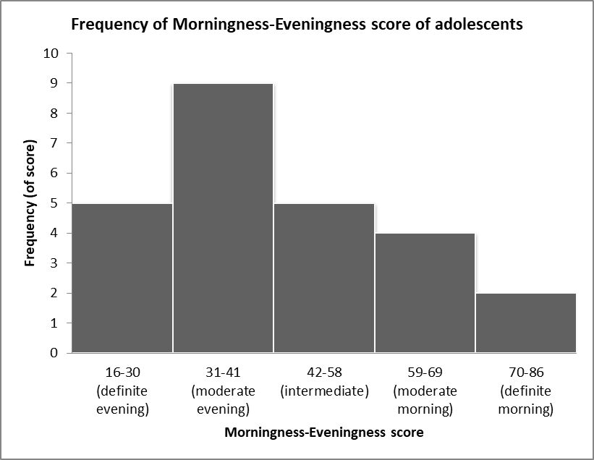
- Referring to the data, describe the conclusion that can be made.
Description | Marks
One mark for description of the data | 1
One mark for a conclusion | 1
Total | 2
Answer could include, but is not limited to:
The data shows that only six adolescents in the study prefer the mornings, five participants do not have a preference and 14 prefer the evening. (1) This suggests that adolescents are more likely to be night owls than early birds. (1)

Sample assessment task

Psychology – General Year 11

Task 8 — Unit 2
Assessment type: Response

Conditions

Period allowed for completion of the task:
- 2 weeks to research the participants in the Seven Up series and view 56 Up
- 1–2 lessons to write a review under supervised conditions

Task weighting

10% of the school mark for this pair of units
__________________________________________________________________________________
Review – Seven Up series (27 marks)
Once you have covered the topics under Developmental Psychology, you will view 56 Up, the latest episode from the Seven Up series. This series began with a group of seven year olds who were interviewed on a range of subjects. They were re-interviewed every seven years up to the age of 56.
Before viewing:
- Briefly research the participants.
- Make notes on their socio-economic background, characteristics, traits, ambitions, occupation etc.
While viewing:
- Add to your existing notes about your participants.
- Focus on the strengths and limitations of recording the Seven Up series.
After viewing:

Write a review of the Seven Up series under the following headings:
Introduction (3 marks)
- aim of the series
- summary of the series
Ethical guidelines (6 marks)
- Describe three (3) ethical guidelines which needed to be considered.
Design (5 marks)
- State whether this series is an example of a longitudinal or cross-sectional design.
- Give an example of a use and a limitation of such a design.
The role of nature and nurture (13 marks)
- Describe what is meant by nature and nurture and provide two examples of each.
- What do psychologists say about the role of nature and nurture on development? Use psychological evidence to support your response.
- With reference to two participants of the series, describe how nature and nurture have shaped who they have become at age 56.

Marking key for sample assessment task 8 — Unit 2
Description | Marks
Introduction
- provides a clear aim of the series | 1
- clearly summarises the major points | 1–2
- briefly identifies some key points
Subtotal | 3
Ethical guidelines
- clearly describes three (3) ethical considerations that apply to this series  (up to 2 marks for each) | 1–6
- limited description of ethical considerations in general terms
(1 mark each)
Subtotal | 6
Design
- identifies that this series is an example of a longitudinal design | 1
- correctly describes the use of this design | 1–2
- briefly comments on the use of this design
- describes the limitations of this design, including an example from the series | 1–2
- briefly comments on the limitation of this design
Subtotal | 5
The role of nature and nurture
- correct description of nature (biological) | 1
- two examples of biological factors (e.g. DNA, heredity) | 2
- correct description of nurture (environmental) | 1
- two examples of environmental factors (e.g. education, nutrition, support) | 2
- clearly explains that both nature and nurture play a role in development with reference to psychological evidence | 1–3
- explains that both nature and nurture play a role in development with brief reference to psychological evidence
- briefly comments on the role of nature and nurture
- provides specific examples of how nature and nurture have shaped two participants  (2 marks for each participant) | 1–4
- refers to the influence of either nurture or nature in shaping two participants
(1 mark for each participant)
Subtotal | 13
Total mark | 27

Sample assessment task

Psychology – General Year 11

Task 11 — Unit 2

Assessment type: Project

Conditions

Time for the task:
- 1 week to research culture and values
- 2 lessons to produce a publication in class under supervised conditions

Task weighting

7.5% of the school mark for this pair of units
__________________________________________________________________________________
Publication – Culture and values (31 marks)
You have been employed by the Department of Health to produce a publication on issues related to culture and values. Your publication can be in the form of a website, pamphlet, brochure, PowerPoint or video recording.
You must include the following:
- definition of attitudes (2 marks)
- definition of social categorisation (2 marks)
- explanation of three reasons why stereotypes exist (9 marks)
- description of three consequences of stereotyping (6 marks)
- explanation of three ways in which stereotypes can be reduced (6 marks)
- examples of cultural differences in attitudes towards disability, ageing and mental illness
(6 marks)
Visit http://www.health.gov.au/ for ideas on how to present your information.

Marking key for sample assessment task 11 — Unit 2
Criteria | Marks
Definition of attitudes
- elaborated definition of attitudes, including details about strength and intensity | 1–2
- concise definition of attitudes
Subtotal | 2
Definition of social categorisation
- elaborated definition of social categorisation, including examples of what features may be used to make social categorisations | 1–2
- concise definition of social categorisation
Subtotal | 2
Why stereotypes exist
- explains three reasons why stereotypes exist and supports each example with evidence  (up to 3 marks each) | 1–9
- explains three reasons why stereotypes exist
(up to 2 marks each)
- briefly comments on three reasons why stereotypes exist
(up to 1 mark each)
Subtotal | 9
Consequences of stereotyping
- detailed description of three consequences of stereotyping  (up to 2 marks each) | 1–6
- brief description of three consequences of stereotyping
(up to 1 mark each)
Subtotal | 6
Reducing stereotypes
- explanation of three ways that stereotypes can be reduced  (up to 2 marks each) | 1–6
- description of three ways that stereotypes can be reduced
(up to 1 mark each)
Subtotal | 6
Cultural differences in attitudes towards disability, ageing and mental illness
- detailed examples of cultural differences in attitudes  (up to 2 marks each) | 1–6
- brief examples of cultural differences in attitudes
(up to 1 mark each)
Subtotal | 6
Total mark | 31

