
Sample Assessment Tasks
Chinese: Second Language
General Year 12

Acknowledgement of Country
Kaya. The School Curriculum and Standards Authority (the Authority) acknowledges that our offices are on Whadjuk Noongar boodjar and that we deliver our services on the country of many traditional custodians and language groups throughout Western Australia. The Authority acknowledges the traditional custodians throughout Western Australia and their continuing connection to land, waters and community. We offer our respect to Elders past and present.
Copyright
© School Curriculum and Standards Authority, 2019
This document – apart from any third-party copyright material contained in it – may be freely copied, or communicated on an intranet, for non-commercial purposes in educational institutions, provided that the School Curriculum and Standards Authority (the Authority) is acknowledged as the copyright owner, and that the Authority’s moral rights are not infringed.
Copying or communication for any other purpose can be done only within the terms of the Copyright Act 1968 or with prior written permission of the Authority. Copying or communication of any third-party copyright material can be done only within the terms of the Copyright Act 1968 or with permission of the copyright owners.
Any content in this document that has been derived from the Australian Curriculum may be used under the terms of the Creative Commons Attribution 4.0 International licence.
Disclaimer
Any resources such as texts, websites and so on that may be referred to in this document are provided as examples of resources that teachers can use to support their learning programs. Their inclusion does not imply that they are mandatory or that they are the only resources relevant to the course. Teachers must exercise their professional judgement as to the appropriateness of any they may wish to use.

Sample assessment task

Chinese: Second Language – General Year 12

Task 1– Unit 3
Assessment type Response – Listening
Conditions Time for the task: 35 minutes
A bilingual Chinese/English print dictionary can be used.
Task weighting 10% of the school mark for this pair of units

Celebrations (30 marks)
Listen to the three texts and answer the questions in English. Texts 1 and 2 are played twice. After the second reading of each text, there is a pause in which to answer questions. Text 3 is a longer text. It will be played once in its entirety, then each part will be played twice, with a pause after the second reading to answer questions.
Text 1 – Announcement (10 marks)
- Complete the following sentence with information from the text. (3 marks)
You can purchase moon cakes _____________________________ of the library from
_______________________________ until ___________________________.
- Indicate () three flavours of moon cakes you can buy. (3 marks)
 | red bean |  | lotus seed paste |  | caramel
 | green tea |  | egg yolk |  | vanilla
- What suggestion does the speaker make? (4 marks)

Text 2 – Conversation (8 marks)
Speaker: 刘伟 male Liu Wei, 张艳female Zhang Yan
- Based on the information in the text, tick () which of the following statements are true and which are false. (8 marks)
Statement | True | False

Zhang Yan is happy.

Zhang Yan is going to Japan with her sister.

Zhang Yan plans to go skiing and visit famous places and historical monuments.

The trip has only recently been planned.

Zhang Yan’s mother is not happy with the idea because she will not be celebrating Chinese New Year with her family.

Zhang Yan plans to travel in January and February.

Liu Wei thinks Zhang Yan’s mother is extremely traditional.

Liu Wei thinks it’s possible that Zhang Yan’s mother will change her mind.
Text 3 – Conversation (12 marks)
Part 1
- Explain what Dawei will be doing Saturday. (1 mark)

- When does this global event take place annually? (2 marks)

- What information is provided about last year’s event? (3 marks)

Part 2
- Based on the information in the text, tick () which of the following statements are true and which are false. (3 marks)
Statement | True | False
The event in which Dawei is participating is a competition.
You need a special invitation to participate.
The event aims to connect people around the world.
- Do you think Dawei’s mother is supportive of his involvement in the event? Using information from the text, give two reasons to support your opinion. (3 marks)

Listening texts for sample assessment task 1 – Unit 3
Text 1 – Announcement
同学们，中秋节快乐。今天我们从早上9点到下午3点在图书馆前面卖月饼。我们的月饼有很多不同口味可供选择，有蛋黄、莲蓉、巧克力和绿茶等不同口味。晚上，你和家人、朋友可以一边吃月饼一边赏月。
Text 2 – Conversation
刘伟： 你好，张艳。哦，怎么了？你好像有点不开心。
张艳： 我告诉妈妈，我和男朋友一月和二月间要去日本旅行，还要去滑雪和参观名胜古迹。旅行的事，我们很久以前已经计划好了，可是妈妈听了很不高兴。
刘伟： 你妈妈为什么不高兴呢？
张艳： 那时候正好是农历新年，农历新年对我妈妈和家人很重要。可是我和男朋友只有这两个月才能放假。去旅行，就不能和家人一起过节了。
刘伟： 明白了，你妈是一个非常传统的人。多给她一点时间吧，也许有一天她会接受你的想法的。
张艳： 你说得对。
Text 3 – Conversation
Part 1
妈妈： 大卫，你为什么在唱歌？
儿子： 我在为星期六做准备。
妈妈： 星期六有什么事吗
儿子： 我要去市区参加世界歌唱日的音乐会。
妈妈： 世界歌唱日？
儿子： 世界歌唱日在世界各地举行，在十月的第三个星期六。人们聚在一起唱卡拉OK。去年，有来自45个国家，220个城市的人们参加了。
Part 2
妈妈： 会获得奖品或者奖金吗？
儿子： 不会，妈妈。这不是一场比赛。这是一种让人们聚在一起，让世界各地的人们和社区联系起来的方式。这也是一种娱乐的方式。每个人都可以参加。你想来吗？
妈妈： 我...我太忙了，没有时间娱乐，而且我唱歌也不好听。
儿子： 没关系，那儿会有600个人，没人会听到你的声音。

Marking key for sample assessment task 1 – Unit 3
Description |  | Marks
Text 1 – Announcement |  | /10
Question 1 |  | /3
- in front |  | 1
- 9 am |  | 1
- 3 pm |  | 1
Question 2 |  | /3
 |  | 1 mark each
   | red bean |  | lotus seed paste |  | caramel
   | green tea |  | egg yolk |  | vanilla
Question 3 |  | /4
- eat your moon cake |  | 1
- with friends or family |  | 1
- while admiring/looking at |  | 1
- the full moon |  | 1
Text 2 – Conversation |  | /8
Question 4 |  | 1 mark each
  Statement | True | False
  Zhang Yan is happy.
  Zhang Yan is going to Japan with her sister.
  Zhang Yan plans to go skiing and visit famous places and historical monuments.
  The trip has only recently been planned.
  Zhang Yan’s mother is not happy with the idea because she will not be celebrating Chinese New Year with her family.
  Zhang Yan plans to travel in January and February.
  Liu Wei thinks Zhang Yan’s mother is extremely traditional.
  Liu Wei thinks it’s possible that Zhang Yan’s mother will change her mind.
Text 3 – Conversation |  | /12
Question 5 |  | /1
- He will be singing at a concert. |  | 1
Question 6 |  | /2
- the third Saturday |  | 1
- in October |  | 1
Question 7 |  | /3
- people from 45 countries |  | 1
- 220 cities |  | 1
- participated in the event |  | 1
Description |  | Marks
Question 8 |  | /3
The event in which Dawei is participating is a competition. | False | 1
You need a special invitation to participate. | False | 1
The event aims to connect people around the world. | True | 1
Question 9 |  | /3
No. |  | 1
She questions whether there will be prizes. |  | 1
She will not be attending the event with him. |  | 1
Total |  | /30

Sample assessment task

Chinese: Second Language – General Year 12

Task 5– Unit 3
Assessment type Oral communication
Conditions Time for the task: four minutes
PowerPoint or a poster board may be used.
Task weighting 15% of the school mark for this pair of units

My neighbourhood (18 marks)
This task has two parts.
Part A – Description (approximately two minutes)
As an introduction to Part B of this task (a conversation with your teacher about your neighbourhood), you will present a description of:
- your neighbourhood
- the activities you can do in your neighbourhood
- your opinion (likes and dislikes) of your neighbourhood
- what you typically do on the weekend in your neighbourhood.
You may use PowerPoint or a poster board to show pictures to illustrate your description.
During the description, your teacher may ask questions to make sure you cover the required content and to keep the description flowing.
Part B – Conversation (approximately two minutes)
After the description (Part A), you will participate in a conversation with your teacher. The conversation will require you to respond to a series of questions which will be based on the practice questions provided on the next page. Not all of the practice questions will be asked, and your teacher may vary the way in which some questions are asked.
Your conversation is scheduled for:
Before the day of the assessment:
- plan, practise, time and revise your description
- revise the practice questions to ensure that you recognise the questions when they are spoken
- identify appropriate information to answer each practice question
- practise linking the answers to two or more questions so that you can give longer responses
- practise your answers, focusing on appropriate tone and intonation.
During the assessment:
- listen for key words in the questions being asked
- use the teacher’s expression, tone and intonation to assist in making meaning of the questions
- avoid answering questions with ‘yes’ or ‘no’ only (add some more information)
- ask for repetition or clarification if you don’t understand or miss something.

Practice questions
1. | 你住在哪儿？ | Where do you live?
2. | 谈谈你的邻居。 | Talk about your neighbourhood.
3. | 你的邻居是怎么样的？ | What are the people in your neighbourhood like?
4. | 你家附近有什么？有公园/咖啡馆/购物中心/运动中心/电影院/图书馆吗？ | What is available in your neighbourhood? Park, coffee shop, shopping centre, sports centre, cinema, library?
5. | 你去过你家附近的公园/咖啡馆/购物中心/运动中心/电影院/图书馆吗？觉得怎么样？ | Have you been to the park/ coffee shop/ shopping centre/ sports centre/ cinema/ library? What do you think about it?
6. | 你最近参加过社区活动吗？请谈谈这个活动。 | Have you recently participated in a community event? Please talk about it.
7. | 你家附近有什么好玩儿的地方？ | What is a fun place near where you live?
8. | 你家附近有汽车站、火车站吗？ | Is there a bus or train station near your home?
9. | 你家离市中心远吗？ | Is your home far from the city centre?
10. | 你经常去市中心吗？去市中心怎么走？ | Do you often go to the city centre? How do you get to the city centre?
11. | 你喜欢你的邻居吗？为什么？ | Do you like your neighbours and why?
12. | 你周末做些什么？ | What do you do on the weekend?
13. | 你的邻居们周末喜欢做什么？ | What do people in your neighbourhood like to do on the weekend?

Marking key for sample assessment task 5 – Unit 3
Description | Marks
Content (Part A – description) /4
Provides all required information: a wide range of relevant information, ideas and opinions. | 4
Provides most required information: a good range of relevant information, ideas and opinions. | 3
Provides some required information: a satisfactory range of relevant information, ideas and opinions. | 2
Provides some information: lacking relevant information, ideas and opinions. | 1
Comprehension (Part B – conversation) /4
Comprehends all or most questions and comments with minimal or no requests for clarification. | 4
Comprehends most questions with some clarification and support. | 3
Comprehends some questions but relies on support and/or clarification. | 2
Shows limited comprehension even with support and/or clarification. | 1
Response (relevance and depth of information) (Part B – conversation) /3
Provides relevant responses to questions. | 3
Provides satisfactory responses to questions. | 2
Responds with limited information, relying on single-word responses. | 1
Language range (vocabulary and grammar) (Part A and Part B) /2
Uses a good range of vocabulary, expressions, grammar and sentence structure. | 2
Uses basic and repetitive vocabulary, expressions, grammar and sentence structure. | 1
Language accuracy (grammar) (Part A and Part B) /3
Applies rules of grammar with a good level of accuracy and consistency.  Makes occasional errors but these do not affect meaning. | 3
Applies rules of grammar with a satisfactory level of accuracy and consistency.  Makes errors which sometimes affect meaning. | 2
Applies rules of grammar inconsistently.  Makes errors which impede meaning. | 1
Speech (flow, pronunciation and intonation) (Part A and Part B) /2
Speaks with some confidence and shows acceptable control of pronunciation, tone and intonation.  Any errors made generally do not impede meaning. | 2
Speaks with some hesitation, sometimes makes errors and/or uses unclear or inaccurate pronunciation and intonation which impede meaning. | 1
Total | /18

Sample assessment task

Chinese: Second Language – General Year 12

Task 7 – Unit 4
Assessment type Written communication
Conditions Time for the task: 30 minutes
A bilingual Chinese/English print dictionary can be used.
Task weighting 5% of the school mark for this pair of units

Welcome to Australia (11 marks)
Write an email to your internet friend at your school’s Chinese sister school, preparing them for their trip to a city or town in Western Australia. Write approximately 100 characters.
You should include information about:
- the weather at the time they will be in Western Australia
- common leisure activities
- food and drink in Australia
- places to see and activities to do.

Marking key for sample assessment task 7 – Unit 4
Description | Marks
Learning contexts and topics – Content and relevance /4
Provides a detailed description, with elaboration where appropriate, of the required information:  - the weather at the time they will be in Australia  - common leisure activities  - food and drink in Australia  - places to see and activities to do. | 4
Provides most of the content required by the question.  Uses some examples to elaborate. | 3
Provides generally relevant content, with minimal elaboration or detail.  Relies on listing and some repetition. | 2
Provides content that is very repetitive and often has little relevance to the question. | 1
Linguistic resources (vocabulary and grammar) – Range /2
Uses a good range of vocabulary, expressions, grammar and sentence structures.  Makes occasional use of Pinyin for less familiar vocabulary. | 2
Uses basic and repetitive vocabulary, expressions, grammar and sentence structures.  Makes frequent use of Pinyin, even for familiar vocabulary. | 1
Linguistic resources – Accuracy /3
Uses language accurately and consistently.  Occasionally omits words or makes errors in sentence structure and characters; inaccuracies do not affect meaning or flow. | 3
Uses language mostly accurately; however, errors interfere with the flow of a phrase or sentence and sometimes affect meaning. | 2
Uses inaccurate and incorrect language which impedes meaning and flow.  Inconsistently applies rules of grammar, which makes some parts of writing awkward. | 1
Text types – Conventions and organisation /2
Writes a coherent and cohesive email that sequences information in an appropriate and logical manner.  Uses all the key conventions of an email in Chinese, including:  - informal (or colloquial) language  - starting with the name of the recipient, followed by a colon  - indenting paragraphs  - following salutation at the end with the name of the writer (left aligned). | 2
Writes a basic and mainly cohesive email that sequences most information.  Uses some of the conventions of the text type; generally uses register appropriate to the purpose of writing and the audience. | 1
Total | /11

Sample assessment task

Chinese: Second Language – General Year 12

Task 9 – Unit 4
Assessment type Response – Viewing and Reading
Conditions Time for the task: 40 minutes
A bilingual Chinese/English print dictionary can be used.
Task weighting 7.5% of the school mark for this pair of units

Destination China and Travel in a modern world (28 marks)
Read the three texts and answer the questions in English.
Text 1 – Chart (6 marks)
度假的时候，我们怎么跟别人联系。
26%
脸书
24%
短信
14%
电话
14%
不用联系别人
9%
Skype
6%
明信片
2%
推特
5%
其他
- What is the purpose of the chart? (2 marks)

- Complete the table with the missing information from the chart. (4 marks)
Communication | %
 | 24%
Phone
 | 6%
Facebook

Text 2 – Table (9 marks)
The following table compares air travel during the ‘Golden Age of flying’ (the 1950s and 1960s) and today.
Glossary
伦敦 London
纽约 New York
 | 你知道吗？
价钱 | ......在五、六十年代坐飞机旅行比今天贵得多了。例如，在1955年从纽约到伦敦要$290，今天这相当于$2,453。现在坐飞机从纽约到伦敦只要$750。
时间 | ......现在坐飞机比以前快多了。比如，今天从纽约飞到伦敦要7个小时20分钟。在1955年要13个小时，时间长多了。
娱乐 | ....在飞机上有很多事情可以做：你可以看电影、听音乐、玩视频游戏，你也可以用iPad、电子书阅读器。1962年以前，在飞机上不能看电影，也不能听音乐。那么，那时候人们做什么呢？他们写明信片、读书和看杂志，有时候也跟旁边的人聊天。
健康 | ......今天坐飞机比以前健康多了。在1950和1960年代，你可以在飞机上吸烟。
- Complete the table below with the missing information about the flights. (4 marks)
Flight/route | Cost  (equivalent to today) | Time taken
Flight New York to London 1950s/60s
Flight New York to London today
- What activities were available on planes before 1962? In the table below, tick () three activities mentioned in the text. (3 marks)

 | play cards |  | listen to music |  | write postcards
 | watch movies |  | read magazines |  | chat with people
- Why is it much healthier to fly today? (2 marks)

Text 3 – Messages (13 marks)
Part A
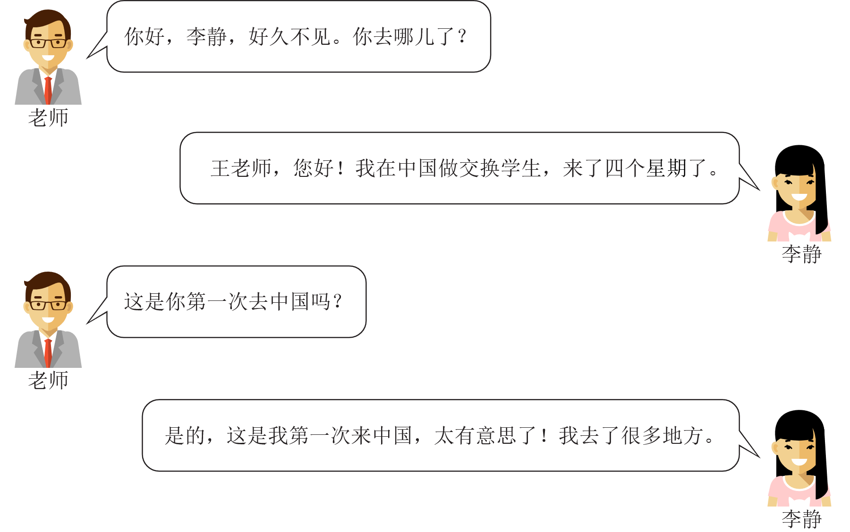
Image: bluebearry via iStock
- Why did Li Jing go to China and how long has she been there? (2 marks)

- Tick () which of the following statements best describes Li Jing’s stay. (1 mark)
It is her first visit and she finds it interesting.
She has been there before and finds it beautiful.
It is her first visit and she finds it very tiring.
She has been there before and finds it boring.

Part B
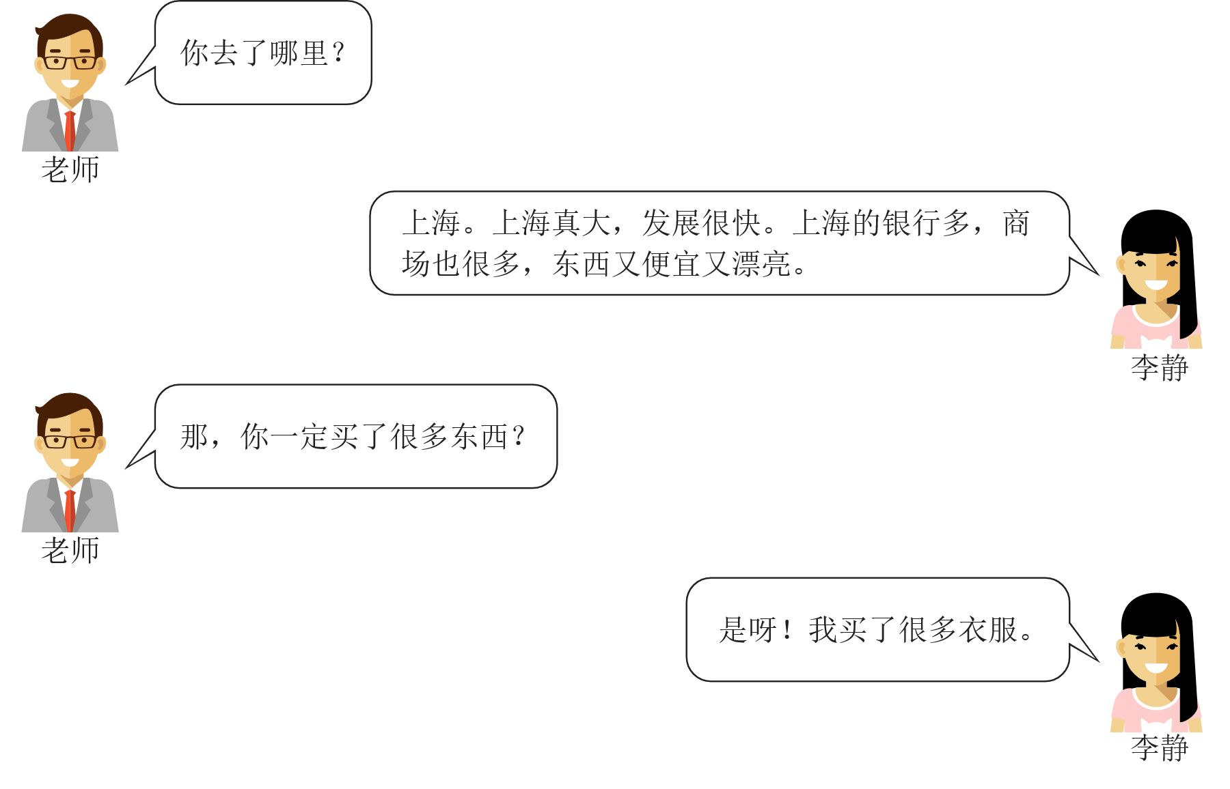
Image: bluebearry via iStock
- Li Jing says in Shanghai there are a lot of: (2 marks)
1.
2.
- What does Li Jing think about the things she can buy in Shanghai? (2 marks)

Part C
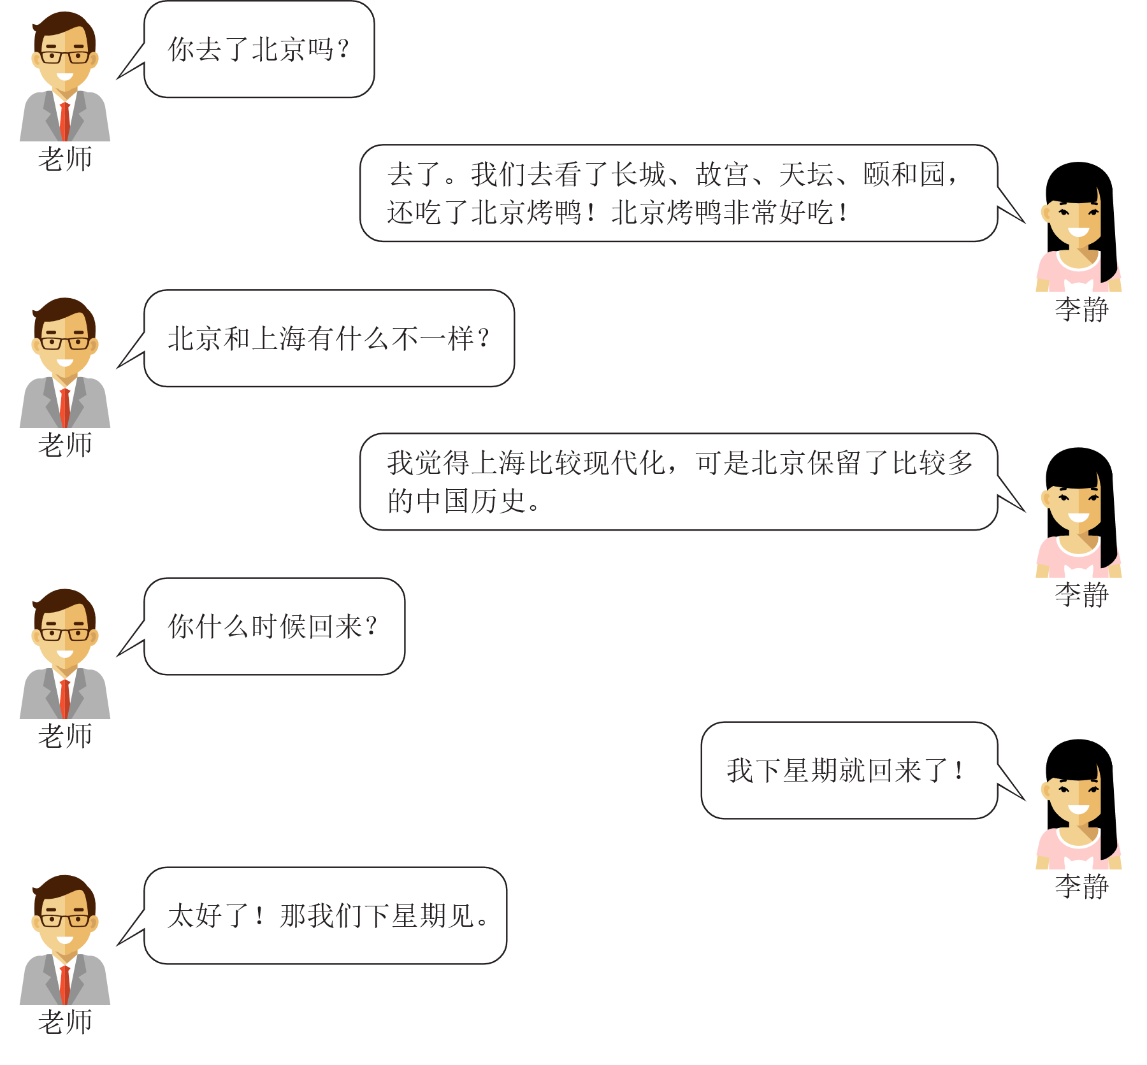
Image: bluebearry via iStock
- Complete the list of the famous monuments that Li Jing has visited in Beijing. (3 marks)
- Great Wall

- What difference did Li Jing discover when visiting Shanghai and Beijing? (2 marks)
Beijing:
Shanghai:
- When will Li Jing return to Australia? (1 mark)

Marking key for sample assessment task 9 – Unit 4
Description | Marks
Text 1 – Chart | /6
Question 1 | /2
- how one communicates | 1
- while on holidays | 1
Question 2 | /4
 | 1 mark each
  Communication | %
  text messaging (1) | 24%
  phone | 14% (1)
  postcard (1) | 6%
  Facebook | 26% (1)
Text 2 – Table | /9
Question 3 | /4
 | 1 mark each
  Flight | Cost  equivalent to today | Time taken
  Flight New York to London 1950s/60s | $2,453 (1) | 13 hrs (1)
  Flight New York to London today | $750 (1) | 7 hrs 20 mins (1)
Question 4 | /3
 | 1 mark each
   | play cards |  | listen to music |  | write postcards
   | watch movies |  | read magazines |  | chat with people
Question 5 | /2
- not allowed | 1
- to smoke now | 1
Text 3 – Conversation | /13
Question 6 | /2
- exchange student | 1
- four weeks | 1
Question 7 | /1
 | 1
  It is her first visit and she finds it interesting.
  She has been there before and finds it beautiful.
  It is her first visit and she finds it very tiring.
  She has been there before and finds it boring.
Question 8 | /2
- banks | 1
- shopping malls/centres | 1
Question 9 | /2
- cheap | 1
- beautiful | 1
Question 10 | /3
- Great Wall  - Temple of Heaven (1)  - Forbidden City (1)  - Summer Palace (1) | 1 mark each
Question 11 | /2
- Beijing reflects historical China/is more historical | 1
- Shanghai reflects modern China/is more modern | 1
Question 12 | /1
- next week | 1
Total | /28

Acknowledgements
Text 1
Chart information from: Jowaheer, R. (2013, April 18). Has social media 'killed' the postcard? Retrieved April, 2015, from http://travel.aol.co.uk/2013/04/18/social-media-kills-the-postcard-holiday-facebook-survey/#!slide=aol_1249237
Text 2
Information from:
Brownlee, J. (2014). What it was really like to fly during the golden age of travel. Retrieved April, 2015, from www.fastcodesign.com/3022215/terminal-velocity/what-it-was-really-like-to-fly-during-the-golden-age-of-travel
Elgot, J. (2014, July 8). Flying in the 'Golden Age': No security checks, better scotch but 5 times more likely to die. Huffington Post. Retrieved April, 2015, from www.huffingtonpost.co.uk/2014/07/08/flying-1950s-vs-2014_n_5566906.html
Novak, M. (2013). Air travel today is a damn bargain. Retrieved April, 2015, from http://paleofuture.gizmodo.com/air-travel-today-is-a-damn-bargain-951705216
Text 3
Image of man adapted from: Bluebearry. (2015). People Generations at Different Ages [Illustration]. Retrieved December, 2024, from https://www.istockphoto.com/vector/people-generations-at-different-ages-gm499123650-80035003
Image of girl adapted from: Bluebearry. (2016). Different School Children Stand Set in Flat Style [Illustration]. Retrieved December, 2024, from https://www.istockphoto.com/vector/different-school-children-stand-set-in-flat-style-gm517711086-89642283

