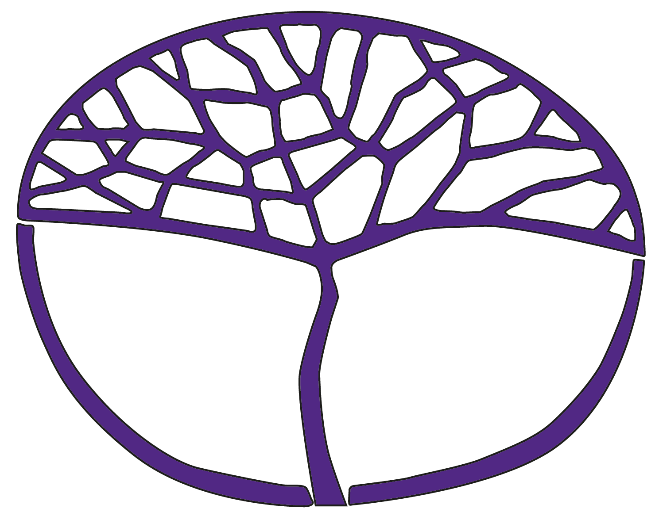Sample Assessment Outline

Human Biology

ATAR Year 12

**Acknowledgement of Country**

Kaya. The School Curriculum and Standards Authority (the Authority) acknowledges that our offices are on Whadjuk Noongar boodjar and that we deliver our services on the country of many traditional custodians and language groups throughout Western Australia. The Authority acknowledges the traditional custodians throughout Western Australia and their continuing connection to land, waters and community. We offer our respect to Elders past and present.

**Copyright**

© School Curriculum and Standards Authority, 2023

This document – apart from any third-party copyright material contained in it – may be freely copied, or communicated on an intranet, for non-commercial purposes in educational institutions, provided that the School Curriculum and Standards Authority (the Authority) is acknowledged as the copyright owner, and that the Authority’s moral rights are not infringed.

Copying or communication for any other purpose can be done only within the terms of the *Copyright Act 1968* or with prior written permission of the Authority. Copying or communication of any third-party copyright material can be done only within the terms of the *Copyright Act 1968* or with permission of the copyright owners.

Any content in this document that has been derived from the Australian Curriculum may be used under the terms of the [Creative Commons Attribution 4.0 International licence](https://creativecommons.org/licenses/by/4.0/).

**Disclaimer**

Any resources such as texts, websites and so on that may be referred to in this document are provided as examples of resources that teachers can use to support their learning programs. Their inclusion does not imply that they are mandatory or that they are the only resources relevant to the course. Teachers must exercise their professional judgement as to the appropriateness of any they may wish to use.

Sample assessment outline

Human Biology – ATAR Year 12

Unit 3 and Unit 4

| Assessment  type | Assessment type  weighting | Assessment task weighting | When | Assessment task |
| --- | --- | --- | --- | --- |
| Science inquiry | 10% | 5% | Semester 1 Weeks 8–10 | Task 2: Investigation – Temperature regulation mechanisms of the human body  In groups, students will plan and conduct an investigation on temperature regulation mechanisms in humans. An individual written report will be prepared partially at home and completed in class under invigilated conditions. |
| 5% | Semester 2 Week 4 | Task 5: Practical – Simulating changes to gene pools  A practical activity modelling changes to gene pools. Students will work in groups to collect data and work individually in class to analyse the data and respond to questions. |
| Extended response | 15% | 7% | Semester 1 Weeks 2–4 | Task 1: Extended response – Recombinant DNA technology and its uses  A research task resulting in the production of a model of the recombinant DNA technology that can be used to demonstrate the application of the process for improving quality of life. The research will also consider the ethical concerns associated with this technology. This is an individual task with the application component completed in class. |
| 8% | Semester 2 Weeks 7–9 | Task 6: Extended response – Further evidence for evolution  A research task on evidence to support the theory of evolution by natural selection. Students will use their research to respond to questions in class under invigilated conditions. |
| Test | 25% | 10% | Semester 1 Week 13 | Task 3: Test – Response to infection  Test consisting of 10 multiple-choice questions, three short-answer questions and one extended answer question |
| 15% | Semester 2 Week 13 | **Task 7:** Test – Evidence for evolution and hominid evolutionary trends  Test consisting of 10 multiple-choice questions, three to four short-answer questions and one extended answer question |
| Examination | 50% | 15% | Semester 1 Week 15 | Task 4: Examination – Semester 1 (Unit 3 content)  Three hours, using the examination design brief from the syllabus  Section One: 30 multiple-choice questions (30%)  Section Two: 6–10 short-answer questions (50%)  Section Three:two questions from a choice of four (20%) |
| 35% | Semester 2  Week 15 | Task 8: Examination – Semester 2 (Unit 3 and 4 content)  Three hours, using the examination design brief from the syllabus  Section One: 30 multiple-choice questions (30%)  Section Two: 6–10 short-answer questions (50%)  Section Three: two questions from a choice of four (20%)  (Content weighting: Unit 3 – 50% and Unit 4 – 50%) |
| **Total** | **100%** | **100%** |  |  |