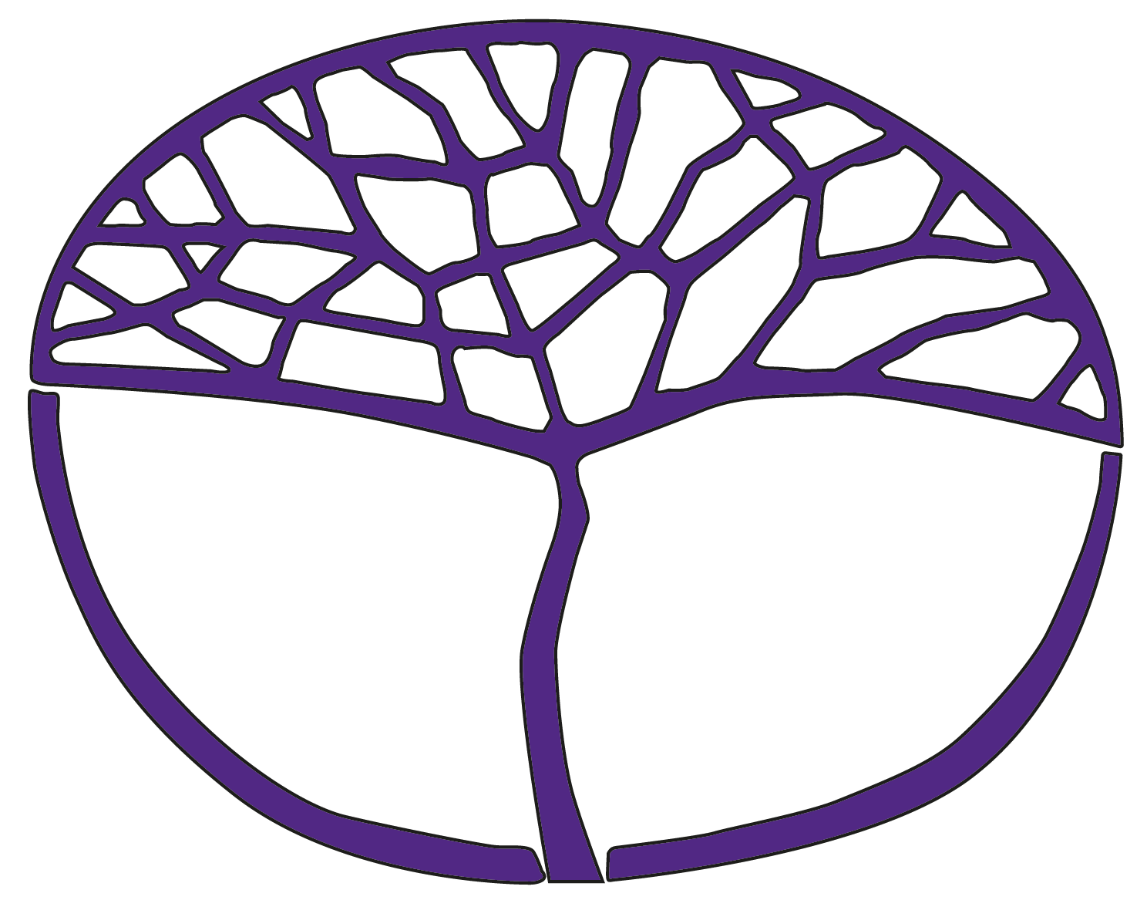Sample Assessment Outline

Physical Education Studies

General Year 11

**Acknowledgement of Country**

Kaya. The School Curriculum and Standards Authority (the Authority) acknowledges that our offices are on Whadjuk Noongar boodjar and that we deliver our services on the country of many traditional custodians and language groups throughout Western Australia. The Authority acknowledges the traditional custodians throughout Western Australia and their continuing connection to land, waters and community. We offer our respect to Elders past and present.

**Copyright**

© School Curriculum and Standards Authority, 2019

This document – apart from any third-party copyright material contained in it – may be freely copied, or communicated on an intranet, for non-commercial purposes in educational institutions, provided that the School Curriculum and Standards Authority (the Authority) is acknowledged as the copyright owner, and that the Authority’s moral rights are not infringed.

Copying or communication for any other purpose can be done only within the terms of the *Copyright Act 1968* or with prior written permission of the Authority. Copying or communication of any third-party copyright material can be done only within the terms of the *Copyright Act 1968* or with permission of the copyright owners.

Any content in this document that has been derived from the Australian Curriculum may be used under the terms of the [Creative Commons Attribution 4.0 International licence](https://creativecommons.org/licenses/by/4.0/).

**Disclaimer**

Any resources such as texts, websites and so on that may be referred to in this document are provided as examples of resources that teachers can use to support their learning programs. Their inclusion does not imply that they are mandatory or that they are the only resources relevant to the course. Teachers must exercise their professional judgement as to the appropriateness of any they may wish to use.

Sample assessment outline

Physical Education Studies – General Year 11

Units 1 and 2

|  |  |  |  |  |  |
| --- | --- | --- | --- | --- | --- |
| **Assessment component** | **Assessment type** | **Assessment  type weighting** | **Weighting for  combined mark** | **Submission date** | **Assessment task** |
| Practical | Practical  assessment | 50% | 25% | Week 15 | Task 2: Performance in selected sport (netball) – developing physical skills and tactics |
| 25% | Week 29 | Task 5: Performance in selected sport (soccer) – developing physical skills and tactics |
|  |  | **Subtotal** | 50% |  |  |
| Written | Investigation | 25% | 12.5% | Week 27 | **Task 4**:Skill observation and analysis – motor learning and coaching |
| 12.5% | Week 17 | Task 3: Fitness testing – exercise physiology |
| Response | 25% | 7.5% | Week 9 | Task 1: Topic test – functional anatomy |
| 17.5% | Week 30 | Task 6: End-of-year test – motor learning and coaching, biomechanics, functional anatomy, sport psychology, exercise physiology |
|  |  | Subtotal | 50% |  |  |
|  |  | Total | 100% |  |  |