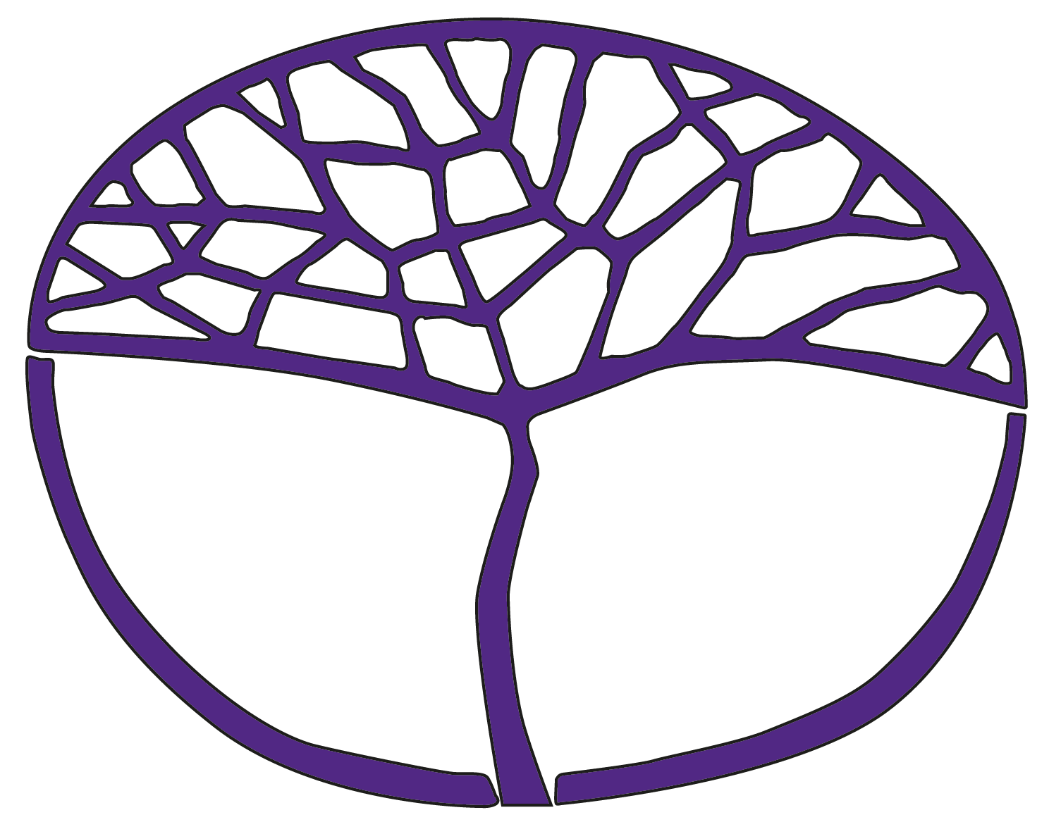Sample Assessment Tasks

Human Biology

ATAR Year 11

**Acknowledgement of Country**

Kaya. The School Curriculum and Standards Authority (the Authority) acknowledges that our offices are on Whadjuk Noongar boodjar and that we deliver our services on the country of many traditional custodians and language groups throughout Western Australia. The Authority acknowledges the traditional custodians throughout Western Australia and their continuing connection to land, waters and community. We offer our respect to Elders past and present.

**Copyright**

© School Curriculum and Standards Authority, 2023

This document – apart from any third-party copyright material contained in it – may be freely copied, or communicated on an intranet, for non-commercial purposes in educational institutions, provided that the School Curriculum and Standards Authority (the Authority) is acknowledged as the copyright owner, and that the Authority’s moral rights are not infringed.

Copying or communication for any other purpose can be done only within the terms of the *Copyright Act 1968* or with prior written permission of the Authority. Copying or communication of any third-party copyright material can be done only within the terms of the *Copyright Act 1968* or with permission of the copyright owners.

Any content in this document that has been derived from the Australian Curriculum may be used under the terms of the [Creative Commons Attribution 4.0 International licence](https://creativecommons.org/licenses/by/4.0/).

**Disclaimer**

Any resources such as texts, websites and so on that may be referred to in this document are provided as examples of resources that teachers can use to support their learning programs. Their inclusion does not imply that they are mandatory or that they are the only resources relevant to the course. Teachers must exercise their professional judgement as to the appropriateness of any they may wish to use.

Sample assessment task

Human Biology – ATAR Year 11

Task 2 – Unit 1

**Assessment type** Science Inquiry – Investigation

**Conditions** Period allowed for completion of the task:

* + - * + investigation planning – one class period
        + conduction of investigation – up to three class periods
        + completion of the introduction, materials and method sections of the scientific report – at home
        + completion of the results, analysis and evaluation of data sections of the scientific report – one period under invigilated conditions.

**Task weighting** 12% of the school mark for this pair of units

Cardiovascular health in teenagers

Plan and conduct an investigation to compare the cardiovascular health of active teenagers (involved in sport/aerobic exercise regularly) with inactive teenagers. Write a scientific report about your investigation, as described below.

1. **Plan the investigation** 
   * Decide on the hypothesis and dependent and independent variables in your investigation.
   * What are the controlled variables?
   * Research and provide background information on cardiovascular health that relates to your hypothesis.
   * Decide upon the appropriate number of subjects and how many and what type of measurements will be made.
   * Describe in detail how you will conduct your investigation.
   * Write down the steps of your investigation in sequence.
   * Propose the way that you will record your data.
   * State how you will process the data to arrive at some conclusions.
2. **Conduct the investigation**
   * Set up times and places for the measurements to be taken with your subjects.
   * Carry out data collection from subjects.
3. **Process, evaluate and communicate findings (40 marks)**

Write up your investigation as a scientific report including the following:

* + Introduction – include background information and a hypothesis (2 marks)
  + Materials and method – list the materials, state how you collected your data and how you minimised the effect of uncontrolled variables, and present raw data in an appropriate format (4 marks)
  + Results – show your processing of raw data, identify any outliers and plot by hand any graphs to show results (10 marks)
  + Analysis and evaluation – describe the trend and pattern in your data, state how your data relates to your hypothesis, use your knowledge and understanding to explain your results, comment on the reliability and accuracy of the data collected, comment on the reliability of your collection strategy, list two limitations in the data collection strategy that may have affected the accuracy of your data and list two improvements you could make to the data collection strategy (20 marks)
  + Conclusion – summarise your findings and comment on the validity of the outcome of the investigation (4 marks)

Marking key for sample assessment task 2 — Unit 1

|  |  |
| --- | --- |
| **Item** | **Mark** |
| **Scientific report** | |
| **Introduction (2)**   * Provides background information included in introduction * States hypothesis clearly | 1  1 |
| **Materials and method (4)**   * Lists all materials | 1 |
| * Describes how data was collected and processed in a safe and ethical manner | 1 |
| * States how the effects of uncontrolled variables and other factors were minimised during data collection | 1 |
| * Records raw data in an appropriate format | 1 |
| **Results (10)**   * Carries out simple processing of raw data   + calculation of mean values   + recorded appropriate format | 1–3 |
| * Identifies outliers in the raw data | 1–2 |
| * Plots an appropriate graph/s of the processed data using correct conventions   + appropriate title stating independent and dependent variables   + correctly labelled axes   + axes labels with units   + correct type of graph   + correctly plotted graph | 1–5 |
| **Analysis and Evaluation (20)**   * Describes the trends and patterns in the processed data * Makes a valid statement about:   + the trends and patterns using data collected   + and relates it to hypothesis. * Explains data using scientific knowledge and understanding   + describes, using scientific terminology, the relationship between exercise and cardiovascular fitness   + provides detail on aerobic capacity and efficiency of circulatory system with exercise * Comments on the reliability of the raw data collected * Comments on the accuracy of the raw data collected * Comments on the reliability of the data collection strategy * Lists at least two limitations in the data collection strategy that may have affected the accuracy or precision of the raw data collected * Suggests at least two improvements to the data collection strategy | 1–2  1–2  1–2  1–2  1–2  1–2  1–2  1–2  1–2  1–2 |
| **Conclusion** **(4)**   * Summarises results of the investigation * Comments on the validity of the outcome of the investigation | 1–2  1–2 |
| **Total** | **/40** |

Sample assessment task

Human Biology – ATAR Year 11

Task 3 – Unit 1

**Assessment type** Extended response

**Conditions** Time for the task:

* + - * + Part 1: two lessons to research topic and complete notes
        + Part 2: one lesson in class to respond to questions in class under invigilated conditions

**Task weighting** 5% of the school mark for this pair of units

Osteoporosis and osteoarthritis

Part 1: Research notes (5 marks)

Osteoporosis and osteoarthritis are both degenerative bone diseases that can cause disability and are usually associated with ageing. Increased understanding of the causes of these conditions has led to improved practices for management and prevention.   
Research:

* the causes and symptoms of osteoporosis and osteoarthritis
* the effect of osteoporosis and osteoarthritis on bone and/or joint structure
* the medical technologies that are currently available for the treatment of each of these diseases along with any risks or side effects.

All research should be based on Australian medical information.

You will need to use your research notes to prepare a single-sided A4 page of notes to be used when completing Part 2.

Note: the research notes need to be your own work. If any identical notes are submitted, all students involved will receive a mark of zero for Part 1.

Part 2: In-class questions (37 marks)

* You will have one lesson to answer a question based on your research.
* You can use your single page of notes.

Note: the single page of notes needs to be your own work. Your teacher will initial the notes at the commencement of the task. Any notes that are deemed identical will be collected and those students will be required to complete the task without them*.*

Part 2: In-class assessment (37 marks)

You will have the whole lesson to answer the questions below. You can use your single page of notes.

Note: the single page of notes needs to be your own work. Your teacher will initial the notes at the commencement of the task. Any notes that are deemed identical will be collected and those students will be required to complete the task without them.

1. Osteoporosis and osteoarthritis are both degenerative bone diseases that can be associated with ageing. Distinguish between osteoporosis and osteoarthritis. (2 marks)
2. Osteoporosis is more common among women than men. In Australia, 5.5% of women, compared to 1.2% of men, have osteoporosis.
3. Describe, in terms of bone structure, how osteoporosis develops and explain why women are more likely to be affected by osteoporosis than men. (10 marks)
4. List **three** risk factors for increased likelihood of being affected by osteoporosis and how it is diagnosed in Australia. (4 marks)
5. Describe **one** form of treatment and any associated risks or side effects. (10 marks)
6. In 2007–08, an estimated 7.6% of all Australians (1.6 million people) had osteoarthritis.
7. Describe the common symptoms of osteoarthritis and provide the main causes of osteoarthritis. (4 marks)
8. Describe the process of diagnosis for osteoarthritis and the most common treatment.  
    (7 marks)

Marking key for sample assessment task 3 — Unit 1

Part 1: Research notes (5 marks)

|  |  |
| --- | --- |
| **Description** | **Mark** |
| Causes and symptoms of osteoporosis | 1 |
| Causes and symptoms of osteoarthritis | 1 |
| Effect of osteoporosis and osteoarthritis on the bones/joints | 1–2 |
| Current medical technology used for treatment of osteoporosis and osteoarthritis | 1 |
| **Total** | **/5** |

Part 2: In-class assessment (37 marks)

1. Distinguish between osteoporosis and osteoarthritis.

|  |  |
| --- | --- |
| **Description** | **Mark** |
| Osteoarthritis = loss/wearing away of cartilage at joints | 1 |
| Osteoporosis = loss of calcium/bone density/weakening of bones | 1 |
| **Total** | **/2** |

1. Osteoporosis is more common among women than men. In Australia, 5.5% of women, compared to 1.2% of men, have osteoporosis.
   1. Describe, in terms of bone structure, how osteoporosis develops and explain why women are more likely to be affected by osteoporosis than men.

|  |  |
| --- | --- |
| **Description** | **Mark** |
| Bones lose minerals  Bone breakdown/resorption occurs faster than new bone formation  Bone density decreases  Bones become more porous and fragile | 1–4 |
| Sex hormones oestrogen and testosterone help maintain bone formation | 1 |
| Men develop greater bone density than females during development | 1 |
| Oestrogen levels decrease rapidly during menopause  which results in rapid increase in bone loss | 1–2 |
| Testosterone gradually decreases over time with age  therefore, increase in bone loss is gradual over time | 1–2 |
| **Total** | **/10** |

* 1. List three risk factors for increased likelihood of being affected by osteoporosis and how it is diagnosed in Australia.

|  |  |
| --- | --- |
| **Description** | **Mark** |
| Any of the following risk factors:   * low calcium intake * low vitamin D levels * low hormone levels/women – early menopause/men – low testosterone * low levels of physical activity * smoking * excessive alcohol intake * high intake of corticosteroids. | 1–3 |
| Any of the following:   * bone density scan * dual-energy absorptiometry (DXA) scan. | 1 |
| **Total** | **/4** |

* 1. Describe one form of treatment and any **associated** risks or side effects.

|  |  |
| --- | --- |
| **Description** | **Mark** |
| Treatment for osteoporosis should include a safe exercise program, including modified strength training and safe weight-bearing exercise. | 2 |
| Treatment for osteoporosis should include fall prevention, including exercise to improve balance, a trip-proof home, wearing a hip protector and wearing sturdy footwear. | 2 |
| Treatment for osteoporosis should include a diet/supplements rich in calcium and vitamin D. | 2 |
| Any one of the following medication treatments with associated risk  Two marks for treatment; two marks for risks (not all risks need to be included) | |
| **Treatment**  Bisphosphonate – most commonly used for initial treatment, bisphosphonate tablets are taken regularly to help reduce bone breakdown  **Risks/side effects**  May cause stomach upset, ulcers and rarely cancer, pain in bones and joints and can cause jawbone decay/osteonecrosis (rarely) | 1–4 |
| **Treatment**  Denosumab – the six-monthly injection works differently to bisphosphonate but has the same results  **Risks/side effects**  Numbness/tingling in fingers, muscle cramps/aches, seizures, skin infection/itchy dry skin, back muscle or bone pain, joint pain of knees, hips and spine, high cholesterol, stomach pain/nausea |
| **Treatment**  Strontium ranelate – a sachet dissolved in water is absorbed similarly to calcium. Helps increase bone formation and decrease bone loss. For the treatment of severe established osteoporosis  **Risks/side effects**  Increased risk of cardiovascular disease, seizure, loss of consciousness, very rare life‑threatening rashes, toxic epidermal necrolysis (TEN), Stevens-Johnson syndrome (SJS) and severe hypersensitivity reactions like drug rash with eosinophilia and systemic symptoms (DRESS) |
| **Treatment**  Selective oestrogen receptor modulators (SERMs) – SERMS mimic oestrogen to help reduce the rate of bone loss  **Risks/side effects**  Potential side effects include hot flushes and a slightly increased risk of deep vein thrombosis. | 1–4 |
| **Treatment**  Hormone replacement therapy (HRT)/testosterone therapy – the artificial supplementation of sex hormones to reduce rate of bone loss  **Risks/side effects**  Breakthrough bleeding, breast tenderness, bloating, nausea. Small chance of increased risk of cardiovascular disease/stroke/deep vein thrombosis/endometrial cancer |
| **Treatment**  Parathyroid hormone (PTH) – daily injections of PTH regulate the amount of calcium, phosphorus and magnesium in bones. Helps increase bone density. For severe cases of osteoporosis  **Risks/side effects**  Nausea, leg cramps, dizziness |
| **Total** | **/10** |

1. In 2007–08, an estimated 7.6% of all Australians (1.6 million people) had osteoarthritis.
   1. Describe the common symptoms of osteoarthritis and provide the main causes of osteoarthritis.

|  |  |
| --- | --- |
| **Description** | **Mark** |
| **Common symptoms**  Pain and stiffness in joints | 2 |
| **Common causes**  Previous joint injuries, being overweight, occupations requiring repetitive use of joints | 2 |
| **Total** | **/4** |

* 1. Describe the process of diagnosis for osteoarthritis and the most common treatment.

|  |  |
| --- | --- |
| **Description** | **Mark** |
| **Diagnosis** formed through presence of symptoms and physical examination | 2 |
| Plus at least one of the following:   * X-rays may show narrowing/disfiguring of joint but are not conclusive * blood test used to rule out other forms of arthritis. | 1 |
| **Treatment** usually includes:   * a form of pain relief such as paracetamol * non-steroidal anti-inflammatory drugs (NSAIDs) * a gentle exercise program * a weight-loss program if the cause is from being overweight * joint replacement surgery if no other treatments are effective for pain management. | 1–4 |
| **Total** | **/7** |

Sample assessment task

Human Biology – ATAR Year 11

Task 7 – Unit 2

**Assessment type** Test

**Conditions** Time for the task: 60 minutes

**Task weighting** 15% of the school mark for this pair of units

Reproduction and inheritance test

Part A: Multiple-choice (10 marks)

This section has 10 questions. Answer all questions on the multiple-choice answer sheet provided.

Questions 1 and 2 refer to the diagram below.

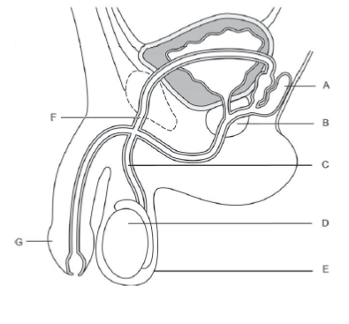

1. The structures shown in the diagram that add fluid to the sperm to form semen are
   1. A and C.
   2. A and B.
   3. B and C.
   4. A and F.
2. Part F is the
   1. vas deferens.
   2. bladder.
   3. prostate gland.
   4. urethra.
3. Which of the following is NOT correct regarding spermatogenesis?
   1. It begins before birth then ceases until after puberty.
   2. It occurs continually after puberty.
   3. The process takes about 72 days.
   4. One spermatogonium results in four viable spermatozoa.
4. The greatest chance for an ovum to be fertilised is having sexual intercourse
   1. at the beginning of the menstrual flow.
   2. at the end of the menstrual flow.
   3. at the end of the menstrual cycle.
   4. two weeks after menstruation starts.
5. During childbirth, there are a number of key events:
   * 1. dilation of the cervix
     2. crowning
     3. delivery of the placenta
     4. breaking of the waters
     5. contractions of the uterus
     6. secretion of oxytocin
     7. delivery of the baby.

Using the above, the normal sequence of events is

* 1. vi, i, v, ii, iv, iii and vii
  2. vi, v, i, iv, ii, vii and iii
  3. i, ii, iv, vi, v, vii, and iii
  4. v, vi, i, ii, iv, vii and iii

1. The placenta is the organ that allows
   1. the mixing of maternal and foetal blood.
   2. foetal blood to give off oxygen to maternal blood.
   3. maternal blood to receive nutrients.
   4. foetal blood to receive nutrients.
2. Gonorrhoea and chlamydia are both sexually transmitted infections caused by
   1. bacteria.
   2. viruses.
   3. fungi.
   4. parasites.
3. Which of the following methods of contraception operates largely by preventing implantation rather than preventing fertilisation?
   1. diaphragm
   2. intra-uterine device
   3. the oral contraceptive pill
   4. condom
4. The transmission of sexually transmitted infections such as AIDS, syphilis and gonorrhoea can be limited by
   1. the oral contraceptive pill.
   2. spermicide.
   3. condoms.
   4. intra-uterine devices.
5. A test that can be done during pregnancy to check for foetal abnormalities such as Down syndrome, using a thin needle to extract fluid from the amniotic sac, is
   1. an ultrasound.
   2. amniocentesis.
   3. genetic profiling.
   4. chorionic villus sampling.

Part B: Short answer (41 marks)

This section has three questions. Answer all questions in the spaces provided.

1. Cystic fibrosis (CF) is an autosomal recessive disorder. A couple with a history of CF in their families undergo genetic counselling before trying to conceive a baby.
2. It is found that the man is a carrier for CF and the woman is homozygous normal. Predict the possible genotypes and phenotypes of their future children. (5 marks)
3. The genetic counsellor drew a pedigree to show the couple how CF has been inherited in their families. In the space provided, construct the pedigree diagram the counsellor would have drawn. Include:

* three labelled generations
* the couple’s parents
* the couple and their siblings. The man has an older sister; his sister was affected with CF. The woman is the oldest child, with a younger sister and an even younger brother who are unaffected
* the prediction of three future children, who are all boys. (8 marks)

1. Use the following diagram of the female reproductive system to answer (a) and (b).

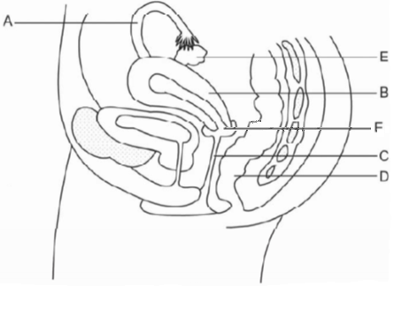

1. Label the following structures: (2 marks)

B:

E:

1. State the function for the following structures: (2 marks)

A:

F:

Use the diagram below to answer questions (c) and (d).

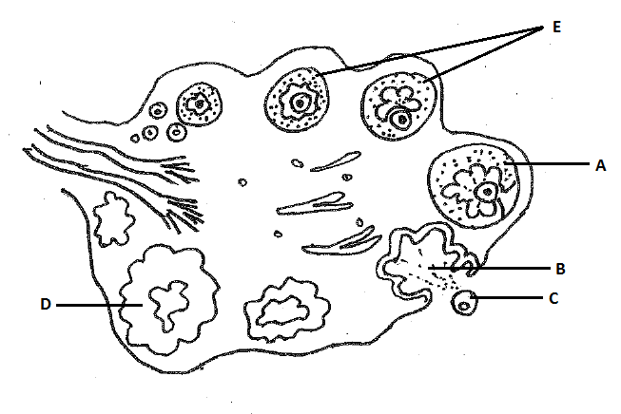

1. Identify the structures: (4 marks)

A: _______________________________________

B: _______________________________________

C: _______________________________________

D: _______________________________________

1. Describe the changes that occur in the ovary during the ovarian cycle. (7 marks)

1. The following diagram shows some of the stages involved in the formation of human ova.

Primary oocyte

Secondary oocyte

1st polar body

Ovum

2nd polar body

1. How many chromosomes would you find in: (3 marks)

|  |  |
| --- | --- |
| Primary oocyte |  |
| Secondary oocyte |  |
| Zygote  (fertilised ovum) |  |

1. State **two** important differences between the formation or characteristics of spermatozoa and ova. (4 marks)

|  |  |  |
| --- | --- | --- |
| **Difference** | **Spermatozoa** | **Ova** |
| One |  |  |
| Two |  |  |

1. How does the process of meiosis produce genetic variation in sperm? (2 marks)

1. Describe how a vasectomy works as a contraceptive method. (2 marks)

1. Is it possible for a man who has had a vasectomy to pass on the sexually transmitted infection HIV to his partner? Explain your answer. (2 marks)

Part C: Extended answer (14 marks)

This section has one question. Answer both parts to the question in the space provided. Make sure you identify each part clearly.

1. The following diagram shows some of the stages involved in the formation of human ova.
2. List five (5) major changes that take place in a female during pregnancy and explain the reason for each change. (10 marks)
3. What information can be determined from ultrasound monitoring during pregnancy?  
    (4 marks)

**END OF TEST**

Marking key for sample assessment task 7 — Unit 2

Reproduction and inheritance test

Part A: Multiple-choice (10 marks)

|  |  |
| --- | --- |
| **Answer** | **Marks** |
| 1. B | 1 |
| 1. A | 1 |
| 1. A | 1 |
| 1. D | 1 |
| 1. B | 1 |
| 1. D | 1 |
| 1. A | 1 |
| 1. B | 1 |
| 1. C | 1 |
| 1. B | 1 |
| **Total** | **10** |

Part B: Short answer (41 marks)

1. Cystic fibrosis (CF) is an autosomal recessive disorder. A couple with a history of CF in their families undergo genetic counselling before trying to conceive a baby.
2. It is found that the man is a carrier for CF and the woman is homozygous normal. Predict the possible genotypes and phenotypes of their future children.

|  |  |
| --- | --- |
| **Description** | **Mark** |
| |  |  |  |  | | --- | --- | --- | --- | |  | | Father | | | C | c | | Mother | C | C C | C c | | C | C C | C c | |  |
| Punnett square:  Father’s genes – heterozygous  Mother’s genes – homozygous | 1–2 |
| Key: C – normal gene c – gene for cystic fibrosis | 1 |
| Phenotype: 100% of children are normal | 1 |
| Genotype: 50% of children homozygous normal; 50% of children heterozygous normal/carriers | 1 |
| **Total** | **/5** |

1. The genetic counsellor drew a pedigree to show the couple how CF has been inherited in their families. In the space provided, construct the pedigree diagram the counsellor would have drawn. Include:

* three labelled generations
* the couple’s parents
* the couple and their siblings. The man has an older sister; his sister was affected with CF. The woman is the oldest child, with a younger sister and an even younger brother who are unaffected
* the prediction of three future children, who are all boys.

|  |  |
| --- | --- |
| **Description** | **Mark** |
| Image | |
| Key for pedigree | 1 |
| Couple’s parents included in generation I | 1 |
| Couple and their siblings included in generation II | 1 |
| Man’s older sister with CF | 1 |
| Man as a carrier of CF | 1 |
| Woman and siblings all normal | 1 |
| Possible offspring all boys | 1 |
| 50% of offspring carriers of CF | 1 |
| **Total** | **/8** |

1. 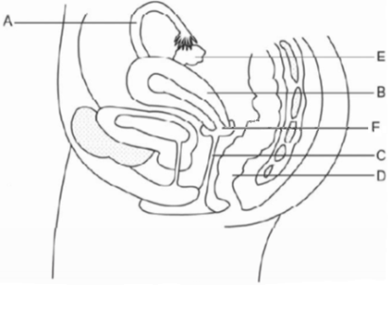Use the following diagram of the female reproductive system to answer the following questions.
2. Label the following structures:

|  |  |
| --- | --- |
| **Description** | **Mark** |
| B: Uterus | 1 |
| E: Ovary | 1 |
| **Total** | **/2** |

1. State the function for the following structures:

|  |  |
| --- | --- |
| **Description** | **Mark** |
| A: Carry ova from fallopian tube to uterus | 1 |
| F: Any of the following   * direct sperm into uterus * allow menstrual blood flow from uterus | 1 |
| **Total** | **/2** |

Below is a diagram of a section through an ovary.

1. Identify the structures:

|  |  |
| --- | --- |
| **Description** | **Mark** |
| A: Graafian follicle or mature ovarian follicle | 1 |
| B: Ruptured follicle | 1 |
| C: Ova | 1 |
| D: Corpus luteum | 1 |
| **Total** | **/4** |

1. Describe the changes that occur in the ovary during the ovarian cycle.

|  |  |
| --- | --- |
| **Description** | **Mark** |
| Secondary follicle starts to develop | 1 |
| Graafian follicle/mature follicle formed | 1 |
| Mature follicle bursts, releasing ova/ovulation | 1 |
| Ruptured follicle collapses and forms corpus luteum | 1 |
| Hormones released to assist development of uterine wall | 1 |
| Corpus luteum reaches maximum development; if fertilisation doesn’t occur, corpus luteum degenerates | 1 |
| If fertilisation occurs, corpus luteum continues to develop and the ovarian cycle ceases during pregnancy | 1 |
| **Total** | **/7** |

1. The following diagram shows some of the stages involved in the formation of human ova.

Primary Oocyte

Secondary Oocyte

1st polar body

Ovum

2nd polar body

How many chromosomes would you find in:

|  |  |  |
| --- | --- | --- |
| **Description** | | **Marks** |
| Primary oocyte | 46 | 1 |
| Secondary oocyte | 23 | 1 |
| Zygote (fertilised ovum) | 46 | 1 |
| **Total** | | **/3** |

1. State **two** important differences between the formation or characteristics of spermatozoa and ova.

|  |  |
| --- | --- |
| **Description** | **Marks** |
| Any two of the following from each category | 1–2 |
| **Spermatozoa**   * Four sperm produced * Even distribution of cytoplasm * Short life span/survival * Produced in testis * Small in size * Motile/has tail * Completes both mitotic and meiotic division at formation * Produced at puberty onwards |
| **Ova**   * One ova produced * Receives majority of cytoplasm * Longer life span/survival * Larger size * Not motile/no tail * Completes second division at fertilisation * Produced before birth | 1–2 |
| **Total** | **/4** |

1. How does the process of meiosis produce genetic variation in sperm?

|  |  |
| --- | --- |
| **Description** | **Marks** |
| Independent assortment – each sperm receives only one of each of the homologous pairs of chromosomes | 1 |
| Crossing over occurring during meiosis | 1 |
| **Total** | **/2** |

1. Describe how a vasectomy works as a contraceptive method.

|  |  |
| --- | --- |
| **Description** | **Marks** |
| Vas deferens is cut so it’s no longer a complete/continuous tube | 1 |
| Sperm is prevented from being able to combine with semen in ejaculation | 1 |
| **Total** | **/2** |

1. Is it possible for a man who has had a vasectomy to pass on the sexually transmitted infection HIV to his partner? Explain your answer.

|  |  |
| --- | --- |
| **Description** | **Marks** |
| Yes | 1 |
| Virus contained in body fluid  Body fluid/semen passed on through ejaculation | 1 |
| **Total** | **/2** |

Part C: Extended answer (14 marks)

1. List five (5) major changes that take place in a female during pregnancy and explain the reason for each change.

|  |  |
| --- | --- |
| **Description** | **Mark** |
| Any five of the following: 1 mark for identifying and 1 mark for explanation |  |
| * Growth of uterus – to accommodate developing foetus * Enlargement of breasts – development of milk-secreting tissue * Emotional changes – due to changing hormone levels * Increased blood volume/size of heart – to increase blood flow to the placenta/kidney * Increased need to urinate – due to increased pressure on bladder * Weight gain – due to growth of foetus/extra blood * Nausea/morning sickness – due to changing hormone levels * Fatigue/sleeplessness – due to discomfort/extra effort * Changes to appetite – due to nutritional demands of foetus * Hormonal changes/increased progesterone/increased HCG/ increased oestrogen – needed to maintain pregnancy * Shifting of abdominal organs – due to growth of foetus/uterus | 1–10 |
| **Total** | **/10** |

1. What information can be determined from ultrasound monitoring during pregnancy?

|  |  |
| --- | --- |
| **Description** | **Mark** |
| Any four of the following: | |
| * Estimate age of foetus * Measure growth/development of foetus * Image can be used to detect malformations in foetus/specific abnormalities can be diagnosed (or named, e.g. spina bifida) * Can determine the position of the baby for delivery * Detection of multiple pregnancies * Determine sex of the foetus | 1–4 |
| **Total** | **/4** |

Acknowledgements

**Sample assessment Task 8**

**Part 2**

**Questions 2–3** Data source: Australian Bureau of Statistics. (2011). *4843.0.55.001—Arthritis and osteoporosis in Australia: A snapshot, 2007–08.* [www.abs.gov.au/ausstats/abs@.nsf/Lookup/4843.0.55.001main+features32007-08](http://www.abs.gov.au/ausstats/abs@.nsf/Lookup/4843.0.55.001main+features32007-08)

Used under Creative Commons [Attribution 2.5 Australia](http://creativecommons.org/licenses/by/2.5/au/) licence.

**Sample assessment Task 17**

**Questions 1–2** Image adapted from: Cull, P. (Ed.). (1989). *The sourcebook of medical illustration*. Park Ridge, NJ: Parthenon. Retrieved May, 2014, from [www.cehd.umn.edu/phys/imagebank/Reproductive/default.html](http://www.cehd.umn.edu/phys/imagebank/Reproductive/default.html) (male reproductive system).

**Question 11** Image adapted from: [Female reproductive system lateral]. (2005). Retrieved May, 2014, from <http://commons.wikimedia.org/wiki/File:Female_reproductive_system_lateral.png>

Used under Creative Commons [Attribution-Share Alike 3.0 Unported](http://creativecommons.org/licenses/by-sa/3.0/deed.en) licence.

**Question 11(c)–(e)** Image adapted from: Lawson, R. (2007). [Ovarian cycle]. Retrieved May, 2014, from <http://commons.wikimedia.org/wiki/File:Anatomy_and_physiology_of_animals_Ovarian_cycle_showing_from_top_left_clockwise.jpg>

Used under Creative Commons [Attribution 3.0 Unported](http://creativecommons.org/licenses/by/3.0/deed.en) licence.