Sample Assessment Tasks

Economics

General Year 11

Copyright
© School Curriculum and Standards Authority, 2014
This document – apart from any third party copyright material contained in it – may be freely copied, or communicated on an intranet, for non-commercial purposes in educational institutions, provided that the School Curriculum and Standards Authority is acknowledged as the copyright owner, and that the Authority’s moral rights are not infringed.
Copying or communication for any other purpose can be done only within the terms of the Copyright Act 1968 or with prior written permission of the School Curriculum and Standards Authority. Copying or communication of any third party copyright material can be done only within the terms of the Copyright Act 1968 or with permission of the copyright owners.
Any content in this document that has been derived from the Australian Curriculum may be used under the terms of the Creative Commons Attribution-NonCommercial 3.0 Australia licence
Disclaimer
Any resources such as texts, websites and so on that may be referred to in this document are provided as examples of resources that teachers can use to support their learning programs. Their inclusion does not imply that they are mandatory or that they are the only resources relevant to the course.

Sample assessment task

Economics – General Year 11

Task 1 – Unit 1
Assessment type: Data interpretation/Short answer

Conditions

Time for the task: 40 minutes

In-class test

Task weighting

10% of the school mark for this pair of units

__________________________________________________________________________________

Section One: Multiple-choice questions (10 marks)

1. The type of income associated with owning shares is

(a) rent.
(b) profit.
(c) wages.
(d) dividend.

2. The type of income associated with saving is

(a) rent.
(b) interest.
(c) wages.
(d) dividend.

3. Which of the following would be regarded as an asset?

(a) a personal loan
(b) a credit card
(c) a share portfolio
(d) a mortgage

4. Which of the following would be regarded as a liability?

(a) shares
(b) a vintage car
(c) a fixed term deposit
(d) a mortgage

5. Wealth is defined as the difference between

(a) a household’s income and expenditure.
(b) a household’s savings and loans.
(c) a household’s assets and liabilities.
(d) a household’s assets and expenses.

6. Which of the following would not increase your wealth?

(a) an increase in your assets
(b) an increase in the value of your shares
(c) an increase in the value of your property
(d) an increase in your liabilities

7. A household’s wealth must increase if

(a) income increases.
(b) assets increase more than liabilities.
(c) the value of assets increases.
(d) the value of liabilities increases.

8. The main factor explaining the difference in salary between a doctor and a nurse would be

(a) age.
(b) gender.
(c) qualifications.
(d) experience.

9. One factor explaining a higher wage for a worker at a remote mine site would be

(a) age.
(b) location.
(c) qualifications.
(d) experience.

10. Contributions to superannuation will

(a) decrease present income and increase future wealth.
(b) increase present income and increase future wealth.
(c) decrease present income and decrease future wealth.
(d) increase present income and decrease future wealth.

Section Two: Data interpretation/Short answer questions (16 marks)

The questions below refer to the information showing Australia’s income and wealth distribution.
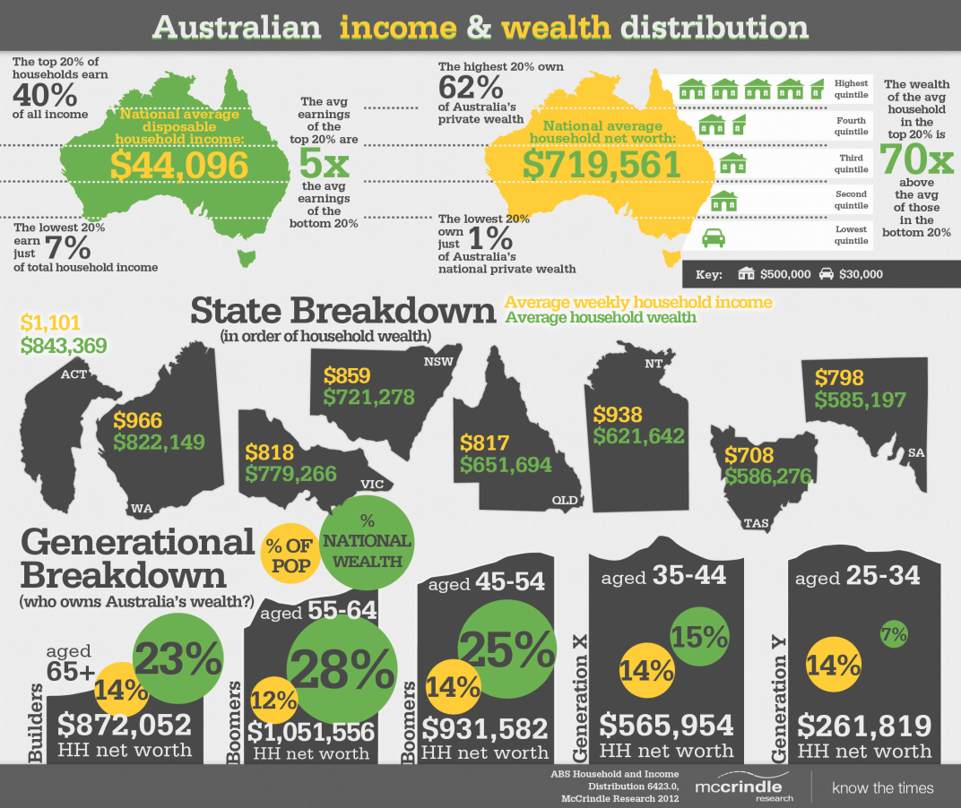

Source: www.mccrindle.com.au

1. Explain the difference between income and wealth. Provide an example of each. (4 marks)

2. What is the national average disposable household income and what is the national average level of household wealth? (2 marks)

3. Is the income gap between rich and poor or the wealth gap between rich and poor larger? Use data from the source above to support your answer. (3 marks)

4. (a) Which State/Territory has the highest average weekly household income?

(b) Which State/Territory has the lowest average weekly household income?

(c) Provide one (1) reason for this difference. (3 marks)

5. (a) Which age group has the largest share of national wealth?

(b) Which age group has the lowest share of national wealth?

(c) Explain the difference between the share of national wealth for these age groups.
(4 marks)

Marking key for sample assessment Task 1 – Unit 1
Section One: Multiple-choice

Answer | Marks
1. D | 1
2. B | 1
3. C | 1
4. D | 1
5. C | 1
6. D | 1
7. B | 1
8. C | 1
9. B | 1
10. A | 1
Total | /10

Section Two: Data interpretation/Short answer

1. Explain the difference between income and wealth. Provide an example of each.
Description | Marks
Explains the difference between income and wealth | 1–2
Provides a correct example of income | 1
Provides a correct example of wealth | 1
Total | /4
Answer
- Income is the payment for the use of resources such as labour or capital
- Wages, interest and rent are examples of income
- Wealth is the difference between a household’s assets and liabilities
- Property, shares and savings are examples of wealth

2. What is the national average disposable household income and what is the national average level of household wealth?
Description | Marks
Correctly states the national average disposable household income | 1
Correctly states the national average level of household wealth | 1
Total | /2
Answer
- National average disposable household income is $44 096
- National average level of household wealth is $719.561

3. Is the income gap between rich and poor or the wealth gap between rich and poor larger? Use data from the source above to support your answer.
Description | Marks
Correctly identifies whether the income or wealth gap is larger | 1
Uses data from the source to support the answer | 1–2
Total | /3
Answer
- The wealth gap is larger
- The average earnings of the top 20% are five times the average earnings of the bottom 20%, whereas the wealth of the average household in the top 20% is 70 times above the average household in the bottom 20%

4. (a) Which State/Territory has the highest average weekly household income?
(b) Which State/Territory has the lowest average weekly household income?
(c) Provide one (1) reason for this difference.
Description | Marks
(a) correctly identifies the State/Territory with the highest average weekly household income | 1
(b) correctly identifies the State/Territory with the lowest average weekly household income | 1
(c) provides a valid reason for the difference between average weekly household income between the highest and lowest States or Territories | 1
Total | /3
Answer
- The ACT has the highest average weekly household income
- Tasmania has the lowest average weekly household income
- Canberra is located in the ACT which has a high concentration of public servants and politicians earning high salaries whereas Tasmania is a relatively isolated State with high unemployment and few industries

5. (a) Which age group has the largest share of national wealth?
(b) Which age group has the lowest share of national wealth?
(c) Explain the difference between the share of national wealth for these age groups.

Description | Marks
(a) correctly identifies the age group with the largest share of national wealth | 1
(b) correctly identifies the age group with the lowest share of national wealth | 1
(c) provides a valid explanation for the difference between the share of national wealth | 2
Total | /4
Answer
- 55–64 age group has the highest share of national wealth
- 25–34 age group has the lowest share of national wealth
- The 55–64 age group are still in the workforce earning income and have had a longer time to build up their assets and pay off their liabilities whereas the younger group have just entered the workforce and are unlikely to have purchased any major assets

Sample assessment task

Economics – General Year 11

Task 2 – Unit 1
Assessment type: Extended answer

Conditions

Time for the task: 40 minutes

In-class test

Task weighting

10% of the school mark for this pair of units

__________________________________________________________________________________

(24 marks)

1. Explain the relationship between income and spending and between price and spending. Use the diagrams below to show this relationship. (4 marks)

Income Price

Spending Spending

2. Explain the difference between purchasing goods using cash or using credit. Compare the
advantages and disadvantages for each method. (10 marks)

3. For each of the following goods, explain which method of purchase, cash or credit, would be more appropriate:

- groceries
- clothes
- rent
- a large screen television
- a car.

(10 marks)

Marking key for sample assessment Task 2 – Unit 1

- Explain the relationship between income and spending and between price and spending. Use the diagrams below to show this relationship.

Description | Marks
Explains the relationship between income and spending | 1
Correctly illustrates the relationship between income and spending on a diagram | 1
Explains the relationship between price and spending | 1
Correctly illustrates the relationship between price and spending on a diagram | 1
Total | /4
Answer
- as income increases spending increases
- as price decreases spending increases

- Explain the difference between purchasing goods using cash or using credit. Compare the advantages and disadvantages for each method.

Description | Marks
Explains the difference between purchasing goods using cash or using credit | 1–2
Outlines the advantages of purchasing goods using cash | 1–2
Outlines a disadvantage of purchasing goods using cash | 1
Outlines the advantages of purchasing goods using credit | 1–2
Outlines the disadvantages of purchasing goods using credit | 1–2
Makes a statement comparing the two methods of paying for goods | 1
Total | /10
Answer could include, but is not limited to:
- cash involves using currency whereas credit allows a consumer to purchase now and pay later
- the advantages of cash are that it is simple and convenient
- the disadvantage of cash is that large purchases require a consumer to have the funds available to spend
- the advantages of credit are it allows the consumer to purchase goods immediately and to have use of those goods
- the disadvantages of credit are that credit incurs a cost, known as interest, and the risk of accumulating debt if credit card payments cannot be made

- For each of the following goods, explain which method of purchase, cash or credit, would be more appropriate:
- groceries
- clothes
- rent
- a large screen television
- a car.
Description | Marks
Correctly identifies the appropriate method of payment for each good | 1–5  (1 mark each)
Provides a logical justification for selecting the method of payment for each good | 1–5  (1 mark each)
Total | /10
Answer
- groceries – cash as groceries are a weekly expense and should be budgeted for each week
- clothes – cash as clothes are not purchased each week and can be saved for
- rent – cash as rent is a weekly expense and should be budgeted for each week
- a large screen television – credit as a television is a large expenditure item and could be paid for over time enabling immediate use
- a new car – credit as a car is a large expenditure item and could be paid for over time enabling immediate use

Sample assessment task

Economics – General Year 11

Task 8 – Unit 2
Assessment type: Investigation

Conditions

Period allowed for completion of the task: 3 weeks

Task weighting

10% of the school mark for this pair of units

__________________________________________________________________________________

(40 marks)

Part A
Working in a group, use sources of information such as the local community newspaper, the internet and local government reports to identify five (5) businesses in the local area. Report your findings in a table. The table should include information such as:
- the name of the business
- the good or service the business provides
- the resources the business uses, for example is it labour or capital intensive?
- the location of the business
- the industry in which the business operates
- aspects of the business that indicate its classification including:
- size – is it a small or medium enterprise?
- ownership – is it a sole trader, partnership, franchise, company?
- purpose including profit or not-for-profit?
(10 marks)

Explain the benefits of businesses to the local community and provide examples from the table to support your answer.
(8 marks)

Part B

Select one (1) business and write a report addressing the following focus questions:
- outline how the business utilises the resources in the production process or the provision of a service
- identify costs the business would face
- identify and explain the level of competition the business would face and the factors that would influence the level of competition
- explain two (2) strategies the business could implement to achieve a competitive advantage. Use examples to support your answer.

(22 marks)

Marking key for sample assessment Task 8 – Unit 2

Part A: Classification of a range of local business and the contribution of business to the local area.

Description | Marks
Identifies businesses from within the local area and provides the required information | 1–10  (2 marks per business)
Explains the benefits of businesses to the local community | 1–6
Utilises examples to support the answer | 1–2
Total | /18
Answers will vary depending on the businesses in the local area.

Part B: Business operation and strategy

Description | Marks
Outlines the use of resources in the production process or the provision of services | 1–4
Identifies the costs the business would face | 1–4
Identifies and explains the level of competition in the market and identifies and explains a range of factors affecting the level of competition | 1–8
Explains the strategies businesses can implement to achieve a competitive advantage using examples to support the answer | 1–6
Total | /22
Answers will vary depending on the business selected.

