Building and Construction

General course
Marking key for the Externally set task
Sample 2016

Copyright
© School Curriculum and Standards Authority, 2014
This document – apart from any third party copyright material contained in it – may be freely copied, or communicated on an intranet, for
non-commercial purposes in educational institutions, provided that the School Curriculum and Standards Authority is acknowledged as the copyright owner, and that the Authority’s moral rights are not infringed.
Copying or communication for any other purpose can be done only within the terms of the Copyright Act 1968 or with prior written permission of the School Curriculum and Standards Authority. Copying or communication of any third party copyright material can be done only within the terms of the Copyright Act 1968 or with permission of the copyright owners.
Any content in this document that has been derived from the Australian Curriculum may be used under the terms of the Creative Commons Attribution-NonCommercial 3.0 Australia licence
Disclaimer
Any resources such as texts, websites and so on that may be referred to in this document are provided as examples of resources that teachers can use to support their learning programs. Their inclusion does not imply that they are mandatory or that they are the only resources relevant to the course.

Building and Construction

Externally set task – marking key
1(a) The owner has pointed out the termite damage to you. Besides this damage, you need to assess the complete pergola structure for suitability and compliance before agreeing to undertake any repair work. Describe three (3) items from either the materials used, the construction methods or the compliance issues that you would check. (3 marks)
Description | Marks
1 mark for any of the following or other suitable response:  - check condition of all timber for damage or weathering  - check the size of the timber used is suitable for loads  - check fastening methods at all junctions  - check pergola attachment to house is suitable  - check for council approval if required | Any three  (1 mark per response)
Total | 3

(b) Sketch a sectional detail of a correct method for fixing a pergola post to the ground. Show the ground in the diagram in relation to the fixing, and include all necessary symbols to show ground or fill, and materials used. (8 marks)
Description | Marks
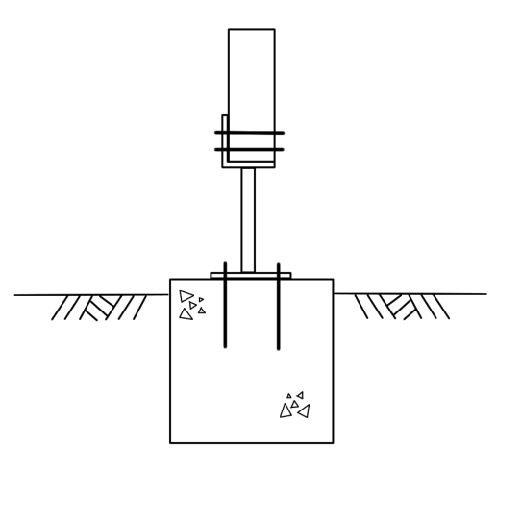

Description | Marks
1 mark showing concrete pad footing  1 mark using correct symbol for concrete  1 mark showing steel stirrup  1 mark showing ground level  1 mark showing correct symbol for ground or fill  1 mark either bolts or cast in anchors to hold stirrup to concrete  1 mark showing wooden post fasten to stirrups  1 mark for showing wooden post  If student shows cast in stirrup, then bolts not required for fastening stirrup to concrete, but correct coverage over top of stirrup should be indicated. | 1  1  1  1  1  1  1  1
Total | 8

(c) From your detailed sketch in Question (b), list all of the materials that you would use to fix the post in place. For each material, describe its most important property in this application. (8 marks)
Description | Marks
Timber (used for pergola post)  - strong in compression  - strong in tension  - easy to work on site  - resistant to weathering  - can be painted easily  - renewable resource  - resistant to attack by insects  Galvanised steel stirrup and fasteners  - corrosion resistant  - extremely strong  Concrete (used for footings)  - can be used in contact with ground  - resistant to insect attack  - heavy to resist lifting loads  - can be formed on site to suit need  - can be mixed onsite in quantities needed  - easy to add fixings to  Earth (ground)  - can support large loads if it is free of organic material and meets acceptable compaction  - allows for drainage of water | 1 mark per material  (maximum of 4)  1 mark per important property for each material  (maximum of 4)
Total | 8

The diagram shows a proposed courtyard. This sketch is not to scale.
In the construction of the courtyard, one area is to be paved. The remainder of the courtyard will be a barbecue area to be concreted with a 125 mm thick slab.
2(a) Calculate the area, in square metres (m²), of the barbecue area. (4 marks)
Description | Marks
Correct calculation  6 m × 7 m  = 42 m²  Now remove upper right corner square ⇒ (1.5 × 1.5 m = 2.25 m²)  = 39.75 m² | 1  1  1  1
Total | 4

(b) Calculate the volume of concrete (m³) to order for the barbecue area. (3 marks)
Description | Marks
Correct use of formula: Volume = area x thickness  = 39.75 m² × 0.125 m  = 4.97 m³ | 1  1  1
Total | 3

(c) Identify one possible hazard and safety control measure that may be encountered in the construction of the courtyard. (2 marks)
Description | Marks
Correctly identifies a risk | 1
Identifies a subsequent correct safety control measure | 1
Total | 2

