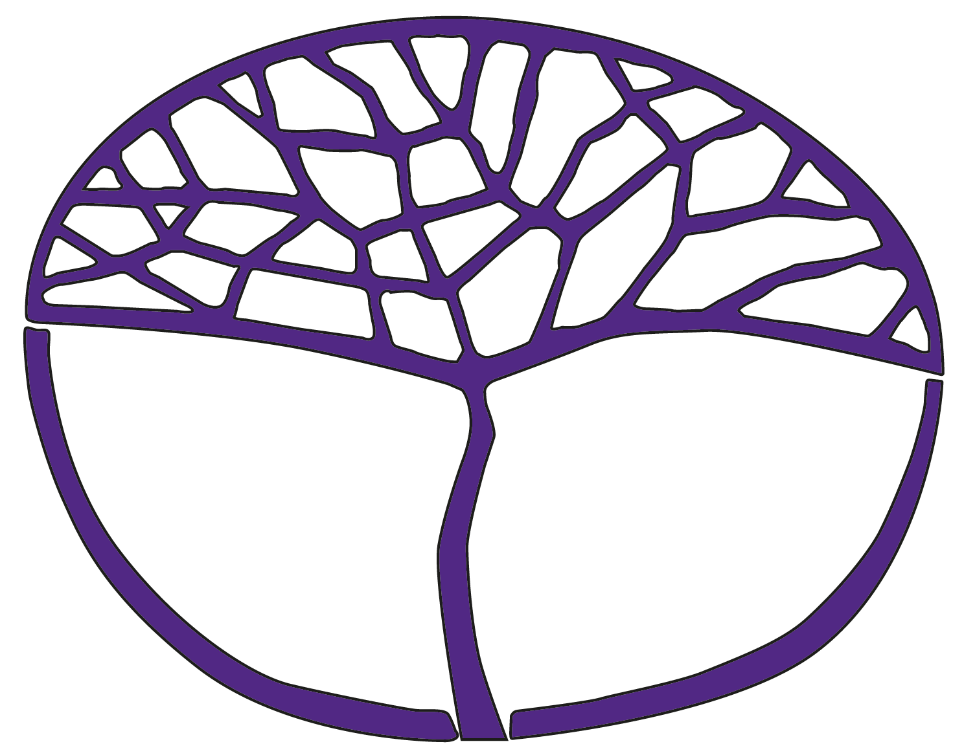Sample Assessment Outline

Humanities and Social Sciences in Action

General Year 11

**Acknowledgement of Country**

Kaya. The School Curriculum and Standards Authority (the Authority) acknowledges that our offices are on Whadjuk Noongar boodjar and that we deliver our services on the country of many traditional custodians and language groups throughout Western Australia. The Authority acknowledges the traditional custodians throughout Western Australia and their continuing connection to land, waters and community. We offer our respect to Elders past and present.

**Copyright**

© School Curriculum and Standards Authority, 2024

This document – apart from any third-party copyright material contained in it – may be freely copied, or communicated on an intranet, for non-commercial purposes in educational institutions, provided that the School Curriculum and Standards Authority (the Authority) is acknowledged as the copyright owner, and that the Authority’s moral rights are not infringed.

Copying or communication for any other purpose can be done only within the terms of the *Copyright Act 1968* or with prior written permission of the Authority. Copying or communication of any third-party copyright material can be done only within the terms of the *Copyright Act 1968* or with permission of the copyright owners.

Any content in this document that has been derived from the Australian Curriculum may be used under the terms of the [Creative Commons Attribution 4.0 International licence](https://creativecommons.org/licenses/by/4.0/).

**Disclaimer**

Any resources such as texts, websites and so on that may be referred to in this document are provided as examples of resources that teachers can use to support their learning programs. Their inclusion does not imply that they are mandatory or that they are the only resources relevant to the course. Teachers must exercise their professional judgement as to the appropriateness of any they may wish to use.

Sample assessment outline

Year 11 General Humanities and Social Sciences in Action

Unit 1 – All humans have rights

Unit 2 – A sense of community

| **Assessment type  (from syllabus)** | **Assessment  type weighting  (from syllabus)** | Assessment  task  weighting | **When/start and submission date** | **Assessment task** |
| --- | --- | --- | --- | --- |
| Social action investigation | 30% | 15% | Issued: Semester 1,  Week 11  Submit: Semester 1, Week 15 | **Task 4: Social action investigation**  Part A: Evidence of research, including bibliography. Research based on content drawn from Focus area 2.  Part B: Present research findings in the form of a library display.  Part C: In-class self-reflection written under test conditions. Students submit their research and library display prior to undertaking their in-class reflection. |
| 15% | Issued: Semester 2,  Week 11  Submit: Semester 2, Week 15 | Task 8: Social action investigation  Part A: Evidence of research, including bibliography. Research based on content drawn from Focus area 2.  Part B: Present research findings in an appropriate written or oral format.  Part C: In-class self-reflection written under test conditions. Students submit their inquiry notes and bibliography prior to undertaking their in-class reflection. |
| Commentary | 30% | 15% | Issued: Semester 1 Week 5  Submit: Semester 1, Week 13 | Task 1: Commentary  A summary of learning and reflections about access to human rights, developed over the course of the unit. Students will complete four entries at various times during the teaching and learning program with at least one entry from the overview, Focus area 1 and Focus area 2. |
| 15% | Issued: Semester 2 Week 2  Submit: Semester 2, Week 12 | Task 5: Commentary  A summary of learning and reflections about a sense of community, developed over the course of the unit. Students will complete four entries at various times during the teaching and learning program with at least one entry from the overview, Focus area 1 and Focus area 2. |
| Response | 40% | 10% | Semester 1  Week 5 | Task 2: Response  Short answer questions comparing two infographics based on the overview content about human rights in Australia. |
| 10% | Semester 1  Week 10 | **Task 3: Response**  A sectionalised extended response from the content in Focus area 1 about the short- and long-term impacts of changing access to human rights for Aboriginal and Torres Strait Islander Peoples. |
| 10% | Semester 2  Week 4 | **Task 6: Response**  Short answer questions relating to the overview content based on an article about youth participation in the community. |
| 10% | Semester 2  Week 10 | **Task 7: Response**  Case study consisting of short answer questions relating to Focus area 1 in the context of homelessness services in Perth and regional areas. |
| Total | 100% | 100% |  |  |