Marine and Maritime Studies

General course
Marking key for the Externally set task
Sample 2016

Copyright
© School Curriculum and Standards Authority, 2014
This document – apart from any third party copyright material contained in it – may be freely copied, or communicated on an intranet, for
non-commercial purposes in educational institutions, provided that the School Curriculum and Standards Authority is acknowledged as the copyright owner, and that the Authority’s moral rights are not infringed.
Copying or communication for any other purpose can be done only within the terms of the Copyright Act 1968 or with prior written permission of the School Curriculum and Standards Authority. Copying or communication of any third party copyright material can be done only within the terms of the Copyright Act 1968 or with permission of the copyright owners.
Any content in this document that has been derived from the Australian Curriculum may be used under the terms of the Creative Commons Attribution-NonCommercial 3.0 Australia licence
Disclaimer
Any resources such as texts, websites and so on that may be referred to in this document are provided as examples of resources that teachers can use to support their learning programs. Their inclusion does not imply that they are mandatory or that they are the only resources relevant to the course.

Marine and Maritime Studies

Externally set task – marking key
- In the picture below, three marine biologists are conducting a survey of a sub-tidal rocky reef habitat.
Examine the picture below carefully and then answer the questions that follow. (26 marks)
(a) What type of surveying method is being used by the marine biologists numbered 1 and 2? (1 mark)
Description | Marks
Quadrats (Sampling) | 1
Total | 1

(b) The apparatuses below are used to measure factors in the marine environment. In the table below, name each piece of apparatus, state what it is used to measure, and indicate whether it is used to measure biotic or abiotic factors. (9 marks)
Description | Marks
Apparatus Name Used to Measure Biotic/Abiotic  Secchi disc Turbidity/water clarity abiotic  Thermometer temperature abiotic  Plankton net productivity biotic | 1 mark each
Total | 9

(c) Explain how to use the apparatus (i) and state what a low measurement reading would indicate.
(3 marks)
Description | Marks
lower secchi disk into water | 1
stop when markings on disc just disappear | 1
measure distance between surface of water and secchi disc | 1
Total | 3
(d) Researchers in Western Australia investigating abalone, a marine invertebrate shellfish, could also use the research method being used by the marine biologists, numbered 1 and 2 in the diagram. Describe briefly the main information gathered when using this method of research and how this could be used to investigate the effect of recreational fishing on abalone. (3 marks)
Description | Marks
Quadrat sampling measures abundance of organisms in area | 1
Abundance can be measured over time | 1
Recorded data can be analysed along with water temperature data to show patterns in numbers of Abalone in an area | 1
Total | 3

(e) Graph this data on the grid below. (5 marks)
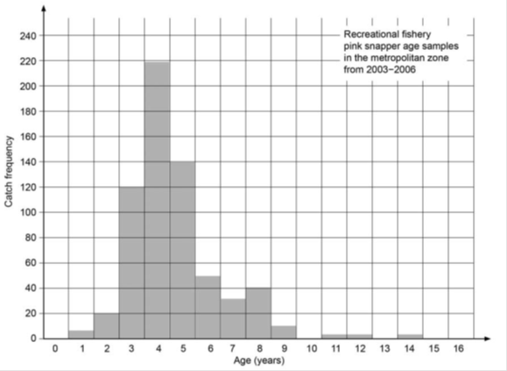
Description | Marks
Correct graph drawn – histogram | 1
Labels axes with correct name and unit | 1–2
Uses suitable scale | 1
Appropriate title | 1
Total | 5

- Describe the age composition of Pink Snapper stocks in the metropolitan zone between 2003 and 2006. (3 marks)
Description | Marks
Correct answer may include, but is not limited to the following
Any three of:  - ages of caught fish range from 1 to 14 years  - no fish older than 14 years of age caught  - age group with most fish caught is 4 years  - majority of fish caught aged between 3 to 5 years of age | 1–3
Total | 3
- Give two (2) possible causes to explain the pattern in the data of the age composition of pink snapper between 2003 and 2006. (2 marks)
Description | Marks
Answer could include, but is not limited to:
Any two of:  - No pink snapper caught older than 14 years because they don’t exist.  - 3 to 5 years ago, there was an unusually high reproductive output of pink snapper and many survived to maturity, hence why most fish caught are 3 to 5 years old.  - At 3 years of age, pink snapper have reached minimum size limits and hence large numbers of reported catches. | 1–2
Total | 2

2. The data table below is the result of marine research into changes in water quality characteristics off the coast of south-western Australia over a period of 6 months. The measurements were taken at a depth of 0.5 m at the same location each time. (18 marks)
(a) What technology could the researchers have used to ensure that they sampled water in the same location each time? (1 mark)
Description | Marks
GPS | 1
Total | 1

(b) Summarise and explain the changes in light intensity over the 6 months. (8 marks)
Description | Marks
small decrease in light intensity between September and November | 1
small decrease in light intensity due to small increase in amount of chlorophyll | 1
- light intensity decreases due to increased turbidity (1)  - from increased number of chlorophyll/algae (1) | 1–2
larger decreases in light intensity between November to February | 1
chlorophyll/algae increases due to warmer temperatures | 1
greater increases in turbidity | 1
larger decreases in light intensity | 1
Total | 8

(c) If chlorophyll-α is a measure of how much microscopic algae (phytoplankton) is in the water, describe the changes in the amount of chlorophyll-α over the time period. (3 marks)
Description | Marks
small increase over initial months | 1
large increase between November to January | 1
large decrease from January to February | 1
Total | 3

- Provide three (3) reasons as to why these changes have occurred, using other evidence from the data table to support your answer. (6 marks)
Description | Marks
increasing temperature provides ideal conditions for growth | 1
increasing chlorophyll leads to increased turbidity which leads (1)  to reduced light penetration (1) | 1–2
- a combination of too much chlorophyll/algae (1)  - not enough light intensity and reduced O₂ (1)  - leads to amount of chlorophyll/algae decreasing through death (1) | 1–3
Total | 6

3. Safety at sea is a huge responsibility for the skipper of a recreational boat. Suppose you are the skipper of a recreational power boat that has become inoperable and is beginning to sink slowly more than two nautical miles off shore.
(a) List, in order of importance, five (5) actions you would take, using the correct nautical terms and give a brief description of your actions. (10 marks)
Description | Marks
Make sure all occupants of the boat put on a PFD. | 1–2
Raise the alarm by using mobile phone/marine radio to contact relevant people.  Activate EPIRB. | 1–4
Anchor vessel to maintain position. | 1–2
Ensure all occupants stay with vessel if safe to do so, or secure occupants together, as vessel or group of people together are easier to spot than individuals. | 1–2
Total | 10

(b) List five (5) pieces of equipment you would need to carry with you on a recreational power boat.
(5 marks)
Description | Marks
bilge pump, fire extinguisher, anchor, life jacket, flares, emergency positioning indicator radio beacon (EPIRB), parachute flares, marine radio (VHF, 27 MHz) | 1–5
Total | 5

