Plant Production Systems
General course

Externally set task
Sample 2016

Note: This Externally set task sample is based on the following content from Unit 3 of the General Year 12 syllabus.
Plant structure and function
- structure and function of stems, roots, leaves, flowers, fruit and seeds
- nutrient requirements throughout plant growth stages
Breeding and improvement
- aims of breeding and selection, including
- profitability
- market requirements
- environmental conditions
- selection criteria including subjective and objective characteristics
Investigating plant production
- design and conduct an investigation, considering aspects of experimental design including variables and controls
In future years, this information will be provided late in Term 3 of the year prior to the conduct of the Externally set task. This will enable teachers to tailor their teaching and learning program to ensure that the content is delivered prior to the students undertaking the task in Term 2 of Year 12.

Copyright
© School Curriculum and Standards Authority, 2014
This document – apart from any third party copyright material contained in it – may be freely copied, or communicated on an intranet, for non-commercial purposes in educational institutions, provided that the School Curriculum and Standards Authority is acknowledged as the copyright owner, and that the Authority’s moral rights are not infringed.
Copying or communication for any other purpose can be done only within the terms of the Copyright Act 1968 or with prior written permission of the School Curriculum and Standards Authority. Copying or communication of any third party copyright material can be done only within the terms of the Copyright Act 1968 or with permission of the copyright owners.
Any content in this document that has been derived from the Australian Curriculum may be used under the terms of the Creative Commons Attribution-NonCommercial 3.0 Australia licence
Disclaimer
Any resources such as texts, websites and so on that may be referred to in this document are provided as examples of resources that teachers can use to support their learning programs. Their inclusion does not imply that they are mandatory or that they are the only resources relevant to the course.

Plant Production Systems

Externally set task
Working time for the task: 60 minutes
Total marks: 40 marks
Weighting: 15% of the school mark

- The following diagram shows a typical flower structure. (7 marks)
Using the diagram below, identify each flower part, and its corresponding function.
B
E
C
A
D
F
G
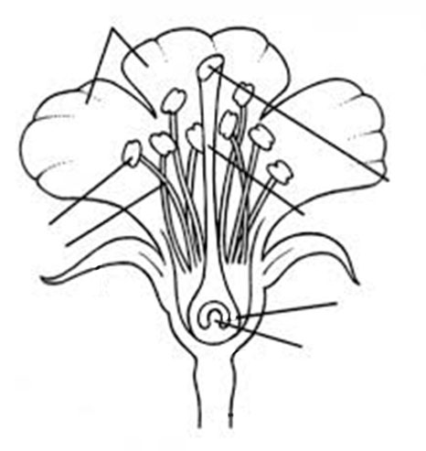

Flower part on diagram | Name and function of flower part
A
B
C
D
E
F
G
- Plant producers aim to optimise profitability by managing plant requirements at different growth stages. Describe each growth stage identified below, and discuss the plant’s requirements at each stage. (12 marks)
Germination (4 marks)
________________________________________________________________________________
________________________________________________________________________________
________________________________________________________________________________
________________________________________________________________________________
________________________________________________________________________________
________________________________________________________________________________
________________________________________________________________________________
Vegetative growth (4 marks)
________________________________________________________________________________
________________________________________________________________________________
________________________________________________________________________________
________________________________________________________________________________
________________________________________________________________________________
________________________________________________________________________________
________________________________________________________________________________
Reproductive growth (4 marks)
________________________________________________________________________________
________________________________________________________________________________
________________________________________________________________________________
________________________________________________________________________________
________________________________________________________________________________
________________________________________________________________________________
________________________________________________________________________________

- Plant producers need to grow varieties which suit their environmental conditions and meet market requirements. (7 marks)

- Select a raw plant product and identify an end (processed) product made from it. (1 mark)

Raw plant product ______________________________________

End (processed) product _____________________________________

- Describe one (1) objective and one (1) subjective criterion that would be used to measure the quality of the raw product.
Objective criterion (3 marks)
________________________________________________________________________________
________________________________________________________________________________
________________________________________________________________________________
________________________________________________________________________________
________________________________________________________________________________
________________________________________________________________________________
Subjective criterion (3 marks)
________________________________________________________________________________
________________________________________________________________________________
________________________________________________________________________________
________________________________________________________________________________
________________________________________________________________________________
________________________________________________________________________________
- Explain one particular reason for developing a new variety of a specific plant type. (3 marks)
________________________________________________________________________________
________________________________________________________________________________
________________________________________________________________________________
________________________________________________________________________________
________________________________________________________________________________
5(a) You have been asked by a plant breeding company to trial three new varieties of a crop in an effort to find a variety that can grow in an environment with a growing season rainfall of 150 mm. The trial is to be undertaken in a glasshouse where rainfall and other conditions can be controlled. The experiment is to be designed to test the hypothesis that one of the new varieties will be more suited to the low rainfall environment than the common variety. (11 marks)

Identify each the following aspects of the experimental design, and explain their importance in conducting a valid trial.

Experimental  aspect | Identification of each aspect | The importance of each aspect
Independent variable
Dependent variable
Control treatment
Replication

- Suppose that you have completed the trial and the results have been collected. Describe the results that you would observe to conclude your hypothesis was NOT supported.
(3 marks)
________________________________________________________________________________
________________________________________________________________________________
________________________________________________________________________________
________________________________________________________________________________
________________________________________________________________________________

Acknowledgement

Question 1 Parts of a flower [Image]. (n.d.). Retrieved March, 2014, from
http://flower-parts-guides.blogspot.com.au/2011/06/also-until-this-week.html
The School Curriculum and Standards Authority have made all reasonable attempts to identify the copyright holder of this image. You are invited to contact the Authority if you are the copyright holder.

