Sample Assessment Tasks

Physical Education Studies

General Year 11

**Acknowledgement of Country**

Kaya. The School Curriculum and Standards Authority (the Authority) acknowledges that our offices are on Whadjuk Noongar boodjar and that we deliver our services on the country of many traditional custodians and language groups throughout Western Australia. The Authority acknowledges the traditional custodians throughout Western Australia and their continuing connection to land, waters and community. We offer our respect to Elders past and present.

**Copyright**

© School Curriculum and Standards Authority, 2024

This document – apart from any third-party copyright material contained in it – may be freely copied, or communicated on an intranet, for non-commercial purposes in educational institutions, provided that the School Curriculum and Standards Authority (the Authority) is acknowledged as the copyright owner, and that the Authority’s moral rights are not infringed.

Copying or communication for any other purpose can be done only within the terms of the *Copyright Act 1968* or with prior written permission of the Authority. Copying or communication of any third-party copyright material can be done only within the terms of the *Copyright Act 1968* or with permission of the copyright owners.

Any content in this document that has been derived from the Australian Curriculum may be used under the terms of the [Creative Commons Attribution 4.0 International licence](https://creativecommons.org/licenses/by/4.0/).

**Disclaimer**

Any resources such as texts, websites and so on that may be referred to in this document are provided as examples of resources that teachers can use to support their learning programs. Their inclusion does not imply that they are mandatory or that they are the only resources relevant to the course. Teachers must exercise their professional judgement as to the appropriateness of any they may wish to use.

Sample assessment task

Physical Education Studies – General Year 11

Task 2 – Units 1 and 2

**Assessment type** Practical assessment

**Conditions** The assessment will be completed over weeks 14 and 15.

**Task weighting** 25% of the school mark for this pair of units

Practical performance (40 marks)

The assessment will comprise of three sections:

* **Section 1: Skill execution**
  + The student is required to demonstrate individual, sport-specific skills within a competitive environment. The assessment will include:
    - proficiency of performance in individual skills
    - selection and application of appropriate skills in specific situations.
  + 20 marks – 35% of the practical assessment
* **Section 2: Tactical application**
  + The student is required to demonstrate individual and/or team, sport-specific tactics within a competitive environment. The assessment will include the use of team/individual tactics in offence and defence.
  + 20 marks – 65% of the practical assessment

**Resources**

For technical information on the performance of individual and/or game skills, reference should be made to the resources provided by the national/state organisations. This is available from

* Netball Australia – Coaching  
  <https://netball.com.au/coaching>
* Netball Australia – Coaching resources  
  <https://wa.netball.com.au/coaching-resources>   
  Note: the INF Foundation Coaching Manual can be downloaded as a PDF from this webpage.

Marking key for sample assessment task 2 – Units 1 and 2

Netball assessment overview

| **Section** | **Netball observations** |
| --- | --- |
| Section one  Skill execution – 20 marks (35% of the practical assessment)   * The student is required to demonstrate individual, sport-specific skills within a competitive environment. The assessment will include:   + proficiency of performance in individual skills   + selection and application of appropriate skills in specific situations. | * execution   + consistency   + control   + fluency * precision * kinematics of arms during throwing/catching, including sequencing and energy transfer * footwork * skill selection and timing |
| Section two  Tactical application – 20 marks (65% of the practical assessment)  The student is required to demonstrate individual and/or team, sport-specific tactics within a competitive environment. The assessment will include the use of team/individual tactics. | Offence   * maintaining possession * setting up a play * ball projection (angle), velocity and spin * pace of attack * creating scoring opportunities * communication with teammates * use of space through movement and/or pass selection * positioning |
| Defence   * regaining possession * preventing scoring opportunities * communication with teammates * support of other defenders * positioning/movement to dispossess or intercept |

Marking key

Section one – Skill execution

|  |  |
| --- | --- |
| Netball – skills for consideration | |
| * execution   + consistency   + control   + fluency   + precision * kinematics of arms during throwing/catching including sequencing and energy transfer * footwork * skill selection and timing | Skill selection and timing   * examples of decisions to be made:   + pass or shot for goal   + type of pass, e.g. shoulder, bounce, lob, chest and overhead   + types of attacking movements, e.g. front cut, clear and drive, change of pace, hold and use of backspace   + types of defence, e.g. shadowing, hands over pressure and delay/deny |

|  |  |
| --- | --- |
| Marks allocation – proficiency  10 marks | Marks |
| Consistently performs skills with precision, efficiency and fluency  Consistently controls the flight and delivery of the ball achieving the desired outcome | 9–10 |
| Performs skills with a high degree of precision and fluency  Demonstrates a high level of control of the delivery and flight of the ball when aiming for a target, with a high degree of success in achieving the desired outcome | 7–8 |
| Performs most skills with precision and fluency  Controls the delivery and flight of the ball when aiming for a target most of the time, mostly achieving the desired outcome | 5–6 |
| Performs skills somewhat fluently with variable precision  Controls the delivery and flight of the ball some of the time when aiming for a target, with some degree of success in achieving the desired outcome | 3–4 |
| Performs few skills demonstrating limited fluency  Demonstrates limited control of the delivery and flight of the ball when aiming for a target, with a low degree of success in achieving the desired outcome | 1–2 |

|  |  |
| --- | --- |
| Marks allocation – selection and application of skills 10 marks | Marks |
| Consistently makes the correct decision and selects a variety of skills that range from simple to complex and are appropriate to the situation, achieving the desired outcome | 9–10 |
| Selects a broad range of simple and complex skills that are mostly appropriate for the situation and has a high degree of success in achieving the desired outcome | 7–8 |
| Selects and uses mainly simple skills that are mostly appropriate for the situation, usually achieving the desired outcome | 5–6 |
| Uses the appropriate skill in some situations, giving preference to the more familiar and less complex skills | 3–4 |
| Performs a limited range of simple skills regardless of the situation with a low degree of success in achieving the desired outcome | 1–2 |

Section two – Tactical application

| Netball – skills for consideration | |
| --- | --- |
| **Offence** | |
| * maintaining possession * setting up a play * ball projection (angle), velocity and spin * pace of attack * creating scoring opportunities * communication with teammates * use of space through movement and/or pass selection * positioning | Setting up a play   * passes to a leading player * passes to a scoring option in a strong position * use of width and depth   Ball projection (angle), velocity and spin   * throws are at an appropriate angle to reach target * passes are at an appropriate speed to teammate’s advantage * throws are at an appropriate angle and speed to score a goal   Pace of attack   * attacks are at an appropriate pace to gain advantage of opponent’s position or weakness   Pass distribution   * examples of decisions to be made:   + short or long passes   + passes to either side of the court   + passes made down the court or to a player behind   + passes made to players in open space   Support of player with ball   * player movement   + into open space   + away from opponent   + into attacking positions   + clearing to create space |

| Netball – skills for consideration | |
| --- | --- |
| **Defence** | |
| * regaining possession * preventing scoring opportunities * communication with teammates * support of other defenders * positioning/movement to dispossess or intercept | Preventing scoring opportunities   * opponents’ moves are blocked * opponents’ attacking options are reduced   Support of other defenders   * position in relation to a teammate defending an opponent * defensive units, e.g. split circle, box and double defence   Positioning/movement to dispossess or intercept   * space available for opposition is closed down * movement into position to reduce passing options * position in relation to opponent to remove them as a passing option * opponents’ passes are anticipated/intercepted |

|  |  |
| --- | --- |
| Marks allocation Offence – 10 marks  Defence – 10 marks | Marks |
| Consistently performs required skills to an exceptional level and appropriate to the competitive situation, demonstrating creativity, deception and anticipation while maintaining intensity under game-like pressure | 9–10 |
| Performs required skills with some consistency to a high level and appropriate to the competitive situation, usually demonstrating creativity, deception and anticipation, while maintaining intensity under game-like pressure on most occasions | 7–8 |
| Performs required skills most of the time and usually appropriate to the competitive situation, at times demonstrating creativity, deception and anticipation at a reduced intensity | 5–6 |
| Performs required skills some of the time, often appropriate to the competitive situation, occasionally demonstrating a low degree of creativity, deception or anticipation at a low intensity | 3–4 |
| Occasionally performs a few of the required skills at a minimal intensity, at times appropriate to the competitive situation, with little or no creativity, deception or anticipation | 1–2 |

Sample assessment task

Physical Education Studies – General Year 11

Task 4 – Units 1 and 2

**Assessment type** Investigation

**Conditions** The task will be completed over 5 weeks

**Task weighting** 12.5% of the school mark for this pair of units

Fitness testing (33 marks)

Part A

Work with two members of your class. For each student, measure their radial or carotid pulse at rest, and record in a table (like the one below). To do this, count the beats for ten seconds and multiply by six. Now ask the student to skip continuously for three minutes; immediately check the pulse and record.

1. For the other two students in your group, identify **three** physiological changes that can be observed following intense physical activity. Outline the difference between the heart rate at rest and after three minutes of intense, continuous exercise and explain why this may be happening. (7 marks)

|  |  |
| --- | --- |
| **Pulse at rest**  **Heart rate (bpm)** | **Pulse immediately after exercise**  **Heart rate (bpm)** |
|  |  |

1. Calculate each student’s cardiac output by using the pulse readings recorded earlier. Assume the athlete’s stroke volume is 0.07 litres per beat. Present the results in a table (like the one below).  
    (2 marks)

|  |  |
| --- | --- |
| **Cardiac output at rest** | **Cardiac output immediately after exercise** |
|  |  |

1. Outline and justify **two** conclusions about cardiac output that you can draw from these figures.  
    (6 marks)
2. For each category below, describe **one** other immediate response of the cardiorespiratory system that the students will experience when participating in physical activity: (14 marks)

* stroke volume
* blood pressure
* arteriovenous oxygen difference
* selective redistribution of blood
* temperature regulation
* ventilation rate
* gaseous exchange in the lungs.

1. Identify the dominant energy system used by each student and outline **three** characteristics of the energy system. (4 marks)

Part B: Fitness testing (continued) (37 marks)

1. Fitness appraisals include information about a person’s current and prior health and medical conditions and current rates of physical activity. Outline **three** reasons why an appraisal by a fitness professional prior to the commencement of a training program is important. (3 marks)
2. Name **one** test item appropriate to measure each fitness component below. Work in your group of three to complete each test item and record your personal results. Use a resource such as [Fitness Testing Norms (topendsports.com)](https://www.topendsports.com/testing/norms/) and provide a rating based on the performance of each test. (12 marks)

|  |  |  |  |
| --- | --- | --- | --- |
| **Fitness component** | **Description of test** | **Results** | |
| **Score** | **Rating**  (excellent, good, average, fair or poor) |
| Cardiorespiratory  endurance |  |  |  |
| Muscular  strength |  |  |  |
| Muscular endurance |  |  |  |
| Flexibility |  |  |  |
| Speed |  |  |  |
| Agility |  |  |  |

1. Evaluate your performance in the fitness test by describing **one** of your strengths and **one** of your weaknesses. (4 marks)
2. Select **two** components of fitness that you consider to be the most relevant in the game of netball and justify your choices. (6 marks)
3. For **one** component of fitness, suggest an alternative test and describe the procedure.  
    (3 marks)
4. For **one** component of fitness, explain how it could be improved as a part of a training program.  
    (2 marks)
5. The warm-up is an essential element of every training program as it prepares the body for exercise and reduces the risk of injury. Identify **five** physiological changes that take place during an effective warm-up. (5 marks)
6. Design a 15-minute cool-down session for players to follow after a rigorous netball game.  
    (2 marks)

Marking key for sample assessment task 4 – Units 1 and 2

Part A

1. For the other two students in your group, identify **three** physiological changes that can be observed following intense physical activity. Outline the difference between the heart rate at rest and after three minutes of intense, continuous exercise and explain why this may be happening.

|  |  |
| --- | --- |
| **Description** | **Marks** |
| One mark for each of **three** physiological changes identified | 1–3 |
| Outlines the difference between the heart rate at rest and after three minutes of exercise | 1 |
| Provides a comprehensive, thorough explanation of why the heart rates are different, with all relevant detail  Provides a clear explanation of why the heart rates are different, with most of the relevant detail  Provides a simple explanation of why the heart rates are different, with some detail | 3  2  1 |
| **Subtotal** | **/7** |

1. Calculate each student’s cardiac output by using the pulse readings recorded earlier. Assume the athlete’s stroke volume is 0.07 litres per beat.

|  |  |
| --- | --- |
| **Description** | **Marks** |
| One mark for each correct calculation of cardiac output, i.e. multiplying heart rate by 0.07 | 1–2 |
| **Subtotal** | **/2** |

1. Outline and justify **two** conclusions about cardiac output that you can draw from these figures.

|  |  |
| --- | --- |
| **Description** | **Marks** |
| One mark for each appropriate conclusion (maximum of two):   * cardiac output increases during exercise to provide an increase in oxygen and fuel, which are needed to circulate to muscle tissues * cardiac output is the amount of blood circulated by the heart in one minute. This is approximately five litres at rest, and around 20 to 35 litres during exercise   Accept other appropriate responses. | 1–2 |
| For the justification of each of **two** conclusions:   * justification is comprehensive with appropriate links to the data * justification is simple with minimal reference to the data | 2  1 |
| **Subtotal** | **/6** |

1. For each category below, describe **one** other immediate response of the cardiorespiratory system that the students will experience when participating in physical activity.

|  |  |
| --- | --- |
| **Description** | **Marks** |
| One mark for each immediate response:  Stroke volume   * The amount of blood the heart pumps out with each beat increases with activity. This occurs because more venous blood is being returned to the heart from the muscles.   Blood pressure   * This increases due to an increase in cardiac output. The fact that blood is travelling through the circulatory system at a faster rate results in greater pressure being applied to the artery walls.   Arteriovenous oxygen difference   * During rest, the body has an oxygen concentration in the arteries of 19ml per 100ml of blood. During rest, the body has an oxygen concentration in the veins of 13ml per 100ml of blood. This means, at rest, 6ml of oxygen is used by the muscles. The av-O2 difference, therefore, is 6. * During exercise, the concentration of oxygen in the arteries stays the same. The concentration of oxygen in the veins drops to 2ml per 100ml of blood. The av‑O2 difference is 17. Therefore, muscles use more O2 during exercise.   Selective redistribution of blood   * During exercise, blood is directed away from non-working areas to active muscles.   Temperature regulation   * To prevent overheating of muscle tissue, blood acts as a temperature regulator by transferring heat from within the body to the skin surface in the form of perspiration.   Ventilation rate   * Increased respiratory rate, which can increase from 15 breaths a minute at rest to between 40 and 50 breaths per minute during exercise.   Gaseous exchange in the lungs   * Diffusion of oxygen and carbon dioxide between the blood and alveoli is increased threefold during exercise.   Accept other appropriate responses.  For the description of each response:   * Provides comprehensive justification with appropriate links to the data * Provides simple justification with minimal reference to the data | 2  1 |
| **Subtotal** | **/14** |

1. Identify the dominant energy system used by each student and outline **three** characteristics of the energy system.

|  |  |
| --- | --- |
| **Description** | **Marks** |
| One mark for correctly identifying ‘anaerobic’ as the dominant energy system | 1 |
| One mark for each key characteristic (maximum of three):   * no oxygen required * rapid supply of energy * uses carbohydrate (glucose) * limited ATP production * used for activities one to two minutes in duration * by-products are lactic acid – causing fatigue   Accept other appropriate responses. | 1–3 |
| **Subtotal** | **/4** |
| **Total – Part A** | **/33** |

Part B (37 marks)

1. Fitness appraisals include information about a person’s current and prior health and medical conditions and current rates of physical activity. Outline **three** reasons why an appraisal by a fitness professional prior to the commencement of a training program is important.

|  |  |
| --- | --- |
| **Description** | **Marks** |
| One mark for each appropriate reason (maximum of three)  Answer could include:   * first step to achieving fitness goals – knowing where to start * know more about the client (strengths and weaknesses) and can tailor programs to the needs of the individual * benchmark to monitor progress   Accept other appropriate responses. | 1–3 |
| **Subtotal** | **/3** |

1. Name **one** test item appropriate to measure each fitness component below. Work in your group of three to complete each test item and record your personal results. Use a resource such as [Fitness Testing Norms (topendsports.com)](https://www.topendsports.com/testing/norms/) and provide a rating based on the performance of each test.

|  |  |
| --- | --- |
| **Description** | **Marks** |
| One mark for each appropriate test item (one per component – maximum of six):   * cardiorespiratory endurance * muscular strength * muscular endurance * flexibility * speed * agility | 1–6 |
| One mark for correct identification of rating for the score in each test | 1–6 |
| **Subtotal** | **/12** |

1. Evaluate your performance in the fitness test by describing **one** of your strengths and **one** of your weaknesses.

|  |  |
| --- | --- |
| **Description** | **Marks** |
| Provides a detailed and accurate description of one of their strengths with justification for their choice  Provides a basic description of one of their strengths | 2  1 |
| Provides a detailed and accurate description of one of their weaknesses with justification for their choice  Provides a basic description of one of their weaknesses | 2  1 |
| **Subtotal** | **/4** |

1. Select **two** components of fitness that you consider to be the most relevant in the game of netball and justify your choices.

|  |  |
| --- | --- |
| **Description** | **Marks** |
| One mark for each of **two** appropriate components of fitness | 1–2 |
| For each component:   * provides a detailed and accurate justification * provides a basic justification with minimal detail | 2  1 |
| **Subtotal** | **/6** |

1. For **one** component of fitness, suggest an alternative test and describe the procedure.

|  |  |
| --- | --- |
| **Description** | **Marks** |
| One mark for an appropriate alternative test for the component | 1 |
| Provides a detailed and accurate description of the alternative test  Provides a basic description of the alternative test with minimal detail | 2  1 |
| **Subtotal** | **/3** |

1. For **one** component of fitness, explain how it could be improved as a part of a training program.

|  |  |
| --- | --- |
| **Description** | **Marks** |
| Provides a detailed and accurate explanation of how the fitness component could be improved  Provides a basic description of how the fitness component could be improved, with minimal detail | 2  1 |
| **Subtotal** | **/2** |

1. The warm-up is an essential element of every training program as it prepares the body for exercise and reduces the risk of injury. Identify five physiological changes that take place during an effective warm-up.

|  |  |
| --- | --- |
| **Description** | **Marks** |
| One mark for each physiological change (maximum of five)  Answer could include:   * increased heart rate and blood flow through the muscle * mental preparation of athlete for exercise * muscles become warm and more flexible * lubrication of the muscle, joint and other connective tissue * reduction of the risk of injury to muscles and joints * decrease of muscle tension * adjustment of the nervous system to the physical and mental demands of the vigorous exercise to come   Accept other appropriate responses. | 1–5 |
| **Subtotal** | **/5** |

1. Design a 15-minute cool-down session for players to follow after a rigorous netball game.

|  |  |
| --- | --- |
| **Description** | **Marks** |
| Provides a detailed session that is appropriate to the situation and achieves the goals of a cool down  Provides a basic session that achieves some of the goals of a cool down | 2  1 |
| Session should show evidence of:   * reducing heart rate, as it is still slightly elevated, to allow more oxygen to reach muscles to clear away lactic acid * loosening tight muscles so they won’t stiffen later   Accept other appropriate responses. |  |
| **Subtotal** | **/2** |
| **Total** | **/37** |

Sample assessment task

Physical Education Studies – General Year 11

Task 1 – Units 1 and 2

**Assessment type** Response

**Conditions** Time for the task: 60 minutes

**Task weighting** 7.5% of the school mark for this pair of units

__________________________________________________________________________________

Topic test: Functional anatomy (33 marks)

Answer each question in the space provided. (3 marks)

1. Identify the name of each anatomical plane described below.
2. the plane that divides the body into left and right sections

1. the plane that divides the body into top and bottom sections

1. the plane that divides the body into front and back sections

1. Describe the type of tissue from which tendons and ligaments are made, and outline the main function of each. (4 marks)

Description of tendon and ligament tissue

Main function of a tendon

Main function of a ligament

1. Identify the bones indicated on the diagram below. (5 marks)

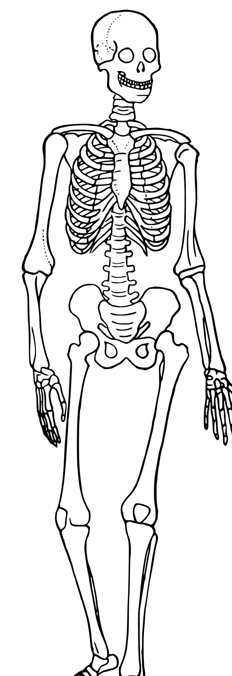

(a)

(e)

(d)

(c)

(b)

1. _____________________________________________
2. _____________________________________________
3. _____________________________________________
4. _____________________________________________
5. _____________________________________________
6. Identify the muscles indicated on the diagram below. (5 marks)

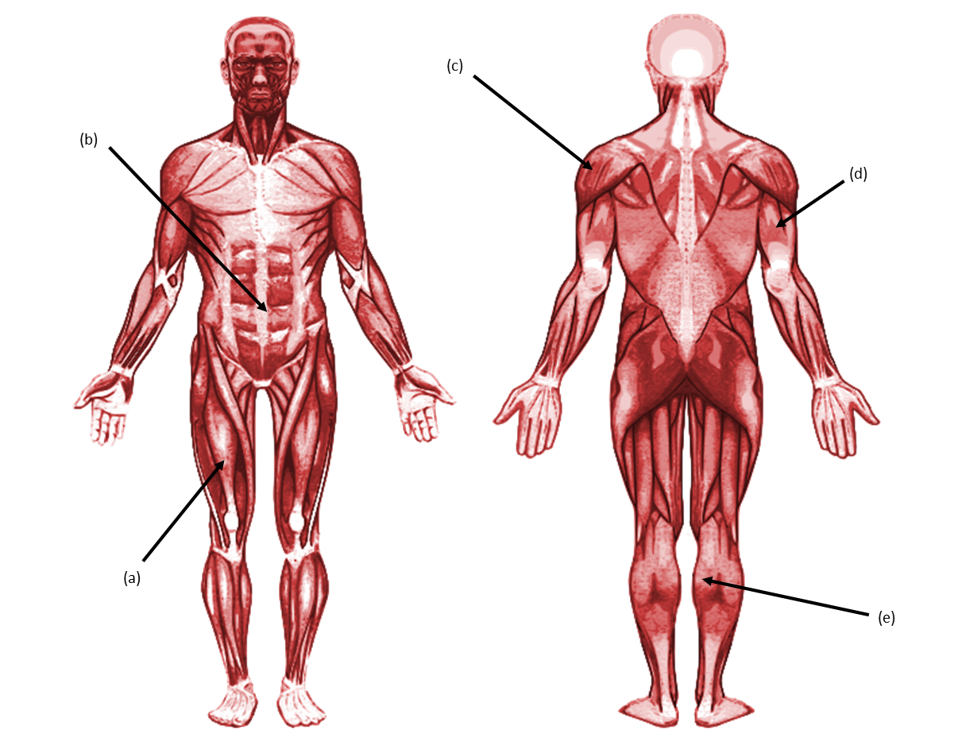

(b)

(c)

(d)

(e)

(a)

1. _____________________________________________
2. _____________________________________________
3. _____________________________________________
4. _____________________________________________
5. _____________________________________________
6. Outline **two** steps of the process by which muscles produce movement. (2 marks)

1. Outline the main function of the following: (3 marks)
2. capillaries

1. veins

1. heart

1. Describe the appearance of a person with the following somatotypes: (6 marks)
2. endomorphic

1. mesomorphic

1. ectomorphic

1. Provide **two** differences between extension and flexion. (2 marks)

1. List **three** places in the body where you would find smooth muscle tissue. (3 marks)

Marking key for sample assessment task 1 – Units 1 and 2

1. Identify the name of each anatomical plane described below.

|  |  |
| --- | --- |
| **Description** | **Marks** |
| One mark for each response:   1. sagittal plane 2. transverse plane 3. frontal plane | 1–3 |
| **Subtotal** | **/3** |

1. Describe the type of tissue from which tendons and ligaments are made, and outline the main function of each.

|  |  |
| --- | --- |
| **Description** | **Marks** |
| * Provides a detailed and accurate description of tendon and ligament tissue * Provides a basic description of tendon and ligament tissue   Answer must include:   * made of fibrous tissue * connective tissue | 2  1 |
| Tendon function – attaches muscle to bone  Ligament function – attaches bone to bone | 1–2 |
| **Subtotal** | **/4** |

1. Identify the bones indicated on the diagram below.

|  |  |
| --- | --- |
| **Description** | **Marks** |
| One mark each for:   1. humerus 2. radius 3. tibia 4. pelvis 5. femur | 1–5 |
| **Subtotal** | **/5** |

1. Identify the muscles indicated on the diagram below.

|  |  |
| --- | --- |
| **Description** | **Marks** |
| One mark each for:   1. quadriceps 2. abdominals 3. deltoid 4. triceps 5. soleus | 1–5 |
| **Subtotal** | **/5** |

1. Outline **two** steps of the process by which muscles produce movement.

|  |  |
| --- | --- |
| **Description** | **Marks** |
| Answer can include any **two** of:   * nerve impulse causing muscle shortening * muscle contracts * pulling action on the bone through the ligament   Accept other appropriate responses. | 1–2 |
| **Subtotal** | **/2** |

1. Outline the main function of the following:

|  |  |
| --- | --- |
| **Description** | **Marks** |
| One mark each for:   1. capillaries – exchange point for oxygen and carbon dioxide 2. veins – receive blood from capillaries and carry it to the heart 3. heart – distributes blood to and from the body and lungs | 1–3 |
| **Subtotal** | **/3** |

1. Describe the appearance of a person with the following somatotypes:

|  |  |
| --- | --- |
| **Description** | **Marks** |
| 1. endomorphic – fat deposits, pear-shaped body, wide hips and shoulders 2. mesomorphic – muscular, broad shoulders, minimal fat 3. ectomorphic – minimal muscle or fat, tall and thin, narrow shoulders and hips  * Provides a detailed and accurate description of each somatotype * Provides a basic description of each somatotype | 2  1 |
| **Subtotal** | **/6** |

1. Provide **two** differences between extension and flexion.

|  |  |
| --- | --- |
| **Description** | **Marks** |
| One mark each for:   * flexion – decreases the angle between two bones; brings bones closer together * extension – increases the angle between two bones; straightening motion   Accept other appropriate responses. | 1–2 |
| **Subtotal** | **/2** |

1. List **three** places in the body where you would find smooth muscle tissue.

|  |  |
| --- | --- |
| **Description** | **Marks** |
| One mark for each (maximum of three):   * blood vessels * stomach * intestines * bladder   Accept other appropriate responses. | 1–3 |
| **Subtotal** | **/3** |
| **Total** | **/33** |

Acknowledgements

**Sample assessment task**

**Task 1 – Units 1 and 2**

**Question 3** Adapted from: GregorDS. (2011). *Human Skeleton Diagram Trace* [Diagram]. Retrieved January, 2024, from <https://en.wikipedia.org/wiki/File:Human_skeleton_diagram_trace.svg>

**Question 4** Termininja. (2012). *Muscular System* [Diagram]. Retrieve January, 2024, from <https://commons.wikimedia.org/w/index.php?curid=20642029>  
Used under the [Creative Commons Attribution-Share Alike 3.0 Unported licence](https://creativecommons.org/licenses/by-sa/3.0/deed.en).

Termininja. (2012). *Muscular System-Back* [Diagram]. Retrieve January, 2024, from [*https://commons.wikimedia.org/wiki/File:Muscular_system-back.svg*](https://commons.wikimedia.org/wiki/File:Muscular_system-back.svg)Used under the [Creative Commons Attribution-Share Alike 3.0 Unported licence](https://creativecommons.org/licenses/by-sa/3.0/deed.en).