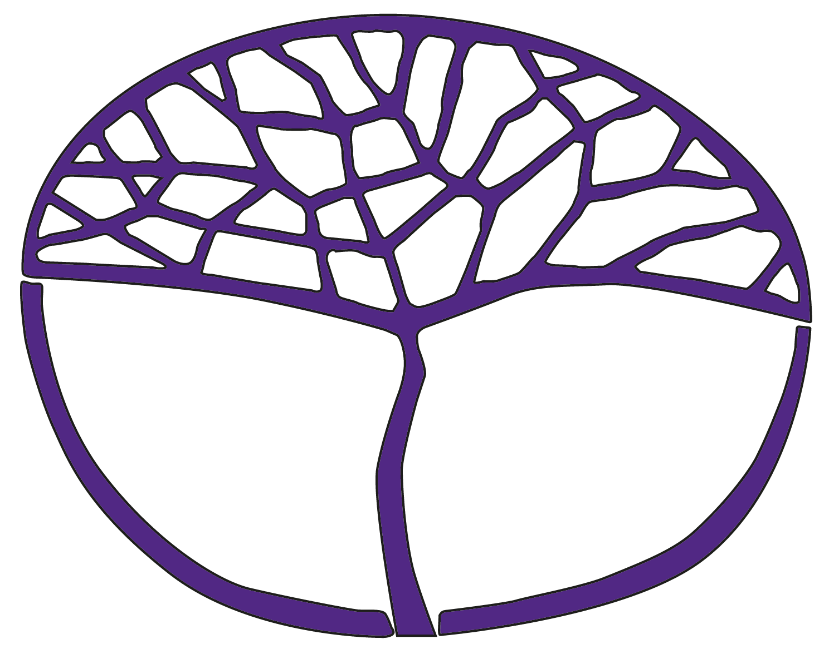Sample Course Outline

Human Biology

ATAR Year 11

**Acknowledgement of Country**

Kaya. The School Curriculum and Standards Authority (the Authority) acknowledges that our offices are on Whadjuk Noongar boodjar and that we deliver our services on the country of many traditional custodians and language groups throughout Western Australia. The Authority acknowledges the traditional custodians throughout Western Australia and their continuing connection to land, waters and community. We offer our respect to Elders past and present.

**Copyright**

© School Curriculum and Standards Authority, 2023

This document – apart from any third-party copyright material contained in it – may be freely copied, or communicated on an intranet, for non-commercial purposes in educational institutions, provided that the School Curriculum and Standards Authority (the Authority) is acknowledged as the copyright owner, and that the Authority’s moral rights are not infringed.

Copying or communication for any other purpose can be done only within the terms of the *Copyright Act 1968* or with prior written permission of the Authority. Copying or communication of any third-party copyright material can be done only within the terms of the *Copyright Act 1968* or with permission of the copyright owners.

Any content in this document that has been derived from the Australian Curriculum may be used under the terms of the [Creative Commons Attribution 4.0 International licence](https://creativecommons.org/licenses/by/4.0/).

**Disclaimer**

Any resources such as texts, websites and so on that may be referred to in this document are provided as examples of resources that teachers can use to support their learning programs. Their inclusion does not imply that they are mandatory or that they are the only resources relevant to the course. Teachers must exercise their professional judgement as to the appropriateness of any they may wish to use.

Sample course outline

Human Biology – ATAR Year 11

Unit 1 – The functioning human body

**Science Inquiry Skills**

All the following Science Inquiry Skills must be taught in each unit. The Science Inquiry Skills align with the Science Understanding and Science as a Human Endeavour content of the unit and are integrated throughout the learning experiences.

* identify, research and construct questions for investigation; propose hypotheses; and predict possible outcomes
* design investigations, including the procedure(s) to be followed, the materials required, and the type and amount of primary and/or secondary data to be collected; conduct risk assessments; and consider research ethics
* conduct investigations safely, competently and methodically for the collection of valid and reliable data
* represent data in meaningful and useful ways; organise and analyse data to identify trends, patterns and relationships; qualitatively describe sources of measurement error and limitations in data; and select, synthesise and use evidence to make and justify conclusions
* interpret a range of scientific and media texts, and evaluate processes, claims and conclusions by considering the quality of available evidence; and use reasoning to construct scientific arguments
* select, construct and use appropriate representations, including labelled diagrams and images of various cells, tissues and organ systems, to communicate conceptual understanding, solve problems and make predictions
* communicate to specific audiences, and for specific purposes, using appropriate language, nomenclature, genres and modes, including scientific reports

| Week | Key teaching points |
| --- | --- |
| 1–2 | **Cells and tissues**   * Hierarchical structural organisation of the body – cells, tissues, organs, systems * Microscopy   + microscopy techniques     - preparation of wet mount slide     - calculating magnification and field of view     - estimating cell size     - drawing labelled diagrams of cells observed under the microscope   Practical activity: Microscopy – observing cells   * Cell structure and function * Tissues   + structure and function – epithelial, connective, muscular, nervous   Practical activity: Microscopy – observing tissues |
| 3–4 | * Cell membrane   Practical activity: Properties of cell membranes   * + fluid mosaic model * Exchange of materials   + osmosis, simple diffusion, facilitated diffusion, active transport and vesicular transport   Practical activity: Diffusion  Practical activity: Osmosis   * Factors affecting exchange across cell membranes   + surface area to volume ratio, concentration gradients, physical and chemical properties   Practical activity: The effect of concentration gradients on exchange of materials |
| 5–6 | **Metabolism**   * Types of metabolism   + anabolism and catabolism * Requirements for efficient metabolism   + oxygen and nutrients (carbohydrates, proteins, lipids, vitamins and minerals) * Cellular respiration   + aerobic respiration     - location in cell, amount of energy (ATP) released   Practical activity: Aerobic respiration   * + anaerobic respiration     - location in cell, amount of energy (ATP) released   Practical activity: Anaerobic respiration   * Enzymes   + models for enzyme functioning – lock and key, induced fit   + factors affecting enzymes     - pH, temperature, inhibitors, co-enzymes, co-factors, concentration of reactants and products   Practical activity: The effect of temperature on enzyme activity  **Task 1:** Test – Cells, tissues and metabolism |
| 7 | **Respiratory system**   * Structure and function of the respiratory system * Characteristics for efficient gas exchange * Mechanics of breathing   Practical activity: Vital capacity |
| 8 | **Circulatory system**   * Structure and function of the heart   Practical activity: Heart dissection   * Structure and function of blood vessels * Components of blood and their function   Practical activity: Observing blood   * Function of the lymphatic system * Blood grouping and transfusions   Practical activity: Blood groups and transfusions  **Commence Task 2:** Investigation – Cardiovascular health in teenagers |
| 9 | **Digestive system**   * Structure of the digestive system * Function of the digestive system   + digestion – mechanical and chemical   Practical activity: Simulating digestion  Practical activity: The effect of pH on enzyme activity   * + absorption of nutrients   + elimination of wastes |
| 10–11 | **Excretory system**   * Function of the excretory system * Structure and function of the urinary system * Role of the nephron in urine formation and composition of body fluids   + Filtration, reabsorption and secretion   Practical activity: Modelling nephron function   * Diagnosis and treatment of kidney dysfunctions   **Submit Task 2:** Investigation – Cardiovascular health in teenagers |
| 12–14 | **Musculoskeletal system**   * Muscular system   + functions of the muscular system   + sliding filament theory   + action of paired muscles * Skeletal system   + functions of the skeleton   + axial skeleton   + appendicular skeleton   + bones     - microscopic structure   Practical activity: Observing bone tissue   * + - types of bones and their function   Practical activity: The anatomy of a long bone   * + joints     - function of joints     - types of joints – immovable, cartilaginous, synovial joints (structure of synovial joints)   Practical activity: Observing joints   * Osteoporosis and osteoarthritis   Practical activity: Modelling the effect of osteoporosis on bone strength  **Commence Task 3:** Extended response – Osteoporosisand osteoarthritis |
| 15 | Revision  **Submit Task 3:** Extended response – Osteoporosis and osteoarthritis |
| 16 | **Task 4:** Semester 1 examination |

Unit 2 – Reproduction and inheritance

**Science Inquiry Skills**

All the following Science Inquiry Skills must be taught in each unit. The Science Inquiry Skills align with the Science Understanding and Science as a Human Endeavour content of the unit and are integrated throughout the learning experiences.

* identify, research and construct questions for investigation; propose hypotheses; and predict possible outcomes
* design investigations, including the procedure(s) to be followed, the materials required, and the type and amount of primary and/or secondary data to be collected; conduct risk assessments; and consider research ethics
* conduct investigations safely, competently and methodically for the collection of valid and reliable data
* represent data in meaningful and useful ways; organise and analyse data to identify trends, patterns and relationships; qualitatively describe sources of measurement error and limitations in data; and select, synthesise and use evidence to make and justify conclusions
* interpret a range of scientific and media texts, and evaluate processes, claims and conclusions by considering the quality of available evidence; and use reasoning to construct scientific arguments
* select, construct and use appropriate representations, including models of DNA replication, transcription and translation, Punnett squares, pedigrees and karyotypes, to communicate conceptual understanding, solve problems and make predictions
* communicate to specific audiences, and for specific purposes, using appropriate language, nomenclature, genres and modes, including scientific reports

| Week | Key teaching points |
| --- | --- |
| 1–2 | **DNA**   * DNA structure and function   Practical activity: Make a DNA model   * DNA replication   Practical activity: Modelling DNA replication   * Protein synthesis   Practical activity: Modelling protein synthesis   * DNA and gene expression   + increased understanding through biotechnological techniques   + epigenetics |
| 3 | **Cell reproduction**   * Mitosis   + purpose of mitosis   + sequence     - DNA replication     - chromosome duplication     - chromosome separation     - production of daughter cells   Practical activity: Modelling mitosis   * Stem cell differentiation * Tumours and cancer, including technologies assisting early detection |
| 4–5 | * Meiosis   + purpose of meiosis   + sequence     - DNA replication     - chromosome pairing     - two nuclear divisions     - production of daughter cells (gametes)   Practical activity: Modelling meiosis   * Variation in gametes and genotypes result from   + crossing over   Practical activity: Modelling crossing over   * + non-disjunction   + random assortment   + fertilisation * Difference between mitosis and meiosis   Task 5: Practical – Observing mitosis |
| 6–7 | **Human reproduction**   * Structure and function of the male and female reproductive systems * Hormonal regulation   + male reproductive system   + female reproductive system, including menstrual cycle and ovarian cycles * Production of gametes   **Commence Task 6**: Extended response – Genetic screening |
| 8–9 | * Conception * Development of the embryo, including germ layers and placenta * Genetic screening, including risks and ethical considerations   + before implantation   + during early development     - blood tests     - ultrasound     - amniocentesis     - chorionic villi sampling   Practical activity: Interpreting karyotypes   * Stages of labour and birth, including changes in child’s circulatory system   **Submit** **Task 6:** Extended response – Genetic screening |
| 10–11 | * Contraception methods, including risks, benefits, limitations and ethical considerations   + fertility awareness   + steroid hormones   + physical barriers   + chemical spermicides   + sterilisation   + after coitus * Sexually transmitted infections   + prevention   + early detection   + treatment * Lifestyle choices affecting foetal development, including diet, illicit drugs, alcohol and nicotine * Assisted reproductive technologies, including risks, benefits and limitations |
| 12–14 | **Types of inheritance**   * Predicting genotypes and phenotypes   + Punnett squares * Patterns of inheritance   + dominance   + co-dominance   + autosomal (e.g. Huntington’s disease, PKU)   + sex linked traits (e.g. red-green colour blindness, haemophilia)   + multiple alleles (e.g. ABO blood groups) * Use of pedigree charts to reveal patterns of inheritance and make prediction for future generations   **Task 7:** Test – Human reproduction and types of inheritance |
| 15 | Revision |
| 16 | **Task 8:** Semester 2 examination |