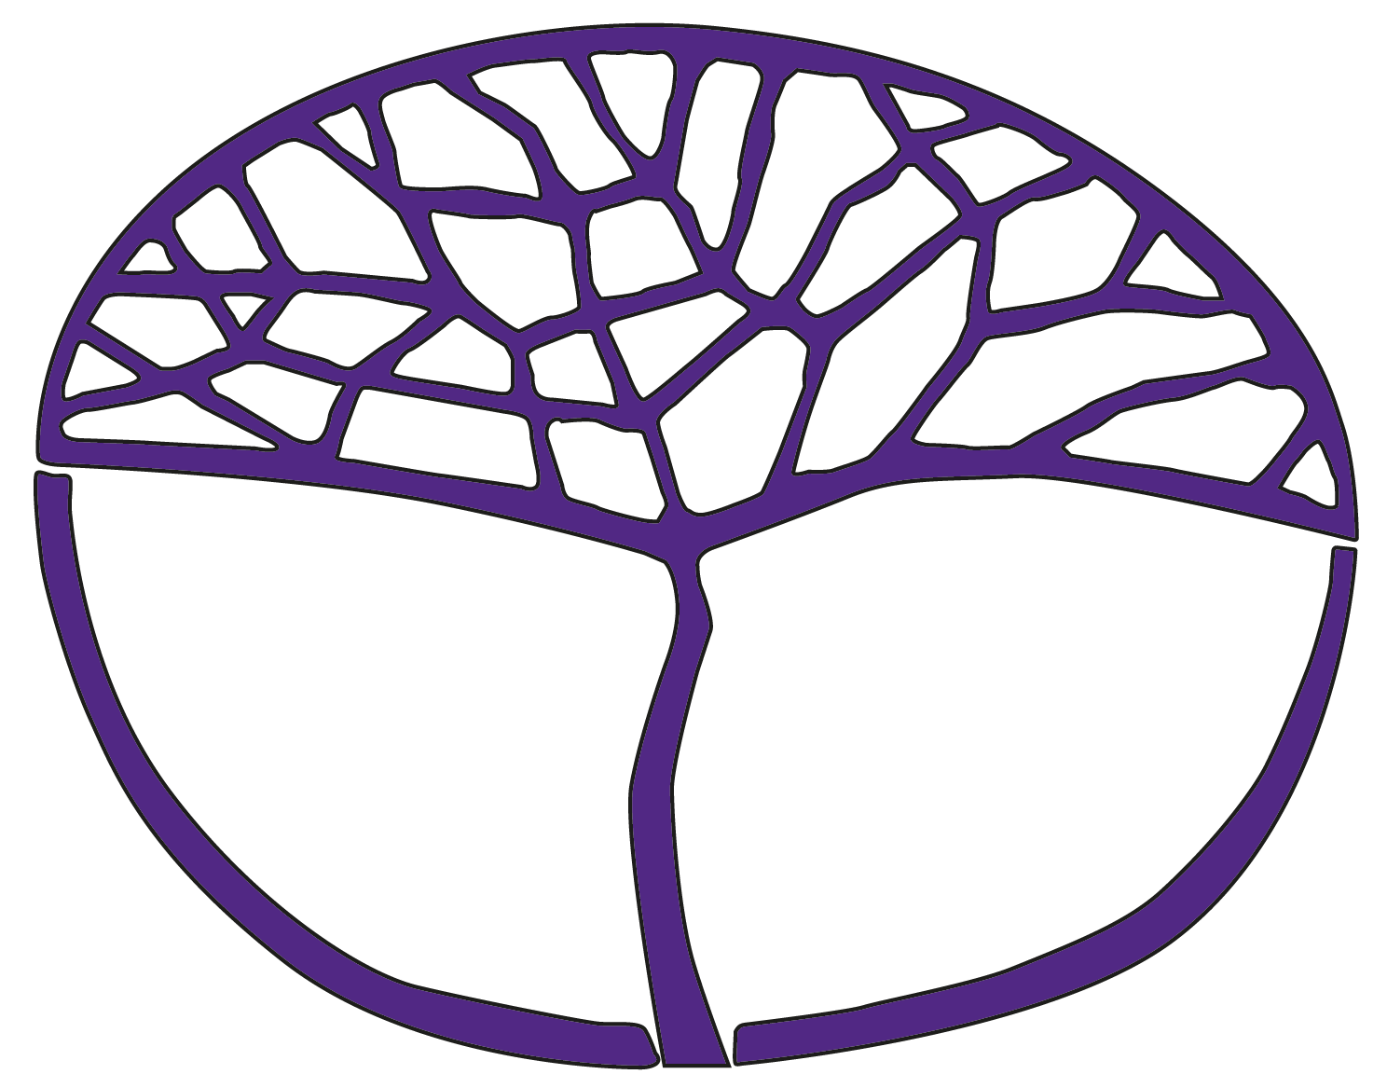Sample Assessment Outline

Modern History

ATAR Year 12

Unit 3 – Elective 2: Russia and the Soviet Union 1914–45 (World War I to the end of World War II)

Unit 4 – Elective 1: The changing European world since 1945

**Acknowledgement of Country**

Kaya. The School Curriculum and Standards Authority (the Authority) acknowledges that our offices are on Whadjuk Noongar boodjar and that we deliver our services on the country of many traditional custodians and language groups throughout Western Australia. The Authority acknowledges the traditional custodians throughout Western Australia and their continuing connection to land, waters and community. We offer our respect to Elders past and present.

**Copyright**

© School Curriculum and Standards Authority, 2024

This document – apart from any third-party copyright material contained in it – may be freely copied, or communicated on an intranet, for non-commercial purposes in educational institutions, provided that the School Curriculum and Standards Authority (the Authority) is acknowledged as the copyright owner, and that the Authority’s moral rights are not infringed.

Copying or communication for any other purpose can be done only within the terms of the *Copyright Act 1968* or with prior written permission of the Authority. Copying or communication of any third-party copyright material can be done only within the terms of the *Copyright Act 1968* or with permission of the copyright owners.

Any content in this document that has been derived from the Australian Curriculum may be used under the terms of the [Creative Commons Attribution 4.0 International licence](https://creativecommons.org/licenses/by/4.0/).

**Disclaimer**

Any resources such as texts, websites and so on that may be referred to in this document are provided as examples of resources that teachers can use to support their learning programs. Their inclusion does not imply that they are mandatory or that they are the only resources relevant to the course. Teachers must exercise their professional judgement as to the appropriateness of any they may wish to use.

Sample assessment outline – Modern History – ATAR Year 12

Unit 3 – Elective 2: Russia and the Soviet Union 1914–45 (World War I to the end of World War II)

Unit 4 – Elective 1: The changing European world since 1945

| **Assessment type  (from syllabus)** | **Assessment  type weighting  (from syllabus)** | Assessment task weighting | **When/start and submission date** | **Assessment task** |
| --- | --- | --- | --- | --- |
| **Historical inquiry** | 20% | 10% | Semester 1  Issue: Week 2  Submission: Week 4  In-class validation: Week 4 | **Task 1 Part A:** The historical inquiry process.  Topic: Internal divisions and crises in Russian society, with a particular focus on the causes and events of the February and October Revolutions in 1917.  **Task 1 Part B:** An in-class validation source analysis completed in 35 minutes.  Source material from Part A may be used. |
| 10% | Semester 2  Issue: Week 8  Submission: Week 11  In-class validation: Week 11 | **Task 6 Part A:** The historical inquiry process.  Topic: The role of significant political leaders throughout the period.  **Task 6 Part B:** An in-class validation explanation completed in 50 minutes.  Research notes may NOT be used. |
| **Explanation** | 20% | 10% | Semester 1, Week 9 | Task 2: An in-class explanation completed in 60 minutes under test conditions.  Topic: The economic changes that transformed Russia/USSR to 1945. |
| 10% | Semester 2, Week 5 | Task 5: An in-class explanation completed in 55 minutes under test conditions.  Topic: The shaping of Europe post-World War Two. |
| **Source analysis** | 20% | 10% | Semester 1, Week 12 | **Task 3:** An in-class source analysis. Sources are based on content related to a significant idea (Stalinism) and the methods employed by the Stalinist regime to control society. |
| 10% | Semester 2, Week 10 | **Task 7:** An in-class source analysis. Sources are based on content related to the collapse of the Communist Bloc, breakup of the Soviet Union and the reunification of Germany. |
| Examination | 40% | 15% | Semester 1, Week 16 | Task 4: Semester 1 examination (3 hours) using the examination design brief from the ATAR Year 12 syllabus. Only content from Unit 3 will be assessed. |
| 25% | Semester 2, Week 16 | Task 8: Semester 2 examination (3 hours) using the examination design brief from the ATAR Year 12 syllabus. Content from Unit 3 and Unit 4 will be assessed. |
| Total | 100% | 100% |  |  |