Design ATAR course practical (portfolio) examination 2024
References/acknowledgements
WA student number:
Instructions to candidate
As a candidate of this examination, you must acknowledge sources of information (references, appropriations, attributions) used in your practical portfolio submitted for assessment.
References and acknowledgements must include:
- all sources (i.e. another person’s ideas, works or images) used in the investigation and development of design concepts. All images obtained from the internet must be provided and the URL cited as shown in the example below
- the name of the CAD software package and/or graphics editing software used throughout the practical (portfolio) examination submission.
All acknowledgements provided on this form must be typed using 11 point Arial font.
Examples of completed tables
Software program used | Design use of software
Adobe Photoshop | Photo editing and manipulation
Adobe InDesign | Portfolio layout
Autodesk Revit | 3D model construction and rendering

Thumbnail of image used | Page it appears in the portfolio | Current authentic and specific URL
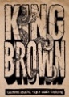 | 2 | https://blog.urbanoutfitters.com/blog/king_brown_magazine_issue_8_launch_exhibition
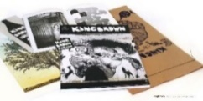 | 6 | http://www.trespassmag.com/interview-ian-mutch/
Tables for candidate to complete
Software program used | Design use of software

Thumbnail of image used | Page it appears in the portfolio | Current authentic and specific URL
 As a candidate of this examination, I acknowledge that all other work not listed above is my own.

