Building and Construction
General course

Externally set task
Sample 2016

Note: This Externally set task sample is based on the following content from Unit 3 of the General Year 12 syllabus.
Drafting
- read and draw plans utilising fundamentals of practical geometry with orthogonal projection and industry conventions
- estimate quantities
  - perimeter of drawn shapes
  - area of drawn shapes
  - volume of materials
- recognise and use industry specific conventions and building and construction terminology
  - set out construction tasks using string lines and formwork
Properties and selection
- material properties, including: hardness, elasticity, conductivity, flexibility and strength
- natural and pre-made construction materials, such as timber, metals, soil types, masonry, plastics and glass appropriate for different applications
Working with materials
- wood or metal frames and structures, including supportive trusses in construction
- different types of materials and construction methods
In future years, this information will be provided late in Term 3 of the year prior to the conduct of the Externally set task. This will enable teachers to tailor their teaching and learning program to ensure that the content is delivered prior to the students undertaking the task in Term 2 of Year 12.

Copyright
© School Curriculum and Standards Authority, 2014
This document – apart from any third party copyright material contained in it – may be freely copied, or communicated on an intranet, for non-commercial purposes in educational institutions, provided that the School Curriculum and Standards Authority is acknowledged as the copyright owner, and that the Authority’s moral rights are not infringed.
Copying or communication for any other purpose can be done only within the terms of the Copyright Act 1968 or with prior written permission of the School Curriculum and Standards Authority. Copying or communication of any third party copyright material can be done only within the terms of the Copyright Act 1968 or with permission of the copyright owners.
Any content in this document that has been derived from the Australian Curriculum may be used under the terms of the Creative Commons Attribution-NonCommercial 3.0 Australia licence
Disclaimer
Any resources such as texts, websites and so on that may be referred to in this document are provided as examples of resources that teachers can use to support their learning programs. Their inclusion does not imply that they are mandatory or that they are the only resources relevant to the course.

Building and Construction

Externally set task
Working time for the task: 60 minutes
Total marks: 28 marks
Weighting: 15% of the school mark

You have been employed to replace a wooden pergola attached to the rear of a single storey house. The current pergola extends 6 m along the house and projects 3m out from the house. Termites have damaged one post and the main beam. These will need to be replaced.

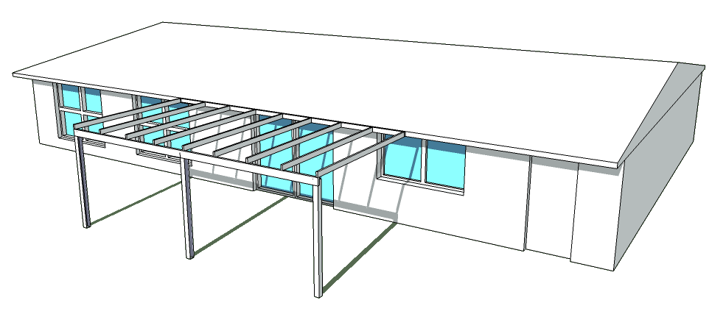
After inspecting the current pergola you notice that the posts are fixed directly into the ground with no footings or fastenings. You have made the judgement from the way the posts are done that the pergola was most likely erected as a DIY job.

1(a) The owner has pointed out the termite damage to you. Besides this damage, you need to assess the complete pergola structure for suitability and compliance before agreeing to undertake any repair work. Describe three (3) items from either the materials used, the construction methods or the compliance issues that you would check. (3 marks)
Item one ________________________________________________________________________
Item two ________________________________________________________________________
Item three _______________________________________________________________________

(b) Sketch a sectional detail of a correct method for fixing a pergola post to the ground. Show the ground in the diagram in relation to the fixing, and include all necessary symbols to show ground or fill, and materials used. (8 marks)

(c) From your detailed sketch in Question (b), list all of the materials that you would use to fix the post in place. For each material, describe its most important property in this application. (8 marks)
Material | Properties

The diagram shows a proposed courtyard. This sketch is not to scale.
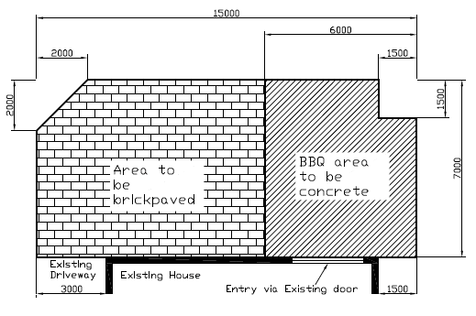

In the construction of the courtyard, one area is to be paved. The remainder of the courtyard will be a barbecue area to be concreted with a 125 mm thick slab.

2(a) Calculate the area, in square metres (m²), of the barbecue area. (4 marks)
________________________________________________________________________________
________________________________________________________________________________
________________________________________________________________________________
________________________________________________________________________________
________________________________________________________________________________
________________________________________________________________________________
________________________________________________________________________________
________________________________________________________________________________

(b) Calculate the volume of concrete (m³) to order for the barbecue area. (3 marks)
________________________________________________________________________________
________________________________________________________________________________
________________________________________________________________________________
________________________________________________________________________________
________________________________________________________________________________
________________________________________________________________________________
(c) Identify one possible hazard and safety control measure that may be encountered in the construction of the courtyard. (2 marks)
________________________________________________________________________________
________________________________________________________________________________
________________________________________________________________________________
________________________________________________________________________________
________________________________________________________________________________

