Sample Assessment Tasks

Humanities and Social Sciences in Action

General Year 11

**Acknowledgement of Country**

Kaya. The School Curriculum and Standards Authority (the Authority) acknowledges that our offices are on Whadjuk Noongar boodjar and that we deliver our services on the country of many traditional custodians and language groups throughout Western Australia. The Authority acknowledges the traditional custodians throughout Western Australia and their continuing connection to land, waters and community. We offer our respect to Elders past and present.

**Copyright**

© School Curriculum and Standards Authority, 2023

This document – apart from any third-party copyright material contained in it – may be freely copied, or communicated on an intranet, for non-commercial purposes in educational institutions, provided that the School Curriculum and Standards Authority (the Authority) is acknowledged as the copyright owner, and that the Authority’s moral rights are not infringed.

Copying or communication for any other purpose can be done only within the terms of the *Copyright Act 1968* or with prior written permission of the Authority. Copying or communication of any third-party copyright material can be done only within the terms of the *Copyright Act 1968* or with permission of the copyright owners.

Any content in this document that has been derived from the Australian Curriculum may be used under the terms of the [Creative Commons Attribution 4.0 International licence](https://creativecommons.org/licenses/by/4.0/).

**Disclaimer**

Any resources such as texts, websites and so on that may be referred to in this document are provided as examples of resources that teachers can use to support their learning programs. Their inclusion does not imply that they are mandatory or that they are the only resources relevant to the course. Teachers must exercise their professional judgement as to the appropriateness of any they may wish to use.

Sample assessment task

Humanities and Social Sciences in Action – General Year 11

Task 1 – Unit 1 – All humans have rights

**Assessment type** Commentary

**Conditions** Four entries over the course of the unit

**Task weighting** 15% for the pair of units

The context for this Commentary task is the ongoing social action for human rights for Aboriginal and Torres Strait Islander Peoples. It is based on the timings in the sample course outline. The content is drawn from all the Unit 1 content.

Over the course of Unit 1, complete the structured overview on the next page.

Note: the following Commentary structured overview should be provided to students either as a hard copy (A3 sheet) or in an electronic format.

The timing of each entry reflects the Unit 1 syllabus content in the course outline as follows:

* Entry 1 – Week 5
* Entry 2 – Week 7
* Entry 3 – Week 10
* Entry 4 – Week 13.

**Commentary structured overview**

|  |  |
| --- | --- |
| **Entry 1:** Describe **two** facts you have learned about human rights in Australia.  (4 marks) | Develop **two** open-ended questions about the actions taken to improve access to human rights in Australia which you would like to investigate.  (4 marks) |

|  |  |
| --- | --- |
| **Entry 2:** Describe **two** facts you have learned about the access to human rights of Aboriginal and Torres Strait Islander Peoples in the past.  (4 marks) | Explain **two** ways this learning has supported or challenged your thinking.  (6 marks)   * I used to think… * Now, I think… * Because… |
| **Entry 3:** Describe **two** examples of contemporary social action/movement designed to improve the human rights access of Aboriginal and Torres Strait Islander Peoples.  (4 marks) | Evaluate, with evidence, which of the two examples has been more effective in the pursuit of the access to human rights of Aboriginal and Torres Strait Islander Peoples.  (5 marks) |
| **Entry 4:** Describe **two** ways the Black Lives Matter movement has brought about social change.  (4 marks) | Explain **two** pieces of evidence that assess the effectiveness of the Black Lives Matter movement.  (7 marks) |
| Reflect on your learning over the course of this unit. Summarise how your thinking about the fight for Aboriginal and Torres Strait Islander Peoples’ human rights has been supported or challenged.  Use information from Entries 1–4 to support your response.  (8 marks) | |

Marking key for sample assessment task 1 – Unit 1

The purpose of the Commentary assessment type is to assess students’ abilities to draw conclusions and reflect on their learning.

Entry 1:

Describe **two** facts you have learned about human rights in Australia. (4 marks)

|  |  |
| --- | --- |
| **Description** | **Marks** |
| **For each fact (2 x 2 marks)** | |
| Describes a fact about human rights in Australia | 2 |
| Makes a general statement about human rights in Australia | 1 |
| Subtotal | **/2** |
| Total | **/4** |

Develop **two** open-ended questions about the actions taken to improve access to human rights in Australia which you would like to investigate. (4 marks)

|  |  |
| --- | --- |
| **Description** | **Marks** |
| **For each question (2 x 2 marks)** | |
| Develops a relevant and appropriate open-ended question, which clearly relates to access to human rights in Australia | 2 |
| Develops a question, which relates partially to access to human rights in Australia | 1 |
| Subtotal | **/2** |
| Total | **/4** |

Entry 2:

Describe **two** facts you have learned about the access to human rights of Aboriginal and Torres Strait Islander Peoples in the past. (4 marks)

|  |  |
| --- | --- |
| **Description** | **Marks** |
| **For each fact (2 x 2 marks)** | |
| Describes a fact about the access to human rights of Aboriginal and Torres Strait Islander Peoples | 2 |
| Makes a general statement about the access to human rights of Aboriginal and Torres Strait Islander Peoples | 1 |
| Subtotal | **/2** |
| Total | **/4** |

Explain **two** ways this learning has supported or challenged your thinking. (6 marks)

|  |  |
| --- | --- |
| **Description** | **Marks** |
| **For each way learning has changed thinking (2 x 3 marks)** | |
| Explains how the information learned has supported or challenged thinking with reference to relevant supporting evidence | 3 |
| Describes how the information learned has supported or challenged thinking with reference to some supporting evidence | 2 |
| Makes a general statement with limited or irrelevant evidence to support the development in thinking | 1 |
| Subtotal | **/3** |
| Total | **/6** |

Entry 3:

Describe **two** examples of contemporary social action/movement designed to improve the human rights access of Aboriginal and Torres Strait Islander Peoples. (4 marks)

|  |  |
| --- | --- |
| **Description** | **Marks** |
| **For each example (2 x 2 marks)** |  |
| Describes a contemporary example of social action/movement to improve the rights access of Aboriginal and Torres Strait Islander Peoples | 2 |
| Makes a general statement about a contemporary example of social action/movement to improve the rights access of Aboriginal and Torres Strait Islander Peoples | 1 |
| Subtotal | **/2** |
| Total | **/4** |

Evaluate, with evidence, which of the two examples has been more effective in the pursuit of the access to human rights of Aboriginal and Torres Strait Islander Peoples. (5 marks)

|  |  |
| --- | --- |
| **Description** | **Marks** |
| Identifies which social action/movement was more effective in the pursuit of access to human rights | 1 |
| **Subtotal** | **/1** |
| **Using evidence to show which social action was more effective** | |
| Evaluates how the chosen piece of evidence supports their conclusion | 4 |
| Explains how the chosen piece of evidence supports their conclusion | 3 |
| Describes how the chosen piece of evidence supports their conclusion | 2 |
| Identifies an appropriate piece of evidence to support their conclusion | 1 |
| Subtotal | **/4** |
| Total | **/5** |

Entry 4:

Describe **two** ways the Black Lives Matter Movement has brought about social change for Aboriginal and Torres Strait Islander Peoples. (4 marks)

|  |  |
| --- | --- |
| **Description** | **Marks** |
| **For each way the Black Lives Matter Movement has brought about social change (2 x 2 marks)** | |
| Describes a way the Black Lives Matter Movement has brought about social change for Aboriginal and Torres Strait Islander Peoples | 2 |
| Makes a general statement about a way the Black Lives Matter Movement has brought about social change for Aboriginal and Torres Strait Islander Peoples | 1 |
| Subtotal | **/2** |
| Total | **/4** |

Explain **two** pieces of evidence that assess the effectiveness of the Black Lives Matter movement.   
 (7 marks)

|  |  |
| --- | --- |
| **Description** | **Marks** |
| Identifies whether the Black Lives Matter movement has been effective | 1 |
| **Subtotal** | **/1** |
| **For each piece of evidence (2 x 3 marks)** | |
| Explains how the chosen piece of evidence supports a conclusion on the effectiveness of the Black Lives Matter movement | 3 |
| Describes how the chosen piece of evidence supports a conclusion on the effectiveness of the Black Lives Matter movement | 2 |
| Identifies appropriate piece of evidence to determine the effectiveness of the Black Lives Matter movement | 1 |
| Subtotal | **/6** |
| Total | **/7** |

Reflect on your learning over the course of this unit. Summarise how your thinking about the fight for Aboriginal and Torres Strait Islander Peoples’ human rights has been supported or challenged.

Use information from Entries 1–4 to support your response. (8 marks)

|  |  |
| --- | --- |
| **Description** | **Marks** |
| Summarises and draws conclusions about how their thinking has been supported or challenged and the reasons why their thinking has developed across the unit, using supporting examples and evidence  Selects and applies terminology and concepts | 7–8 |
| Explains and draws simple conclusions about how their thinking has been supported or challenged and some reasons why their thinking has developed across the unit, using examples and evidence  Uses terminology and concepts | 5–6 |
| Describes how their thinking has been supported or challenged across the unit and suggests a reason why their thinking has developed, using some examples and evidence  Uses some terminology and concepts | 3–4 |
| Makes an attempt to show that their thinking has been supported or challenged throughout the unit with limited reference to the reasons why their thinking has developed, using limited examples and evidence  Uses limited terminology and concepts | 1–2 |
| Total | **/8** |
| Assessment total | **/46** |

Sample assessment task

Humanities and Social Sciences in Action – General Year 11

Task 2 – Unit 1 – All humans have rights

**Assessment type** Response

**Conditions** One class period under test conditions

**Task weighting** 10% for the pair of units

Use the 2018 Gender Equality infographic published by the Australian Human Rights Commission to answer the questions below.

1. Describe **two** roles of the Human Rights Commission. (4 marks)

1. Identify **one** piece of evidence from the 2018 infographic that suggests gender equality has declined and **one** piece of evidence that suggest gender equality has improved. (2 marks)

1. Identify **three** examples of gender inequality in the workplace shown in the 2018 infographic.  
    (3 marks)

Use the 2023 Australian Government Status of Women Report Card to answer the questions below.

1. Using data from the Australian Government Status of Women Report Card, explain the gender pay gap between men and women in Australia in 2023. (4 marks)

1. Identify **two** demographic factors from the Status of Women Report Card that could create further challenges for women to access their human rights. (2 marks)

1. With reference to both the Gender Equality infographic published by the Australian Human Rights Commission in 2018 and the 2023 Australian Government Status of Women Report Card, evaluate whether women’s access to human rights has improved or worsened between 2018 and 2023. (5 marks)

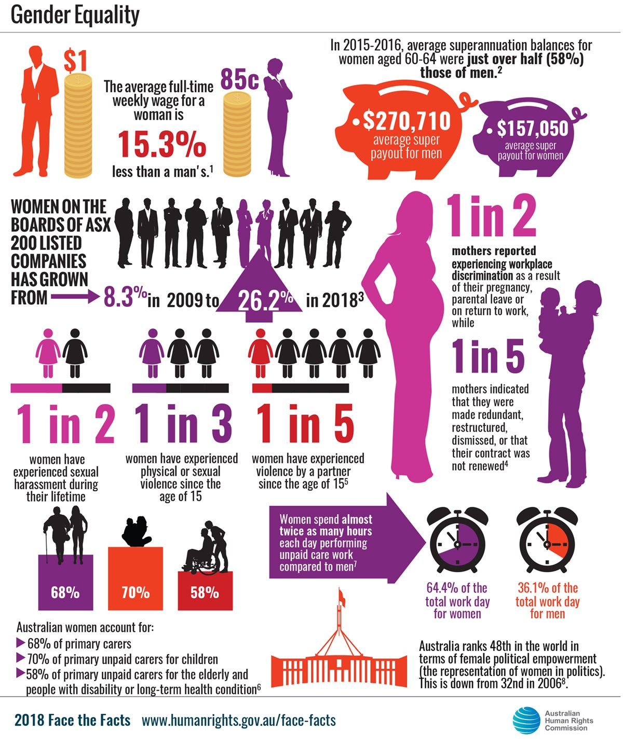

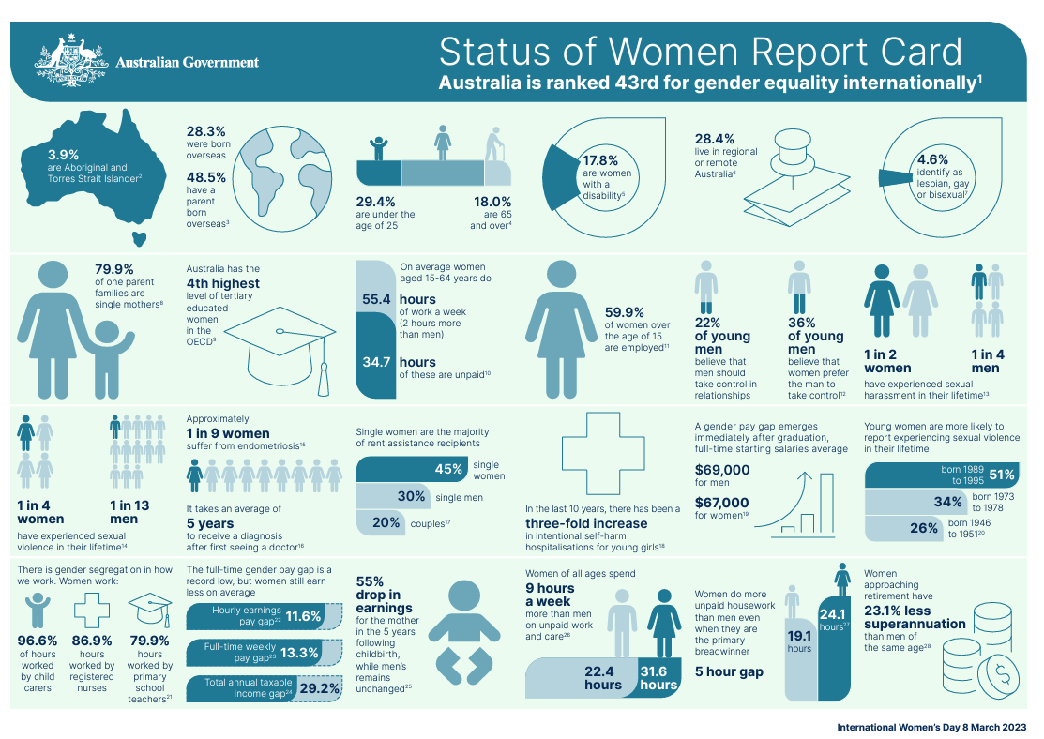

**Source:** <https://genderequality.gov.au/status-women-report-cards/2023-report-card>

Marking key for sample assessment task 2 - Unit 1

1. Describe **two** roles of the Human Rights Commission. (4 marks)

|  |  |
| --- | --- |
| **Description** | **Marks** |
| For each role of the Human Rights Commission (2 x 2 marks) | |
| Describes a role of the Human Rights Commission | 2 |
| Identifies a role of the Human Rights Commission | 1 |
| **Subtotal** | **/2** |
| **Total** | **/4** |
| **Answers may include** | |
| * to investigate and resolve human rights complaints * to lobby government for human rights to be considered in policy, and make submissions to parliamentary inquiries * to raise awareness of human rights in Australia through various event platforms and educational resources * to research human rights and discrimination issues in Australia * to provide legal advice on human rights to courts * to create guidelines for employers, and provide training to assist organisations in supporting diversity and inclusion in their workplaces and supply chains * to monitor Australia’s performance in meeting its international human rights commitments | |
| Accept other relevant answers | |

1. Identify **one** piece of evidence from the 2018 infographic that suggests gender equality has declined and **one** piece of evidence that suggest gender equality has improved. (2 marks)

|  |  |
| --- | --- |
| **Description** | **Marks** |
| Identifies one piece of evidence suggesting gender inequality has declined | 1 |
| Identifies one piece of evidence suggesting gender inequality has improved | 1 |
| **Total** | **/2** |
| **Answers may include** | |
| One piece of evidence equality has declined:   * Australia ranks 48th in the world in terms of female political empowerment (the representation of women in politics). This is down from 32nd in 2006.   One piece of evidence equality has improved:   * The number of women on the boards of ASX 200-listed companies has grown from 8.3% in 2009 to 26.2% in 2018. | |
| Accept other relevant answers | |

1. Identify **three** examples of gender inequality in the workplace shown in the 2018 infographic.  
    (3 marks)

|  |  |
| --- | --- |
| **Description** | **Marks** |
| For each example (3 x 1 mark) | |
| Identifies an example of workplace gender inequality shown in the infographic | 1 |
| **Subtotal** | **/1** |
| **Total** | **/3** |
| **Answers may include** | |
| * the average full-time weekly wage for a woman is 15.3% less than a man’s * 1 in 2 mothers reported experiencing workplace discrimination as a result of their pregnancy, parental leave or on return to work * in 2015–16, average superannuation balances for women aged 60–64 were just over half (58%) those of men | |
| Accept other relevant answers | |

1. Using data from the Australian Government Status of Women Report Card, explain the gender pay gap between men and women in Australia in 2023. (4 marks)

|  |  |
| --- | --- |
| **Description** | **Marks** |
| Explains the gender pay gap with extensive use of data from the Status of Women Report Card | 4 |
| Explains the gender pay gap using some data from the Status of Women Report Card | 3 |
| Describes the gender pay gap with limited use of data from the Status of Women Report Card | 2 |
| Makes a comment about the gender pay gap | 1 |
| **Total** | **/4** |
| **Answers may include** | |
| * the gender pay gap of $2 000 emerges immediately after graduation * gender pay gap is 11.6% hourly, 13.3% weekly and 29.2% annually * women spend on average nine hours per week doing unpaid care work and five hours a week of unpaid care work when they are the primary breadwinner * there is a 55% drop in earnings for women in the five years following childbirth while men’s income remains unchanged * women approaching retirement have 23.1% less superannuation than men of the same age   Students do not require all the gender pay gap data points to receive full marks; they should identify some data and explain how that data demonstrates the gender pay gap. | |
| Accept other relevant answers | |

1. Identify **two** demographic factors from the Status of Women Report Card that could create further challenges for women to access their human rights. (2 marks)

|  |  |
| --- | --- |
| **Description** | **Marks** |
| Identifies two factors that could create further disadvantage for women | 2 |
| Identifies one factor that could create further disadvantage for women | 1 |
| **Total** | **/2** |
| **Answers may include** | |
| * born overseas * Aboriginal and Torres Strait Islander * over the age of 65 * living in regional or remote areas * identify as lesbian, gay or bisexual | |
| Accept other relevant answers | |

1. With reference to both the Gender Equality infographic published by the Australian Human Rights Commission in 2018 and the 2023 Australian Government Status of Women Report Card, evaluate whether women’s access to human rights has improved or worsened between 2018   
   and 2023. (5 marks)

|  |  |
| --- | --- |
| **Description** | **Marks** |
| Evaluates the ways in which rights have improved or worsened, using a range of evidence from the sources to support their position | 5 |
| Discusses the ways in which rights have improved or worsened, using evidence from the sources to support their position | 4 |
| Explains whether rights have improved or worsened, using some evidence from the sources to support their position | 3 |
| Describes whether rights have improved or worsened, with limited use of evidence from the sources to support their position | 2 |
| Makes a statement identifying whether rights have improved or worsened | 1 |
| **Total** | **/5** |
| **Answers may include** | |
| Evidence women’s rights have improved:   * narrowing of weekly gender pay gap from 15.3% in 2018 to 13.3% in 2023 – this is a record low * fewer women have experienced sexual violence; one in three in 2018 compared to one in four in 2023   Evidence women’s rights have remained the same:   * in both 2018 and 2023, one in two women said they had experienced sexual harassment   Evidence human rights have worsened:   * women continue to work 55 hours a week with 34 of those hours unpaid – which is twice as many as men | |
| Accept other relevant answers | |
| **Assessment total** | **/20** |

Sample assessment task

Humanities and Social Sciences in Action – General Year 11

Task 5 – Unit 2 – Sense of community

**Assessment type** Commentary

**Conditions** Four entries over the course of the unit

**Task weighting** 15% for the pair of units

The context for this Commentary task is homelessness services and Foodbank. It is based on the timings in the sample course outline. The content is drawn from all the Unit 2 content.

**Entry 1, Week 2: KWL Chart**

Complete a KWL chart at the beginning of the Overview and end of Focus Area 2.

**At the beginning of Focus Area 1**

When completing the ‘K’ column, answer the following questions:

* What is a community?
* Why are communities important?
* What social issues occur in your local community?
* How are the social issues addressed?
* How do communities change over time?

To complete the ‘W’ column, write **four** open-ended questions that you would like to explore.

**At the end of Focus Area 2**

Complete the ‘L’ column by:

* answering your questions from the ‘W’ column
* explaining **two** facts you learned during the unit about community services and community initiatives.

**Entry 2, Week 5: Perspectives on managing community resources**

**Lesson activity**

Studentsread and discuss the following article, which explores perspectives of various stakeholders about the potential closure of Ruah’s Safe Night Space for women:  
ABC News – ‘Ruah’s Safe Night Space has been keeping vulnerable women off the streets, but not for much longer’ by Keane Bourke   
<https://www.abc.net.au/news/2023-11-21/looming-closure-of-east-perth-safe-night-space-for-women/103120846>

**Commentary entry**

Create two social media posts from the perspectives of two different stakeholders regarding the City of Perth’s decision to close the women’s refuge at the Rod Evans Community Centre. The social media posts can be for any platform and may include images, audio and/or video. Comment on which of your two social media posts most closely aligns with your perspective on the issue.

**Entry 3, Week 8: Homelessness documentary**

**Lesson activity**

View a documentary about homelessness in Australia, such as:

* ABC *Four Corners* – No Place to Call Home: The new face of homelessness in Australia, broadcast 3 October 2022  
  <https://www.abc.net.au/news/2022-10-03/no-place-to-call-home/14072740>
* *Under Cover*   
  https://www.undercoverdocumentary.com/  
  Note: documentary about female homelessness narrated by Margot Robbie
* *The Oasis*  
  <https://theoasismovie.com.au/>   
  Note: documentary that follows the lives of homeless youth in a program run by the Salvation Army
* *Filthy Rich & Homeless*  
  <http://blackfellafilms.com.au/project/filthy-rich-homeless/>

**Commentary entry**

At the end of the video, students record a two-minute verbal summary of their learning to include as part of their commentary. The commentary entry is to include answers to a minimum of **two** of the following questions:

* What are the causes of homelessness mentioned in the documentary?
* What are the effects of homelessness mentioned in the documentary?
* What strategies are being used to address homelessness?
* How could these strategies be applied to your local community?

All commentary entries must address this question:

* How did the documentary support and/or challenge what you have learned?

**Entry 4, Week 12: Participating in social action**

**Lesson activity**

Students work with a provider of a community initiative either organised by the teacher (e.g. the class volunteering for an afternoon with a local community group) or through their own contacts in the community (e.g. volunteering to work in the canteen at a local sporting club).

**Commentary entry**

Share in a group of 2–4 what you learned from working with the service provider. As part of the commentary entry, reflect on:

* how you were feeling in the lead-up to working with the service provider
* the reasons the people you were working with are involved in the community initiative
* how the service improves liveability in the community
* how the community initiative could be improved or adapted for other communities
* how your perspective on the community initiative and its users has changed.

Choose an appropriate format for your commentary entry. Some suggestions include an audio recording of your group’s discussion, a written record of each person’s ‘take home’ message or a collection of photographs with captions documenting the impacts of the initiative on their community.

Marking key for sample assessment task 5 – Unit 2

The purpose of the Commentary assessment type is to assess students’ abilities to draw conclusions and reflect on their learning.

| **Description** | **Marks** |
| --- | --- |
| **Knowledge and understanding** | |
| Accurately evaluates structures, systems and processes related to communities and homelessness | 4 |
| Explains structures, systems and processes related to communities and homelessness | 3 |
| Describes structures, systems and processes related to communities and homelessness | 2 |
| Makes statements about structures, systems and processes related to communities and homelessness | 1 |
| Subtotal | **/4** |
| **Terminology** | |
| Selects and accurately applies terminology and concepts to develop accurate and relevant commentary entries on the community services and initiatives | 4 |
| Uses terminology and concepts to develop relevant commentary entries on the community services and initiatives | 3 |
| Uses some terminology to develop commentary entries on the community services and initiatives | 2 |
| Makes limited use of terminology to develop commentary entries on the community services and initiatives | 1 |
| **Subtotal** | **/4** |
| **Communication formats** | |
| Selects and uses appropriate communication formats to present findings | 3 |
| Uses appropriate communication formats to present findings | 2 |
| Demonstrates an attempt to use an appropriate communication format to present findings | 1 |
| Subtotal | **/3** |
| **Evidence** | |
| Uses relevant evidence to draw conclusions and justify courses of action | 4 |
| Uses mainly relevant evidence to draw conclusions and justify courses of action | 3 |
| Uses evidence to draw some conclusions and briefly justifies courses of action | 2 |
| Demonstrates an attempt to use evidence to make a statement | 1 |
| Subtotal | **/4** |
| **Reflection on learning** | |
| Critically reflects and draws conclusions on how their thinking has changed and the reasons why their thinking has developed across the unit | 7–8 |
| Reflects and draws simple conclusions about how their thinking has changed and some reasons why their thinking has developed across the unit | 5–6 |
| Describes how their thinking has changed across the unit and suggests a reason why their thinking has developed | 3–4 |
| Makes an attempt to show that their thinking has changed throughout the unit with limited reference to the reasons for why their thinking has developed | 1–2 |
| Subtotal | **/8** |
| Total | **/23** |

Sample assessment task

Humanities and Social Sciences in Action – General Year 11

Task 6 – Unit 2 – A sense of community

**Assessment type** Response

**Conditions** One class period under test conditions

**Task weighting:** 10% for the pair of units

Read this extract of the article available at <https://www.abc.net.au/news/2024-03-03/heywire-trailblazers-give-advice-on-how-to-start-a-project/103448272> and answer the questions that follow.

**Want to make a change in your community? Here's how to go about it, according to Heywire's regional Trailblazers**

By Lara Smit

Published Sun 3 Mar 2024

**Josie: Ability Agriculture**

Josie Clarke from Bellimbopinni in New South Wales founded Ability Agriculture, an online platform to share the remarkable stories of people living with disabilities and working on the land.

The program, which Josie says highlights that agriculture can be an inclusive industry, is a registered not-for-profit charity. It has more than 2,000 Facebook community members, but Josie is eager to keep growing.

To that end she is launching an audiovisual series called Heard to bring Ability Agriculture's stories to life.

Josie stresses the importance of coming up with a plan when starting a new project.

"I'd say 'go for it', but with a plan. If you have an idea, don't just run this one-off project or program in your community, but think about all the little tedious details. Think about budget, think about costs to run an event, wages, all these things. Talk about the nitty-gritty of it.

"Sometimes you might feel like you have to do it all, but you don't.

"You might have good marketing skills, but you're not a business person or an accountant.”

**Jahdai: One Percent Better Communities**

Jahdai Vigona is a proud Tiwi Islands man with a passion for improving the lives of Indigenous people.

With Danté Rodrigues, he founded One Percent Better Communities to improve mental and physical health for young Indigenous men.

Their program combines boxing, kickboxing, Muay Thai, theatre and mindfulness to promote health, offer stress relief and create connections.

"When we first started we really had to establish what the program is and what we needed to be able to do it. If we want to run a program like this, we're going to need an ABN [Australian Business Number], insurance, a venue and equipment. Networking is important too, knowing the right people that can help you out."

Jahdai says it's important to get the right guidance from the beginning.

"The biggest thing though, would to be to have a mentor," he says.

**Luke: Zero Gamble**

Luke Mead is from Darwin in the Northern Territory and has founded Zero Gamble. Through his work as a disability support worker he has seen firsthand what a gambling addiction can do to a young person's life.

He created a web-based app called Zero Gamble, which is designed to empower young people to regain control over their gambling habits at their own pace.

It provides tools, tips and programs to help people manage their gambling urges and remain on the path to recovery.

Luke says the best way to start a project is by identifying a problem and bringing your own unique solution.

"I like technology and I brought a technology perspective to solving a gambling issue," he says.

"I think bringing your idea to the problem is really important, and then just getting started and doing something.

"It may not be perfect, or what the end product is now, but it's a step in the right direction. And just that action will help you get results."

He also explains that there will be challenges along the way.

"A lot of your friends and family won't understand why you're doing it or what's the point.

"But no-one else will stand up for you and support you to do it if you don't have the guts to do it yourself."

Source: <https://www.abc.net.au/news/2024-03-03/heywire-trailblazers-give-advice-on-how-to-start-a-project/103448272>

Question 1 (4 marks)

Define the terms:

* active citizenship

* community

* diversity

* liveability

Question 2 (6 marks)

For One Percent Better Communities and Zero Gamble:

* describe the initiative
* identify **one** community group that would benefit from the initiative .

One Percent Better Communities:

Zero Gamble:

Question 3 (6 marks)

Identify **two** stakeholders involved in Ability Agriculture. Describe how they would benefit from this community initiative.

Stakeholder 1:

Stakeholder 2:

Question 4 (3 marks)

Explain how the Zero Gamble app may have improved the liveability of its community.

Question 5 (6 marks)

Explain how One Percent Better Communities is:

* encouraging active participation of people within their community
* addressing social issues in their community.

Marking key for sample assessment task 6 – Unit 2 –Task 6

Question 1 (4 marks)

Define the terms:

* active citizenship

|  |  |
| --- | --- |
| **Description** | **Marks** |
| Refers to involvement and informed participation in the civic and political activities of society at local, state, regional, national, and global levels | 1 |
| **Total** | **/1** |
| Accept other relevant answers |  |

* community

|  |  |  |  |
| --- | --- | --- | --- |
| **Description** | | **Marks** | |
| A group of people who have common characteristics, share similar interests or reside in the same place | | 1 | |
| **Total** | | **/1** | |
| Accept other relevant answers |  | |

* diversity

|  |  |  |  |
| --- | --- | --- | --- |
| **Description** | | **Marks** | |
| The mix of people in a group or society, i.e. differences in factors such as age, abilities, culture and religion and/or in how people identify in relation to factors such as gender and sexuality | | 1 | |
| **Total** | | **/1** | |
| Accept other relevant answers |  | |

* liveability

|  |  |
| --- | --- |
| **Description** | **Marks** |
| An assessment of what a place is like to live in, using particular criteria; for example, environmental quality; crime and safety; education and health provision; access to shops and services; recreational facilities and cultural activities | 1 |
| **Total** | **/1** |
| Accept other relevant answers |  |

Question 2 (6 marks)

For One Percent Better Communities and Zero Gamble:

* describe the initiative
* identify one community group that would benefit from the initiative .

|  |  |
| --- | --- |
| **Description** | **Marks** |
| **For each community initiative (2 x 3 marks)** | |
| Describes the community initiative | 2 |
| States one fact about the community initiative | 1 |
| **Subtotal** | **/2** |
| Identifies one community group that would benefit from the initiative | 1 |
| **Subtotal** | **/1** |
| **Total** | **/6** |
| **Answers may include** | |
| One Percent Better Communities:   * a program to improve the mental and physical health of young Indigenous men through kickboxing, Muay Thai, theatre and mindfulness to offer stress relief and create connections * the community initiative benefits young Aboriginal and Torres Strait Islander men   Zero Gamble:   * an app that provides tips, tools and programs to enable young people to regain control over their gambling habits and helps people to manage their gambling urges * the initiative benefits young people and problematic gamblers | |
| Accept other relevant answers | |

Question 3 (6 marks)

Identify two stakeholders involved in Ability Agriculture. Describe how they would benefit from this community initiative.

|  |  |
| --- | --- |
| **Description** | **Marks** |
| **For each stakeholder (2 x 3 marks)** |  |
| Identifies a stakeholder involved in Ability Agriculture | 1 |
| **Subtotal** | **/1** |
| Describes a benefit for a stakeholder from the community initiative | 2 |
| Identifies a benefit for a stakeholder from the community initiative | 1 |
| **Subtotal** | **/2** |
| **Total** | **/6** |
| **Answers may include** | |
| Stakeholder 1: farm owners   * shares best practice in how to enable people with a disability to work in the agricultural industry * creates a larger workforce from which farm owners can employ people and possibly increase the output on their property * highlights inclusivity in the farming industry of those farm owners working with people with a disability which may increase goodwill towards the business in the wider community   Stakeholder 2: people with a disability   * allows people with a disability to see people with shared experiences working in the community * increases employment opportunities for people with a disability * connects people with a disability with a farm owner who is an inclusive employer | |
| Accept other relevant answers | |

Question 4 (3 marks)

Explain how the Zero Gamble app may have improved the liveability of its community.

|  |  |
| --- | --- |
| **Description** | **Marks** |
| Explains a way in which the Zero Gamble app has improved the liveability of its community | 3 |
| Describes a way in which the Zero Gamble app has improved the liveability of its community | 2 |
| Identifies a way in which the Zero Gamble app has improved the liveability of its community | 1 |
| **Total** | **/3** |
| **Answers may include** | |
| * reduces gambling within the local community * could redirect resources from government anti-gambling programs that can be spent elsewhere in the community * gambling may be linked to other social problems in the community; by reducing gambling, other social problems may decrease (e.g. crime rates and indebtedness within the community) | |
| Accept other relevant answers | |

Question 5 (6 marks)

Explain how One Percent Better Communities is:

* encouraging active participation of people within their community
* addressing social issues in their community.

|  |  |
| --- | --- |
| **Description** | **Marks** |
| Explains a way in which active participation is encouraged, with reference to examples | 3 |
| Describes a way in which active participation is encouraged | 2 |
| Identifies a way in which active participation is encouraged | 1 |
| **Subtotal** | **/3** |
| Explains how the community initiative addresses the social issue/s, with reference to examples. | 3 |
| Describes how the community initiative addresses the social issue/s | 2 |
| Identifies how the community initiative addresses the social issue/s | 1 |
| **Subtotal** | **/3** |
| **Total** | **/6** |
| **Answers may include** | |
| Encourages active participation:   * by organising in-person, physical events * events including boxing, kickboxing, Muay Thai, theatre and mindfulness are useful avenues for One Percent Better Communities to improve the mental and physical health for young Indigenous men * these events create ongoing connections between the participants and organisers to enhance active participation within their community   Addresses social issues:   * the social issues One Percent Better Communities is seeking to improve are mental and physical health for young Indigenous men * the nature of the activities that they provide offer opportunities to relieve stress and create connections * when stress is reduced people tend to have better physical and mental health outcomes * greater community connection is likely to improve mental health by creating a support network for people within that community | |
| Accept other relevant answers | |
| **Assessment total** | **/25** |

Sample assessment task

Humanities and Social Sciences in Action – General Year 11

Task 8 – Unit 2 – Influencing Community Change

**Assessment type** Social action investigation

**Conditions** Period allowed for completion of the task:

Part A and B – two weeks of directed classwork and homework

Part C – 50 minutes in class under test conditions with no notes

**Task weighting** 15% for the pair of units

**Syllabus content assessed in this investigation**

Investigate one contemporary example of a community initiative by an individual, group, organisation or community that has contributed to social change. The initiative should provide a similar service to Foodbank, which has been investigated as our class case study.

For the selected community initiative, investigate:

* reasons why the service is important to the community
* how this initiative is accessed in the community
* the influence/impact of the community initiative on social change in the community
* how this initiative can be improved and/or adapted by a range of other communities.

Part A: Investigation process (12 marks)

1. Develop a plan for conducting your inquiry with clearly defined aims, using an appropriate framework. (4 marks)
2. Select and locate a range of reliable and current sources. (2 marks)
3. Organise information and/or data into an appropriate note making framework. (4 marks)  
   The inquiry notes must:

* be clear and ordered (headings can be used)
* cover all aspects of the inquiry.

1. Use appropriate referencing techniques to acknowledge sources. The sources of information for your inquiry notes must be recorded following the school protocols. (2 marks)

The inquiry notes and the bibliography are to be submitted at the same time as you present your findings.

Part B: Communicating findings (25 marks)

Select an appropriate format to communicate your findings. (2 marks)

Formats could include a written report, oral presentation or multimodal formats.

Written reports should be a minimum of 400 words. Oral presentations should be a minimum of five minutes and must include palm cards and/or PowerPoint presentation notes.

Include clear and accurate answers to the following questions. (23 marks)

* Explain why this initiative is important to the community.
* Describe **two** ways this initiative can be accessed by users.
* Describe **two** ways individuals or businesses can participate in the initiative.
* Discuss **two** ways the initiative has caused social change in the community.
* Compare the initiative you have studied with Foodbank. Describe **one** similarity and **one** difference between the initiatives.

Part C: In-class reflection (16 marks)

Complete a 3-2-1 reflection in class under test conditions. You will have 30 minutes to complete the reflection. You will not be able to refer to any notes during this time.

**Part C: In-class reflection (16 marks)**

**Reflection on what I have learned**

The community initiative I investigated:

**Three** facts I have learned: (9 marks)

|  |  |  |
| --- | --- | --- |
|  |  |  |

**Two** questions I still have: (4 marks)

|  |  |
| --- | --- |
|  |  |

**One** opinion I now hold and evidence to support it: (3 marks)

|  |
| --- |
|  |

Marking key for sample assessment task 8 – Unit 2

**Part A: Inquiry process**

|  |  |
| --- | --- |
| **Description** | **Marks** |
| **Inquiry plan** | |
| Presents a clear, well-organised plan for conducting the inquiry that includes defined aims and appropriate methodology | 4 |
| Presents a simple, organised plan for conducting the inquiry that includes some defined aims and methodology | 3 |
| Presents a general brief plan for conducting the inquiry, with limited defined aims and/or methodology | 2 |
| Presents some general brief statements about the inquiry process | 1 |
| Subtotal | **/4** |
| **Selection of sources** | |
| Selects a range of reliable and useful sources | 2 |
| Selects some reliable and useful sources | 1 |
| **Subtotal** | **/2** |
| **Note­-making** | |
| Records notes in a well-organised manner, using an appropriate note-making framework | 2 |
| Records notes with limited organisation, using a simple format | 1 |
| Subtotal | **/2** |
| Selects and records relevant information that addresses all aspects of the inquiry | 2 |
| Selects and records some relevant information that addresses aspects of the inquiry | 1 |
| Subtotal | **/2** |
| **Bibliography** | |
| Follows correct format according to school protocols | 2 |
| Lists sources used | 1 |
| Subtotal | **/2** |
| Part A Total | **/12** |

**Part B: Communicating findings**

| **Description** | **Marks** |
| --- | --- |
| **Presentation of research** |  |
| Selects an appropriate organised format to communicate findings that meets the requirements (i.e. if a written report, it should be a minimum of 400 words; if an oral presentation, it should be a minimum of five minutes and must include palm cards) | 2 |
| Selects a mostly appropriate format to communicate findings. | 1 |
| Subtotal | **/2** |
| **Inquiry content: importance of initiative** |  |
| Explains the importance of the selected initiative to its community | 3 |
| Describes the importance of the selected initiative to its community | 2 |
| Makes a statement about the importance of the selected initiative to its community | 1 |
| Subtotal | **/3** |
| **Inquiry content: accessibility for users (2 x 2 marks)** |  |
| Describes one way users can access the community initiative | 2 |
| Identifies one way users can access the community initiative | 1 |
| **Subtotal** | **/4** |
| **Inquiry content: ways of participating (2 x 2 marks)** |  |
| Describes one way individuals and/or businesses can participate in the community initiative | 2 |
| Identifies one way individuals and/or businesses can participate in the community initiative | 1 |
| Subtotal | **/4** |
| **Inquiry content: social change (2 x 4 marks)** |  |
| Discusses, using a range of relevant examples, how the community initiative has led to social change  Uses subject-specific language and terminology to develop an accurate and relevant discussion | 4 |
| Explains briefly, using relevant examples, how the community initiative has led to social change  Uses subject-specific language and terminology to develop a relevant explanation | 3 |
| Describes, using some relevant examples, how the community initiative has led to social change  Uses some subject-specific language and terminology to develop description | 2 |
| Makes basic statements, with limited examples, about how the community initiative has led to social change  Makes limited use of subject-specific language and terminology | 1 |
| Subtotal | **/8** |
| **Inquiry content: comparison with Foodbank (2 marks for each)** |  |
| Describes, using relevant examples, a similarity or difference between Foodbank and the selected community initiative in the community | 2 |
| Makes a general statement about a similarity or difference between Foodbank and the selected community initiative in the community | 1 |
| Subtotal | **/4** |
| Part B Total | **/25** |

**Part C: Reflection**

|  |  |
| --- | --- |
| **Description** | **Marks** |
| **Explain three facts you have learned (3 x 3 marks)** |  |
| Explains a fact about the selected initiative | 3 |
| Describes a fact about the selected initiative | 2 |
| Makes a general statement about the selected initiative | 1 |
| Subtotal | **/9** |
| **Write two questions you still have (2 x 2 marks)** |  |
| Devises a relevant and appropriate question which clearly relates to the initiative studied in the inquiry | 2 |
| Devises a question which relates partially to the initiative studied in the inquiry | 1 |
| Subtotal | **/4** |
| **Explain one opinion you now hold and evidence to support it** | |
| Explains briefly one opinion and refers to some relevant evidence from the inquiry to support it | 3 |
| Describes briefly one opinion and refers to some evidence which may support it | 2 |
| Makes a general statement with limited evidence to support the opinion | 1 |
| Subtotal | **/3** |
| Part C Total | **/16** |

Acknowledgements

**Sample assessment task 2 – Unit 1 – All humans have rights**

**Question 6:** Australian Human Rights Commission. (2018). *Face the Facts: Gender Equality 2018* [Infographic]. Retrieved September, 2024, from <https://humanrights.gov.au/our-work/education/face-facts-gender-equality-2018> © Australian Human Rights Commission 2017.  
Used under [Creative Commons Attribution 4.0 International licence](https://creativecommons.org/licenses/by/4.0/).

Department of the Prime Minister and Cabinet. (2023). *Status of Women Report Card* [Infographic]. Retrieved September, 2024, from <https://genderequality.gov.au/status-women-report-cards/2023-report-card> © Commonwealth of Australia, Department of the Prime Minister and Cabinet. Working for Women: A Strategy for Gender Equality.  
Used under [Creative Commons Attribution 4.0 International licence](https://creativecommons.org/licenses/by/4.0/).

**Sample assessment task 6 – Unit 2 – A sense of community**

**Article extract:** Adapted from: Smit, L. (2024, March 3). *Want to Make a Change in Your Community? Here's how to go About it*, According to Five of Heywire's Regional Trailblazers. ABC News. Retrieved September, 2024, from <https://www.abc.net.au/news/2024-03-03/heywire-trailblazers-give-advice-on-how-to-start-a-project/103448272>