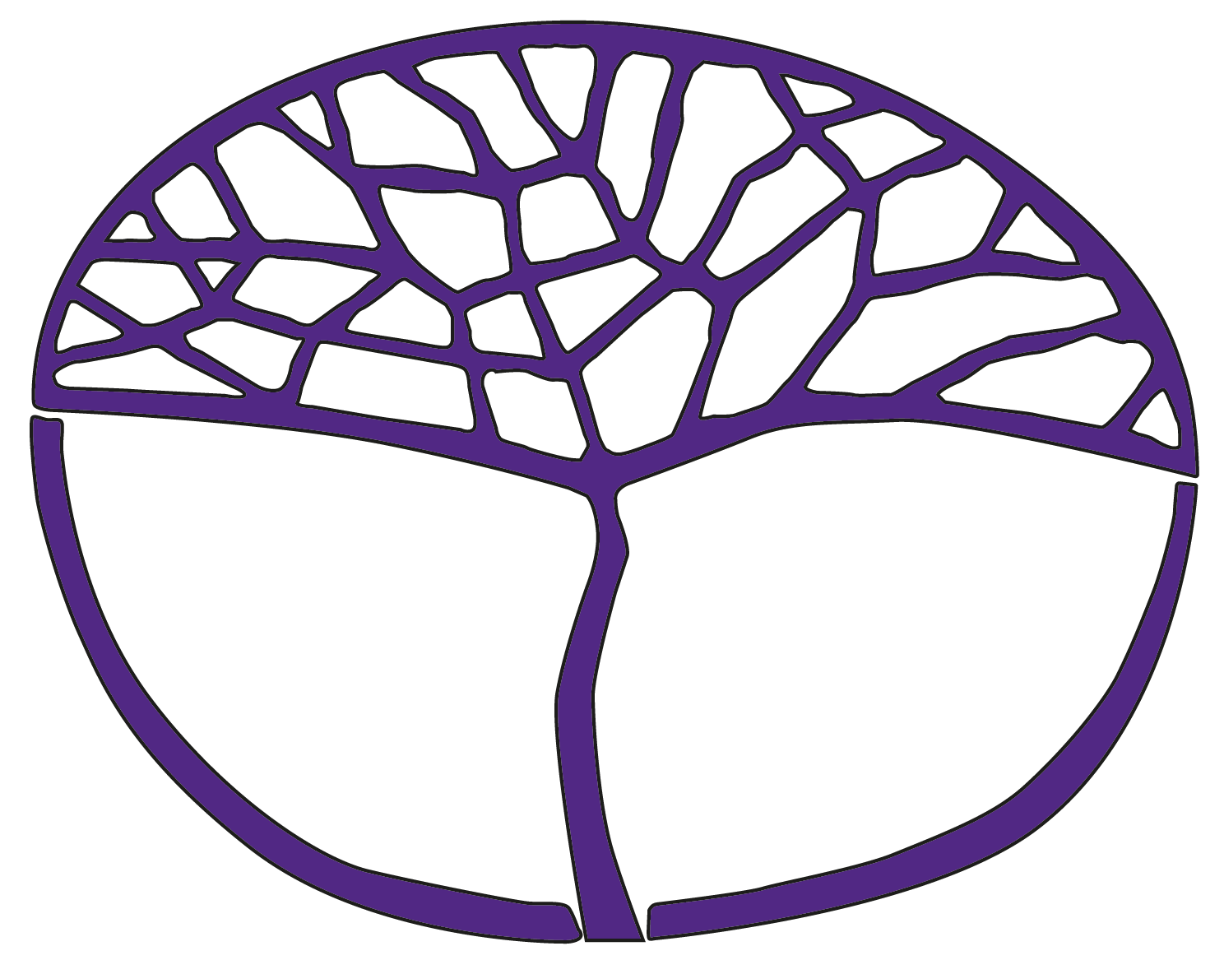Sample Course Outline

Tamil: Second Language

ATAR Year 12

**Acknowledgement of Country**

Kaya. The School Curriculum and Standards Authority (the Authority) acknowledges that our offices are on Whadjuk Noongar boodjar and that we deliver our services on the country of many traditional custodians and language groups throughout Western Australia. The Authority acknowledges the traditional custodians throughout Western Australia and their continuing connection to land, waters and community. We offer our respect to Elders past and present.

**Copyright**

© School Curriculum and Standards Authority, 2024

This document – apart from any third-party copyright material contained in it – may be freely copied, or communicated on an intranet, for non-commercial purposes in educational institutions, provided that the School Curriculum and Standards Authority (the Authority) is acknowledged as the copyright owner, and that the Authority’s moral rights are not infringed.

Copying or communication for any other purpose can be done only within the terms of the *Copyright Act 1968* or with prior written permission of the Authority. Copying or communication of any third-party copyright material can be done only within the terms of the *Copyright Act 1968* or with permission of the copyright owners.

Any content in this document that has been derived from the Australian Curriculum may be used under the terms of the [Creative Commons Attribution 4.0 International licence](https://creativecommons.org/licenses/by/4.0/).

**Disclaimer**

Any resources such as texts, websites and so on that may be referred to in this document are provided as examples of resources that teachers can use to support their learning programs. Their inclusion does not imply that they are mandatory or that they are the only resources relevant to the course. Teachers must exercise their professional judgement as to the appropriateness of any they may wish to use.

Sample course outline

Tamil: Second Language – ATAR Year 12

Unit 3

Semester 1

| **Week** | **Key teaching points** |
| --- | --- |
| 1–5 | **Introduction**  Overview of the Tamil: Background Language course, unit and assessment requirements.  **Perspectives and topics**  Provide opportunities for learning and assessment on the following perspective and topic:   * Personal – Entertainment. Students explore popular entertainment in their lives and in the lives of young people in Tamil-speaking communities to develop an insight into the culture.   **Text types and styles of writing**  Text types  Provide opportunities for students to respond to and/or produce the following text types:   * advertisement * conversation * discussion * image * presentation * review * song.   Styles of writing  Provide opportunities for students to respond to and produce the following styles of writing:   * descriptive * personal * reflective.   **Linguistic resources**  Provide opportunities for students to acquire and use the following resources:  Vocabulary   * introduce new vocabulary, phrases and expressions through texts related to the topic Entertainment.   Grammar   * adjectives (qualitative and quantitative) * adverbs (qualitative and quantitative) * conjunctions (case and connective) * pronouns (personal and indefinite) * sentences and phrases (simple, compound and interactive) * verbs (adjectival participle, adverbial participle, past continuous, past perfect and present tense).   Sound and writing systems   * the difference in complexity between formal written Tamil and spoken Tamil * accurately pronouncing short and long vowels, and hard, soft and intermediate consonants * using the correct verb endings according to subject, tense, place, and number * recognising complex forms of grammatical structures; for example, cases, joining words and sentence patterns * expanding on spoken language with an understanding of relationships between language and cultural identity.   **Intercultural understandings**  Provide opportunities for students to enhance understanding of their own language/s and culture/s in relation to Tamil language and culture:   * the role of Tamil cinema in Tamil culture and lifestyle * the influence of popular Tamil films, music, TV series, music and film festivals on Tamil culture and lifestyle * popular actors, artists, musicians, musical groups and celebrities in Tamil-speaking countries * major professional and traditional sports and their importance in Tamil-speaking countries and Australia; for example, Silambattam, Eruthazhuvuthal, Kabaddi, Kilithattu, Sathurangam, Malyuththam, etc.   **Language learning and communication strategies**  Provide opportunities for students to practise the following strategies:   * make connections with first language and practise speaking in Tamil * reflect on cultural meanings, including register and tone * use oral clues to predict and help with interpreting meaning * ask for clarification and repetition to assist understanding * manipulate known elements in a new context to create meaning in spoken forms * structure an argument and express ideas and opinions * use cohesive devices, apply register and grammar, and use repair strategies to practise Tamil.   Dictionaries   * develop the necessary skills to use a monolingual and/or bilingual printed dictionary effectively.   **Assessment Task 1: Oral communication**  Participate in an 8–10 minute conversation in Tamil. |
| 6–10 | **Perspectives and topics**  Provide opportunities for learning and assessment on the following perspective and topic:   * Community – Cultural heritage. Students investigate the ways Tamil-speaking communities preserve their cultural heritage.   **Text types and styles of writing**  Text types  Provide opportunities for students to respond to and/or produce the following text types:   * article * comic strip * conversation * journal entry * letter * note * poem * speech * table.   Styles of writing  Provide opportunities for students to respond to and produce the following styles of writing:   * descriptive * informative * personal * reflective.   **Linguistic resources**  Provide opportunities for students to acquire and use the following resources:  Vocabulary   * introduce new vocabulary, phrases and expressions through texts related to the topic Cultural heritage.   Grammar   * adjectives (qualitative and quantitative) * adverbs (qualitative and quantitative) * conjunctions (case, connective and complex) * pronouns (personal and indefinite) * sentences and phrases (simple, compound and proverb) * verbs (adjectival participles, adverbial participles, past tense, present tense and conditional) * voice (passive).   Sound and writing systems   * the appropriate level of politeness and formality depending on the audience and situation * recognising the specific sound difference between consonants and their correct pronunciation to avoid distorting the meaning of words * recognising complex forms of grammatical structures; for example, cases, joining words and sentence patterns * using the correct verb endings according to subject, tense, place and number.   **Intercultural understandings**  Provide opportunities for students to enhance understanding of their own language/s and culture/s in relation to Tamil language and culture:   * official organisations that promote and celebrate Tamil culture and arts worldwide; for example, International Institute of Tamil Studies, International Institute of Tamil Arts * aspects of cultural identity found in, for example, traditions, values, beliefs, festivals, ceremonies, arts, music, media, entertainment, sports, food and clothing * contributions of Tamil culture to the global community; for example, architecture, sculpture, crafts, weaving, cuisine, design, arts, fashion * popular Tamil literature in Tamil-speaking countries, including the influence of religion and culture * the role of cultural heritage in Tamil-speaking communities.   **Language learning and communication strategies**  Provide opportunities for students to practise the following strategies:   * read, listen to and view texts in Tamil * learn vocabulary and set phrases in context * make connections with prior learning * listen and determine essential information from keywords * make links between English and Tamil texts * analyse and evaluate information and ideas * scan texts, highlight key words and select appropriate information * use information in a text to draw conclusions.   Dictionaries   * develop the necessary skills to use a monolingual and/or bilingual printed dictionary effectively.   **Assessment Task 2: Responding to texts**  Listen to, read and view texts in Tamil and respond in Tamil or English, as specified, to questions in Tamil or English. |
| 11–15 | **Perspectives and topics**  Provide opportunities for learning and assessment on the following perspective and topic:   * Global – Tamil culture in the world. Students investigate the contribution of Tamil people and their culture to the world.   **Text types and styles of writing**  Text types  Provide opportunities for students to respond to and/or produce the following text types:   * account * blog post * email * invitation * message * report * review * script – speech, interview, dialogue.   Styles of writing  Provide opportunities for students to respond to and produce the following styles of writing:   * descriptive * informative * persuasive * reflective.   **Linguistic resources**  Provide opportunities for students to acquire and use the following resources:  Vocabulary   * introduce new vocabulary, phrases and expressions through texts related to the topic Tamil culture in the world.   Grammar   * adjectives (qualitative and quantitative) * adverbs (qualitative and quantitative) * conjunctions (case, connective and complex) * pronouns (personal and indefinite) * sentences and phrases (simple and compound) * verbs (past tense, present tense and future tense).   Sound and writing systems   * the difference in complexity between formal written Tamil and spoken Tamil * forming words using syllables of vowels and consonants and considering letters that can be used at the beginning and end of Tamil words * the hard consonants and their conjunction with soft consonants, which assists with correct spelling * recognising complex forms of grammatical structures; for example, cases, joining words and sentence patterns * using the correct verb endings according to subject, tense, place, and number.   **Intercultural understandings**  Provide opportunities for students to enhance understanding of their own language/s and culture/s in relation to Tamil language and culture:   * antiquity, heritage and language history * influence of popular culture on Tamil-speaking communities and their identity * influence of famous Tamil literature on Tamil-speaking communities * reasons for Tamil movement around the globe * migration experiences of Tamil-speaking communities (past and present) * contributions of Tamil speakers to the international community * Tamil media, entertainment, food, art, clothing and its influence on society and the global community.   **Language learning and communication strategies**  Provide opportunities for students to practise the following strategies:   * learn vocabulary and set phrases in context * read a question and determine the topic, audience, purpose, text type and style of writing * manipulate known elements in a new context to create meaning in written forms * use synonyms for variety in the sentences, and conjunctions to link sentences * organise and maintain coherence of written text * evaluate and redraft written texts to enhance meaning * proofread text once written.   Dictionaries   * develop the necessary skills to use a monolingual and/or bilingual printed dictionary effectively.   **Assessment Task 3: Written communication**  Write an article of approximately 200 words in Tamil. |
| 16 | Review structure of the practical (oral) and written examinations for Semester 1.  Prepare for the practical (oral) and written examinations.  **Assessment Task 4 (a): Semester 1 practical (oral) examination**  **Assessment Task 4 (b): Semester 1 written examination** |

Sample course outline

Tamil: Second Language – ATAR Year 12

Unit 4

Semester 2

| **Week** | **Key teaching points** |
| --- | --- |
| 1–5 | **Introduction**  Overview of the unit and assessment requirements.  **Perspectives and topics**  Provide opportunities for learning and assessment on the following perspective and topic:   * Personal – Planning my future. Students explore their choices as they plan for their future.   **Text types and styles of writing**  Text types  Provide opportunities for students to respond to and/or produce the following text types:   * account * discussion * journal entry * interview * plan * report * role play * speech.   Styles of writing  Provide opportunities for students to respond to and produce the following styles of writing:   * descriptive * informative * personal * reflective.   **Linguistic resources**  Provide opportunities for students to acquire and use the following resources:  Vocabulary   * introduce new vocabulary, phrases and expressions through texts related to the topic Planning my future.   Grammar   * adjectives (qualitative) * adverbs (qualitative and time) * conjunctions (case and connective) * prepositions (time) * pronouns (personal and possessive) * sentences and phrases (simple, compound and complex) * verbs (future tense).   Sound and writing systems   * the difference in complexity between formal written Tamil and spoken Tamil * accurately pronouncing short and long vowels, and hard, soft and intermediate consonants * recognising complex forms of grammatical structures; for example, cases, joining words and sentence patterns * using the correct verb endings according to subject, tense, place, and number * expanding on spoken language with an understanding of relationships between language and cultural identity.   **Intercultural understandings**  Provide opportunities for students to enhance understanding of their own language/s and culture/s in relation to Tamil language and culture:   * plans after school; for example, further education, employment, gap year, travel or volunteering * careers and opportunities now and in the future * opportunities available to students in different communities and countries * uptake of higher education in Tamil-speaking countries and Australia * common future plans, goals and aspirations of young people in Australia and Tamil‑speaking communities – future studies, finding work and career opportunities in Australia and abroad.   **Language learning and communication strategies**  Provide opportunities for students to practise the following strategies:   * connect with a native speaker of Tamil * reflect on cultural meanings, including register and tone * make connections with first language and practise speaking in Tamil * use oral clues to predict and help with interpreting meaning * ask for clarification and repetition to assist understanding * manipulate known elements in a new context to create meaning in spoken forms * use cohesive devices, apply register and grammar, and use repair strategies to practise Tamil.   Dictionaries   * develop the necessary skills to use a monolingual and/or bilingual printed dictionary effectively.   **Assessment Task 5: Oral communication**  Participate in a 10–12 minute interview in Tamil. |
| 6–10 | **Perspectives and topics**  Provide opportunities for learning and assessment on the following perspective and topic:   * Community – Youth issues. Students investigate current youth issues in the Tamil‑speaking communities.   **Text types and styles of writing**  Text types  Provide opportunities for students to respond to and/or produce the following text types:   * announcement * article * chart * conversation * email * infographic * interview * invitation * message * report * song.   Styles of writing  Provide opportunities for students to respond to and produce the following styles of writing:   * descriptive * informative * personal * reflective.   **Linguistic resources**  Provide opportunities for students to acquire and use the following resources:  Vocabulary   * introduce new vocabulary, phrases and expressions through texts related to the topic Youth issues.   Grammar   * adjectives (qualitative) * adverbs (qualitative and time) * conjunctions (case and connective) * prepositions (time) * pronouns (possessive and indefinite) * sentences and phrases (simple, compound, complex, composition, proverbs) * verbs (present tense, present continuous, future tense, conditional).   Sound and writing systems   * the appropriate level of politeness and formality depending on the audience and situation * recognising the specific sound difference between consonants and their correct pronunciation to avoid distorting the meanings of words * recognising complex forms of grammatical structures; for example, cases, joining words and sentence patterns * using the correct verb endings according to subject, tense, place and number.   **Intercultural understandings**  Provide opportunities for students to enhance understanding of their own language/s and culture/s in relation to Tamil language and culture:   * common youth issues in Australia and Tamil-speaking countries * attitudes to youth issues ­– education, health, poverty and pressures on everyday life in Tamil‑speaking countries and Australia * unity in diversity – multiculturalism and social divides in Tamil-speaking countries (wealth, ethnicity, religion, gender, rural/urban) * links between poverty, health and education * perceptions of youth issues in Tamil-speaking society; for example, the impact of Westernisation * coping with change in the global community.   **Language learning and communication strategies**  Provide opportunities for students to practise the following strategies:   * read, listen to and view texts in Tamil * listen and determine essential information from keywords * make links between English and Tamil texts * analyse and evaluate information and ideas * scan texts, highlight key words and select appropriate information * recognise the attitude, purpose and intention of a text * use information in a text to draw conclusions.   Dictionaries   * develop the necessary skills to use a monolingual and/or bilingual printed dictionary effectively.   **Assessment Task 6: Responding to texts**  Listen to, read and view texts in Tamil and respond in Tamil or English, as specified, to questions in Tamil or English. |
| 11–15 | **Perspectives and topics**  Provide opportunities for learning and assessment on the following perspective and topic:   * Global – Environment. Students examine current environmental issues and how young people can contribute to make a difference.   **Text types and styles of writing**  Text types  Provide opportunities for students to respond and/or produce the following text types:   * article * blog post * journal entry * letter * note * review * script – speech, interview, dialogue.   Styles of writing  Provide opportunities for students to respond to and produce the following styles of writing:   * descriptive * informative * personal * persuasive.   **Linguistic resources**  Provide opportunities for students to acquire and use the following resources:  Vocabulary   * introduce new vocabulary, phrases and expressions through texts related to the topic Environment.   Grammar   * adjectives (qualitative) * adverbs (qualitative and time) * conjunctions (case and connective) * prepositions (time) * pronouns (personal, possessive and indefinite) * sentences and phrases (simple, compound and complex) * verbs (present tense, future tense and conditional).   Sound and writing systems   * the difference in complexity between formal written Tamil and spoken Tamil * forming words using syllables of vowels and consonants and considering letters that can be used at the beginning and end of Tamil words * the hard consonants and their conjunction with soft consonants, which assists with correct spelling * recognising complex forms of grammatical structures; for example, cases, joining words and sentence patterns * using the correct verb endings according to subject, tense, place and number.   **Intercultural understandings**  Provide opportunities for students to enhance understanding of their own language/s and culture/s in relation to Tamil language and culture:   * influence of the natural environment on daily life and lifestyles * current environmental issues in Tamil-speaking countries and Australia and the influence these have on everyday life and lifestyles; for example, pollution and climate change * how Tamil-speaking communities tackle the battle for a healthy environment through promoting recycling, organic food, commuting and their attitudes towards the environment * the benefits to Tamil-speaking communities when citizens make environmentally friendly   lifestyle choices   * youth involvement in environmental causes * the growth of ecotourism.   **Language learning and communication strategies**  Provide opportunities for students to practise the following strategies:   * analyse and evaluate information and ideas * read a question and determine the topic, audience, purpose, text types and style of writing * structure an argument and express ideas and opinions * use synonyms for variety in the sentences, and conjunctions to link sentences * organise and maintain coherence of written text * evaluate and redraft written texts to enhance meaning * proofread text once written.   Dictionaries   * develop the necessary skills to use a monolingual and/or bilingual printed dictionary effectively.   **Assessment Task 7: Written communication**  Write a report of approximately 250 words in Tamil. |
| 16 | Review structure of the practical (oral) and written examinations for Semester 2.  Prepare for the practical (oral) and written examinations.  **Assessment Task 8 (a): Semester 2 practical (oral) examination**  **Assessment Task 8 (b): semester 2 written examination** |