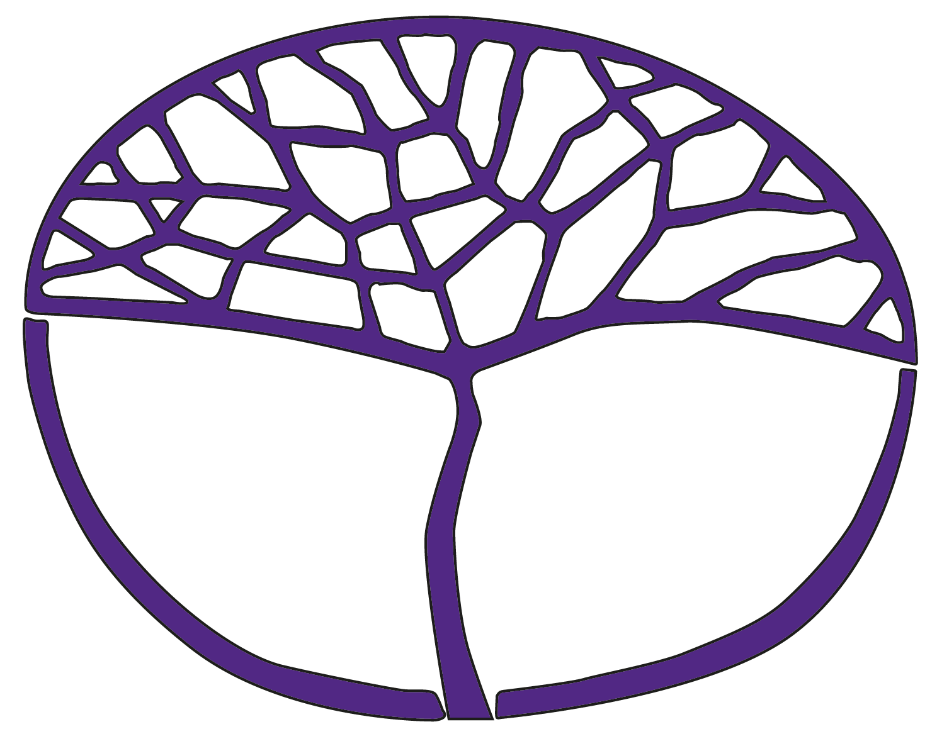Sample Course Outline

Human Biology

ATAR Year 12

**Acknowledgement of Country**

Kaya. The School Curriculum and Standards Authority (the Authority) acknowledges that our offices are on Whadjuk Noongar boodjar and that we deliver our services on the country of many traditional custodians and language groups throughout Western Australia. The Authority acknowledges the traditional custodians throughout Western Australia and their continuing connection to land, waters and community. We offer our respect to Elders past and present.

**Copyright**

© School Curriculum and Standards Authority, 2023

This document – apart from any third-party copyright material contained in it – may be freely copied, or communicated on an intranet, for non-commercial purposes in educational institutions, provided that the School Curriculum and Standards Authority (the Authority) is acknowledged as the copyright owner, and that the Authority’s moral rights are not infringed.

Copying or communication for any other purpose can be done only within the terms of the *Copyright Act 1968* or with prior written permission of the Authority. Copying or communication of any third-party copyright material can be done only within the terms of the *Copyright Act 1968* or with permission of the copyright owners.

Any content in this document that has been derived from the Australian Curriculum may be used under the terms of the [Creative Commons Attribution 4.0 International licence](https://creativecommons.org/licenses/by/4.0/).

**Disclaimer**

Any resources such as texts, websites and so on that may be referred to in this document are provided as examples of resources that teachers can use to support their learning programs. Their inclusion does not imply that they are mandatory or that they are the only resources relevant to the course. Teachers must exercise their professional judgement as to the appropriateness of any they may wish to use.

Sample course outline

Human Biology – ATAR Year 12

Unit 3 and Unit 4

Semester 1 – Homeostasis and disease

**Science Inquiry Skills**

All the following Science Inquiry Skills must be taught in each unit. The Science Inquiry Skills align with the Science Understanding and Science as a Human Endeavour content of the unit and are integrated throughout the learning experiences.

* identify, research and construct questions for investigation; propose hypotheses; and predict possible outcomes
* design investigations, including the procedure(s) to be followed, the materials required, and the type and amount of primary and/or secondary data to be collected; conduct risk assessments; and consider research ethics
* conduct investigations safely, competently and methodically for the collection of valid and reliable data
* represent data in meaningful and useful ways, including the use of mean, median, range and probability; organise and analyse data to identify trends, patterns and relationships; discuss the ways in which measurement error, instrumental accuracy, the nature of the procedure and the sample size may influence limitations in data; and select, synthesise and use evidence to make and justify conclusions
* interpret a range of scientific and media texts, and evaluate models, processes, claims and conclusions by considering the quality of available evidence, and use reasoning to construct scientific arguments
* select, use and/or construct appropriate representations, including diagrams, models and flow charts, to communicate conceptual understanding, solve problems and make predictions.
* communicate to specific audiences, and for specific purposes, using appropriate language, nomenclature, genres and modes, including scientific reports

| **Week** | **Key teaching points** |
| --- | --- |
| 1–2 | **Endocrine system**   * Endocrine glands   + location of endocrine glands – hypothalamus, pituitary, thyroid, parathyroid, pancreas, thymus, gonads, pineal and adrenal glands   + specific target organs and action of hormones secreted from endocrine glands – hypothalamus, pituitary, thyroid, parathyroid, pancreas and adrenal glands   + hypothalamic control of pituitary gland * Hormones   + types of hormones – water-soluble, lipid-soluble   + synthetic hormones     - development using recombinant DNA technology     - for treatment of endocrine dysfunctions – diabetes mellitus, hypothyroidism and hyperthyroidism   **Commence Task 1:** Extended response – Recombinant DNA technology and its uses |
| 3 | **Central and peripheral nervous system**   * Division of the nervous system   + central nervous system (CNS)     - structure and function of the CNS – cerebellum, cerebrum, medulla oblongata, hypothalamus, corpus callosum, spinal cord, bones of the skull, meninges and cerebrospinal fluid   Practical activity: Brain dissection   * + peripheral nervous system     - autonomic and somatic     - sympathetic and parasympathetic     - afferent and efferent |
| 4–5 | * Receptors   + function of thermoreceptors, osmoreceptors, chemoreceptors, touch and pain receptors   Practical activity: Perception of stimuli   * Neurons   + structure and function of neurons – sensory, motor and interneuron   + transmission of nerve impulses   + reflex arc   Practical activity: Reflexes  **Submit Task 1:** Extended response – Recombinant DNA technology and its uses |
| 6 | * Nervous system disorders   + cell replacement therapy for treating Alzheimer’s and Parkinson’s * Comparison of the endocrine and nervous systems   + speed of action   + duration of action   + nature and transmission of the message   + specificity of message |
| 7–8 | **Homeostasis**   * Need for homeostasis * Negative feedback/stimulus response models * Thermoregulation   + methods of heat loss and gain     - metabolic activity     - conduction, convection, radiation     - evaporation   + Methods of controlling heat loss and gain     - physiological – vasoconstriction, vasodilation, shivering, sweating     - behavioural   + Negative feedback/stimulus response model for thermoregulation   Practical activity: Thermoregulation  Commence Task 2: Investigation – Temperature regulation mechanisms of the human body |
| 9 | * Regulation of blood sugar levels   + the liver     - glycogenesis     - glycogenolysis     - gluconeogenesis   + the pancreas     - insulin     - glucagon   + the adrenal glands     - glucocorticoids     - adrenaline and noradrenaline   + negative feedback/stimulus response models for the regulation of blood sugar levels   + treatment of diabetes mellitus, including synthetic hormones and gene therapy |
| 10 | * Regulation of body fluid concentrations   + methods of water loss and gain   + ADH and aldosterone   + thirst reflex   + negative feedback/stimulus response models for the regulation of water balance * Regulation of gas concentrations   + negative feedback model for the control of breathing   + voluntary control of breathing   **Submit Task 2:** Investigation – Temperature regulation mechanisms of the human body |
| 11 | **Response to infection**   * Pathogens   + types of pathogens – viruses and bacteria   + transmission of pathogens     - direct and indirect contact     - transfer by body fluids     - disease-specific vectors     - contaminated food and water |
| 12 | * External defence mechanisms against pathogens   + skin   + digestive tract   + urogenital tract   + respiratory system   + the ear   + the eye * Non-specific immune response   + inflammation   + fever |
| 13 | * Specific immune responses   + antibody-mediated immunity   + cell-mediated immunity * Treatment and prevention of pathogen-induced infections   + antiviral drugs     - mode of action   + antibiotic drugs     - mode of action   + vaccines     - types     - mode of action     - production, including the use of recombinant DNA technology * Immunity   + passive and active immunity   + herd immunity   Practical activity: Modelling herd immunity   * + immunisation     - social influences on immunisation programs     - economic influences on immunisation programs     - cultural influences on immunisation programs   **Task 3:** Test – Response to infection |
| 14 | Revision |
| 15 | **Task 4:** Examination – Semester 1 |

Semester 2 – Human variation and evolution

**Science Inquiry Skills**

All the following Science Inquiry Skills must be taught in each unit. The Science Inquiry Skills align with the Science Understanding and Science as a Human Endeavour content of the unit and are integrated throughout the learning experiences.

* identify, research and construct questions for investigation; propose hypotheses; and predict possible outcomes
* design investigations, including the procedure(s) to be followed, the materials required, and the type and amount of primary and/or secondary data to be collected; conduct risk assessments; and consider research ethics
* conduct investigations safely, competently and methodically for valid and reliable collection of data
* represent data in meaningful and useful ways; organise and analyse data to identify trends, patterns and relationships; discuss the ways in which measurement error, instrumental accuracy, the nature of the procedure and sample size may influence limitations in data; and select, synthesise and use evidence to make and justify conclusions
* interpret a range of scientific and media texts, and evaluate models, processes, claims and conclusions by considering the quality of available evidence; and use reasoning to construct scientific arguments
* select, use and/or construct appropriate representations, including diagrams, models and flow charts, to communicate conceptual understanding, solve problems and make predictions
* communicate to specific audiences, and for specific purposes, using appropriate language, nomenclature, genres and modes, including scientific reports

|  |  |
| --- | --- |
| Week | Key teaching points |
| 1 | **Mutations**   * Causes of gene and chromosomal mutations   + DNA replication   + cell division   + mutagens * Mutations can be favourable or unfavourable for survival * Causes of variation   + mutations introducing new alleles   + environmental influence on genotypes producing a variety of phenotypes |
| 2–4 | **Gene pools**   * Gene pools and populations * Causes of changes to gene pools   + mutations   + selection pressures   + random genetic drift, including founder effect   + barriers to gene flow * Effect of genetic diseases on gene pools   + sickle-cell anaemia   Practical activity: Genetic diseases and changing gene pools  **Task 5:** Practical – Simulating changes to gene pools |
| 5–6 | * Natural selection   + mechanisms underpinning evolution by natural selection     - variation     - isolation     - struggle for existence     - selection     - speciation   Practical activity: Natural selection |
| 7–9 | **Evidence for evolution**   * Comparative biochemistry   + DNA (genomic and mitochondrial) and proteins   + biotechnological techniques used to facilitate DNA sequencing     - polymerase chain reaction (PCR) – denaturing, annealing, elongation     - gel electrophoresis   Practical activity: Gel electrophoresis   * Bioinformatics * Phylogenetic trees   Practical activity: Our close relations  **Task 6:** Extended response – Furtherevidence for evolution |
| 10 | * Fossils   + fossil formation   + problems and limitations of the fossil record   + application and limitations of dating methods     - relative dating techniques – stratigraphy and index fossils     - absolute dating techniques – radiocarbon and potassium-argon   Practical activity: Dating fossils |
| 11–13 | **Hominid evolutionary trends**   * Classification of humans as great apes * Differences between humans and other great apes   + relative size of cerebral cortex   + mobility of digits   + stance and locomotion – bipedalism, brachiation, quadrupedalism   + prognathism and dentition   Practical activity: Comparing apes and humans   * Possible relatedness and evolutionary pathways   + *Australopithecus afarensis*   + *Australopithecus africanus*   + *Paranthropus robustus*   + *Homo habilis*   + *Homo erectus*   + *Homo neanderthalensis*   + *Homo sapiens*   Practical activity: Trends in hominid skulls   * Tool cultures of Homo habilis, Homo erectus, Homo neanderthalensis and Homo sapiens   + trends in manufacturing techniques and materials   + as evidence for cognitive evolution and lifestyle   **Task 7:** Test – Evidence for evolution and hominid evolutionary trends |
| 14 | Revision |
| 15 | **Task 8:** Examination – Semester 2 |