Guide to using the VET Industry Specific Course
and Post-Secondary Pathways document

Background

The Post-Secondary Pathways provide students with a snapshot of the potential opportunities in further and higher education. It illustrates the progression from Australian Qualification Framework (AQF) level 2 through to level 9 within the relevant industry or industries. The Post-Secondary Pathways are a support material for each of the ten VET industry specific courses. They may also be used for other purposes such as career counselling or to support your VET credit transfer programs.

AQF

The AQF spectrum is represented across the top of the document. Qualifications are displayed under each AQF level to illustrate the position of qualifications within the hierarchy of nationally recognised qualifications.

Use of colour

If using in print form, to maximise the use of the document it is suggested that it is printed in colour on size A3 paper with landscape orientation.

Colour is used throughout the AQF spectrum to indicate progression into higher level qualifications within a particular industry area and potential job outcomes. Qualifications have also been loosely grouped into possible education pathways.

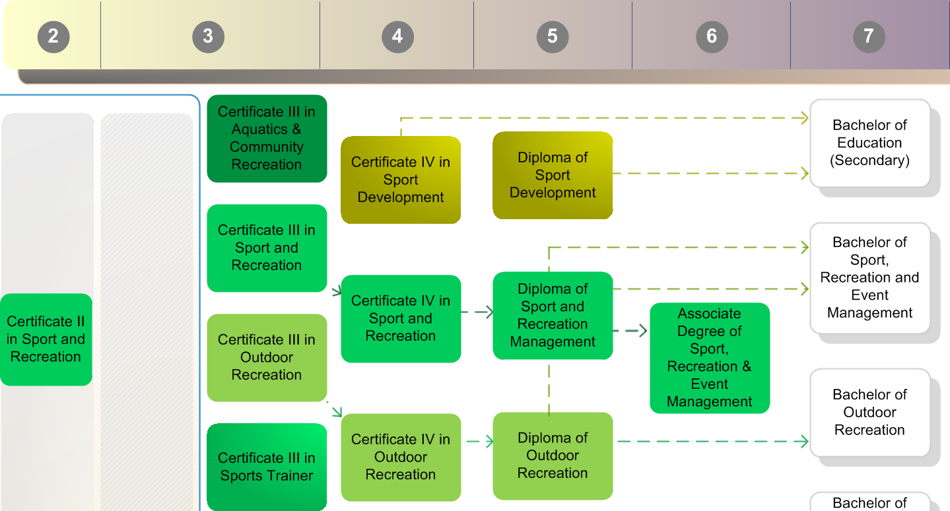

Links

Links have been provided throughout the document to access electronically. Click the links for quick website access to research an industry occupation or to support overall career development activities.

Quick Response or QR codes

QR codes have been provided on the back page of the document if presented in print form. Scan QR codes with a smart phone or tablet for quick website access to research an industry occupation or to support overall career development activities.

Related Occupations

The related occupations section is shown on the right-hand side of the front page. These occupations are linked to various AQF outcomes however are not necessarily displayed sequentially in order of the skills, knowledge and expertise required for the job. Hospitality and Tourism and Sport and Recreation Pathways documents do however indicate this progression evident in the AQF colour spectrum to the right of the list.

For further information on the VET industry specific courses refer to http://wace1516.scsa.wa.edu.au/syllabus-and-support-materials/vet-industry-specific
or email us at VETinfo@scsa.wa.edu.au

