Music
General course

Externally set task
Sample 2016

Note: This Externally set task sample is based on the following content from Unit 3 of the General Year 12 syllabus.
The Externally set task is worth 15% of the overall assessment and is based on the generic Aural and theory and Composing and arranging content. Listening examples will be played simultaneously to all candidates from a common source.
Questions could include:
- Aural: recognition of scales, intervals, tonality and/or modulations, pitch, melodic and rhythmic dictations, chord progressions, rhythmic and/or pitch discrepancies, aural and visual analysis
- Theory: identification and writing of scales, intervals, triads, chords, visual analysis of score extracts, identification of rhythmic, melodic and harmonic elements, tempo, metre, form and structure, tonality, modulation, dynamics, articulation and expressive devices, compositional devices, instrumentation and instrumental techniques and effects, transposition, chord analysis and harmonisation
- Composing and arranging: melody writing, harmonisation, transposition, composing in a form/structure
- Investigation and analysis: examination of the main characteristics and features of the context/culture/style or era/period selected for study, stylistic/contextual characteristics and performance conventions, use of context appropriate notation and terminology
In future years, this information will be provided late in Term 3 of the year prior to the conduct of the Externally set task. This will enable teachers to tailor their teaching and learning program to ensure that the content is delivered prior to the students undertaking the task in Term 2 of Year 12.

Copyright
© School Curriculum and Standards Authority, 2014
This document – apart from any third party copyright material contained in it – may be freely copied, or communicated on an intranet, for non-commercial purposes in educational institutions, provided that the School Curriculum and Standards Authority is acknowledged as the copyright owner, and that the Authority’s moral rights are not infringed.
Copying or communication for any other purpose can be done only within the terms of the Copyright Act 1968 or with prior written permission of the School Curriculum and Standards Authority. Copying or communication of any third party copyright material can be done only within the terms of the Copyright Act 1968 or with permission of the copyright owners.
Any content in this document that has been derived from the Australian Curriculum may be used under the terms of the Creative Commons Attribution-NonCommercial 3.0 Australia licence
Disclaimer
Any resources such as texts, websites and so on that may be referred to in this document are provided as examples of resources that teachers can use to support their learning programs. Their inclusion does not imply that they are mandatory or that they are the only resources relevant to the course.

Music

Externally set task
Working time for the task: 60 minutes
Total marks: 60 marks
Weighting: 15% of the school mark
Materials required for this task:
- This Question/Answer Booklet
- Sound files to be downloaded from the SCSA website

Aural (40 marks)
- Aural analysis (18 marks)

- The following melody will be played four times. Complete the melody by adding the required signs and symbols, selecting from the list indicated below: (16 marks)
- tempo indication
- key signature
- accidentals
- time signature
- bar-lines
- repeat signs
- first and second time bars
- D.C. al fine
- D.S. al coda
- dynamics
- articulation

- Identify an example of a sequence on the score, indicating it with a bracket. (1 mark)
- Name the overall form of this extract. (1 mark)
______________________________________________
- Chord progression (8 marks)
Complete the following chord progression, providing the Roman numerals for the missing chords. The tonic chord will be played prior to the progression being heard.

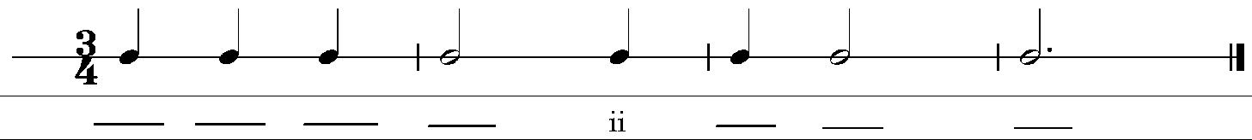

- Dictation (14 marks)
Complete the following 8 bar dictation, providing the missing pitches and/or rhythm. The melody will be played 6 times in the following way:
- the entire dictation played once
- the first four bars played twice
- the second four bars played twice
- the entire dictation played once

Theory and composition (20 marks)
- Melody writing (14 marks)
Select one (1) of the following three (3) options to complete an 8 bar melody for the instrument of your choice that is stylistically appropriate for the selected context studied in Unit 3. You must address each of the criteria outlined below.

Option (a): Continuation of a melodic motif
Name the instrument for which the melody is written.____________________________________

- Indicate an appropriate tempo. (1 mark)

- Ensure that the melody is within the instrument’s range and technical capabilities. (2 marks)

- Use stylistically appropriate dynamics and bowings/articulation indications. (3 marks)

- Maintain consistent stylistic and motivic continuity (melodic and rhythmic). (2 marks)

- Incorporate effective melodic contour and a clear climax. (3 marks)

- Include a melodic sequence and mark it clearly on the score. (2 marks)

- Present a neat and accurate score. (1 mark)

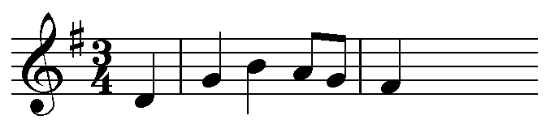

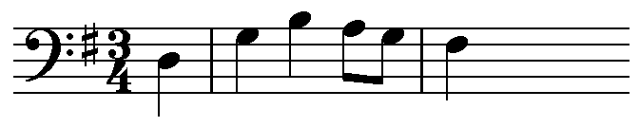

OR

Option (b): Continuation of a melodic motif (14 marks)

Name the instrument for which the melody is written.___________________________________

- Indicate an appropriate tempo. (1 mark)

- Ensure the melody is written within the instrument’s range and technical capabilities.
(2 marks)

- Use stylistically appropriate dynamics and bowings/articulation indications. (3 marks)

- Maintain consistent stylistic and motivic continuity (melodic and rhythmic). (2 marks)

- Incorporate effective melodic contour and a clear climax. (3 marks)

- Ensure the melody fits the given chord structure. (2 marks)

- Present a neat and accurate score. (1 mark)

OR

Option (c): Writing a melody to a given text (14 marks)

Name the voice type for which the melody is written. ________________________________

- Indicate an appropriate tempo (1 mark)

- Ensure the melody is written within the range and technical capabilities of the selected voice type (2 marks)

(c) Use stylistically appropriate dynamics and articulation indications (3 marks)

(d) Maintain consistent stylistic and motivic continuity (melodic and rhythmic) (2 marks)

(e) Incorporate effective melodic contour and a clear climax (3 marks)

(f) Demonstrate appropriate rhythmic scansion (2 marks)

(g) Present a neat and accurate score. (1 mark)

What sparkles above on the water so clear, defies what lies beneath, inky blackness and fear
Rhythmic scansion

Melody
- Referring to the context you have been studying in Unit 3, write at least two (2) extended paragraphs in response to the following question. You must address all the listed criteria in your response.
If you were to arrange the melody you completed in question one for a small ensemble, name the instruments you would use and describe how you would arrange the melody to create a stylistically appropriate piece.
- List the instruments you would use in your ensemble and discuss why you chose them.
- Explain how you would arrange the melody, referring to instrumentation, timbre, harmonisation, and texture.
- Make reference to the use of dynamics, articulation and stylistic devices that you would include in your arrangement and that are appropriate to the context.
(6 marks)

________________________________________________________________________________
________________________________________________________________________________
________________________________________________________________________________
________________________________________________________________________________
________________________________________________________________________________
________________________________________________________________________________
________________________________________________________________________________
________________________________________________________________________________
________________________________________________________________________________
________________________________________________________________________________
________________________________________________________________________________
________________________________________________________________________________
________________________________________________________________________________
________________________________________________________________________________
________________________________________________________________________________
________________________________________________________________________________
________________________________________________________________________________
________________________________________________________________________________
________________________________________________________________________________
________________________________________________________________________________
________________________________________________________________________________

