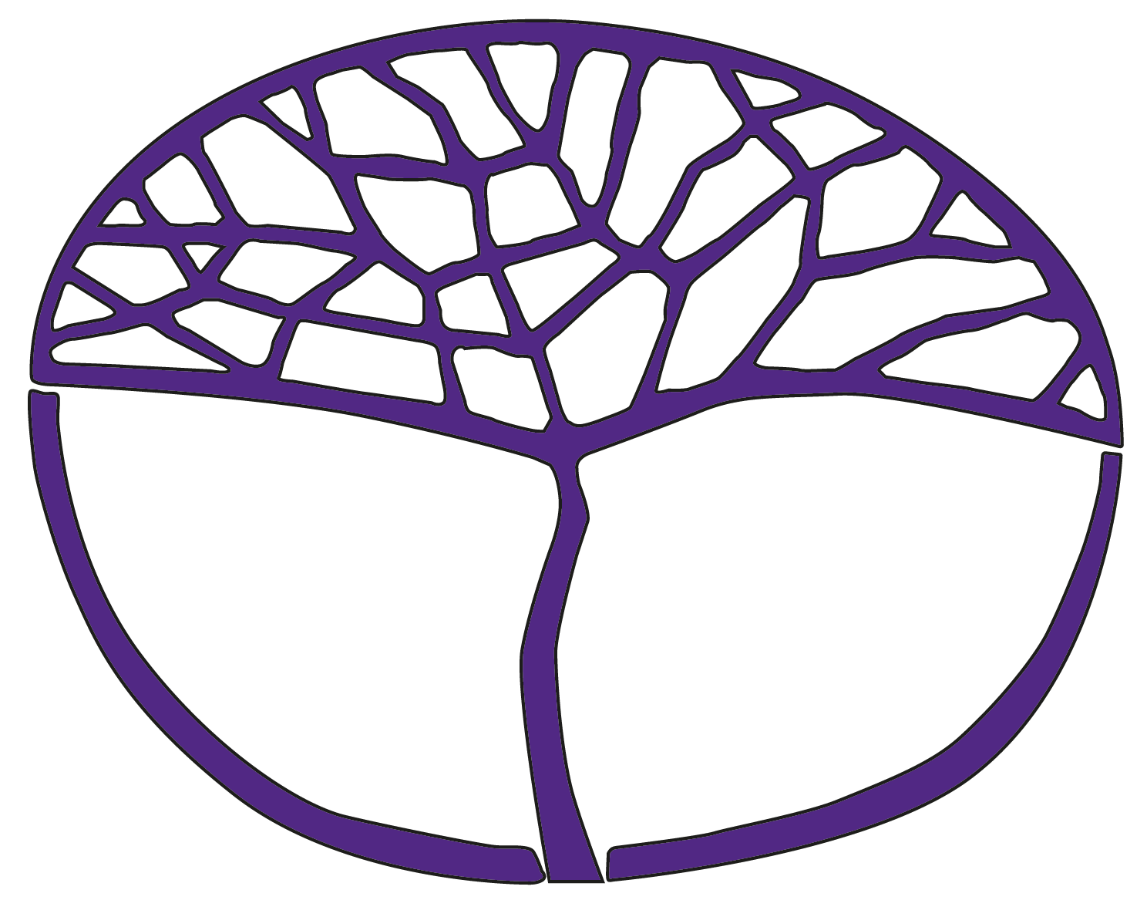Sample Course Outline

Aboriginal and Intercultural Studies

ATAR Year 11

**Acknowledgement of Country**

Kaya. The School Curriculum and Standards Authority (the Authority) acknowledges that our offices are on Whadjuk Noongar boodjar and that we deliver our services on the country of many traditional custodians and language groups throughout Western Australia. The Authority acknowledges the traditional custodians throughout Western Australia and their continuing connection to land, waters and community. We offer our respect to Elders past and present.

**Copyright**

© School Curriculum and Standards Authority, 2024

This document – apart from any third-party copyright material contained in it – may be freely copied, or communicated on an intranet, for non-commercial purposes in educational institutions, provided that the School Curriculum and Standards Authority (the Authority) is acknowledged as the copyright owner, and that the Authority’s moral rights are not infringed.

Copying or communication for any other purpose can be done only within the terms of the *Copyright Act 1968* or with prior written permission of the Authority. Copying or communication of any third-party copyright material can be done only within the terms of the *Copyright Act 1968* or with permission of the copyright owners.

Any content in this document that has been derived from the Australian Curriculum may be used under the terms of the [Creative Commons Attribution 4.0 International licence](https://creativecommons.org/licenses/by/4.0/).

**Disclaimer**

Any resources such as texts, websites and so on that may be referred to in this document are provided as examples of resources that teachers can use to support their learning programs. Their inclusion does not imply that they are mandatory or that they are the only resources relevant to the course. Teachers must exercise their professional judgement as to the appropriateness of any they may wish to use.

Sample course outline

Aboriginal and Intercultural Studies – ATAR Year 11 for 2025

Intercultural Skills

**Research**

* develop and modify a range of focus questions to investigate a specific topic/issue
* plan an inquiry with clearly defined aims, using appropriate methodologies
* collect, record and compare information and/or data from relevant culturally responsive resources
* identify and practise ethical scholarship when conducting research, including respecting variation between cultural groups of processes and protocols for collecting information

**Analysis and use of sources**

* identify the origin, purpose and context of a variety of sources
* evaluate the reliability, bias and usefulness of different sources
* analyse and account for differences in perspectives and interpretations of the past, presented in a variety of sources
* identify and analyse relationships, and use evidence from different sources to support a point of view

**Evaluating and communicating**

* evaluate information and/or data to draw evidence-based conclusions and explanations taking into account ambiguities and different perspectives
* communicating findings using formats appropriate to purpose and audience
* use respectful and inclusive language and terminology
* identify and practise ethical scholarship when communicating research, including
  + respecting variation between cultural groups of processes and protocols for acknowledging and communicating information
  + adopting protocols and conventions to communicate in culturally appropriate ways
  + applying appropriate referencing techniques accurately and consistently

**Reflection**

* acknowledge differences in personal perspectives, interpretations and world views when developing a response
* reflect on own learning to review original understandings and on why all findings are tentative

Semester 1 – Unit 1

All the Intercultural skills must be taught during this unit. Relevant skills should be emphasised for each assessment task.

|  |  |
| --- | --- |
| Week | Key teaching points |
| 1–2 | **Overview of the diversity of First Nations Peoples**   * define the following key terms and concepts as they relate to, and by privileging, First Nations Peoples’ voices and perspectives   + culture   + identity   + heritage   + colonisation * who are First Nations (Indigenous) Peoples and groups according to the United Nations * demographics of First Nations Peoples globally, including portion of the population, number of distinct groups and languages * cultural rights of First Nations Peoples, included in   + Section 28 of the *Human Rights Act 2019*   + Articles 2, 8, 11, 12 and 13 of the *United Nations Declaration on the Rights of Indigenous Peoples* |
| 3–5 | * the diversity of Australian First Nations Peoples including   + number of distinct groups and languages   + population distribution * evidence of Australian First Nations Peoples being the oldest, continuous living cultures in the world, including scientific and archaeological evidence * evidence of changing societal attitudes to valuing First Nations Peoples’ unique ways of knowing, being and doing (e.g. language revitalisation, use of First Nations Peoples’ knowledge and practices)   **Intercultural Skills**   * Analysis and use of sources * Evaluating and communicating   **Task 1: Short answer** |
| 6–10 | **Depth Study One**  Through community experiences and/or secondary sources, and by privileging First Nations Peoples’ voices and perspectives, students investigate the cultural diversity and identities of **one** Western Australian First Nations People and **one** Torres Strait Islander First Nations People.  For the **two** selected Australian First Nations Peoples, students investigate:   * location * cultural identity, including   + language   + spiritual beliefs   + Dreaming stories, songlines and ancestors   + kinship and family structures   + leadership and decision-making processes, including the role of the Elders   + connection to and care of Country   + places of significance and why they are significant * perspectives and experiences of ‘invasion and colonisation’, for three of the following   + frontier wars   + massacres   + methods of dispossession and removal from Country   + interruption to language and culture   + relationship between First Nations Peoples and colonisers * the evidence of the continuous practice and revitalisation of the selected First Nations Peoples cultural identity   **Intercultural Skills**   * Research * Analysis and use of sources * Evaluating and communicating * Reflection   **Task 2: Inquiry** |
| 11–13 | **Depth Study Two**  Through community experiences and/or secondary sources, and by privileging First Nations Peoples’  voices and perspectives, students investigate the importance and protection of Australian First Nations Peoples’ cultural heritage, including:   * Australian First Nations Peoples’ tangible and intangible cultural heritage * the importance of protecting Australian First Nations Peoples’ cultural heritage * **one** example of the destruction of Australian First Nations Peoples’ cultural heritage, including   + why and how it happened   + actions taken by the government following the destruction   + local, national and/or global reaction to the destruction * the *Aboriginal Heritage Act 1972* (WA)**,** including   + the purpose of the Act   + the background and perspectives on the *Aboriginal Heritage Act 2021* (WA) and why it was repealed   + key changes and amendments to the 1972 Act   **Intercultural Skills**   * Evaluating and communicating   **Task 3: Extended answer** |
| 14–15 | * the contribution of Australian First Nations Peoples tourism in promoting and showcasing their cultural heritage, including **two** specific examples of Aboriginal-owned cultural tourism experiences |
| 16 | **Task 4: Examination** |

Semester 2 – Unit 2

All the Intercultural skills must be taught during this unit. Relevant skills should be emphasised for each assessment task.

|  |  |
| --- | --- |
| Week | Key teaching points |
| 1–2 | **Overview of the diversity of First Nations Peoples’ cultural expressions and protocols**   * define the following key terms and concepts as they relate to, and by privileging First Nations Peoples’ voices and perspectives   + cultural expressions   + empowerment   + resiliency   + self-determination * the impact of invasion and colonisation on First Nations Peoples’ cultural expressions in both Australia and **one** other country * the contribution of contemporary cultural expressions to the empowerment and resiliency of First Nations Peoples in both Australia and one other country, including:   + sharing and maintaining cultural knowledge   + health and wellbeing   + economic opportunities   + as an advocate for the rights of First Nations Peoples |
| 3–5 | * Indigenous Cultural and Intellectual Property and the *Protocols for using First Nations Cultural and Intellectual Property in the Arts* (<https://creative.gov.au/investment-and-development/protocols-and-resources/protocols-for-using-first-nations-cultural-and-intellectual-property-in-the-arts/>) including:   + what are the protocols   + what is Indigenous Cultural and Intellectual Property   + Indigenous peoples’ rights to Cultural and Intellectual Property   + **one** example of the protocols for using First Nations Peoples’ Cultural and Intellectual Property in practice in Australia * international protection of Indigenous Cultural and Intellectual Property, including Article 31 of the *United Nations Declaration on the Rights of Indigenous Peoples*   **Intercultural Skills**   * Analysis and use of sources * Evaluating and communicating   **Task 5: Short answer** |
| 6–10 | **Depth Study One**  Through community experiences and/or secondary sources, and by privileging First Nations Peoples’ voices and perspectives, students investigate **one** form of cultural expression and its significance for Australian First Nations Peoples.  From the list below, select **one** of the forms of cultural expression:   * visual arts – encompassing drawing, painting, computer art, photography, sculpture, ceramics, homewares, fabrics, textiles and printmaking * theatre – involving musical theatre, plays, storytelling and puppet shows * events – featuring cultural community festivals and workshops, art exhibitions and installations * dance – including classical and contemporary ballet, traditional dance and contemporary dance forms * music – covering activities such as composing, recording, publishing, performing, and touring, including songs and live performances * written works comprising fiction and non-fiction works, poetry, biographies and/or playwriting.   For the selected form of cultural expression, investigate:   * Australian First Nations Peoples’ perspectives, cultures or histories represented through the form of cultural expression * the role of information and telecommunications technologies in showcasing and celebrating the form of cultural expression locally, nationally and/or globally * the changing engagement in the form of cultural expression by Australian society over time * the contribution of the form of cultural expression to the continuation and sharing of Australian First Nations Peoples’ cultural knowledge and practices.   **Intercultural Skills**   * Research * Analysis and use of sources * Evaluating and communicating * Reflection   **Task 6: Inquiry** |
| 11–12 | **Depth Study Two**  Through community experiences and/or secondary sources, and by privileging First Nations Peoples’ voices and perspectives, students investigate the importance of Australian First Nations Peoples cultural expressions in showcasing the world’s oldest living cultures and as a way of educating and changing people’s perceptions.  Students investigate:   * a film or documentary which advocates for the rights of First Nations Peoples, including the human rights, social justice issues and/or different perspective included (e.g. *In My Blood It Runs*) * the importance of the Aboriginal flag and the Torres Strait Islander flag as expressions of cultural identity to Australian First Nations Peoples, including   + why are there two different flags   + the significance of the colour, shapes and/or symbols on the flags   + different perspectives relating to the use of the flags |
| 13–15 | * **one** example of an Australian First Nations Peoples-led program or initiative which provides opportunities for individual and/or community cultural expressions to be shared, including the background and benefit of the program or initiative * the role of the WA Museum Boola Bardip and **one** other cultural centre in showcasing, educating and changing peoples’ perceptions about Australian First Nations Peoples’ histories and cultures.   **Intercultural Skills**   * Evaluating and communicating   **Task 7: Extended answer** |
| 16 | **Task 8: Examination** |