Sample Assessment Tasks

Mathematics Essential

General Year 12

**Acknowledgement of Country**

Kaya. The School Curriculum and Standards Authority (the Authority) acknowledges that our offices are on Whadjuk Noongar boodjar and that we deliver our services on the country of many traditional custodians and language groups throughout Western Australia. The Authority acknowledges the traditional custodians throughout Western Australia and their continuing connection to land, waters and community. We offer our respect to Elders past and present.

**Copyright**

© School Curriculum and Standards Authority, 2015

This document – apart from any third-party copyright material contained in it – may be freely copied, or communicated on an intranet, for non-commercial purposes in educational institutions, provided that the School Curriculum and Standards Authority (the Authority) is acknowledged as the copyright owner, and that the Authority’s moral rights are not infringed.

Copying or communication for any other purpose can be done only within the terms of the *Copyright Act 1968* or with prior written permission of the Authority. Copying or communication of any third-party copyright material can be done only within the terms of the *Copyright Act 1968* or with permission of the copyright owners.

Any content in this document that has been derived from the Australian Curriculum may be used under the terms of the [Creative Commons Attribution 4.0 International licence](https://creativecommons.org/licenses/by/4.0/).

**Disclaimer**

Any resources such as texts, websites and so on that may be referred to in this document are provided as examples of resources that teachers can use to support their learning programs. Their inclusion does not imply that they are mandatory or that they are the only resources relevant to the course. Teachers must exercise their professional judgement as to the appropriateness of any they may wish to use.

Sample assessment task

Mathematics Essential – General Year 12

Task 1 – Unit 3

**Assessment type:** Practical application

**Conditions** Class discussion in the school car park on features of a car park, prior to the independent completion of the plan and report

Task to be completed in class over three lessons

Technology, textbooks, rulers, calculators and A3 paper permitted

Authentication interview to be conducted between teacher and student, mid task and at task completion

Note: while the School Curriculum and Standards Authority (the Authority) provides sample assessment tasks for guidance, it is the expectation of the Authority that teachers will develop tasks customised to reflect their school’s context and the needs of the student cohort. This resource is available on a public website and use of the resource without modification may affect the integrity of the assessment.

**Task weighting**: 10% of the school mark for this pair of units

**Situation**

**Designing a car park for a new restaurant business**

In your role as an architect, Secant Restaurant has asked you to design a concrete car park with a range of parking bays, direction lanes and other features which are to be in accordance with the design conditions shown on the next page.

The design must be based on the measurements as shown in the diagram shown below.

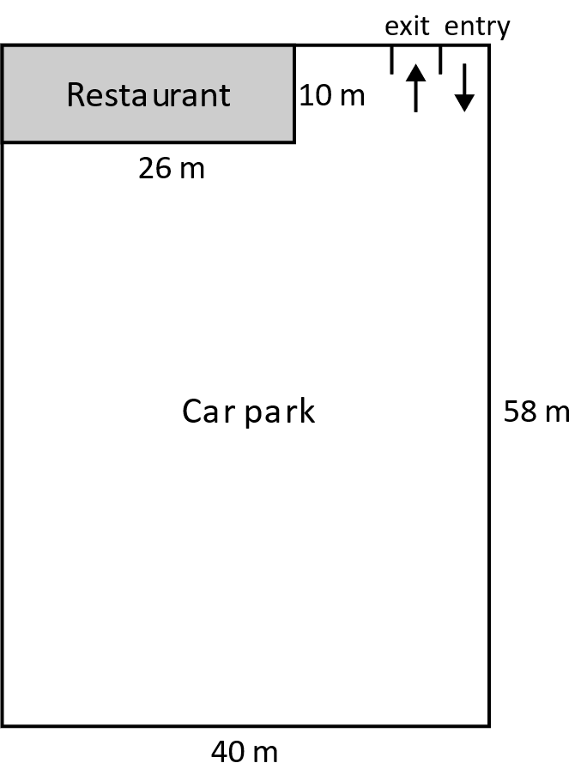

**Car park design conditions**

* Front- or rear-end parking only (no angle parking or parallel parking), with bays measuring 2.6 metres by 5 metres
* Disabled parking bays based on the ratio of 25 standard bays to 1 disabled bay. Disabled bays should measure 3 metres by 5 metres
* Clearly labelled directions on all lanes. One single lane should measure 3.6 metres in width. You may use single-lane or double-lane thoroughfares
* A loading dock measuring 4 metres by 8 metres that allows room for food delivery trucks to get in and out needs to be placed appropriately to suit your design
* The car park will require some landscaping. You will need to allocate appropriate sections for this displaying their location on your plan and determine the total overall area for the landscaping.

Practical application task (33 marks)

Write a report to explain the reasoning for your car park design using the mathematical thinking process and including an accurate scaled plan on A3 paper or by using technology.

In your report, indicate the decisions you have made to produce your design with justification and calculations for landscaping area.

Your report on developing the design should:

* Include an introduction in which you interpret and describe the task in your own words, including all key information. (4 marks)
* Identify and explain the mathematics you will use to complete the task. (4 marks)
* Analyse the information and conditions, apply your mathematical knowledge and draw a completed scale diagram for the car park design, including areas for landscaping, and calculate the total landscaping area. (Students who require extra support may be supplied with the outline of an accurately scaled diagram, to assist them in obtaining a solution. If this occurs then a maximum of 12 marks should be given.) (14 marks)
* Verify and justify the design of your car park and area for landscaping. Discuss the changes you made during the process to help improve your design and any assumptions made. Are there any further changes or changes to the car park conditions you would recommend? (7 marks)
* Communicate your task findings using correct mathematical language and a description of your final solution. (4 marks)

|  |
| --- |
| **Sample solution** |
| This report is based on the design of a concrete car park for a new restaurant. The design itself is a scale drawing with appropriate features and dimensions.  Many conditions have been considered when designing the car park. These conditions include position and size of car park bays, allocation of disabled parking bays, labelling directions for driving lanes, an appropriate position for the loading dock and the positioning and area of landscaping.  This report will include decisions made in the process of the car park design, the design itself, including landscaping areas, and the calculation of the total landscaping area required.  The mathematics I have used for this task includes the dimensions for car bays provided to allocate bays. For this I used addition/subtraction and multiplication/division strategies to ensure I allocated the appropriate number of bays in the space provided. I left room for cars to drive in, out and around the car park. I used length/perimeter measurements, ratio and scales as well as calculations for area of landscaping parts, using area of composite shapes to determine the total, to help with my decision making. I decided on an appropriate scale to use so that my drawing is easily legible and followed.  Reasoning and problem solving were utilised in order to design my car park that satisfies all the conditions of the design.  **The design and area calculation**  Refer to scale diagram attached.  Landscaping calculation:  Outdoor Sitting Area: $6.8×10=68 m^{2}$ Left of Loading Dock: $13.4×1=13.4 m^{2}$ Right of loading dock: $5×1.6=8 m^{2}$ Entry to outdoor area: $0.8×5×2=8{ m}^{2}$ Near Car bay 1: $1.2×5=6 m^{2}$ Back of car park: $40×6-5×2.6×11=97 m^{2}$ Total area to be landscaped: $68+13.4+8+8+6+97=200.4 m^{2}$ The verification and justification for the decisions I have made are given below:  **Placement of loading dock/disabled bays**  I wanted to place the loading dock near the building for easier access. I had to make an assumption that where I placed the loading dock, workers could easily access the delivered goods and there would be provision for easy entry into the building. Initially I placed the dock to the right of the building but felt there was too much void area around it. I decided to place this closer to the far left of the building, which would then allow for an outdoor sitting area, assuming that is feasible for the restaurant owners to consider. I didn’t place it in the far back corner as accessibility for trucks would be compromised. Initially, I had a parking bay next to bay number 33, but decided to remove it to give trucks room to manoeuvre in and out of the loading dock with more ease.  I placed the disabled bays at the front of the building so that those requiring disabled access didn’t need to walk too far.  **Entry and exit**  I initially made the entry and exit to the car park one way, thinking it was easier for those entering and exiting to clearly determine the direction in which they would need to travel. I decided that this would be a problem with trucks entering that need access to the loading dock as they have to go around the whole car park to get to it, so I changed it to two ways for the most part.  I found the position of the entry/exit points difficult to manage. Currently parking bays are reduced to allow room for cars entering. I would recommend moving the entry/exit points closer to the building, so that more bays could potentially be utilised, but only if the outdoor sitting area is not feasible for Secant restaurant to consider.  **Landscaping**  I placed landscaping in void areas that cars wouldn’t be able to access, and along the back of the car park where I thought some trees could be planted to provide some shade. I also have included the outdoor sitting area as part of my landscaping as that would need to be designed with lots of greenery to improve the restaurant atmosphere. Trees could be planted around this area to provide shade for those sitting outside. At the front of the building there are four landscaping strips. Two of them could include a pathway to access the outdoor sitting area without having to go into the building, the other two are on either side of the loading dock. This was designed so that if any extra room, and/or further pathways to enter into the restaurant were needed this could be arranged.  **Recommendation**  I would recommend that provisions for delivery access be given in the initial problem so that position of the loading dock could be more accurately determined ensuring it is in a suitable spot for access to goods.  **Report summary**  I have been asked to design a car park for a restaurant with set conditions and determine landscaping position and area for my design. After deciding on the mathematics I needed to use, I began my car park design, trying to use all conditions provided. I drew a very rough sketch of the ideas I had, catering for the conditions as required.  After making a number of changes, as discussed above I decided on a scale that would help me (and others) interpret the diagram with ease and address the calculations of number of car parks required. The scale I used for the design is: 1:200. I used this scale as it allowed me to fit the whole car park on an A3 sheet of paper and it made the numbers easy enough to manage and interpret because every one centimetre on the diagram, represented two metres in real life.  You will see that I have included 57 standard car bays which results in me having to also include 3 disabled bays based on the 1:25 provision for disabled bays to standard car bays. I placed these disabled bays and the loading dock close to the building for the best access. The number of bays should be able to cater to all patrons attending the restaurant with landscaping to make the whole area look attractive and enticing to visit.  I left sufficient room around the loading dock so that trucks could enter and leave more easily. This resulted in the loss of one car bay, but I decided that was worthwhile.  I have tried to maximise the number of car bays by using minimal landscaping around the border of the car park, except for the back, and back corners as they would have been inaccessible to cars. Trees could be planted in the landscaping areas to bring shade. I also included an outdoor sitting area at the right of the restaurant, which I have included in my total landscaping area calculation. The total area required for landscaping is 200.4 m2.  The entry and exit points could be changed to be closer to the building to further increase the number of bays required, but that would reduce the space for the outdoor sitting area. It would depend on whether the restaurant owners would like the provision of an outdoor area over extra car bays.  Please refer to the scale drawing for my final design. |

Marking key for sample assessment task 1 – Unit 3

Include an introduction in which you interpret and describe the task in your own words, including all key information.

|  |  |
| --- | --- |
| **Specific behaviours** | **Marks** |
| Clearly restates the problem in own words | 1 |
| Identifies at least two key pieces of information/conditions that influence the task | 2 |
| Outlines plan of report | 1 |
| **Total** | **/4** |

Identify and explain the mathematics you will have to use to complete the task.

|  |  |
| --- | --- |
| **Specific behaviours** | **Marks** |
| Describes in detail the mathematics needed to solve the problem | 4 |
| Describes most of the mathematics needed to solve the problem | 3 |
| Describes some of the mathematics needed to solve the problem | 2 |
| Describes a single part of the mathematics needed to solve the problem | 1 |
| **Total** | **/4** |

Analyse the information and conditions, apply your mathematical knowledge and draw a completed scale diagram for the car park design including areas for landscaping and calculate the total landscaping area.

|  |  |
| --- | --- |
| **Specific behaviours** | **Marks** |
| Determines appropriate scale used for diagram | 1 |
| Uses an accurate scale | 1 |
| Determines the correct scaled size of car bays that fit specifications | 1 |
| Determines the appropriate number of disabled bays based on car bay number ratio | 1 |
| Draws disabled bays accurately to correct scale | 1 |
| Uses appropriate direction lanes for ease of access in and out of the car park | 1 |
| Shows arrows for direction in lanes | 1 |
| Displays that all car bays are accessible for cars to drive in and out of | 1 |
| Draws loading dock in a suitable position and is accurate to specifications | 1 |
| Draws a diagram that is easy to follow | 1 |
| Draws a diagram that displays appropriate landscaping areas | 1 |
| Determines total area for landscaping | 1 |
| Calculates the total area for landscaping accurately | 1 |
| Uses correct units for length and area measurements | 1 |
| **Total** | **/14** |

Verify and justify the design of your car park and area for landscaping. Discuss any changes you made during the process to help improve your design. Are there any further changes or changes to the car park conditions you would recommend?

|  |  |
| --- | --- |
| **Specific behaviours** | **Marks** |
| Provides 4 or more valid justifications for the car park design | 4 |
| Provides 3 valid justifications for the car park design | 3 |
| Provides 2 valid justifications for the car park design | 2 |
| Provides 1 valid justifications for the car park design | 1 |
| **Subtotal** | **/4** |
| Clearly states justification for landscaping area positions throughout design | 2 |
| **Subtotal** | **/2** |
| Provides at least one recommendation for changes to design | 1 |
| **Subtotal** | **/1** |
| **Total** | **/7** |

Communicate your task findings with the correct mathematical language. Describe your final solution.

|  |  |
| --- | --- |
| **Specific behaviours** | **Marks** |
| Clearly states at least one factor that influenced the design of the scale drawing and/or choice of scale used. | 1 |
| States the number of car bays and number of disabled bays | 1 |
| States the area of landscaping required | 1 |
| Summarises process and ideas used | 1 |
| **Total** | **/4** |

Sample assessment task

Mathematics Essential – General Year 12

Task 7 – Unit 4

**Assessment type:** Response – Test

**Conditions:** Time for the task: 50 minutes

In class, calculator permitted

**Marks:** 31 marks

**Task weighting:** 12% of the school mark for this pair of units

1. As of 2014, the distribution of blood types in Australia is as follows:

|  |  |  |
| --- | --- | --- |
| **Blood group** | **RhD** | **% of population** |
| O | O+ | 40 |
| O- | 9 |
| A | A+ | 31 |
| A- | 7 |
| B | B+ | 8 |
| B- | 2 |
| AB | AB+ | 2 |
| AB- | 1 |

* 1. What is the probability that an Australian resident will have B+ blood type? (1 mark)
  2. Every week, Australia needs over 27 000 blood donations. How many of these blood donations could be from people with A+ blood type? (3 marks)

1. The following tree diagram represents the possible outcomes of a family which has two children.

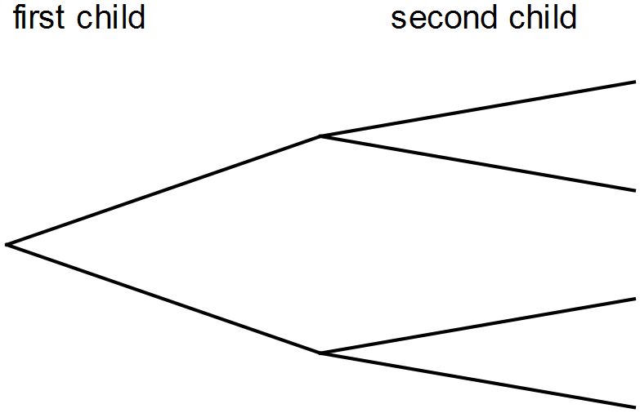

1. Label the diagram to show the possibilities of boy and girl. (2 marks)
2. What is the chance the family would have two girls? (2 marks)
3. If the family had a third child, what is the chance there would be two girls and a boy?

(4 marks)

3. An agricultural research company has completed an investigation into the effect of a new fertiliser on plant growth. The heights of 50 plant seedlings grown under experimental conditions for several weeks were measured and recorded to the nearest centimetre.   
The heights are listed here.

107, 162, 151, 145, 133, 125, 116, 108, 111, 113, 125, 126, 158, 142, 139,

165, 168, 152, 141, 147, 147, 131, 137, 137, 111, 119, 121, 125, 125, 156,

117, 133, 138, 157, 124, 124, 159, 132, 131, 139, 141, 137, 129, 131, 148,

127, 136, 136, 121, 148

1. Use the data above to complete the table below: (3 marks)

|  |  |  |
| --- | --- | --- |
| **Height (cm)** | **Frequency** | **Relative Frequency** |
|  | 2 | 0.04 |
|  | 6 | 0.12 |
|  | 11 | 0.22 |
|  | 14 |  |
|  | 8 |  |
|  |  |  |
|  |  |  |

1. What is the probability of plants growing to a height between 120 cm and 129 cm?

(2 marks)

1. What is the probability of plants growing to a height of at least 130 cm? (2 marks)
2. If the experiment is expanded to 1000 plants, how many plants would you expect to grow to a height of at least 130 cm? (2 marks)
3. The fertiliser is considered effective if 75% of seedlings have a height of 130 cm or more. Comment on the effectiveness of the fertiliser on plant growth, based on the results from the experiment. (3 marks)

4. To win a prize in the Wheat Flakes company’s Cereal Prize Giveaway, customers must collect all of the letters of the word CEREAL from packets of Wheat Flakes.

One letter is placed in each packet of Wheat Flakes. This process is repeated over and over.

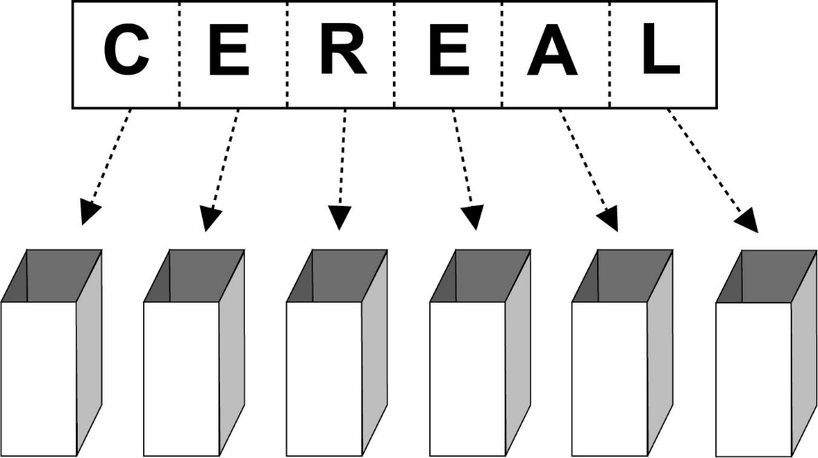

Nguyen wants to be able to estimate the number of packets of Wheat Flakes he would need to purchase, on average, before he is likely to win a prize.

Nguyen uses random numbers from his calculator to simulate the selection of letters for this situation. He assigns letters to random numbers, as in the table below:

|  |  |
| --- | --- |
| **Number range** | **Letter** |
| 000–099 | A |
| 100–199 | C |
| 200–399 | E |
| 400–499 | L |
| 500–599 | R |

Any number greater than or equal to 600 is ignored.

1. Why are 200 numbers assigned to the letter E and only 100 numbers to the other letters?

(1 mark)

The first 20 random numbers that Nguyen gets from his calculator are shown below, with his first number being 242, the second, 413, and so on.

|  |  |  |  |  |  |  |  |  |  |
| --- | --- | --- | --- | --- | --- | --- | --- | --- | --- |
| 242 | 413 | 176 | 075 | 500 | 832 | 416 | 974 | 587 | 004 |
| 723 | 124 | 543 | 219 | 853 | 361 | 643 | 054 | 387 | 634 |

(b) Use Nguyen’s random numbers to assign letters until you have spelt the word CEREAL.  
 (3 marks)

|  |  |
| --- | --- |
| **Random number used** | **Letter** |
| 242 | E |
| 413 |  |
| 176 |  |
|  |  |
|  |  |
|  |  |
|  |  |
|  |  |
|  |  |
|  |  |
|  |  |
|  |  |
|  |  |
|  |  |
|  |  |

(c) How many packets of Wheat Flakes would Nguyen need to buy to win a prize in this competition, on the basis of the results in part (b)? (1 mark)

(d) If you ran this simulation with your calculator, what would be the minimum number of times you would need to generate a random number to spell CEREAL? (1 mark)

(e) Nguyen’s friend Georgina buys 30 packets of Wheat Flakes. Will she definitely win a prize? Explain. (1 mark)

Marking key for sample assessment task 7 – Unit 4

1. (a) What is the probability that an Australian resident will have B+ blood type?

|  |  |
| --- | --- |
| **Solution** | |
| 8% of the Australian population have B+ blood type, so the probability is 8% or 0.08 | |
| **Specific behaviours** | **Marks** |
| Identifies the correct proportion from the table | 1 |
| **Total** | **/1** |

(b) Every week, Australia needs over 27 000 blood donations. How many of these blood donations could be from people with A+ blood type?

|  |  |
| --- | --- |
| **Solution** | |
| 31% of the population is A+ blood type  31% x 27 000 = 8370  It is possible approximately 8000 donors could be A+ | |
| **Specific behaviours** | **Marks** |
| Identifies the percentage | 1 |
| Determines the proportion with A+ blood type | 1 |
| Gives an appropriate approximation | 1 |
| **Total** | **/3** |

1. (a) Label the diagram to show the possibilities of boy and girl.

|  |  |
| --- | --- |
| **Solution** | |
| first child second child | |
| **Specific behaviours** | **Marks** |
| Correctly labels diagram for first child | 1 |
| Correctly labels diagram for second child | 1 |
| **Total** | **/2** |

1. What is the chance the family would have two girls?

|  |  |
| --- | --- |
| **Solution** | |
| first child second child  The probability of having two girls is | |
| **Specific behaviours** | **Marks** |
| Recognises there are four possible outcomes | 1 |
| Determines the probability of two girls | 1 |
| **Total** | **/2** |

1. If the family had a third child, what is the chance there would be two girls and a boy?

|  |  |
| --- | --- |
| **Solution** | |
| There are eight possible outcomes with three of these outcomes having two girls and a boy.  The probability would be  or 0.375. | |
| **Specific behaviours** | **Marks** |
| Extends sample space | 1 |
| Recognises there are eight possible outcomes for three children | 1 |
| Identifies three outcomes with two girls and a boy | 1 |
| Determines the probability | 1 |
| **Total** | **/4** |

3. An agricultural research company has completed an investigation into the effect of a new fertiliser on plant growth. The heights of 50 plant seedlings grown under experimental conditions for several weeks were measured and recorded to the nearest centimetre. The heights are listed here.

107, 162, 151, 145, 133, 125, 116, 108, 111, 113, 125, 126, 158, 142, 139,

165, 168, 152, 141, 147, 147, 131, 137, 137, 111, 119, 121, 125, 125, 156,

117, 133, 138, 157, 124, 124, 159, 132, 131, 139, 141, 137, 129, 131, 148,

127, 136, 136, 121, 148

1. Use the data above to complete the table below:

|  |  |
| --- | --- |
| **Solution** | |
| |  |  |  | | --- | --- | --- | | **Height (cm)** | **Frequency** | **Relative Frequency** | |  | 2 | 0.04 | |  | 6 | 0.12 | |  | 11 | 0.22 | |  | 14 | **0.28** | |  | 8 | **0.16** | |  | **6** | **0.12** | |  | **3** | **0.06** | | |
| **Specific behaviours** | **Marks** |
| Correctly completes frequency column | 1 |
| Correctly fills two rows of relative frequency | 1 |
| Correctly completes relative frequency column | 1 |
| **Total** | **/3** |

1. What is the probability of plants growing to a height between 120 cm and 129 cm?

|  |  |
| --- | --- |
| **Solution** | |
| Relative frequency for the height interval of is 0.22, so the probability is 0.22. | |
| **Specific behaviours** | **Marks** |
| Identifies the relative frequency for the interval | 1 |
| Recognises the relative frequency is an expression of probability | 1 |
| **Total** | **/2** |

1. What is the probability of plants growing to a height of at least 130 cm?

|  |  |
| --- | --- |
| **Solution** | |
| 32 plants have heights of at least 130 cm.  Probability is | |
| **Specific behaviours** | **Marks** |
| Determines number of plants fulfilling criteria | 1 |
| Determines probability | 1 |
| **Total** | **/2** |

1. If the experiment is expanded to 1000 plants, how many plants would you expect to grow to a height of at least 130 cm?

|  |  |
| --- | --- |
| **Solution** | |
| Would expect 640 plants to grow to a height of at least 130 cm. | |
| **Specific behaviours** | **Marks** |
| Applies relative frequency to calculation | 1 |
| Determines the number of plants expected to meet criteria | 1 |
| **Total** | **/2** |

1. The fertiliser is considered effective if 75% of seedlings have a height of 130 cm or more. Comment on the effectiveness of the fertiliser on plant growth based on the results from the experiment.

|  |  |
| --- | --- |
| **Solution** | |
| Relative frequency of 0.64 is the same as 64%.  Of the 50 seedlings, only 64% reached a height of at least 130 cm, which suggests the fertiliser may not be effective. | |
| **Specific behaviours** | **Marks** |
| Refers to relative frequency | 1 |
| Connects relative frequency to percentage | 1 |
| Draws a conclusion based on results | 1 |
| **Total** | **/3** |

1. (a) Why are 200 numbers assigned to the letter E and only 100 numbers to the other letters?

|  |  |
| --- | --- |
| **Solution** | |
| There are twice as many Es as any other letter in the word CEREAL. | |
| **Specific behaviours** | **Marks** |
| States the relationship of the number of Es to the number of other letters | 1 |
| **Total** | **/1** |

The first 20 random numbers that Nguyen gets from his calculator are shown below, with his first number being 242, the second, 413, and so on.

|  |  |  |  |  |  |  |  |  |  |
| --- | --- | --- | --- | --- | --- | --- | --- | --- | --- |
| 242 | 413 | 176 | 075 | 500 | 832 | 416 | 974 | 587 | 004 |
| 723 | 124 | 543 | 219 | 853 | 361 | 643 | 054 | 387 | 634 |

1. Use Nguyen’s random numbers to assign letters until you have spelt the word CEREAL.

|  |  |
| --- | --- |
| **Solution** | |
| |  |  | | --- | --- | | Random number used | Letter | | 242 | E | | 413 | **L** | | 176 | **C** | | **075** | **A** | | **500** | **R** | | **416** | **L** | | **587** | **R** | | **004** | **A** | | **124** | **C** | | **543** | **R** | | **219** | **E** | | |
| **Specific behaviours** | **Marks** |
| Correctly completes the next entry in the table | 1 |
| Correctly adds six entries to the table | 1 |
| Correctly completes the table | 1 |
| **Total** | **/3** |

1. How many packets of Wheat Flakes would Nguyen need to buy to win a prize in this competition, on the basis of the results in part (b)?

|  |  |
| --- | --- |
| **Solution** | |
| 11 | |
| **Specific behaviours** | **Marks** |
| Correctly states the number of packs required | 1 |
| **Total** | **/1** |

1. If you ran this simulation with your calculator, what would be the minimum number of times you would need to generate a random number to spell CEREAL?

|  |  |
| --- | --- |
| **Solution** | |
| 6 | |
| **Specific behaviours** | **Marks** |
| Correctly states the minimum number of trials | 1 |
| **Total** | **/1** |

1. Nguyen’s friend Georgina buys 30 packets of Wheat Flakes. Will she definitely win a prize? Explain.

|  |  |
| --- | --- |
| **Solution** | |
| No, it is possible but not certain. | |
| **Specific behaviours** | **Marks** |
| Correctly states no with a supporting reason | 1 |
| **Total** | **/1** |

Sample assessment task

Mathematics Essential – General Year 12

Task 4 – Unit 3

**Assessment type:** Statistical investigation process

**Conditions:** Students will need to have access to technology with a spreadsheet function.

50 minutes in class under test conditions

**Marks**: 23 marks

**Task weighting:** 10% of the school mark for this pair of units

**Which, if any, is the better predictor for height – arm span or the length of a person’s right foot?**

A completed statistical investigation should include:

* an introduction that outlines the question to be answered and any further questions that could be explored
* selection and application of suitable mathematical and graphical techniques you have studied to analyse the provided data
* interpretation of your results, relating your answer to the original problem
* communication of your results and conclusions in a concise, systematic manner.

Your investigation report should include the following: (23 marks)

1. Introduction

two or three sentences providing an overview of your investigation (3 marks)

2. Numerical and graphical analysis

choose various statistical measures you have studied to analyse the data (4 marks)

consider the most appropriate graphs which represent the data provided (5 marks)

3. Interpretation of the results of this analysis in relation to the original question (7 marks)

describe any trend and pattern in your data (two to three sentences)

state how your data relates to the original problem (two to three sentences)

use your knowledge and understanding gained in this unit to explain your results in one paragraph

4. Conclusion (4 marks)

summarise your findings and conclusions in one paragraph.

**Data**

A sample of data is provided below. The data includes the height, arm span and length of right foot for a sample size of 30 taken from a survey of students aged 14 to 17.

|  |  |  |  |  |  |  |  |  |  |  |
| --- | --- | --- | --- | --- | --- | --- | --- | --- | --- | --- |
| **Height** | **Arm span** | **Right foot length** |  | **Height** | **Arm span** | **Right foot length** |  | **Height** | **Arm span** | **Right foot length** |
| 170 | 71 | 23 |  | 158 | 150 | 30 |  | 162 | 130 | 25 |
| 155 | 150 | 21 |  | 169 | 174 | 28 |  | 147 | 27 | 24 |
| 169 | 173 | 26 |  | 55 | 55 | 23 |  | 176 | 176 | 26 |
| 177 | 176 | 23 |  | 165 | 160 | 36 |  | 148 | 149 | 23 |
| 153 | 149 | 26 |  | 147 | 142 | 21 |  | 156 | 155 | 24 |
| 150 | 166 | 25 |  | 175 | 176 | 25 |  | 172 | 178 | 25 |
| 159 | 156 | 26 |  | 166 | 157 | 26 |  | 150 | 142 | 24 |
| 170 | 162 | 26 |  | 150 | 136 | 21 |  | 158 | 80 | 25 |
| 169 | 154 | 26 |  | 176 | 171 | 24 |  | 145 | 147 | 21 |
| 162 | 152 | 26 |  | 163 | 164 | 23 |  | 167 | 169 | 21 |

Marking key for sample assessment task 4 – Unit 3

|  |  |
| --- | --- |
| **Introduction** | |
| This statistical investigation is to determine which, if any, is the better predictor of a person’s height; the arm span or the length of the right foot. In order to make an informed decision, I will compare the strength of the association between the pairs of variables; that is, the association between height and arm span and the association between height and the length of the right foot. | |
| **Specific behaviours** | **Marks** |
| Provides a simple introduction of the question | 1 |
| Restates question in own words | 1 |
| Mentions comparison of association between variables | 1 |
| **Total** | **/3** |

|  |  |
| --- | --- |
| **Numerical analysis** | |
| Of the data, there are four outliers  **Height Arm span Right foot**  170 70 23  55 55 23  147 27 24  158 80 25  These have been removed for the graphical analysis | |
| **Specific behaviours** | **Marks** |
| Identifies one outlier | 1 |
| Identifies at least two outliers | 1 |
| Identifies all outliers | 1 |
| Removes outliers | 1 |
| **Total** | **/4** |

|  |  |
| --- | --- |
| **Graphical analysis** | |
|  | |
|  | |
| **Specific behaviours** | **Marks** |
| Constructs a single scatterplot | 1 |
| Shows comparative scatterplots | 1 |
| Uses a similar scale for the horizontal axis (height) | 1 |
| Presents correct graphs, including labelling | 2 |
| **Total** | **/5** |

|  |  |
| --- | --- |
| **Interpretation** | |
| Sample interpretation:  Outliers have been removed from four data points as these were probably due to incorrect measurement and would therefore have not given a true picture of any association between the variables.  The scatterplot for height and arm span is positive and linear. The association appears to be strong.  The scatterplot for height and right foot length is not linear. The association appears to be weak. | |
| **Specific behaviours** | **Marks** |
| Interpretation linked to numerical and graphical data | 1 |
| Makes an appropriate statement about the outliers | 1 |
| Gives a reason for removing the outliers | 1 |
| Compares the shape of each scatterplot | 2 |
| States the linear relationship between height and arm span | 1 |
| States the non-linear relationship between height and length of right foot | 1 |
| **Total** | **/7** |

|  |  |
| --- | --- |
| **Conclusion** | |
| Sample conclusion:  The removal of four outliers from the data has reduced the sample to 26 students.  Analysis of data from these 26 students has shown that the linear relationship between height and arm span is a better predictor of height as there is a strong association between the two variables. | |
| **Specific behaviours** | **Marks** |
| Makes a valid statement about the results | 1 |
| Relates conclusion back to the original question | 1 |
| Refers to strong relationship/association between height and arm span | 1 |
| Provides a concise and coherent summary of the analysis | 1 |
| **Total** | **/4** |

Acknowledgements

**Task 4 – Unit 3**

Data from *CensusAtSchool*, Australian Bureau of Statistics.

Used under Creative Commons [Attribution 2.5 Australia](http://creativecommons.org/licenses/by/2.5/au/) licence.