Sample Assessment Tasks

Mathematics Essential

General Year 12

Copyright
© School Curriculum and Standards Authority, 2015
This document – apart from any third party copyright material contained in it – may be freely copied, or communicated on an intranet, for non-commercial purposes in educational institutions, provided that the School Curriculum and Standards Authority is acknowledged as the copyright owner, and that the Authority’s moral rights are not infringed.
Copying or communication for any other purpose can be done only within the terms of the Copyright Act 1968 or with prior written permission of the School Curriculum and Standards Authority. Copying or communication of any third party copyright material can be done only within the terms of the Copyright Act 1968 or with permission of the copyright owners.
Any content in this document that has been derived from the Australian Curriculum may be used under the terms of the Creative Commons Attribution 4.0 International licence.
Disclaimer
Any resources such as texts, websites and so on that may be referred to in this document are provided as examples of resources that teachers can use to support their learning programs. Their inclusion does not imply that they are mandatory or that they are the only resources relevant to the course.

Sample assessment task

Mathematics Essential – General Year 12

Task 8 – Unit 4
Assessment type: Response – Test

Conditions

Time for the task: 50 minutes

In class, calculator permitted
Marks: 31 marks

Task weighting: 8% of the school mark for this pair of units
_________________________________________________________________________________
- As of 2014, the distribution of blood types in Australia is as follows:
Blood group | RhD | % of population
O | O+ | 40
 | O- | 9
A | A+ | 31
 | A- | 7
B | B+ | 8
 | B- | 2
AB | AB+ | 2
 | AB- | 1
- What is the probability that an Australian resident will have B+ blood type? (1 mark)
- Every week, Australia needs over 27 000 blood donations. How many of these blood donations could be from people with A+ blood type? (3 marks)

- The following tree diagram represents the possible outcomes of a family which has two children.
- Label the diagram to show the possibilities of boy and girl. (2 marks)
- What is the chance the family would have two girls? (2 marks)
- If the family had a third child, what is the chance there would be two girls and a boy?
(4 marks)
3. An agricultural research company has completed an investigation into the effect of a new fertiliser on plant growth. The heights of 50 plant seedlings grown under experimental conditions for several weeks were measured and recorded to the nearest centimetre.
The heights are listed here.
107, 162, 151, 145, 133, 125, 116, 108, 111, 113, 125, 126, 158, 142, 139,
165, 168, 152, 141, 147, 147, 131, 137, 137, 111, 119, 121, 125, 125, 156,
117, 133, 138, 157, 124, 124, 159, 132, 131, 139, 141, 137, 129, 131, 148,
127, 136, 136, 121, 148
- Use the data above to complete the table below: (3 marks)
Height (cm) | Frequency | Relative Frequency
 | 2 | 0.04
 | 6 | 0.12
 | 11 | 0.22
 | 14
 | 8
- What is the probability of plants growing to a height between 120 cm and 129 cm?
(2 marks)
- What is the probability of plants growing to a height of at least 130 cm? (2 marks)
- If the experiment is expanded to 1000 plants, how many plants would you expect to grow to a height of at least 130 cm? (2 marks)
- The fertiliser is considered effective if 75% of seedlings have a height of 130 cm or more. Comment on the effectiveness of the fertiliser on plant growth, based on the results from the experiment. (3 marks)

4. To win a prize in the Wheat Flakes company’s Cereal Prize Giveaway, customers must collect all of the letters of the word CEREAL from packets of Wheat Flakes.
One letter is placed in each packet of Wheat Flakes. This process is repeated over and over.
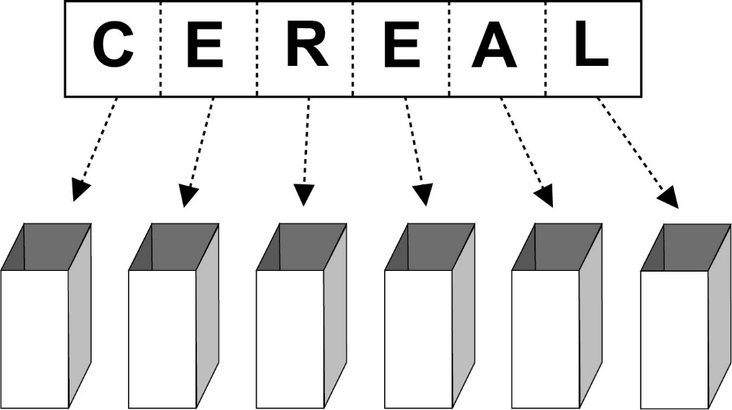
Nguyen wants to be able to estimate the number of packets of Wheat Flakes he would need to purchase, on average, before he is likely to win a prize.
Nguyen uses random numbers from his calculator to simulate the selection of letters for this situation. He assigns letters to random numbers, as in the table below:
Number range | Letter
000 – 099 | A
100 – 199 | C
200 – 399 | E
400 – 499 | L
500 – 599 | R
Any number greater than or equal to 600 is ignored.
- Why are 200 numbers assigned to the letter E and only 100 numbers to the other letters?
(1 mark)

The first 20 random numbers that Nguyen gets from his calculator are shown below, with his first number being 242, the second, 413, and so on.
242 | 413 | 176 | 075 | 500 | 832 | 416 | 974 | 587 | 004
723 | 124 | 543 | 219 | 853 | 361 | 643 | 054 | 387 | 634
(b) Use Nguyen’s random numbers to assign letters until you have spelt the word CEREAL.
(3 marks)
Random number used | Letter
242 | E
413
176

(c) How many packets of Wheat Flakes would Nguyen need to buy to win a prize in this competition, on the basis of the results in part (b)? (1 mark)
(d) If you ran this simulation with your calculator, what would be the minimum number of times you would need to generate a random number to spell CEREAL? (1 mark)
(e) Nguyen’s friend Georgina buys 30 packets of Wheat Flakes. Will she definitely win a prize? Explain. (1 mark)

Marking key for sample assessment task 8 – Unit 4
1. (a) What is the probability that an Australian resident will have B+ blood type?
Solution
8% of the Australian population have B+ blood type, so the probability is 8% or 0.08
Specific behaviours | Marks | Rating
Identifies the correct proportion from the table | 1 | simple
Total | /1
(b) Every week, Australia needs over 27 000 blood donations. How many of these blood donations could be from people with A+ blood type?
Solution
31% of the population is A+ blood type
31% x 27 000 = 8370
It is possible approximately 8000 donors could be A+
Specific behaviours | Marks | Rating
Identifies the percentage | 1 | simple
Determines the proportion with A+ blood type | 1 | simple
Gives an appropriate approximation | 1 | complex
Total | /3
- (a) Label the diagram to show the possibilities of boy and girl.
Solution
first child second child

Specific behaviours | Marks | Rating
Correctly labels diagram for first child | 1 | simple
Correctly labels diagram for second child | 1 | simple
Total | /2

- What is the chance the family would have two girls?
Solution
first child second child
The probability of having two girls is

Specific behaviours | Marks | Rating
Recognises there are four possible outcomes | 1 | simple
Determines the probability of two girls | 1 | simple
Total | /2
- If the family had a third child, what is the chance there would be two girls and a boy?
Solution
There are eight possible outcomes with three of these outcomes having two girls and a boy.
The probability would be or 0.375.
Specific behaviours | Marks | Rating
Extends sample space | 1 | simple
Recognises there are eight possible outcomes for three children | 1 | simple
Identifies three outcomes with two girls and a boy | 1 | complex
Determines the probability | 1 | simple
Total | /4

3. An agricultural research company has completed an investigation into the effect of a new fertiliser on plant growth. The heights of 50 plant seedlings grown under experimental conditions for several weeks were measured and recorded to the nearest centimetre. The heights are listed here.
107, 162, 151, 145, 133, 125, 116, 108, 111, 113, 125, 126, 158, 142, 139,
165, 168, 152, 141, 147, 147, 131, 137, 137, 111, 119, 121, 125, 125, 156,
117, 133, 138, 157, 124, 124, 159, 132, 131, 139, 141, 137, 129, 131, 148,
127, 136, 136, 121, 148
- Use the data above to complete the table below:
Solution
Height (cm) | Frequency | Relative Frequency
 | 2 | 0.04
 | 6 | 0.12
 | 11 | 0.22
 | 14 | 0.28
 | 8 | 0.16
 | 6 | 0.12
 | 3 | 0.06

Specific behaviours | Marks | Rating
Correctly completes frequency column | 1 | simple
Correctly fills two rows of relative frequency | 1 | simple
Correctly completes relative frequency column | 1 | simple
Total | /3
- What is the probability of plants growing to a height between 120 cm and 129 cm?
Solution
Relative frequency for the height interval of is 0.22. So the probability is 0.22.
Specific behaviours | Marks | Rating
Identifies the relative frequency for the interval | 1 | simple
Recognises the relative frequency is an expression of probability | 1 | simple
Total | /2
- What is the probability of plants growing to a height of at least 130 cm?
Solution
32 plants have heights of at least 130 cm.
Probability is
Specific behaviours | Marks | Rating
Determines number of plants fulfilling criteria | 1 | complex
Determines probability | 1 | simple
Total | /2

- If the experiment is expanded to 1000 plants, how many plants would you expect to grow to a height of at least 130 cm?
Solution
Would expect 640 plants to grow to a height of at least 130 cm.
Specific behaviours | Marks | Rating
Applies relative frequency to calculation | 1 | simple
Determines the number of plants expected to meet criteria | 1 | simple
Total | /2
- The fertiliser is considered effective if 75% of seedlings have a height of 130 cm or more. Comment on the effectiveness of the fertiliser on plant growth based on the results from the experiment.
Solution
Relative frequency of 0.64 is the same as 64%.
Of the 50 seedlings, only 64% reached a height of at least 130 cm , which suggests the fertiliser may not be effective.
Specific behaviours | Marks | Rating
Refers to relative frequency | 1 | complex
Connects relative frequency to percentage | 1 | complex
Draws a conclusion based on results | 1 | complex
Total | /3
- (a) Why are 200 numbers assigned to the letter E and only 100 numbers to the other letters?
Solution
There are twice as many Es as any other letter in the word CEREAL.
Specific behaviours | Marks | Rating
States the relationship of the number of Es to the number of other letters | 1 | simple
Total | /1
The first 20 random numbers that Nguyen gets from his calculator are shown below, with his first number being 242, the second, 413, and so on.
242 | 413 | 176 | 075 | 500 | 832 | 416 | 974 | 587 | 004
723 | 124 | 543 | 219 | 853 | 361 | 643 | 054 | 387 | 634

(b) Use Nguyen’s random numbers to assign letters until you have spelt the word CEREAL.
Solution
Random number used | Letter
242 | E
413 | L
176 | C
075 | A
500 | R
416 | L
587 | R
004 | A
124 | C
543 | R
219 | E

Specific behaviours | Marks | Rating
Correctly completes the next entry in the table | 1 | simple
Correctly adds six entries to the table | 1 | simple
Correctly completes the table | 1 | simple
Total | /3
(c) How many packets of Wheat Flakes would Nguyen need to buy to win a prize in this competition, on the basis of the results in part (b)?
Solution
11
Specific behaviours | Marks | Rating
Correctly states the number of packs required | 1 | complex
Total | /1
- If you ran this simulation with your calculator, what would be the minimum number of times you would need to generate a random number to spell CEREAL?
Solution
6
Specific behaviours | Marks | Rating
Correctly states the minimum number of trials | 1 | complex
Total | /1
- Nguyen’s friend Georgina buys 30 packets of Wheat Flakes. Will she definitely win a prize? Explain.
Solution
No, it is possible but not certain.
Specific behaviours | Marks | Rating
Correctly states no with a supporting reason | 1 | complex
Total | /1

Sample assessment task

Mathematics Essential – General Year 12

Task 3 – Unit 3
Assessment type: Practical application

Conditions:

Time for the task: 50 minutes

In class under test conditions, calculator permitted
Marks: 19 marks

Task weighting: 7% of the school mark for this pair of units
_________________________________________________________________________________
Background
A ramp is an inclined, flat access way between one level and another. Ramps are particularly important for persons with mobility issues who have difficulty accessing stairs, such as those persons with physical impairment or who use a wheelchair.
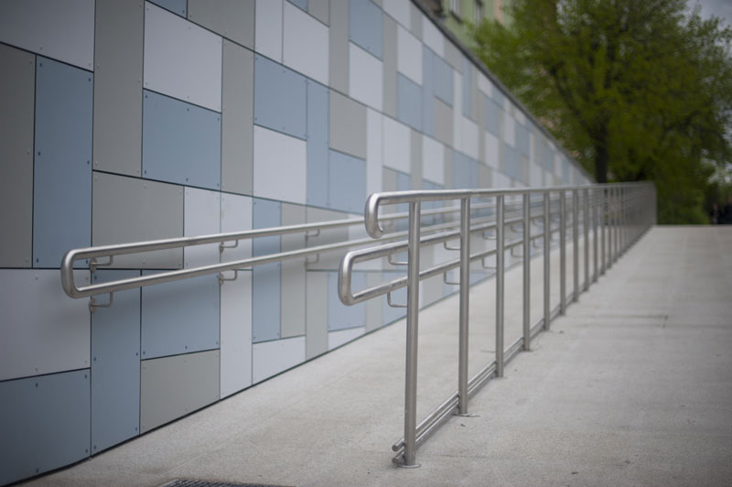
Standard ramps have an inclined access way with a gradient (slope) steeper than 1 in 20 (Diagram 1), but not steeper than 1 in 14 (Diagram 2)
Diagram 1
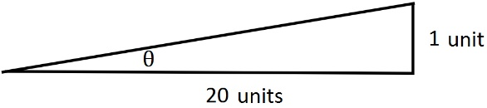
Diagram 2
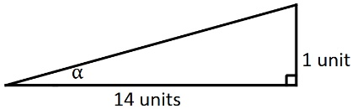
This standard could be interpreted in terms of the angle of inclination of each ramp.
The slope a ramp will have is dependent on the horizontal distance covered by the ramp, i.e. the steeper the ramp, the less horizontal distance is covered.
  - A planner wants to determine how much horizontal distance will be covered by a ramp leading to the entrance of a building. The ramp needs to reach a vertical height of 0.6 m.

Determine the range of horizontal distances a ramp with the minimum to the maximum slope would cover. (11 marks)
  - The current Building Code of Australia requires a ramp to have level landings every nine metres of the slant distance.

For what range of slope would a ramp reaching a height of 0.6 m need to include a level landing to comply with the Building Code of Australia? (8 marks)

Use the Mathematical Thinking process, outlined below, to complete this Practical Application assessment:
- interpret the task and gather the key information
  - what is the decision or conclusion to be made?
  - what information has been provided that will help you to complete the task?
- identify the mathematics which could help to complete the task
  - what mathematical techniques/calculations have you learnt that will help you with this task?
- analyse information and data from a variety of sources
  - how will you use the information provided?
  - what other information will you need to complete the task?
- apply existing mathematical knowledge and strategies to obtain a solution
  - use the mathematical techniques you have identified to carry out calculations
- verify the reasonableness of the solution
  - are your results relevant and do they make sense in the context of the task?
- communicate findings in a systematic and concise manner
  - show how you have organised and used the information provided to carry out mathematical techniques/calculations that will support your conclusion
  - make a concluding statement with an explanation to back up your decision/conclusion
The written submission is expected to include:
- appropriate calculations which show how information has been used
- concluding statements which clearly describe and verify the decisions/conclusions.

ACKNOWLEDGEMENTS
Introductory text from: JobAccess. (2012). Ramps. Retrieved March, 2015, from www.jobaccess.gov.au/content/ramps

Marking key for sample assessment Task 3 – Unit 3
- Determine the range of horizontal distances a ramp with the minimum to the maximum slope would cover.
Sample solution (Note: diagrams are not to scale)
$$\tan{α}=\frac{1}{14}$$  $$α={\text{tan}}^{-1}(\frac{1}{14})$$  $$α=4.1°$$  $$\tan{4.1°}=\frac{0.6}{l}$$  $$l=\frac{0.6}{\tan{4.1°}}$$  $$l=8.37\text{m}$$ | $$\tan{θ}=\frac{1}{20}$$  $$θ={\text{tan}}^{\text{-1}}\left(\frac{1}{20}\right)$$  $$θ=2.9°$$  $$\text{tan}{\text{2.9°}}\text{=}\frac{\text{0.6}}{\text{L}}$$  $$\text{L}=\frac{0.6}{\tan{2.9}°}$$  $$\text{L}\text{ = 11.84 }\text{m}$$
The range of horizontal distance covered by a ramp of minimum to maximum slope is from 8.37 m to 11.84 m where the steeper slope has the shorter horizontal distance.
Specific behaviours |  | Marks
Correctly uses provided information to carry out task |  | 1
Recognises the need to determine the angle of inclination for the minimum and maximum slope |  | 1
Chooses an appropriate method to determine the angles of inclination |  | 1
Correctly calculates the angles of inclination |  | 1
Chooses an appropriate method to determine the horizontal distance |  | 1
Calculates the horizontal distance for one ramp |  | 1
Correctly calculates horizontal distances for minimum and maximum slopes using previously calculated angles |  | 1
Rounds to an appropriate level for the context |  | 1
States a range of horizontal distances |  | 1
Makes a correct connection between the degree of slope and the amount of horizontal distance in conclusion |  | 1
Uses accurate mathematical language to communicate methods and solutions |  | 1
Total |  | /11

- For what range of slope would a ramp reaching a height of 0.6 m need to include a level landing to comply with the Building Code of Australia?
Sample solution (Note: diagrams are not to scale)
$$\sin{4.1°}=\frac{0.6}{\text{S}}$$
$$\text{S}=\frac{0.6}{\sin{4.1°}}$$
$$\text{ S = 8.39 }\text{m}$$
Ramp with maximum slope does not require a level landing.
$$\sin{2.9°}=\frac{0.6}{s}$$
$$s=\frac{0.6}{\sin{2.9°}}$$
$$s=11.86 \text{m}$$
A ramp with minimum slope has a slant distance which exceeds 9 m and therefore requires a level landing.

$$\sin{σ=\frac{0.6}{9}}$$
$$σ={\text{sin}}^{ -1}\frac{0.6}{9}$$
$$σ=3.8°$$
Ramp with a slant distance of 9 m has an angle of inclination of 3.8˚, therefore ramps with a slope between 2.9˚ and 3.8˚ would require a level landing after 9 m if they were to reach a height of 0.6 m.

Specific behaviours | Marks
Recognises criteria for inclusion of a level landing | 1
Chooses an appropriate method to determine the slant distance | 1
Recognises the ramp needs to reach 0.6 m | 1
Determines slant distance for one ramp | 1
Makes a correct conclusion about the need or not to include a level landing | 1
Determines the slope for a slant height of 9 m | 1
States the range of slope for which a level landing is required | 1
Uses accurate mathematical language to communicate methods and solutions | 1
Total | /8

Sample assessment task

Mathematics Essential – General Year 12

Task 5 – Unit 3

Assessment type: Statistical investigation process
Conditions
Students will need to have access to technology with a spreadsheet function.

50 minutes in class under test conditions
Marks: 23 marks

Task weighting: 7% of the school mark for this pair of units
_________________________________________________________________________________
Which, if any, is the better predictor for height – arm span or the length of a person’s right foot?
A completed statistical investigation should include:
- an introduction that outlines the question to be answered and any further questions that could be explored
- selection and application of suitable mathematical and graphical techniques you have studied to analyse the provided data
- interpretation of your results, relating your answer to the original problem
- communication of your results and conclusions in a concise, systematic manner.
Your investigation report should include the following: (23 marks)
1. Introduction
- two or three sentences providing an overview of your investigation (3 marks)
2. Numerical and graphical analysis
- choose various statistical measures you have studied to analyse the data (4 marks)
- consider the most appropriate graphs which represent the data provided (5 marks)
3. Interpretation of the results of this analysis in relation to the original question (7 marks)
- describe any trend and pattern in your data (two to three sentences)
- state how your data relates to the original problem (two to three sentences)
- use your knowledge and understanding gained in this unit to explain your results in one paragraph
4. Conclusion (4 marks)
- summarise your findings and conclusions in one paragraph.

DATA
A sample of data is provided below. The data includes the height, arm span and length of right foot for a sample size of 30 taken from a survey of students aged 14 to 17.
Height | Arm span | Right foot length |  | Height | Arm span | Right foot length |  | Height | Arm span | Right foot length
170 | 71 | 23 |  | 158 | 150 | 30 |  | 162 | 130 | 25
155 | 150 | 21 |  | 169 | 174 | 28 |  | 147 | 27 | 24
169 | 173 | 26 |  | 55 | 55 | 23 |  | 176 | 176 | 26
177 | 176 | 23 |  | 165 | 160 | 36 |  | 148 | 149 | 23
153 | 149 | 26 |  | 147 | 142 | 21 |  | 156 | 155 | 24
150 | 166 | 25 |  | 175 | 176 | 25 |  | 172 | 178 | 25
159 | 156 | 26 |  | 166 | 157 | 26 |  | 150 | 142 | 24
170 | 162 | 26 |  | 150 | 136 | 21 |  | 158 | 80 | 25
169 | 154 | 26 |  | 176 | 171 | 24 |  | 145 | 147 | 21
162 | 152 | 26 |  | 163 | 164 | 23 |  | 167 | 169 | 21
ACKNOWLEDGEMENTS
Data from CensusAtSchool, Australian Bureau of Statistics.
Used under Creative Commons Attribution 2.5 Australia licence.

Marking key for sample assessment task 5 – Unit 3
Introduction
This statistical investigation is to determine which, if any, is the better predictor of a person’s height; the arm span or the length of the right foot. In order to make an informed decision, I will compare the strength of the association between the pairs of variables; that is, the association between height and arm span and the association between height and the length of the right foot.
Specific behaviours | Marks
Provides a simple introduction of the question | 1
Restates question in own words | 1
Mentions comparison of association between variables | 1
Total | /3

Numerical analysis
Of the data, there are four outliers
Height Arm span Right foot
170 70 23
55 55 23
147 27 24
158 80 25
These have been removed for the graphical analysis
Specific behaviours | Marks
Identifies one outlier | 1
Identifies at least two outliers | 1
Identifies all outliers | 1
Removes outliers | 1
Total | /4

Graphical analysis
Specific behaviours | Marks
Constructs a single scatterplot | 1
Shows comparative scatterplots | 1
Uses a similar scale for the horizontal axis (height) | 1
Presents correct graphs, including labelling | 2
Total | /5

Interpretation
Sample interpretation:
Outliers have been removed from four data points as these were probably due to incorrect measurement and would therefore have not given a true picture of any association between the variables.
The scatterplot for height and arm span is positive and linear. The association appears to be strong.
The scatterplot for height and right foot length is not linear. The association appears to be weak.
Specific behaviours | Marks
Interpretation linked to numerical and graphical data | 1
Makes an appropriate statement about the outliers | 1
Gives a reason for removing the outliers | 1
Compares the shape of each scatterplot | 2
States the linear relationship between height and arm span | 1
States the non-linear relationship between height and length of right foot | 1
Total | /7

Conclusion
Sample conclusion:
The removal of four outliers from the data has reduced the sample to 26 students.
Analysis of data from these 26 students has shown that the linear relationship between height and arm span is a better predictor of height as there is a strong association between the two variables.
Specific behaviours | Marks
Makes a valid statement about the results | 1
Relates conclusion back to the original question | 1
Refers to strong relationship/association between height and arm span | 1
Provides a concise and coherent summary of the analysis | 1
Total | /4

