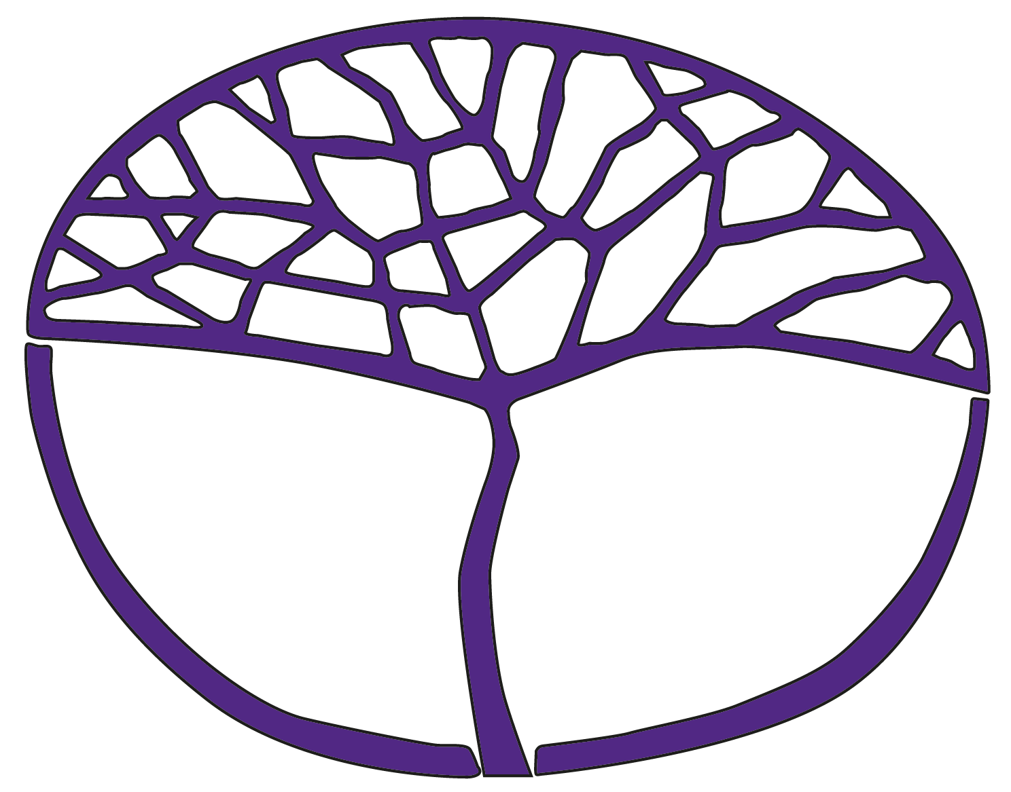
Sample Assessment Outline
Chinese: Second Language
General Year 12

Acknowledgement of Country
Kaya. The School Curriculum and Standards Authority (the Authority) acknowledges that our offices are on Whadjuk Noongar boodjar and that we deliver our services on the country of many traditional custodians and language groups throughout Western Australia. The Authority acknowledges the traditional custodians throughout Western Australia and their continuing connection to land, waters and community. We offer our respect to Elders past and present.
Copyright
© School Curriculum and Standards Authority, 2015
This document – apart from any third-party copyright material contained in it – may be freely copied, or communicated on an intranet, for non-commercial purposes in educational institutions, provided that the School Curriculum and Standards Authority (the Authority) is acknowledged as the copyright owner, and that the Authority’s moral rights are not infringed.
Copying or communication for any other purpose can be done only within the terms of the Copyright Act 1968 or with prior written permission of the Authority. Copying or communication of any third-party copyright material can be done only within the terms of the Copyright Act 1968 or with permission of the copyright owners.
Any content in this document that has been derived from the Australian Curriculum may be used under the terms of the Creative Commons Attribution 4.0 International licence.
Disclaimer
Any resources such as texts, websites and so on that may be referred to in this document are provided as examples of resources that teachers can use to support their learning programs. Their inclusion does not imply that they are mandatory or that they are the only resources relevant to the course. Teachers must exercise their professional judgement as to the appropriateness of any they may wish to use.

Sample assessment outline

Chinese: Second Language – General Year 12

Unit 3 and Unit 4
Assessment  type | Assessment type  weighting | Assessment task  weighting | When | Assessment task
Oral communication | 30% | 15% | Semester 1  Week 15 | Task 5: Present a two-minute description and engage in a two-minute conversation in Chinese related to The individual – My neighbourhood.
Oral communication | 30% | 15% | Semester 2  Week 10 | Task 8: Listen to a three-minute interview in Chinese related to The Chinese-speaking communities – Welcome to Australia.
Response: Listening | 20% | 10% | Semester 1  Week 6 | Task 1: Listen to texts in Chinese related to The changing world – Let’s celebrate and The Chinese – speaking communities – Celebrations and respond in English.
Response: Listening | 20% | 10% | Semester 2  Week 15 | Task 10: Listen to texts in Chinese related to The Chinese-speaking communities – Welcome to Australia and The changing world – Travel in a modern world and respond in English.
Response: Viewing and reading | 25% | 10% | Semester 1  Week 8 | Task 2: Read texts in Chinese related to The Chinese-speaking communities – Celebrations and The changing world – Let’s celebrate and respond in English.
Response: Viewing and reading | 25% | 7.5% | Semester 2  Week 4 | Task 6: Read texts in Chinese related to The Chinese-speaking communities – Welcome to Australia and respond in English.
Response: Viewing and reading | 25% | 7.5% | Semester 2  Week 15 | Task 9: Read texts in Chinese related to The individual – Destination China and The changing world – Travel in a modern world and respond in English.
Written communication | 10% | 5% | Semester 1  Week 10 | Task 3: Write a description of approximately 100 characters based on a stimulus related to The individual – My neighbourhood.
Written communication | 10% | 5% | Semester 2  Week 5 | Task 7: Write an email of approximately 100 characters related to The Chinese-speaking communities – Welcome to Australia.
Externally  set task | 15% | 15% | Semester 1  Week 13 | Task 4: A task set by the School Curriculum and Standards Authority (the Authority) based on the following content from Unit 3 – <teacher to insert information provided by the Authority>.
Total | 100% | 100%

